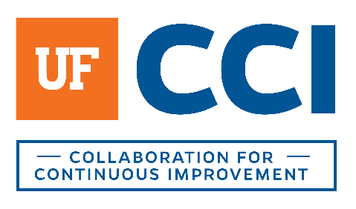
PROJECT NAME

Organizational Context

Participants

Purpose
The objective of the session is to develop a shared understanding of the direction and organizational context.
The input gathered in this session provides the lens through which we as a team can look at the {PROJECT DETAILS} and the potential future implications and impact of this work on the University.

OVERALL CONTEXT
- What trends and business strategies are occurring at UF or within your department today?
- Are there any strategic changes that are anticipated?
- Are there any existing threats that you must address to be competitive or grow in the manner you are expecting?

Internal Context
- Describe your unit in structure and function.
- Beyond this training program’s stated objectives, what specific organizational goals/objectives is your unit focused on?
- How do these goals or objectives impact this training program?
- What are the key areas of strength of your team today?
- What are the key areas of opportunity of your team today?

EXTERNAL FOCUS
- Who are your customers? (focus for next two years)
- What do your current customers like about doing business with your unit or when engaged in this process?
- How do you decide what work to do?
- What do your customers need that you are not currently providing or what are some areas your customers would like to see you improve?

PROGRAM FOCUS
- What is the history of continuous improvement on campus?
- What previous exposure has your unit had to continuous improvement theory/practice?
- Beyond your unit’s goals, and what has been previously stated, what are the key improvements or capabilities you want to see result from this project?
- Have there been any recent events driving this project?
- Are there any key influencers who may be particularly interested in this success of this project or key deterrers?
- What cultural influences might we encounter in this work?
- What physical or political barriers might we encounter?

