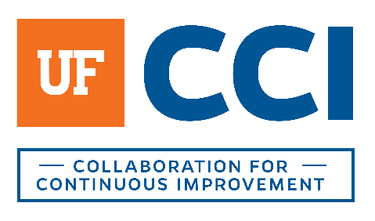

Project Intake and Discovery

Introduction
Use this document when investigating a potential new project.
Who is involved in this discussion? ____________________________________________________
Who/what units will be involved in the potential project?__________________________________

Disclaimer
Even though we are conducting this activity, this is not formal authorization for the project. This discussion neither expresses or implies approval for the project to move forward at this time.

Explain Business Process Improvement

What is Business Process Improvement (BPI)?
It is a process that follows a structured approach to define and analyze a predetermined scope. It has a start and a stop with multiple activities and actions that take place to reach the objective of the process (i.e. Monthly reconciliation, Registering for classes, Paying student refunds, etc.)
of work to improve its performance.
It is an iterative process that challenges processes, technology, norms and patterns.
It is a process of forward-thinking action aimed to understand what is happening now in a process, why it is happening, and what is desired to happen in the future.

What does BPI consist of?
- Initiating the Project and Defining the Organizational Context
- Defining the Current State: document a process by highlighting what you do, how you do it, who does the work, and how frequently the process is done. Deliverable: current state process map.
- Analysis of the Current State: analyze defined process by exploring why the work is done (necessary business function, technical limitation, regulatory or legal requirement, or other reason), identifying pain points, bottlenecks, gaps, inefficiencies or waste, and highlighting initial opportunities for improvement within the process. Deliverable: analysis summary spreadsheet outlining the process in terms of policy, process, and technology, pain points, and initial opportunities for improvement.
- Visioning the Desired Future State: collaboratively design a desired future state of the process that is informed by the information learned during the current state and analysis stages. Deliverable: future state process map
- Recommended Action Plan (RAP): detailed action plan to guide prioritization of change efforts and detailed implementation planning. Deliverable: RAP summary with action steps, potential benefits of the actions, and timeline and progress tracker.

Discovery Topics and Questions
- Please provide an overview of the project.
- Please provide an overview of the process(es) you would like to assess.
- What should be included and what can we specifically exclude?
- What pains/issues exist (or what event happened or is anticipated to happen) that caused this?
- What is your ideal timeframe for completion?
- What are you hoping to accomplish and is there a way to measure that?
- What are the departments and customers that will be impacted by the outcomes?
- How and to what extent will they be impacted?
- To what extent are they open to potential changes?
- Is there anything that is off limits for change?
- At what level is there executive sponsorship of this project and who is that person(s)?
- How does this project relate to your unit’s strategic goals or the University’s goals?
- Are there any metrics available now that would help understand the issues (cost, time, quality, service, compliance, experience)?
- What is the “Definition for Success” (efficiency, effectiveness, customer service, customer satisfaction, lowering costs, risk, etc.)?
- What target metrics do you have that support the definition?
- Who will be assigned to the project from your unit?
- How much time will they contribute to it?
- Are there any potential unavailable periods?
- What is our estimated level of effort (likely number of workshops, meetings, etc.)?
- What is you plan for action after this work is complete?
- Will you need addition support?
- Will there be a clear handoff?

Conclusion
Conclude the meeting with a recap of your understanding of the need, clarify any open issues. Explain that you will determine capacity to meet the needs of this project and follow up on a specific target date.

Possible Follow Up
Explain that you may need to follow up with additional questions to ensure the proposed project receives thorough consideration and planning.

