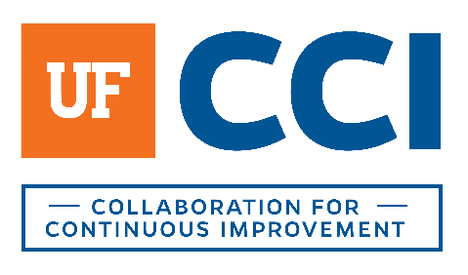
recommended action plan (rap) development facilitation guide

In Advance
- Review work done to date:
  - Current State process map(s)
  - Process Analysis Outputs and Deliverables, Key Pain Points and Future State Opportunities for Improvement (OFIs)
  - Future State maps
  - Familiarize yourself with general capabilities of any software discussed – as needed
  - Consult with the assigned BA – as needed

During the Meeting

rap information collection

Collect these items from the walls/discussion:
- Benefits - Tangible and intangible ways is it better
  - Consider improvements in compliance, cost, quality, service, speed, and experience
- Actions that can be taken - What needs to happen to implement our future state
  - Quick hits, short term, medium term, and long term?
- Metrics - What metrics should be collected/identified in the future state?
- Critical Success Factors - What are the critical things that MUST happen for this process to work?

rap deliverable completion
After the session, establish a RAP:
- Refer to the Current State map(s), Analysis deliverable, the Future State map(s), and any notes taken during the sessions.
- Identify the sub-process(es) impacted (may be more than one)
- Number the Action Plan in the deliverable document (RAP – 1, RAP – 2) (Also rename the tab at the bottom to match)
- Create a Process Context
  - Provide a context around the pain points that exist from the Analysis phase or that arose within the future state session. The context should tell the story of what area can be improved. Consider time/speed, cost, quality, service, compliance, or experience.
- Describe the Opportunity for Improvement (OFI) – detail out the OFI with information. Remember the time/speed, cost, quality, service, compliance.
- Then, detail any actions that can be taken to help the stakeholders work towards the OFI (reaching the desired future state). (The Driver and Goal for Completion sections will be left blank. These are for the stakeholders internal use.)
- Identify any Tangible and Intangible Benefits in relation to cost, quality, time/speed, service, compliance, and EXPERIENCE.
- You may need to consult a BA or Project Manager to determine potential next steps or to get more information.
- Once you complete the RAP, route it to another teammate for a second review.

rap deliverable delivery
Once two team members have reviewed the RAP:
- Change the title of the document to FINAL.
- Save the final version of the RAP to Box in the appropriate folder.
- Tailor the cover letter for the RAP to the stakeholder group (see template).
- Send the cover letter and RAP file to the stakeholders (cc: BA as appropriate).

