


Gators for
The Win

University Athletic Association, Inc. Financial Statements 2024-2025

CONTENTS
INDEPENDENT AUDITORS’ REPORT
6
6 Independent Auditors’ Report

REQUIRED SUPPLEMENTARY INFORMATION
13
13 Management’s Discussion and Analysis

BASIC FINANCIAL STATEMENTS
26
26 Statements of Net Position
27 Statements of Revenues, Expenses and Changes In Net Position
28 Statements of Cash Flows
30 Statements of Fiduciary Net Position
31 Statements of Changes In Fiduciary Net Position
35 Notes to Financial Statements

OTHER REPORTING REQUIRED
52
BY GOVERNMENT AUDITING STANDARDS
52 Report on Internal Control Over Financial Reporting and on Compliance and Other Matters Based on an Audit of Financial
Statements Performed in Accordance with Government Auditing Standards

G AT ORS Vision

2 | UNIVERSITY ATHLETIC ASSOCIATION, INC.

BE THE MODEL collegiate athletics program, combining excellence and integrity in academics, athletics and fan engagement to elevate the UF brand.

2024-2025 | FINANCIAL STATEMENTS | 3

4 | UNIVERSITY ATHLETIC ASSOCIATION, INC.
G AT ORS Values

TEAMWORK
- We promote cooperation by sharing information and working to understand each other’s perspective.
- We display loyalty as we work together to create a successful experience for student-athletes, employees and fans.
PASSION
- We give everything
we have for the people and the place we love.
- We love what we do and why we do it.
EXCELLENCE
- We strive to perform and achieve at the highest level in all that we do.
- We continuously improve and demand a higher level of performance than what is necessary.
INNOVATION
- We find creative solutions and embrace change.
RESPECT
  - We treat each other with fairness, honesty, kindness and civility.
INTEGRITY
  - We act in a fair, ethical and honest manner.
  - We do things the right way every day.

2024-2025 | FINANCIAL STATEMENTS | 5



INDEPENDENT AUDITORS’ REPORT

The Audit Committee,
The University Athletic Association, Inc.:
Report on the Audit of the Financial Statements
Opinions
We have audited the financial statements of the business-type activities and the aggregate remaining fund information of The University Athletic Association, Inc. (the Association), a direct support organization and component unit (for accounting purposes only) of the University of Florida, as of and for the years ended June 30, 2025 and 2024, and the related notes to the financial statements, which collectively comprise the Association’s basic financial statements as listed in the table of contents.
In our opinion, the accompanying financial statements present fairly, in all material respects, the respective financial position of the business-type activities and the aggregate remaining fund information of the Association as of and for the years ended June 30, 2025 and 2024, and the respective changes in financial position and, where applicable, cash flows thereof for the years then ended in accordance with accounting principles generally accepted in the United States of America.
Emphasis of Matter – Change in Accounting Principle
As discussed in Note 1(n) to the financial statements, the Association implemented GASB Statement No. 101, Compensated Absences, which required a restatement of beginning net position as of July 1, 2023. Our opinion is not modified with respect to this matter.
Basis for Opinions
We conducted our audits in accordance with auditing standards generally accepted in the United States of America (GAAS) and the standards applicable to financial audits contained in Government Auditing Standards (GAS), issued by the Comptroller General of the United States. Our responsibilities under those standards are further described in the Auditor’s Responsibilities for the Audit of the Financial Statements section of our report. We are required to be independent of the Association and to meet our other ethical responsibilities, in accordance with the relevant ethical requirements relating to our audit. We believe that the audit evidence we have obtained is sufficient and appropriate to provide a basis for our audit opinions.
Responsibilities of Management for the Financial Statements
Management is responsible for the preparation and fair presentation of the financial statements in accordance with accounting principles generally accepted in the United States of America, and for the design, implementation, and maintenance of internal control relevant to the preparation and fair presentation of financial statements that are free from material misstatement, whether due to fraud or error.
In preparing the financial statements, management is required to evaluate whether there are conditions or events, considered in the aggregate, that raise substantial doubt about the Association’s ability to continue as a going concern for twelve months beyond the financial statement date, including any currently known information that may raise substantial doubt shortly thereafter.

6 | UNIVERSITY ATHLETIC ASSOCIATION, INC.

Auditor’s Responsibilities for the Audit of the Financial Statements
Our objectives are to obtain reasonable assurance about whether the financial statements as a whole are free from material misstatement, whether due to fraud or error, and to issue an auditor’s report that includes our opinions. Reasonable assurance is a high level of assurance but is not absolute assurance and therefore is not a guarantee that an audit conducted in accordance with GAAS will always detect a material misstatement when it exists. The risk of not detecting a material misstatement resulting from fraud is higher than for one resulting from error, as fraud may involve collusion, forgery, intentional omissions, misrepresentations, or the override of internal control. Misstatements are considered material if there is a substantial likelihood that, individually or in the aggregate, they would influence the judgment made by a reasonable user based on the financial statements.
In performing an audit in accordance with GAAS, we:
- Exercise professional judgment and maintain professional skepticism throughout the audit.
- Identify and assess the risks of material misstatement of the financial statements, whether due to fraud or error, and design and perform audit procedures responsive to those risks. Such procedures include examining, on a test basis, evidence regarding the amounts and disclosures in the financial statements.
- Obtain an understanding of internal control relevant to the audit in order to design audit procedures that are appropriate in the circumstances, but not for the purpose of expressing an opinion on the effectiveness of the Association’s internal control. Accordingly, no such opinion is expressed.
- Evaluate the appropriateness of accounting policies used and the reasonableness of significant accounting estimates made by management, as well as evaluate the overall presentation of the financial statements.
- Conclude whether, in our judgment, there are conditions or events, considered in the aggregate, that raise substantial doubt about the Association’s ability to continue as a going concern for a reasonable period of time.
We are required to communicate with those charged with governance regarding, among other matters, the planned scope and timing of the audit, significant audit findings, and certain internal control–related matters that we identified during the audit.
Required Supplementary Information
Accounting principles generally accepted in the United States of America require that the management's discussion and analysis, as listed in the table of contents, be presented to supplement the basic financial statements. Such information is the responsibility of management and, although not a part of the basic financial statements, is required by the Governmental Accounting Standards Board who considers it to be an essential part of financial reporting for placing the basic financial statements in an appropriate operational, economic, or historical context. We have applied certain limited procedures to the required supplementary information in accordance with auditing standards generally accepted in the United States of America, which consisted of inquiries of management about the methods of preparing the information and comparing the information for consistency with management’s responses to our inquiries, the basic financial statements, and other knowledge we obtained during our audit of the basic financial statements. We do not express an opinion or provide any assurance on the information because the limited procedures do not provide us with sufficient evidence to express an opinion or provide any assurance.

2024-2025 | FINANCIAL STATEMENTS | 7

Other Reporting Required by Government Auditing Standards
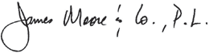
In accordance with Government Auditing Standards, we have also issued our report dated September 9, 2025, on our consideration of the Association's internal control over financial reporting and on our tests of its compliance with certain provisions of laws, regulations, contracts, and grant agreements and other matters. The purpose of that report is solely to describe the scope of our testing of internal control over financial reporting and compliance and the results of that testing, and not to provide an opinion on the effectiveness of internal control over financial reporting or on compliance. That report is an integral part of an audit performed in accordance with Government Auditing Standards in considering the Association’s internal control over financial reporting and compliance.

Gainesville, Florida September 9, 2025

8 | UNIVERSITY ATHLETIC ASSOCIATION, INC.


G AT ORS

Drive
2024-2025 | FINANCIAL STATEMENTS | 9

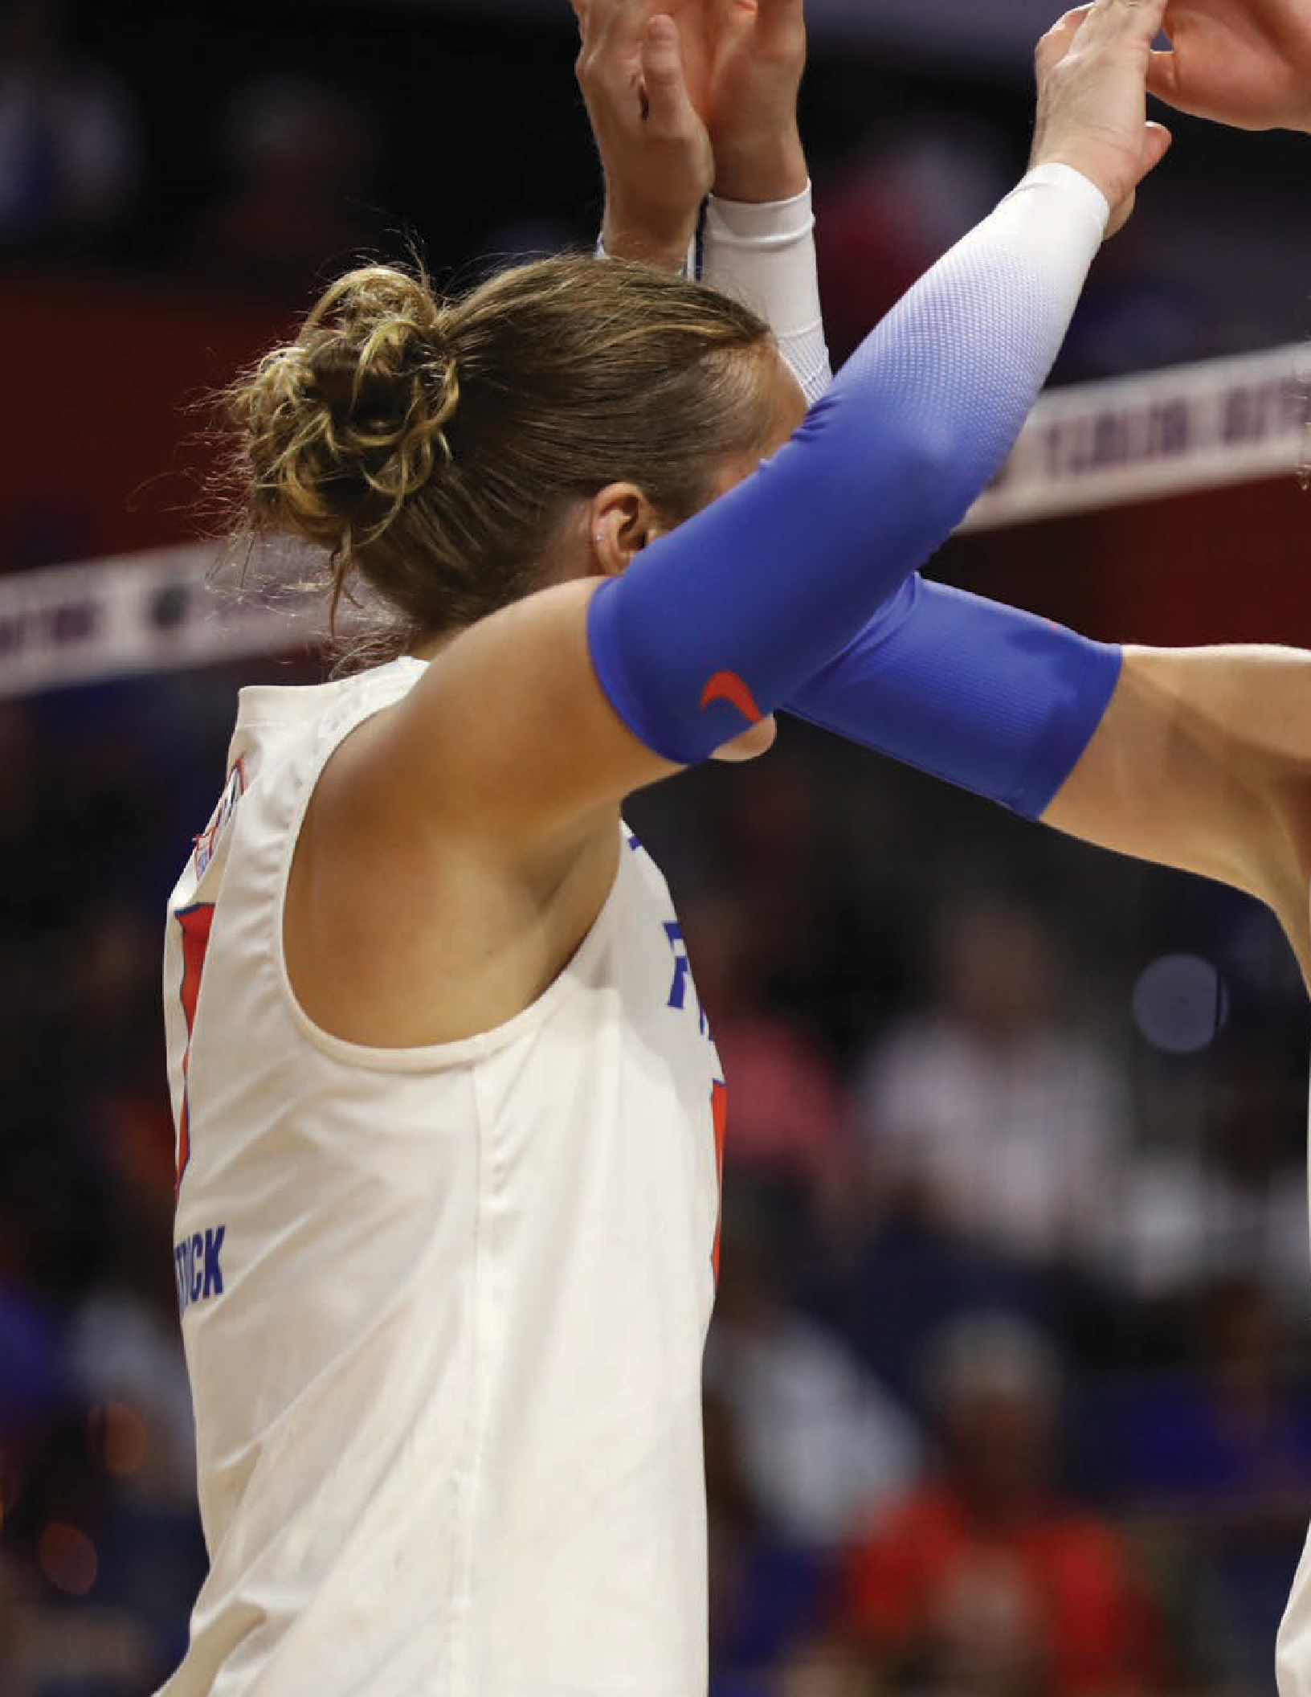

G AT ORS Teamwork

10 | UNIVERSITY ATHLETIC ASSOCIATION, INC.



For 41 consecutive years Florida achieved top-10 finishes in national all-sports standings. Florida is the only program to be among the top 10 in each all-sports ranking since 1983-84. Sixty-four Gators collected a total of 140 All-America honors in 2024-25. Two Gator teams won conference titles in 2024-25. Florida’s 266 Southeastern Conference team titles all-time leads the league.

2024-2025 | FINANCIAL STATEMENTS | 11

G AT ORS
Passion



12 | UNIVERSITY ATHLETIC ASSOCIATION, INC.

Management’s Discussion & Analysis

INTRODUCTION
The University Athletic Association, Inc. (The Association), a not-for-profit corporation, is a direct support organization of the University of Florida (UF or University). The Association exists to advance UF’s teaching, research and service missions through the intercollegiate athletics program.
The Association’s strategic purpose focuses on providing a championship experience with integrity on and off the field for student-athletes and The Gator Nation. The Association’s vision is to be the model collegiate athletics program, combining excellence and integrity in academics, athletics and fan engagement to elevate the UF brand. The Association recognizes its responsibility to UF to operate in an efficient manner using sound business principles within an ethical decision-making process.
The success of the athletic program can be attributed to many factors: outstanding coaches and support staff, extremely talented student-athletes, a great academic institution, a strong recruiting base, University support, supportive alumni and friends and a commitment to each sport. The commitment to success in each sport, not just those with net revenue, brands the program as a national model for collegiate athletics. The Association’s financial strength is also a key component in its success and is a major factor in maintaining or surpassing its current level of achievement in all the Association’s endeavors. The following pages highlight the success both academically and on the field of play for our teams during this past fiscal year.
well as, the Association’s detailed financial statements and notes which begin on Page 24.
With support from fans and donors, the University and the Southeastern Conference (SEC), the Association continues to preserve its financial health. The cooperation among management, the Association Board of Directors and the University led to sound fiscal stewardship and efficient operations. Total net position is one indicator of the improvement or erosion of the Association’s financial health. As displayed below, over the last 10 years, the Association has managed to steadily grow its net position by 50% from $157.4 million in 2016 to $235.7 million in 2025. This growth is evidence of the Association’s effort to maintain financial self-sufficiency.
The Association has also experienced steady rates of growth in its operating revenues and expenses each of the last 10 years except for fiscal year 2021, due to the pandemic. As shown below, operating revenues have grown by 51% from $135.3 million to $204.2 million and operating expenses have grown by 57% from $124.4 million to $195.4 million. In 2025, revenues remained at historic highs, up 12% year over year, while expenses remained on pace with revenue, up 9% year over year.
The impact of The Association’s financial stewardship has translated to success both on the field and in the classroom. Once again Gator student-athlete’s performance is in the top quartile in both the SEC and nationally and this is shown on the following pages.

10 Year History – Net Position, Revenues and Expenses
(in thousands)

250,000,000
OVERVIEW OF THE FINANCIAL STATEMENTS AND FINANCIAL ANALYSIS

The Association is pleased to present its financial statements for the fiscal years ended June 30, 2025 and 2024. This discussion and analysis is a narrative explanation of the Association’s financial condition and operating activities for these years. The overview presented highlights the significant financial activities which occurred during the past three fiscal years and describes changes in financial activity from the prior year. Please read this overview in conjunction with the comparative summaries for net position, revenues, expenses and changes in net position, and cash flow as

200,000,000

150,000,000

100,000,000

2016 2017 2018 2019 2020 2021 2022 2023 2024 2025


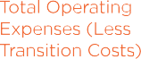


2024-2025 | FINANCIAL STATEMENTS | 13

Rankings

Gators in 2024-25 All-Sports Rankings
The Association proves, year after year, to be a national leader in total revenues generated by the athletics program. This financial success is only possible because of the overall academic and athletic success of the intercollegiate athletics program and the condition of its facilities. The success of the intercollegiate athletics program for the current year is evidenced by the information displayed below and on the following page.
Southeastern Conference
TOP 10

Total Revenues Ranking
TOP 25
NCAA Division 1 Institutions - Nationwide

NATIONAL – GATORS NO. 7
LEARFIELD SPORTS DIRECTORS’ CUP
LEARFIELD Sports Directors’ Cup Standings 2024-25
Rank School | Total
1. Texas | 1255.25
2. Southern Cal | 1253.75
3. Stanford | 1251.00
4. North Carolina | 1195.25
5. UCLA | 1149.00
6. Tennessee | 1078.00
7. FLORIDA | 1072.00
8. Ohio State | 1032.25
9. Oklahoma | 1017.20
10. Duke | 1010.00

- The Gator men’s basketball team’s NCAA Championship led nine top-10 team finishes as the University of Florida athletics program placed seventh in the 2024-25 LEARFIELD Directors’ Cup standings.
- Florida is the only program among top 10 in each of the last 41 national all-sports rankings.
- This is the 16th consecutive complete season with a Gators team winning a national team title. Florida is one of two programs with a national title each complete season since the 2008-09 campaign. UF has 28 championships in that span.
- The LEARFIELD Directors’ Cup, presented annually by the nation’s athletics directors, recognizes the schools with the best overall sports performances in an academic year. The scoring system uses scores for finishes in NCAA Division I men’s and women’s basketball, baseball, women’s soccer and women’s volleyball championship action. Additionally, a program can receive points in up to 14 other sports toward its final score.

Gators by the Numbers
3
16
5
9

NCAA titles for men’s basketball – 2006, 2007 and 2025. Florida is the only program in the nation to win at least three national titles in football (1996, 2006, 2008) and
men’s basketball.
Consecutive complete season with a national title team. Florida is one of two programs to win at least one national title each of the last 16 complete seasons, winning 28 in that span.
Gators claimed five 2025 NCAA individual event titles. This is
the 44th consecutive complete season with a Gator winning at least one individual national title.
Top-10 national team finishes for Florida. The includes men’s
basketball national win – Gators Athletics 49th national title.

14 | UNIVERSITY ATHLETIC ASSOCIATION, INC.

CAPITAL ONE CUP
MEN – NO. 3 | WOMEN – NO. 13
SOUTHEASTERN CONFERENCE
GATORS – NO. 4

- A top 10 finish was earned by the University of Florida men’s (3rd) program in the 2024-25 Capital One Cup standings. Florida women finished 13th.
- In the 15-year history of the Capital One Cup, UF has four Capital One Cup wins: Men: 2010-11, 2011-12, 2022-23 | Women: 2013-14
- UF and Stanford are the only schools to win both in the award’s history. Three wins for each UF, Notre Dame and Stanford lead the men’s Capital One Cup all-time standings.
Another SEC Title in 2024-25
- Florida was fourth in 2024-25 USA Today Network Southeastern Conference All-Sports standings. The Gators men’s golf title marked the 47th consecutive season Florida has won an SEC title – the longest current streak among the league programs.
- Two Gator teams won 2025 conference tournament titles. Men’s basketball won the 2025 SEC Tournament title. In Gator lacrosse’s first season in the Big 12 Conference, Florida swept the regular-season and tournament titles.

Florida’s LEARFIELD Directors’ Cup All-Sports Finishes Since 1983-84
Rank | Years
2nd | 2013-14, 2012-13, 2011-12, 2009-10,  1997-98
3rd | 2018-19, 2017-18, 2016-17, 2008-09,  2001-02, 1995-96
4th | 2023-24, 2014-15, 2010-11, 1998-99,  1993-94, 1992-93, 1986-87, 1984-85
5th | 2022-23, 2021-22, 2020-21, 2015-16,  2005-06, 1996-97, 1994-95, 1991-92,  1990-91, 1989-90, 1987-88, 1983-84
6th | 2007-08, 2006-07, 2004-05, 2003-04
7th | 2024-25, 2002-03, 2000-01, 1999-00
8th | 1985-86
9th | 1988-89

2024-25 SEC All-Sports Overall Standings
Place | School | Total # of Part. teams | Points | Quotient
1 | Texas | 179.75 | 227.75 | 0.7892
2 | Tennessee | 149.50 | 227.75 | 0.6564
3 | Texas A&M | 148.25 | 231.75 | 0.6397
4 | FLORIDA | 148.00 | 236.75 | 0.6251
5 | Georgia | 138.75 | 240.75 | 0.5763
6 | South Carolina | 130.75 | 228.25 | 0.5728
7 | LSU | 128.50 | 236.75 | 0.5428
8 | Alabama | 123.75 | 236.75 | 0.5227
9 | Arkansas | 117.75 | 225.75 | 0.5216
10 | Vanderbilt | 73.13 | 143.50 | 0.5096
11 | Oklahoma | 113.63 | 228.25 | 0.4978
12 | Auburn | 119.50 | 240.75 | 0.4964
13 | Mississippi | 99.38 | 203.75 | 0.4877
14 | Mississippi State | 84.00 | 200.25 | 0.4195
15 | Kentucky | 97.50 | 236.75 | 0.4118
16 | Missouri | 70.13 | 221.75 | 0.3162

41
64
408
266

Consecutive years of Florida top-10 finishes in national all-sports standings. Florida is the only program among the top 10
in each all-sports ranking since 1983-84.
Gators collected 140 All-
America honors in 2024-25.
Earned Southeastern Conference Academic Honor Roll accolades in 2024-25 – No. 3
all-time for the Gator program.
Southeastern Conference team titles claimed by Florida leads the league. Gators won SEC men’s golf title and lacrosse won Big 12 crown in 2025.

2024-2025 | FINANCIAL STATEMENTS | 15


MD&A

USING THESE FINANCIAL STATEMENTS

This report consists of a series of financial statements, prepared in accordance with the Governmental Accounting Standards Board (GASB) Statement No. 34, Basic Financial Statements and Management’s Discussion and Analysis – for State and Local Governments and Statement No. 35, Basic Financial Statements – and Management’s Discussion and Analysis – for Colleges and Universities.

There are three financial statements presented: The Statements of Net Position; the Statements of Revenues, Expenses and Changes in Net Position; and the Statements of Cash Flows. As well, the addition of the Statements of Fiduciary Net Position and Statements of Changes in Fiduciary Net Position for the University Athletic Association Employees’ Money Purchase Pension Plan as required by GASB Statement No. 84, Fiduciary Activities.

SUMMARY OF NET POSITION
The Statements of Net Position shared in summary on the next page and in detail on page 24 present the assets, liabilities and net position of the Association as of the end of the last two fiscal years. A Statement of
Net Position is a point-in-time financial statement. Its purpose is to present to the readers of the financial statements a fiscal snapshot of the Association. The Statements of Net Position present end-of-the-year data concerning assets (what the Association owns and how much is owed to the Association by others), liabilities (what the Association owes to others and has collected from others before the service has been provided) and net position (assets minus liabilities). The statements are prepared using the economic resources measurement focus and the accrual basis of accounting, where revenues are recorded when they are earned and expenses are recognized when they are incurred.

From the data presented, readers of the Statements of Net Position are able to determine the assets available to continue the operations of the Association. They are able to determine how much the Association owes to vendors and lending institutions. Finally, the Statements of Net Position provide a picture of the net position and their availability for expenditure by the Association.

Net Position is divided into three major categories. Net investment in capital assets presents the Association’s equity in property, plant and equipment. Restricted net position has constraints placed upon its use by independent donors. Unrestricted net position is available to the Association for any legal use.

16 | UNIVERSITY ATHLETIC ASSOCIATION, INC.

MD&A
2024 - 2023
2025 - 2024
Condensed Summary of Net Position (thousands of dollars)
67,765 57,819 9,946 17% 48,840 8,979 18%
$ 235,729 $ 222,700 $ 13,029 6% $ 208,656 $ 14,044 7%
3%
5,065
159,816
2%
3,083
164,881
167,964
Net Position
Net investment in capital assets Unrestricted
Total net position
96,441 88,943 7,498 8% 83,816 5,127 6%
231,336 231,533 (197) 0% 233,936 (2,403) -1%
Other liabilities
Total liabilities

 |  |  |  | Increase | Percent |  |  |  | Increase | Percent
 | 2025 |  | 2024 | (decrease) | change |  | 2023 |  | (decrease) | change
Assets  Current assets | $ 102,839 |  | $ 85,241 | $ 17,598 | 21% |  | $ 80,168 |  | $ 5,073 | 6%
Capital assets, net of depreciation | 302,835 |  | 307,444 | (4,609) | -1% |  | 309,880 |  | (2,436) | -1%
Other assets | 61,391 61,548 (157) |  |  |  | 0% 52,544 9,004 17%
Total assets | 467,065 454,233 12,832 |  |  |  | 3% 442,592 11,641 3%
Liabilities  Long-term debt outstanding | 134,895 | 142,590 |  | (7,695) | -5% | 150,120 |  | (7,530) |  | -5%

HIGHLIGHTS
The Association experienced a net increase in total assets of $12.8 million in 2025. This included an increase of $17.6 million in current assets due to an increase in cash balances and monies due from Gator Boosters, Inc., as well as a decrease in capital assets due to depreciation.

Long-term and other liabilities saw a decrease of
$0.2 million from the pay down of long-term debt by
$7.7 million and an increase in other liabilities due to increases in payables and unearned revenue and money due Gator Boosters. This increase is attributable to additional tickets sales and booster related contributions for the 2025 football season. There was an increase to overall net position of $13.0 million driven primarily by these noted changes.
SUMMARY OF REVENUES, EXPENSES AND CHANGES IN NET POSITION
The Statements of Revenues, Expenses and Changes in Net Position on page 16 present the revenues and expenses incurred during each year. Revenues and expenses are reported as operating and nonoperating. In
general, operating revenues are received for providing goods and services to the Association’s various customers and constituencies. Operating expenses are those expenses paid to acquire or produce goods and services provided in return for the operating revenues, and to carry out the mission of the Association. The utilization of long-lived assets, referred to as capital assets, is reflected in the financial statements as depreciation, which amortizes and reduces operating income, by the cost of an asset over its expected useful life.

Nonoperating revenues (expenses) are revenues received for which goods or services are not provided, such as investment income and interest expense on capital asset related debt. Capital contributions are considered neither operating nor nonoperating and are reported after “Income before contributions.”

Changes in total net position as presented on the Statements of Net Position are based on the activity presented in the Statements of Revenues, Expenses and Changes in Net Position. The purpose of the Statements of Revenues, Expenses and Changes in Net Position is to present the operating and nonoperating revenues received by the Association and the operating and nonoperating expenses paid by the Association, and any other revenues, expenses, gains and losses received or spent by the Association.

2024-2025 | FINANCIAL STATEMENTS | 17

MD&A

Condensed Summary of Revenues, Expenses and Changes in Net Position (thousands of dollars)
2025 - 2024 2024 - 2023
 |  |  |  | Increase | Percent |  |  | Increase |  | Percent
 | 2025 |  | 2024 | (decrease) | change |  | 2023 | (decrease) |  | change
Operating revenues  Sales of goods and services | $ 54,774 |  | $ 45,604 | $ 9,170 | 20% |  | $ 42,273 | $ 3,331 |  | 8%
SEC and NCAA distributions | 62,453 |  | 52,856 | 9,597 | 18% |  | 51,756 | 1,100 |  | 2%
Contributions | 42,346 |  | 41,996 | 350 | 1% |  | 41,756 | 240 |  | 1%
Royalties and sponsorships | 28,538 |  | 27,792 | 746 | 3% |  | 25,299 | 2,493 |  | 10%
Other 16,066 14,213 1,853 13% 9,186 5,027 55%
Total operating revenues 204,177 182,461 21,716 12% 170,270 12,191 7%
Nonoperating revenues
Investment income (loss), net 6,954 9,140 (2,186) -24% 8,074 1,066 13% Total revenues 211,131 191,601 19,530 10% 178,344 13,257 7%
Operating expenses
Salaries, wages and benefits 85,063 78,048 7,015 9% 74,567 3,481 5%
Direct team expenses 39,198 36,770 2,428 7% 38,563 (1,793) -5%
Scholarships and athlete support services 31,612 27,861 3,751 13% 27,937 (76) 0%
Administrative services and facilities 24,819 22,786 2,033 9% 21,746 1,040 5% Camps and depreciation 14,675 14,406 268 2% 13,558 850 6% Total operating expenses 195,367 179,871 15,495 9% 176,371 3,502 2%
Nonoperating expenses
Interest on capital related debt 4,014 4,256 (242) -6% 3,853 403 10% Other nonoperating expenses 9,871 685 9,186 1341% 425 260 61% Total nonoperating expenses 13,885 4,941 8,944 181% 4,278 663 15%
Total expenses | 209,252 184,812 24,439 13% | 180,649 4,165 2%
Income (loss) before capital contributions | 1,879 6,789 (4,909) -72% | (2,305) 9,092 -395%
Capital contributions from
Gator Boosters, Inc. and others 11,150 8,403 2,747 33% 10,449 (2,046) -20%
Increase (decrease) in net position 13,029 15,192 (2,162) -14% 8,144 7,046 87% Net position, beginning of year* 222,700 207,508 15,191 7% 200,512 6,997 3% Net position, end of year $ 235,729 $ 222,700 $ 13,029 6% $ 208,656 $ 14,043 7%
*Note: Beginning net position for 2024 has been restated for the cumulative effect of GASB 101 - see Note 1(n) to the financial statements.

REVENUES

Student Fees
1%

Other
8%
Nonoperating Revenues 3%

Student Fees
1%

Other
8%
Nonoperating Revenues 5%

Royalties & Sponsorships
23%

2025
Royalties & Sponsorships
23%

2024

Camps 1%
Auxiliaries 1%
Other Sports
3%

Men’s

Football 52%

Camps 1%
Auxiliaries 1%
Other Sports
3%

Men’s
Football 51%

Basketball
8%
Basketball
7%

18 | UNIVERSITY ATHLETIC ASSOCIATION, INC.


MD&A
HIGHLIGHTS

During fiscal year 2025, the Association experienced both stabilization and continued growth in operating revenues with an increase across all categories of revenue. Overall revenue was up 12% for a total of $21.7 million driven by increase in tickets sales, SEC distributions and support from the University including an out of state tuition waiver. Operating expenses were up 9% year-over-year for a total of $15.5 million. This includes increases to scholarship expenses, direct team support and increases for salaries and benefits. Non-operating was up $9.1 million which includes a $3.8 million contribution to the University and $6 million in support to Gator Boosters for fundraising services. The Association continues its effort to ensure expense increases do not outpace revenue growth while continuing to fund the student-athlete experience to the fullest extent. This has pushed the Association’s management to be creative in finding additional revenue streams while keeping expense increases to a minimum.

EXPENSES
Gator Boosters, a related party entity and the fund-raising arm of the Association, raised and transferred capital gifts of $11.2 million to the Association in 2025.

Depreciation
6%
Camps 1%
Auxiliaries 2%

Administrative
Services
23%
Nonoperating Expenses 7%

2025

Football 17%

Men’s Basketball 5%

Other Sports
14%

Depreciation
7%
Camps 1%
Auxiliaries 2%

Administrative
Services
24%
Nonoperating Expenses 3%

2024

Football 17%

Men’s Basketball 4%

Other Sports
16%

Support Services
14%
Scholarships 11%

Support Services
15%
Scholarships 11%

2024-2025 | FINANCIAL STATEMENTS | 19


MD&A

SUMMARY OF CASH FLOWS

The primary purpose of the Statements of Cash Flows shared in summary below and in detail on page 26 is to provide relevant information about the Association’s cash receipts and cash payments during the years shown. The statements classify cash receipts and cash payments as they result from operating, noncapital financing, capital and related financing, or investing activities. The first section, cash flows from operating activities, presents the cash effects of transactions and other events that enter into the determination of the Association’s operating income. The second section, cash flows from noncapital financing activities, shows
Condensed Summary of Cash Flows (thousands of dollars)
2025 - 2024
2024 - 2023
the cash received and spent for nonoperating, non-investing, and noncapital financing purposes and includes contributions to and from the University of Florida, the University of Florida Foundation and the State of Florida. The next section, cash flows from capital and related financing activities, provides information about cash used for the acquisition and construction of capital and related items and cash received from contributions specifically designated for capital purposes. The fourth section, cash flows from investing activities, details the purchases, proceeds and income received from investing activities. The final section reconciles the net cash provided by operating activities to the operating income reflected on the Statements of Revenues, Expenses and Changes in Net Position.

 | 2025 |  | 2024 | Increase (decrease) | Percent change |  | 2023 |  | Increase (decrease) | Percent change
Cash flows from:
Operating activities | $ 25,759 |  | $ 14,804 | $ 10,955 | 74% |  | $ (666) |  | $ 15,470 | -2323%
Noncapital financing activities | (9,871) |  | (685) | (9,186) | 1341% |  | (425) |  | (260) | 61%
Capital & related financing activities | (9,420) |  | (14,032) | 4,612 | -33% |  | (26,922) |  | 12,890 | -48%
Investing activities | (8,205) | (1,001) |  | (7,204) | 720% 28,364 (29,365) |  |  |  |  | -104%
Net change in cash and cash equivalents | (1,737) | (914) |  | (823) | 90% 351 (1,265) |  |  |  |  | -360%
Cash and cash equivalents, beginning of year | 3,852 4,766 (914) |  |  |  | -19% 4,415 351 8%
Cash and cash equivalents, end of year | $ 2,115 $ 3,852 $ (1,737) |  |  |  | -45% $ 4,766 $ (914) -19%

20 | UNIVERSITY ATHLETIC ASSOCIATION, INC.

HIGHLIGHTS

Cash and cash equivalents were down year-over-year by $1.7 million. This is a result of an increase in operating activities which includes additional cash flow from tickets sales, Southeastern Conference distributions and University support, as well as a decrease in payments to suppliers and an increase in payments to employees, scholarships and non-capital financing activities. There was also a decrease in investing activities and a decrease in capital and related financing activities. Cash flows from investing activities will vary based on market conditions and the purchases or sales of securities. Cash flows from capital and related financing activities fluctuate based on capital projects and debt amortization schedules.

Net Cash Flow Activities
(in thousands)
MD&A

CAPITAL ASSET AND DEBT ADMINISTRATION

The Association is financially responsible for all major capital projects and improvements. The Association coordinates all capital projects under University construction guidelines and with University personnel, but has full financial responsibility for the cost of the projects.

The Association has a rich history of financing these projects through a combination of major capital gifts, Association operating funds and tax-exempt debt. Operating funds do not include bond principal payments, which total $64.8 million from the years ended June 30, 2015 through 2025. See exhibits below:

Annual Capitalized Projects – 2015 through 2025
Operating

30,000

Operating Activities Noncapital Financing Activities
Capital & Related Financing Activities
25,000
20,000
15,000
10,000
5,000
0
-5,000
-10,000
-15,000
-20,000
-25,000
2025

2024
2023

Bond Issuance
40%

80,000,000
Funds
19%

$288M

Private Capital Contributions 41%

-30,000

Investing Activities
70,000,000

60,000,000


50,000,000

40,000,000

30,000,000

20,000,000

10,000,000

0
2015 2016 2017 2018 2019 2020

2021

2022

2023 2024 2025

Private Capital Contributions
Bond Issuance
Operating Funds

2024-2025 | FINANCIAL STATEMENTS | 21


MD&A

As of June 30, 2025, the Association had a total of $134.9 million in long-term outstanding debt. This debt was used to finance a number of different athletic facilities, including a 2001 expansion of the Ben Hill Griffin Stadium Skybox and press box complex, a 2007 expansion and renovation of the football offices and student-athlete strength and conditioning center, a 2011 expansion of the west concourse of Ben Hill Griffin Stadium, an expansion and renovation of the gymnastics practice facility and an expansion and renovation of the Charles R. and Nancy V. Perry Indoor Tennis Facility. Other projects included the 2016 construction of the Gary Condron Family Football Indoor Practice Facility and renovation and expansion of the Hawkins Center at Farrior Hall.

The series 2018 bond funded the construction of the Condron Ballpark and renovation and expansion of the Katie Seashole Pressly Softball Stadium. The series 2021 bond for $50 million supported the expansion and renovation of the Soccer and Lacrosse support facility and the Heavener Football Training Center. For further details regarding the Association’s debt structure please reference note 6A.

ECONOMIC OUTLOOK

The Association maintains a strong financial position amongst its peers. Within the SEC and the NCAA, the Association is uniquely prepared for the changing landscape of college athletics, which provides the opportunity to continue to grow and move forward as an organization.

Average Annual Cost of the UF Experience per Scholarship Student-Athlete (466)

Facility Maintenance

NCAA legislative changes in recent years have been a factor in increased scholarship and direct sport team expenses. For FY26, the revenue sharing model will increase expenses by $20.5 million. The ability of the Association to fund the maximum permissible NCAA benefits as well as ensure the equity and quality of the student-athlete experience takes tremendous resources and will continue to put fiscal pressure on the UAA.

Fiscal highlights for the year include completion of almost $300 million in capital projects over the last
10 years with support from operational revenue and capital gifts from Gator Boosters. The ability for the Association to issue debt, amortize the debt and keep the commitment to the facilities master plan represents the solid foundation and management of finances over time. The support the University has provided for these initiatives will position the Association for future growth and financial stability.

The University of Florida is in a position of strength to make the most of these opportunities and sustain support for some of the best collegiate athletes in the industry.

and Overhead
13%
Scholarships 27%
CONTACTING MANAGEMENT

Student Athlete Support Services
12%

$174,422

Direct Team Support 48%
This financial narrative is designed to provide the reader with a general overview of the University Athletic Association, Inc.’s finances and to show the Association’s accountability for the money it receives. If you have questions about this report or need additional financial information, contact the Association’s Business Office at Ben Hill Griffin Stadium, Gainesville, Fla.:

The University Athletic Association, Inc., Attn: Sr. Associate Athletics Director – CFO, PO Box 14485, Gainesville, FL 32604-2485; (352) 375-4683.

22 | UNIVERSITY ATHLETIC ASSOCIATION, INC.

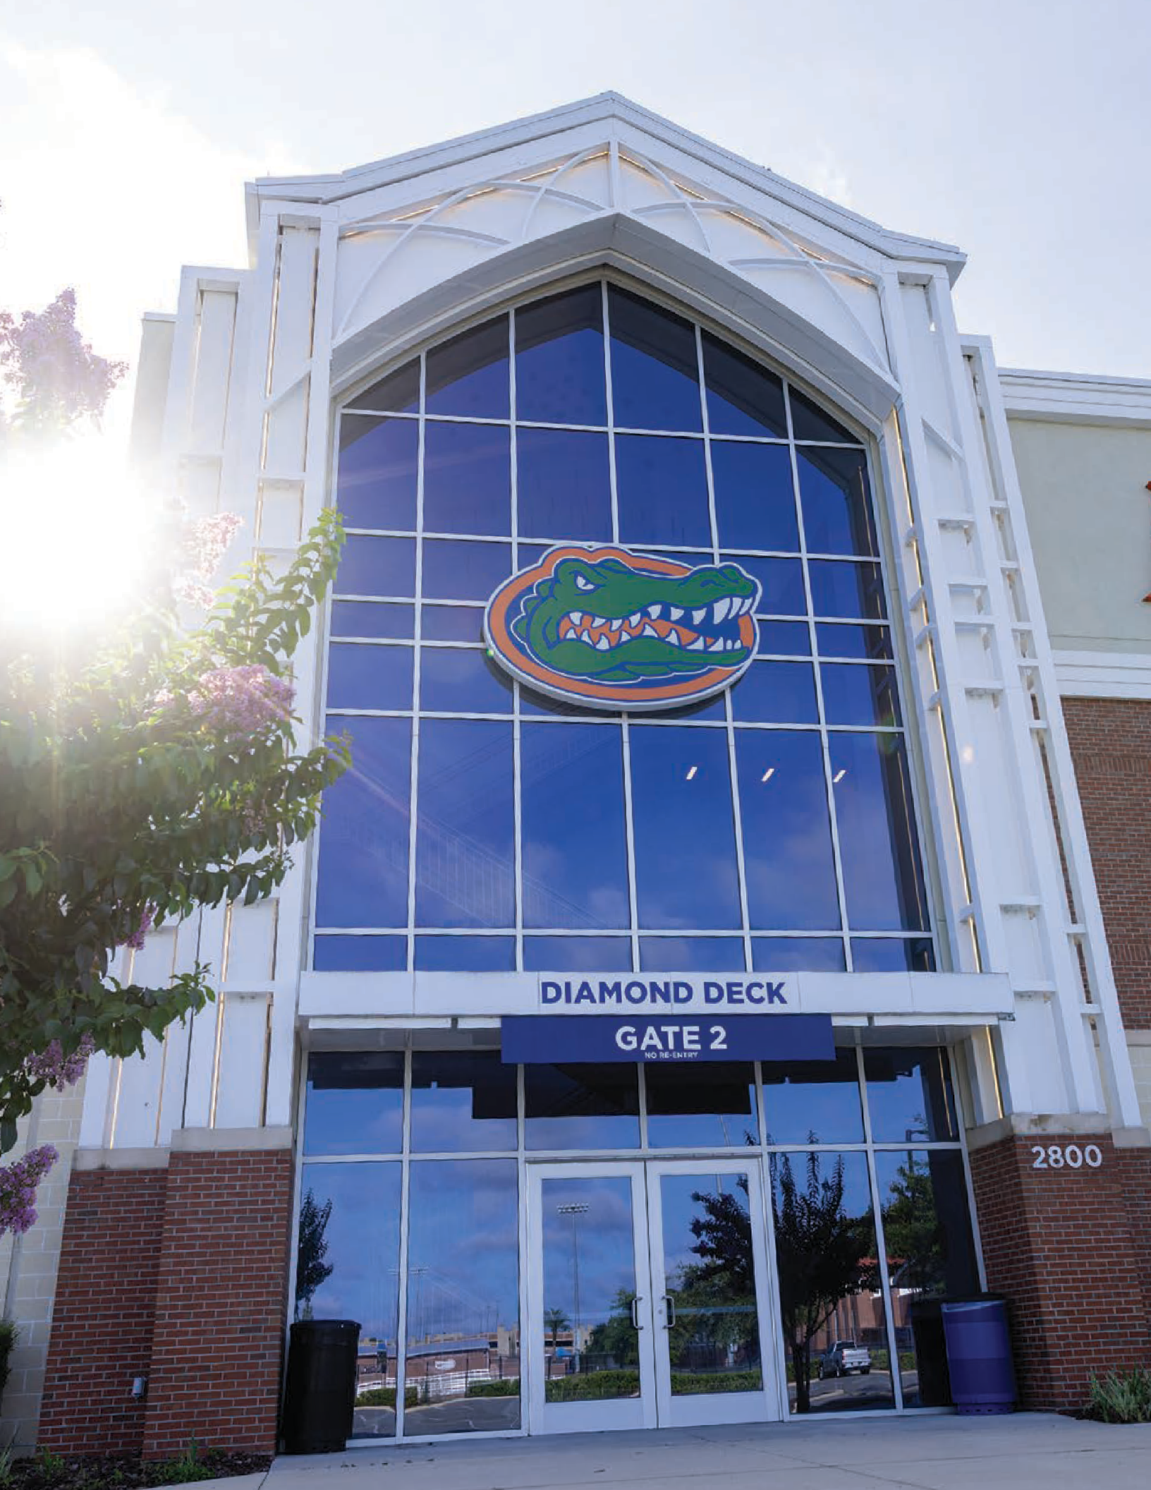
MD&A

2024-2025 | FINANCIAL STATEMENTS | 23



G AT ORS Excellence

24 | UNIVERSITY ATHLETIC ASSOCIATION, INC.


ACADEMICS

Student-athletes are committed not only to excellence on the field but also in the classroom. The Association is privileged to offer student-athletes a preeminent education by investing in people and programs to help UF help the world. UF Preeminence began in 2013 when the Florida Legislature designated UF the state’s preeminent institution. This grew into an opportunity to achieve national and international recognition for our work in serving students and the world. We’re taking what we are good at and making it great. We’re taking what we’re great at and making it world-class. We’re extending the reach of our efforts, so we can help even more people in even more places. And by transforming the state’s flagship university into a truly global university, we’re showing the world that the Gator Good is the greater good.

2024-2025 | FINANCIAL STATEMENTS | 25

BASIC FINANCIAL STATEMENTS
Statements of Net Position
(As of June 30, 2025 and 2024)

 | 2025 |  | 2024
ASSETS  Current Assets  Cash and cash equivalents | $ 2,115,570 |  | $ 3,851,992
Short-term investments | 78,655,335 |  | 62,992,406
Accounts and other receivables, net | 12,879,031 |  | 11,135,847
Due from Gator Boosters, Inc. | 7,508,192 |  | 6,019,664
Inventories | 114,807 |  | 64,742
Prepaid expenses and other current assets | 1,566,331 |  | 1,176,132
Total current assets | 102,839,266 |  | 85,240,783
Noncurrent Assets
Investments | 60,647,966 | 61,152,504
Due from Gator Boosters, Inc., less current portion | - | 210
Right to use lease asset, net of accumulated amortization | 742,643 | 395,560
Capital assets not being depreciated | 14,641,254 | 6,932,140
Capital assets being depreciated, net of accumulated depreciation | 288,193,498 | 300,511,671
Total noncurrent assets | 364,225,361 | 368,992,085
TOTAL ASSETS | $ 467,064,627 | $ 454,232,868
LIABILITIES
Current Liabilities
Accounts payable and accrued expenses | $ 9,856,141 | $ 7,742,921
Accrued compensated absences, current | 139,000 | 309,000
Contracts payable, current | 1,389,294 | 1,754,077
Long-term debt, current | 7,870,000 | 7,695,000
Long-term lease payable, current | 290,663 | 129,252
Unearned revenues, current | 43,910,314 | 41,303,128
Due to Gator Boosters, Inc., current | 35,181,408 | 31,570,185
Total current liabilities | 98,636,820 | 90,503,563
Noncurrent Liabilities
Accrued compensated absences, less current portion | 2,926,753 | 2,530,423
Contracts payable, less current portion | 2,139,077 | 3,365,077
Unearned revenues, less current portion | 180,000 | -
Long-term debt, less current portion | 127,025,000 | 134,895,000
Long-term lease payable, less current portion | 428,137 | 239,039
Total noncurrent liabilities | 132,698,967 | 141,029,539
TOTAL LIABILITIES | $ 231,335,787 | $ 231,533,102
NET POSITION
Net investment in capital assets | $ 167,963,595 | $ 164,881,080
Unrestricted | 67,765,245 | 57,818,686
TOTAL NET POSITION | $ 235,728,840 | $ 222,699,766

The accompanying notes are an integral part of these financial statements.

26 | UNIVERSITY ATHLETIC ASSOCIATION, INC.

BASIC FINANCIAL STATEMENTS 2024-2025

Statements of Revenues, Expenses and Changes In Net Position
(for the years ended June 30, 2025 and 2024)

 | 2025 |  | 2024
Operating Revenues  Ticket sales | $ 49,082,356 |  | $ 39,694,840
SEC and NCAA distributions | 62,452,584 |  | 52,856,113
Contributions | 42,345,758 |  | 41,996,089
Royalties and sponsorships | 28,537,957 |  | 27,791,986
Student fees | 2,571,952 |  | 2,491,420
Direct state support | 3,713,015 |  | 3,201,121
Camps | 2,786,301 |  | 2,711,669
Other sports revenue | 2,905,681 |  | 3,197,398
Other revenue | 9,780,827 |  | 8,520,899
Total operating revenues | 204,176,431 |  | 182,461,535
Operating Expenses
Salaries, wages and benefits | 85,063,142 | 78,048,301
Direct sports team expenses | 39,198,083 | 36,769,633
Scholarships | 22,258,895 | 18,791,526
Student-athlete support services | 9,353,192 | 9,069,007
Administrative services | 14,347,912 | 12,803,961
Facility maintenance and overhead | 10,470,602 | 9,981,857
Camps | 1,242,271 | 1,217,988
Depreciation and amortization | 13,432,541 | 13,189,440
Total operating expenses | 195,366,638 | 179,871,713
Operating income | 8,809,793 | 2,589,822
Nonoperating revenues (expenses)  Investment income, net | 6,953,947 | 9,140,133
Interest on capital asset related debt | (4,013,674) | (4,255,863)
Other nonoperating expenses | (9,870,900) | (684,903)
Net nonoperating revenues (expenses) | (6,930,627) | 4,199,367
Income before capital contributions | 1,879,166 | 6,789,189
Capital contributions from Gator Boosters, Inc. | 11,149,908 | 8,402,821
Increase in net position | 13,029,074 | 15,192,010
Net position, beginning of year, as restated | 222,699,766 | 207,507,756
Net position, end of year | $ 235,728,840 | $ 222,699,766

The accompanying notes are an integral part of these financial statements.

2024-2025 | FINANCIAL STATEMENTS | 27

BASIC FINANCIAL STATEMENTS
Statements of Cash Flows
(for the years ended June 30, 2025 and 2024)

 | 2025 | 2024
Cash flows from operating activities  Contributions from Gator Boosters, Inc. | $ 40,568,753 | $ 40,150,276
Receipts from ticket holders and others | 61,684,864 | 55,842,130
Receipts from the Southeastern Conference and NCAA | 62,415,459 | 52,789,488
Receipts from rights, royalties, and sponsors | 25,519,033 | 26,309,080
Receipts from the University of Florida and the State of Florida | 6,284,967 | 5,692,541
Other receipts | 7,042,228 | 6,240,912
Payments to suppliers and others | (71,597,993) | (75,027,265)
Payments to employees | (83,899,117) | (78,051,325)
Payments for scholarships | (22,258,895) | (19,141,695)
Net cash provided by operating activities | 25,759,299 | 14,804,142
Cash flows from noncapital financing activities  Payments of other nonoperating expenses | (9,870,900) | (684,903)
Net cash used in noncapital financing activities | (9,870,900) | (684,903)
Cash flows from capital and related financing activities
Purchase of capital assets | (8,484,112) | (10,578,850)
Capital contributions from Gator Boosters, Inc. | 11,149,908 | 8,402,821
Principal paid on bonds | (7,695,000) | (7,530,000)
Interest paid on bonds | (4,044,887) | (4,144,976)
Payments for right to use lease assets | (345,634) | (181,183)
Net cash used in capital and related financing activities (9,419,725) (14,032,188)
Cash flows from investing activities
Purchases of investment securities | (67,972,492) | (59,477,853)
Proceeds from sale and maturities of investment securities | 57,790,000 | 56,500,000
Interest and dividends received 1,977,396 1,976,911
Net cash used in investing activities | (8,205,096) | (1,000,942)
Net decrease in cash and cash equivalents | (1,736,422) | (913,891)
Cash and cash equivalents, beginning of year | 3,851,992 | 4,765,883
Cash and cash equivalents, end of year $ 2,115,570 $ 3,851,992

The accompanying notes are an integral part of these financial statements.

28 | UNIVERSITY ATHLETIC ASSOCIATION, INC.

BASIC FINANCIAL STATEMENTS 2024-2025

Statements of Cash Flows
(for the years ended June 30, 2025 and 2024)

 | 2025 |  | 2024
Reconciliation of operating income to net cash provided by operating activities
Operating income | $ 8,809,793 |  | $ 2,589,822
Adjustments to reconcile operating income to
net cash provided by operating activities:
Depreciation and amortization | 13,432,541 |  | 13,189,440
Loss on disposal of capital assets | - |  | 30,000
Changes in assets and liabilities:
Accounts and other receivables | (1,742,528) |  | (3,167,853)
Due from/to Gator Boosters, Inc. | 2,122,905 |  | 1,153,972
Inventories | (50,065) |  | 34,213
Prepaid expenses and other assets | (390,199) |  | (105,841)
Accounts payable and accrued expenses | 2,154,119 |  | (7,717,420)
Accrued compensated absences | 226,330 |  | 52,239
Contracts payable | (1,590,783) |  | (785,478)
Unearned revenues | 2,787,186 |  | 9,531,048
Net cash provided by operating activities | $ 25,759,299 |  | $ 14,804,142

The accompanying notes are an integral part of these financial statements.

2024-2025 | FINANCIAL STATEMENTS | 29

BASIC FINANCIAL STATEMENTS
Statements of Fiduciary Net Position – Fiduciary Funds - Pension Trust Fund

Assets
(as of December 31, 2024 and 2023)

2024 2023

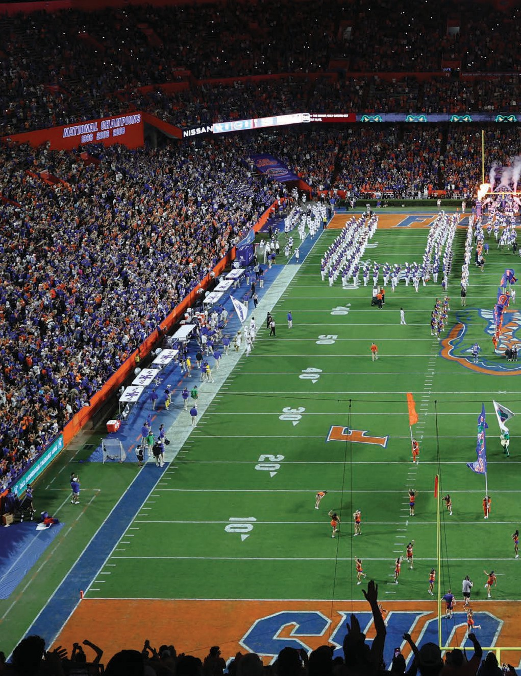
Non-interest bearing cash | $ 162,054 |  | $ | -
Receivables  Employer contributions receivable | 3,754,436 |  |  | 3,396,630
Accrued income and other receivables | 8,911,537 |  |  | 33,193
Total receivables | 12,665,973 |  |  | 3,429,823
Total investments, at fair value | 61,082,122 |  |  | 59,779,745
Total assets | $ 73,910,149 |  | $ | 63,209,568
Liabilities  Accrued expenses | $ 8,894,348 |  | $ 2,258
Total liabilities | $ 8,894,348 |  | $ 2,258
Net position
Held in trust for pension benefits | $ | 65,015,801 | $ | 63,207,310

The accompanying notes are an integral part of these financial statements.

30 | UNIVERSITY ATHLETIC ASSOCIATION, INC.

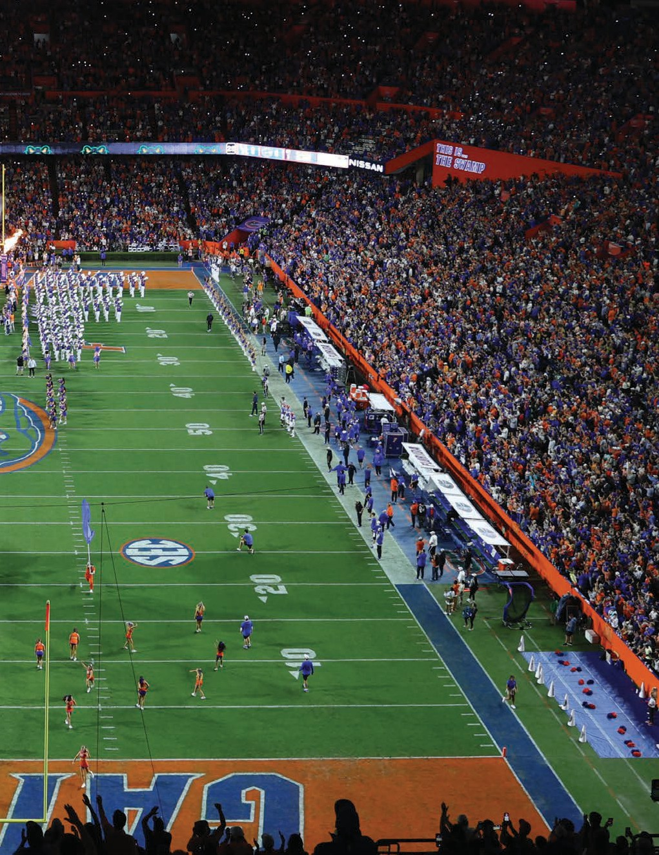
BASIC FINANCIAL STATEMENTS 2024-2025

Statements of Changes in Fiduciary Net Position – Fiduciary Funds - Pension Trust Fund
(for the years ended December 31, 2024 and 2023)
2024 2023
Additions
Contributions:
Employer $ 2,854,405 $ 2,496,630
Investment earnings:
Interest and dividends 1,549,606 1,389,511 Net appreciation in fair value of investments 4,860,830 7,143,867
Total investment income 6,410,436 8,533,378 Total additions, net 9,264,841 11,030,008
Deductions
Benefit payments 7,454,943 2,989,752
Investment management fees 1,407 4,829
Total deductions | 7,456,350 | 2,994,581
Net increase in fiduciary net position | 1,808,491 | 8,035,427
Net position held in trust for pension benefits, beginning of year | 63,207,310 | 55,171,883

Net position held in trust for pension benefits, end of year $ 65,015,801 $ 63,207,310

The accompanying notes are an integral part of these financial statements.

2024-2025 | FINANCIAL STATEMENTS | 31

G AT ORS
Innovation



32 | UNIVERSITY ATHLETIC ASSOCIATION, INC.


ELEVATE UF

Leading a Brighter Tomorrow: The Gator Good isn’t about any one university taking on a single cause. It’s about bringing in the brightest minds to solve our toughest challenges, together. The problems facing our planet are bigger than any one person. One organization. One university. But together, we’re solving them — because positive change goes further when we work as a team. The Association is committed to playing its part to contribute back to the University in its mission to move the whole world forward.

2024-2025 | FINANCIAL STATEMENTS | 33

G AT ORS
Respect



34 | UNIVERSITY ATHLETIC ASSOCIATION, INC.

Notes to Financial Statements:
NOTES

(1) SUMMARY OF SIGNIFICANT ACCOUNTING POLICIES:

The following is a summary of the more significant accounting policies of The University Athletic Association, Inc. (the Association), which affect significant elements of the accompanying basic financial statements.
- Reporting entity—The Association is a not-for-profit entity organized in 1929 for the purpose of conducting various intercollegiate athletic programs for and on behalf of the University of Florida. The Association operates for the service and convenience of the University of Florida and is a direct support organization and component unit (for accounting purposes only) of the University of Florida.
- Measurement focus, basis of accounting and financial statement presentation—For financial reporting purposes, the Association is considered a special-purpose government engaged only in business type activities. Accordingly, the Association prepares its financial statements using the economic resources measurement focus and the accrual basis of accounting in accordance with generally accepted accounting principles (GAAP) in the United States of America for proprietary funds, which is similar to those for private business enterprises. All assets and liabilities (whether current or noncurrent) are included on the Statements of Net Position. The Statements of Revenues, Expenses and Changes in Net Position presents increases (revenues) and decreases (expenses) in total net position. Under the accrual basis of accounting, revenues are recognized in the period in which they are earned while expenses are recognized in the period in which the liability is incurred.

The Association distinguishes operating revenues and expenses from nonoperating items. Operating revenues and expenses for the Association are those that result from the operation of the University of Florida’s intercollegiate athletic programs. It also includes all revenue and expenses not related to capital and related financing, noncapital financing, or investing activities. Governmental Accounting Standards Board (GASB) standards require that capital contributions from Gator Boosters, Inc. and contributions to the University of Florida and University of Florida Foundation, Inc. are not considered operating revenues or expenses. They are reported after nonoperating revenues and expenses in the accompanying Statements of Changes in Revenues, Expenses and Changes in Net Position. In addition to the business-type activities noted above, the Association
reports the net position held in trust for the University Athletic Association, Inc. Employees’ Money Purchase Pension Plan and Trust (the Pension Plan), which is reported separately from the business-type activities as a fiduciary fund.

- Cash and cash equivalents—Cash and cash equivalents include cash in banks and money market funds available for immediate use.

- Accounts receivable—Accounts receivable are stated at the amount management expects to collect from balances at year-end. Based on management’s assessment of the credit history with organizations and individuals having outstanding balances and current relationships with them, it has concluded that realization losses on balances outstanding at year-end will be immaterial. The Association has no policy requiring collateral or other security to support its accounts receivable.

- Inventories—Inventories consist of items held for sale at the golf course pro shop and snack bar. Inventory items at the golf course pro shop are recorded at the lower of cost or market using the average cost method. All other inventory items are recorded at the lower of cost or market, as determined by using the first-in, first-out (FIFO) method.

- Fair value measurement—The Association categorizes its fair value measurements within the fair value hierarchy established by GAAP. The hierarchy is based on the valuation inputs used to measure the fair value of the asset. Level 1 inputs are quoted prices in active markets for identical assets; Level 2 inputs are significant other observable inputs; Level 3 inputs are significant unobservable inputs.

- Capital and right to use lease assets— Capital assets purchased with an original cost of $5,000 or more are recorded at cost and depreciated utilizing the straight-line method over the estimated useful lives of assets (generally five years for furniture, fixtures and equipment and 10 to 15 years for capital improvements, except for improvements to buildings which range from 20 to 50 years). Costs to maintain or repair these assets are expensed as incurred. Right to use lease assets with noncancelable terms greater than 12 months, and annual payments exceeding $5,000 for equipment and $100,000 for real estate, are capitalized as right to use lease assets and amortized over the shorter of the lease term or the useful life of the asset. Leases with noncancelable terms



2024-2025 | FINANCIAL STATEMENTS | 35

NOTES

of less than 12 months are considered short-term leases and expensed as incurred. Subscription-based information technology arrangements (SBITAs) with noncancelable terms greater than 12 months and payments exceeding $4,000,000 over the life of the agreement are capitalized as right to use subscription assets and amortized over the shorter of the subscription term or the useful life of the asset. SBITAs with noncancelable terms of less than 12 months are considered short-term SBITAs and are expensed as incurred.
- Accrued compensated absences—Eligible employees are entitled to annual vacation and sick leave with pay. The Association accrues accumulated unpaid annual vacation leave and associated employee-related costs. Vacation pay is expensed when earned by the employee up to the maximum payout. The Association accrues accumulated unpaid annual sick leave and associated employee-related costs for leave that is more likely than not to be used by an employee. These amounts are included in the accompanying Statements of Net Position.

- Unearned revenues—Current unearned revenues consist of advance sales of tickets for sport seasons in the next fiscal year, and miscellaneous other unearned fees received. The unearned items are recognized as revenue when the related games are played and when the service is performed or event occurs for which miscellaneous fees were received.
Additionally, unearned revenues included in other liabilities consist of advance sponsorship and royalty payments. The sponsorship and royalty amounts are recognized over the life of the agreements.
- Net position—Net position is classified and displayed in two components:
  - Net investment in capital assets – consists of capital assets, net of accumulated depreciation and right to use lease assets, net of accumulated amortization, reduced by the outstanding balances of any debt or lease liability that is attributable to those assets.
  - Unrestricted – consists of assets that are available to the Association for any legal use.
  - The Association had no restricted net position at June 30, 2025 and 2024.

- Sales taxes retained—In accordance with Chapter 1006, Section 71 of the Florida Statutes, the Association retains an amount equal to the sales taxes collected from ticket sales to athletic events for use in the support of women’s athletic programs. Sales taxes retained totaled $3,336,241 and $2,824,348 for the years ended June 30, 2025 and 2024, respectively, and are included in other operating revenues in the Statements of Revenues, Expenses, and Changes in Net Position.
- Income taxes—The Association is exempt from federal income taxes under the provisions of Section 501(c)(3) of the Internal Revenue Code. However, the Association is subject to income tax on unrelated business income. The Association’s primary source of unrelated business income is from certain investments in a limited liability company. Income taxes incurred during the year, if any, are estimated to be immaterial to the financial statements.

The Association files tax returns in the U.S. federal jurisdiction and in the state of Florida. Management of the Association considers the likelihood of changes by taxing authorities in its filed income tax returns and




36 | UNIVERSITY ATHLETIC ASSOCIATION, INC.

NOTES


recognizes a liability for or discloses potential significant changes that management believes are more likely than not to occur upon examination by tax authorities, including changes to the Association’s status as a not-for-profit entity. Management believes the Association met the requirements to maintain its tax-exempt status and has not identified any uncertain tax positions subject to the unrelated business income tax that require recognition or disclosure in the accompanying financial statements. The Association’s income tax returns for the past three years are subject to examination by tax authorities and may change upon examination.
- In-kind contributions—Donations of materials and services are recorded at their fair market value at the date of donation.
- Recently issued accounting pronouncements—The Governmental Accounting Standards Board (GASB) issued GASB Statement No. 101, Compensated Absences, in June 2022. GASB Statement No. 101, Compensated Absences, amends existing guidance and requires governments to recognize a liability for compensated absences when the leave is attributable to services already rendered and it is more likely than not that the leave will be used. Previously, liabilities were recognized primarily when leave was paid upon termination. The provisions of GASB 101 are effective for fiscal years beginning after December 15, 2023.
The Association adopted GASB 101 in fiscal year 2025. Implementation of GASB 101 is treated as a change in accounting principle, in accordance with GASB 100, and has been applied retroactively to the beginning of the earliest period presented in these financial statements, July 1, 2023. As a result of implementation, the Association recognized an additional compensated absences liability of $1,148,130 as of July 1, 2023 and beginning net position was restated from $208,655,886 to $207,507,756 to reflect the cumulative effect of the change.

GASB issued Statement No. 102, Certain Risk Disclosures, in December 2023. The objective of GASB 102 is to provide users of government financial statements with essential information about risks related to a government’s vulnerabilities due to certain concentrations or constraints. Implementation of GASB 102 had no material impact to the financial statements.
The following pronouncements with required implementation dates effective for subsequent fiscal years have not yet been implemented. The Association has not currently determined what, if any, impact implementation of the following will have on the Association's financial statements.
GASB issued Statement No. 103, Financial Reporting Model Improvements, in April 2024. The objective of GASB 103 is to improve key components of the financial reporting model to enhance its effectiveness in providing information that is essential for decision making and assessing a government’s accountability. The effective date for implementation is fiscal years beginning after June 15, 2025, and all reporting periods thereafter.
GASB issued Statement No. 104, Disclosure of Certain Capital Assets, in September 2024. GASB Statement No. 104 requires governments to disclose separate information about specific types of capital assets and establishes criteria for identifying and reporting capital assets held for sale. The objective of GASB 104 is to enhance transparency and improve the usefulness of financial statements for stakeholders by providing more detailed information on these assets. The provisions are effective for fiscal years beginning after June 15, 2025.

- Reclassification—Certain prior year amounts have been reclassified to conform to the current year presentation.
(2) CASH AND CASH EQUIVALENTS:

The amounts reported as cash and cash equivalents include cash on hand, cash in bank demand accounts, cash held at the University of Florida and money market funds. Cash and cash equivalents at June 30, 2025 and 2024 were as follows:

Table 1. Cash and Cash Equivalents (Note 2)
 | 2025 |  | 2024
Money market funds | $ 31,724 |  | $ 7,188
Cash in bank demand accounts | 1,672,906 |  | 3,236,745
Cash held at the University of Florida | 304,940 |  | 497,059
Cash on hand | 106,000 |  | 111,000
Total cash and cash equivalents | $ 2,115,570 |  | $ 3,851,992
Cash in bank demand accounts are held in regional banks. Bank account balances for these bank demand accounts were $2,933,471 and $5,729,802, as of June 30, 2025 and 2024, respectively. Deposits are uncollateralized and are insured up to $250,000 per institution by the Federal Deposit Insurance Corporation (FDIC). Uninsured bank balances totaled $2,592,379 and $5,224,107 as of June 30, 2025 and 2024, respectively. Money market funds are uninsured and collateralized by securities held by the institution, not in the Association’s name. For deposits, custodial credit risk is the risk that in the event of a bank failure, the Association’s deposits may not be returned to it. The Association does not have a policy for custodial credit risk.

2024-2025 | FINANCIAL STATEMENTS | 37

NOTES

(3) INVESTMENTS:

- University Athletic Association:
The Association reports investments at fair value, except those money market investments that have a remaining maturity at the time of purchase of one year or less are reported at amortized cost, provided that the fair value of those investments is not significantly affected by the impairment of the credit standing of the issuer or by other factors. Money market investments are defined as short-term, highly liquid debt instruments including commercial paper, banker’s acceptances, U.S. Treasury and agency obligations.

Short-term investments are comprised of investments in external investment pools with the State of Florida Division of Treasury and the State Board of Administration (SBA), and a separately managed investment account managed by Buckhead Capital Management and are reported at fair value. Short-term investments typically are funds accumulated from Southeastern Conference (SEC) distributions, advance ticket sales and booster
contributions and will be used to fund operations in the upcoming fiscal year. Other investments include mutual funds, and commingled funds that are reported at fair value as determined by their net asset values at year end. The classification of investments between short-term and long-term is based on management’s anticipated cash flow needs. However, the needs of the Association may require the sale or retention of investment balances that differ from the classifications reflected in the accompanying Statements of Net Position.
The Association’s corporate investment policy divides the Association’s assets into two portfolios, the long-term portfolio and the short-term portfolio. The policy states that the short-term portfolio invests in cash and cash equivalents and the long-term portfolio invests in a diversified portfolio of commingled and/or mutual funds in the following classes: domestic large cap equity, domestic small cap equity, international equity, hedged strategies and fixed income.
All of the Association’s recurring fair value measurements as of June 30, 2025 and 2024 are valued using quoted market prices (Level 1 inputs), with the exception of

The Association’s investments at June 30, 2025 are reported as follows:

Table 2. Investments - June 30, 2025 (Note 3A)
 |  | Fair Value Measurements Using
 |  | Quoted Prices in Significant Significant
 |  | Active Markets Other Observable Unobservable
 |  | for Identical Assets Inputs Inputs
Investments by fair value level | Amount | (Level 1) (Level 2) (Level 3)
External Investment Pool:
State Treasury Special Purpose Investment Account | $ 1,061,619 | $ - $ - $ 1,061,619
Cash Equivalents Classified as Short-Term Investments:
Commercial Paper | 5,210,595 | - 5,210,595 -
Non-Proprietary Cash Sweep | 349,390 | 349,390 - -
Government Agency | 503,950 | 503,950 - -
US Treasury Bills | 52,121,878 | 52,121,878 - -
Bonds and Notes:
Corporate Backed Obligations | 3,645,444 | - 3,645,444 -
Corporate Bonds | 1,724,538 | - 1,724,538 -
Treasury Notes & Bonds | 2,485,844 | 2,485,844 - -
Mortgage Backed Securities | 11,635,833 | - 11,635,833 -
Mutual Funds:
Corporate Bonds | 10,087,468 | 10,087,468 - -
Money Market | 2,511,649 | 2,511,649 - -
Equity | 47,952,285 | 38,161,523 - 9,790,762
Total investments by fair value level | $ 139,290,493 | $ 106,221,702 $ 22,216,410 $ 10,852,381
Investments measured at amortized cost
SBA Florida PRIME | $ 12,808
Total investments | $ 139,303,301

38 | UNIVERSITY ATHLETIC ASSOCIATION, INC.

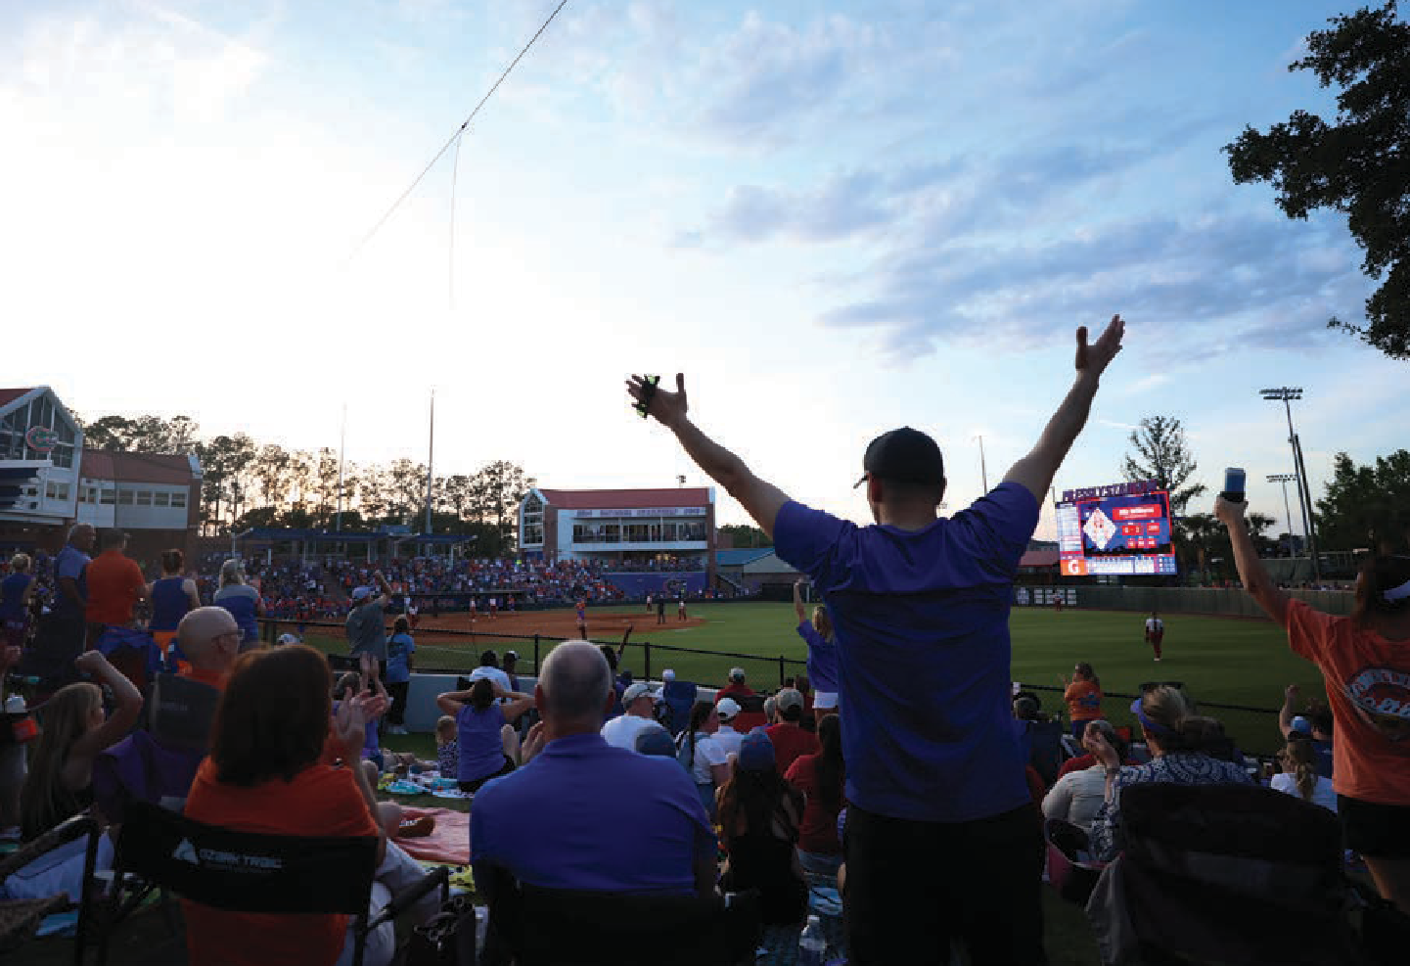
NOTES
The Association’s investments at June 30, 2024 are reported as follows:

Table 3. Investments - June 30, 2024 (Note 3A)
 |  | Fair Value Measurements Using
 |  | Quoted Prices in Significant Significant
 |  | Active Markets for Other Observable Unobservable
 |  | Identical Assets Inputs Inputs
Investments by fair value level | Amount | (Level 1) (Level 2) (Level 3)
External Investment Pool:
State Treasury Special Purpose Investment Account | $ 1,014,889 | $ - $ - $ 1,014,889
Cash Equivalents Classified as Short-term Investments:
Commercial Paper | 6,348,529 | - 6,348,529 -
Non-Proprietary Cash Sweep | 25,520,768 | 25,520,768 - -
US Treasury Bills | 7,909,600 | 7,909,600 - -
Bonds and Notes:
Corporate Backed Obligations | 11,097,009 | - 11,097,009 -
Corporate Bonds | 1,967,518 | - 1,967,518 -
Mortgage Backed Securities | 9,139,904 | - 9,139,904 -
Mutual Funds:
Corporate Bonds | 8,558,828 | 6,431,428 2,127,400 -
Equity | 52,575,660 | 40,539,775 - 12,035,885
Total investments by fair value level | $ 124,132,705 | $ 80,401,571 $ 30,680,360 $ 13,050,774
Investments measured at amortized cost
SBA Florida PRIME | $ 12,205
Total investments | $ 124,144,910

2024-2025 | FINANCIAL STATEMENTS | 39

NOTES


bonds and notes which are valued using a matrix pricing model (Level 2 inputs), investments with the State Treasury, GQG Partners LLC, Oaktree Real Estate Income Fund, and Boyd Watterson GSA Fund which are valued based on the Association’s share of the pool (Level 3 inputs).

External Investment Pools—The Association reported investments at fair value totaling $1,061,619 and
$1,014,889 at June 30, 2025 and 2024 respectively, in the State Treasury Special Purpose Investment Account (SPIA) investment pool, representing ownership of a share of the pool, not the underlying securities. Pooled investments with the State Treasury are not registered with the Securities and Exchange Commission. Oversight of the pooled investments with the State Treasury is provided by the Treasury Investment Committee per Section 17.575, Florida Statutes. The authorized investment types are set forth in Section 17.57, Florida Statutes. The SPIA carried a credit rating of AA-f by Standard & Poor’s (S&P), had an effective duration of 3.33 years and 3.23 years and fair value factor of 1.0030 and 0.9958 at June 30, 2025 and 2024, respectively. Participants contribute to the Treasury Pool on a dollar basis. These funds are
commingled and a fair value of the pool is determined from the individual values of the securities. The fair value of the securities is summed and a total pool fair value is determined. A fair value factor is calculated by dividing the pool’s total fair value by the pool participant’s total cash balances. The fair value factor is the ratio used to determine the fair value of an individual participant’s pool balance. The Association relies on policies developed by the State Treasury for managing interest rate risk or credit risk for this investment pool. Disclosures for the State Treasury investment pool are included in the notes to financial statements of the State’s Annual Comprehensive Financial Report.

Bonds and Notes—The Association reported investments totaling $19,491,659 and $22,204,431 as of June 30, 2025 and 2024, respectively, in bonds and notes held in separately managed investment accounts. The investment managers of these accounts use an investment philosophy that is based on a multifaceted, total return methodology which focuses on the four key components of fixed income portfolio construction: duration management, yield curve positioning, sector rotation, and security selection.

40 | UNIVERSITY ATHLETIC ASSOCIATION, INC.

NOTES

The managers seek to add value and control risk in each component of the portfolio construction process to deliver superior risk-adjusted returns through all phases of the economic and interest rate cycles. The bonds and notes are priced on a frequent basis using valuation methodologies and techniques available through independent third parties. The Association’s bonds and notes are subject to credit and interest rate risk as outlined in the sections below.

Custodial Credit Risk—For an investment, custodial credit risk is the risk that, in the event of the failure of the counterparty, the Association will not be able to recover the value of its investments or collateral securities that are in the possession of an outside party. Investments are subject to custodial credit risk if the securities are uninsured, not registered in the Association’s name, and are held by the party that either sells to or buys for the Association. The Association does not have a policy regarding custodial credit risk. Custodial credit risk for the Association’s bonds, notes and bond mutual funds as of June 30, 2025 and 2024 is categorized in the following schedule using S&P nationally recognized statistical ratings quality organizations:

Table 4. Investments - Custodial Credit Risk (Note 3A)
 | Quality 2025 2024
 | Rating Fair Value Fair Value
Corporate Backed Obligation | S&P AAA $ 3,011,769 $ 7,293,701
Corporate Backed Obligation | Unrated 633,675 3,803,308
Corporate Bonds | S&P A - 218,603
Corporate Bonds | S&P A- 1,019,845 861,774
Corporate Bonds | S&P AA+ - 137,822
Corporate Bonds | S&P BBB+ 353,360 172,014
Corporate Bonds | S&P BBB 351,333 352,674
Corporate Bonds | S&P BBB- - 224,631
Mortgage Backed Securities | S&P AA+ 7,210,561 5,711,436
Mortgage Backed Securities | S&P AAA 2,521,933 1,703,933
Mortgage Backed Securities | Unrated 1,903,339 500,356
Mortgage Backed Securities | S&P A-1+ - 1,224,179
Treasury Notes & Bonds | S&P AA+ 2,485,844 -
Subtotal | 19,491,659 22,204,431
Bond Mutual Funds | Unrated 10,087,468 8,558,828
Total | $ 29,579,127 $ 30,763,259
Interest Rate Risk—For an investment, interest rate risk is the risk that changes in market interest rates will adversely affect the fair value of an investment. Generally, the longer the time to maturity, the greater the exposure to interest rate risk. The Association does not have a policy for interest rate risk associated with
its investments. Interest rate risk associated with average duration for the Association’s bonds, notes and bond mutual funds as of June 30, 2025 and 2024 is as follows:

Table 5. Investments - Interest Rate Risk (Note 3A)
 | Average 2025 2024
 | Duration Fair Value Fair Value
Corporate Backed | Less than one year $ 3,645,444 $ 11,097,009
Obligations
Corporate Bonds | Less than one year 1,724,538 1,967,518
Mortgage Backed
Securities | Less than one year 11,635,833 9,139,904
Treasury Notes &
Bonds | Less than one year 2,485,844 -
Subtotal | 19,491,659 22,204,431
Bond Mutual Funds | Less than one year 10,087,468 8,558,828
Total | $ 29,579,127 $ 30,763,259
Concentration of Credit Risk—Concentration of credit risk is the risk of loss attributed to the magnitude of an entity’s investment in a single issuer. At June 30, 2025 and 2024, the Association’s investments were not concentrated to a single issuer to meet this threshold.


2024-2025 | FINANCIAL STATEMENTS | 41

NOTES


Credit Risk—Credit risk is the risk that a debt issuer or other counter-party to an investment will not fulfill its obligations. The Association utilizes portfolio diversification in order to limit investments to the highest rated securities as rated by nationally recognized rating agencies. All are rated within the investment policy guidelines at June 30, 2025 and 2024.
Foreign Currency Risk—Foreign currency risk is the risk that changes in exchange rates will adversely affect the fair value of an investment. The Association’s investment policy allows for foreign securities to be limited to 20% of a manager’s portfolio. At June 30, 2025 and 2024, the Association held no investments denominated in foreign currencies.
- University Athletic Association, Inc. Employees’ Money Purchase Pension Plan and Trust – Fiduciary Funds – Pension Trust Fund
The fund’s investments at December 31, 2024 are reported as follows:
Fair Value Measurements Using
Investments by fair value level
Interest bearing cash
Registered investment companies Common/collective trusts:
Equity funds
Limited partnership interests
Total investments by fair value level Total investments measured at fair value
Quoted Prices in Active Markets for Identical Assets (Level 1)
$
472,060 $
45,407,824
Significant Significant Other Observable Unobservable
Inputs Inputs
(Level 2) (Level 3)
- $
-
Amount
$ 472,060
45,407,824
-
-
11,950,606
11,950,606
-
-
3,251,632 3,251,632 - -
$ 61,082,122 $ 61,082,122 $ - $ -
$ 61,082,122
Table 6. Pension Investments - December 31, 2024 (Note 3B)

The fund’s investments at December 31, 2023 are reported as follows:
Fair Value Measurements Using
Investments by fair value level
Interest bearing cash
U.S. Government securities Preferred corporate bonds Registered investment companies Common/collective trusts:
Fixed income funds
Limited partnership interests
Total investments by fair value level Total investments measured at fair value
Quoted Prices in Significant Significant Active Markets for Other Observable Unobservable
Identical Assets Inputs Inputs
(Level 1) (Level 2) (Level 3)
$
Amount
244,992
2,463,369
310,875
42,505,471
$
244,992
-
- 42,505,471
$
- 2,463,369
310,875
-
$
-
-
-
-
10,674,835
10,674,835
-
-
3,580,203 3,580,203 - -
$ 59,779,745 $ 57,005,501 $ 2,774,244 $ -
$ 59,779,745
Table 7. Pension Investments - December 31, 2023 (Note 3B)

42 | UNIVERSITY ATHLETIC ASSOCIATION, INC.

NOTES

Interest Rate Risk—For an investment, interest rate risk is the risk that changes in market interest rates will adversely affect the fair value of an investment. Generally, the longer the time to maturity, the greater the exposure to interest rate risk. The established performance objectives of the Pension Plan require investment maturities to provide sufficient liquidity to pay obligations as they become due.

Credit Risk—Credit risk is the risk that a debt issuer or other counter-party to an investment will not fulfill its obligations. The Pension Plan utilizes portfolio diversification in order to limit investments to the highest rated securities as rated by nationally recognized rating agencies. All are rated within the investment policy guidelines at December 31, 2024 and 2023.

Concentration of Credit Risk—Concentration of credit risk is the risk of loss attributed to the magnitude of an entity’s investment in a single issuer. The Pension Plan policy does not allow more than five (5) percent of its assets in the common stock, capital stock, or convertible securities of any one issuing company, nor shall the aggregate investment in any one issuing company, exceed five (5) percent of the outstanding stock of that company, nor shall the aggregate of its investments at market in common stock, capital stock and convertible securities exceed seventy (70) percent of the fund’s total assets. The Pension Plan policy also does not allow for the aggregate investment in any one issuing company to exceed twelve and one-half (12.5) percent of the outstanding stock of that company. At December 31, 2024 and 2023, the investment portfolios met the single issuer limitations.
Custodial Credit Risk—Custodial credit risk is the risk that the Association may not recover cash and investments held by another party in the event of financial failure. Custodial credit risk is limited since investments are held in independent custodial safekeeping accounts or mutual funds.

Foreign Currency Risk—Foreign currency risk is the risk that changes in exchange rates will adversely affect the fair value of an investment. The Pension Plan policies allow for up to twenty-five (25) percent of its investments in common stock, capital stock and convertible securities at market value in foreign securities. At June 30, 2025 and 2024, the Association held no investments denominated in foreign currencies.
(4) PENSION PLAN
In 1979, the Association established The University Athletic Association, Inc. Employees’ Money Purchase Pension Plan and Trust, a defined contribution pension plan covering substantially all full-time employees. Total pension expense for the plan was $3,667,073 and

$3,519,241, and pension plan forfeitures were $500,000 and $900,976 for the years ended June 30, 2025 and 2024, respectively. Contributions are made by the Association to the pension plan based on 10% of an eligible employee’s earnings. The Internal Revenue Code Section 401(a)(17) set the annual compensation limit applicable to retirement plans at $350,000 for 2025 and $345,000 for 2024.

2024-2025 | FINANCIAL STATEMENTS | 43

NOTES

Capital and right to use lease asset activity for the year ended June 30, 2025 was as follows:
Table 8. Capital and Right To Use Lease Assets - June 30, 2025 (Note 5)
Beginning Balance
Additions
Decreases
Ending Balance
(5) CAPITAL AND RIGHT TO USE LEASE ASSETS:

Capital assets not being depreciated:
Land and land improvements | $ 2,430,236 | $ - | $ | - | $ 2,430,236
Construction in progress | 4,501,904 | 7,709,114 |  | - | 12,211,018
Total capital assets not being depreciated | 6,932,140 | 7,709,114 | - |  | 14,641,254
Capital assets being depreciated:
Buildings and improvements | 6,641,755 | - | - |  | 6,641,755
Furniture and equipment | 33,266,356 | 774,997 | (64,384) |  | 33,976,969
Leasehold improvements | 425,263,256 | - | - |  | 425,263,256
Total capital assets being depreciated | 465,171,367 | 774,997 | (64,384) |  | 465,881,980
Less accumulated depreciation for:
Buildings and improvements | 5,241,821 | 64,245 | - |  | 5,306,066
Furniture and equipment | 20,074,062 | 2,835,734 | (64,384) |  | 22,845,412
Leasehold improvements | 139,343,812 | 10,193,192 | - |  | 149,537,004
Total accumulated depreciation | 164,659,695 | 13,093,171 | (64,384) |  | 177,688,482
Total capital assets being depreciated, net | 300,511,672 | (12,318,174) | - |  | 288,193,498
Right to use lease assets being amortized:
Leased equipment | 712,885 | 686,453 | (77,735) |  | 1,321,603
Less accumulated amortization for:
Leased equipment | 317,325 | 323,677 | (62,042) |  | 578,960
Total right to use lease assets being amortized, net | 395,560 | 362,776 | (15,693) |  | 742,643
Total capital and right to use lease assets, net | $ 307,839,372 | $ (4,246,284) | $ (15,693) |  | $ 303,577,395
Capital and right to use lease asset activity for the year ended June 30, 2024 was as follows:

Table 9. Capital and Right To Use Lease Assets - June 30, 2024 (Note 5)
 | Beginning Balance | Additions | Decreases Ending Balance
Capital assets not being depreciated:
Land and land improvements | $ 2,430,236 | $ - | $ - $ 2,430,236
Construction in progress | 1,333,922 | 8,691,139 | (5,523,157) 4,501,904
Total capital assets not being depreciated | 3,764,158 | 8,691,139 | (5,523,157) 6,932,140
Capital assets being depreciated:
Buildings and improvements | 6,641,755 | - | - 6,641,755
Furniture and equipment | 34,019,260 | 1,908,983 | (2,661,887) 33,266,356
Leasehold improvements | 419,761,371 | 5,501,885 | - 425,263,256
Total capital assets being depreciated | 460,422,386 | 7,410,868 | (2,661,887) 465,171,367
Less accumulated depreciation for:
Buildings and improvements | 5,135,243 | 106,578 | - 5,241,821
Furniture and equipment | 20,014,297 | 2,691,652 | (2,631,887) 20,074,062
Leasehold improvements | 129,156,680 | 10,187,132 | - 139,343,812
Total accumulated depreciation | 154,306,220 | 12,985,362 | (2,631,887) 164,659,695
Total capital assets being depreciated, net | 306,116,166 | (5,574,494) | (30,000) 300,511,672
Right to use lease assets being amortized:
Leased equipment | 1,007,374 | 113,579 | (408,068) 712,885
Less accumulated amortization for:
Leased equipment | 566,565 | 158,828 | (408,068) 317,325
Total right to use lease assets being amortized, net | 440,809 | (45,249) | - 395,560
Total capital and right to use lease assets, net | $ 310,321,133 | $ 3,071,396 | $ (5,553,157) $ 307,839,372
Depreciation and amortization expense were $13,432,541 and $13,189,440 for the years ended June 30, 2025 and 2024, respectively.

44 | UNIVERSITY ATHLETIC ASSOCIATION, INC.

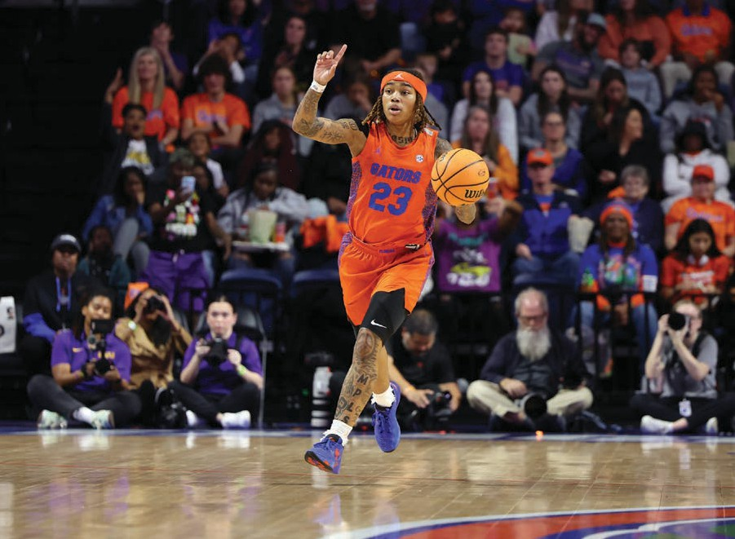
NOTES

The change in long-term obligations for the year ended June 30, 2025 was as follows:
(6) LONG-TERM OBLIGATIONS:

Table 10. Long-term Obligations - June 30, 2025 (Note 6)
 | Beginning Amounts Due
Type of Long-term Liabilities | Balance Additions Reductions Ending Balance Within One Year
Contracts payable | $ 5,119,154 $ 163,294 $ (1,754,077) $ 3,528,371 $ 1,389,294
Accrued compensated absences | 2,839,423 399,126 (172,796) 3,065,753 139,000
Unearned revenues | 41,303,128 44,068,964 (41,281,778) 44,090,314 43,910,314
Long-term debt | 142,590,000 - (7,695,000) 134,895,000 7,870,000
Long-term lease payable | 368,291 511,398 (160,889) 718,800 290,663
Total long-term liabilities | $ 192,219,996 $ 45,142,782 $ (51,064,540) $ 186,298,238 $ 53,599,271
The change in long-term obligations for the year ended June 30, 2024 was as follows:

Table 11. Long-term Obligations - June 30, 2024 (Note 6)
 | Beginning Amounts Due
Type of Long-term Liabilities | Balance Additions Reductions Ending Balance Within One Year
Contracts payable | $ 5,904,632 $ 528,077 $ (1,313,555) $ 5,119,154 $ 1,754,077
Accrued compensated absences | 2,787,184 209,674 (157,435) 2,839,423 309,000
Unearned revenues | 31,772,080 39,832,641 (30,301,593) 41,303,128 41,303,128
Long-term debt | 150,120,000 - (7,530,000) 142,590,000 7,695,000
Long-term lease payable | 384,776 113,579 (130,064) 368,291 129,252
Total long-term liabilities | $ 190,968,672 $ 40,683,971 $ (39,432,647) $ 192,219,996 $ 51,190,457

2024-2025 | FINANCIAL STATEMENTS | 45


NOTES

- Long-term Debt:
At June 30, 2025 and 2024, the Association’s Bonds outstanding bear interest based upon the following schedule:

Table 12. Long-term Debt (Note 6A)
Series | Outstanding Amount | June 30, 2025  Term |  | Interest Rate |  | Outstanding Amount |  | June 30, 2024  Term |  | Interest Rate
2001 | $ 14,235,000 | Daily Rate |  | Weekly |  | $ 14,235,000 |  | Daily Rate |  | Weekly
2001 | 15,950,000 | 10/01/23 - 10/01/31 |  | 4.44% |  | 15,950,000 |  | 10/01/23-10/01/31 |  | 4.44%
*2001 | - | 11/27/13 – 10/01/24 |  | 1.78% |  | 3,640,000 |  | 11/27/13 – 10/01/24 |  | 1.78%
2007 | 1,500,000 | 10/01/16 - 10/01/26 |  | 2.08% |  | 2,000,000 |  | 10/01/16 - 10/01/26 |  | 2.08%
2011 | 5,250,000 | 10/01/16 - 10/01/26 |  | 2.08% |  | 6,000,000 |  | 10/01/16 - 10/01/26 |  | 2.08%
2015 | 8,250,000 | 10/01/20 – 10/01/30 |  | 1.94% |  | 9,000,000 |  | 10/01/20 – 10/01/30 |  | 1.94%
2018 | 41,585,000 | 7/24/18 - 10/01/38 |  | 3.43% |  | 43,110,000 |  | 7/24/18 - 10/01/38 |  | 3.43%
2021 | 48,125,000 | 03/19/21 - 10/01/41 |  | 1.97% |  | 48,655,000 |  | 03/19/21 - 10/01/41 |  | 1.97%
 | $ 134,895,000 |  |  |  |  | $ 142,590,000
*In December 2019, the Association re-marketed the bonds for the purpose of a lower interest rate and debt service savings.

46 | UNIVERSITY ATHLETIC ASSOCIATION, INC.

NOTES

Debt service requirements at June 30, 2025 were as follows:

Table 13. Debt Service Requirements (Note 6A)
Year Ended June 30, | Principal | Interest | Total Principal and Interest
2026 | $ 7,870,000 | $ 3,817,984 | $ 11,687,984
2027 | 8,070,000 | 3,630,512 | 11,700,512
2028 | 8,280,000 | 3,344,580 | 11,624,580
2029 | 8,495,000 | 3,020,460 | 11,515,460
2030 | 8,720,000 | 2,690,308 | 11,410,308
2031-2035 | 29,995,000 | 9,859,650 | 39,854,650
2036-2040 | 22,245,000 | 6,640,317 | 28,885,317
2041-2045 | 23,150,000 | 5,860,172 | 29,010,172
2046-2050 | 14,905,000 | 2,497,563 | 17,402,563
2051 | 3,165,000 39,560 3,204,560
 | $ 134,895,000 $ 41,401,106 $ 176,296,106
The Association is subject to certain general and financial covenants related to the Bond agreements (the Agreements). The first financial covenant requires the Association to maintain a Net Revenues to Principal and Interest Requirements due on the bonds, as defined in the Agreements, of greater than 1.10:1.00, tested annually at the end of each fiscal year. The Association’s ratio of net revenues to required principal and interest was 2.27 and
1.51 in 2025 and 2024, respectively. The second financial covenant requires the Association to maintain unrestricted cash, marketable securities and investments in an amount greater than twenty-five percent (25%) of its total indebtedness measured at the end of the fiscal year. At June 30, 2025, the required amount of liquidity was
$33,723,750 and the actual amount was $141,418,870. At June 30, 2024, the required amount of liquidity was
$35,647,500 and the actual amount was $127,996,902.

- Unearned Revenues:
Changes in current unearned revenues for June 30, 2025 and 2024 are as follows:

Table 14. Changes in Current Unearned Revenues (Note 6B)
 | 2025 2024
Balance, beginning of year | $ 41,303,128 $ 30,502,080
Additions:
Advance ticket sales and | 42,055,795 37,799,714
related handling
Unearned camp fees | 1,773,169 2,032,852
Unearned other income | - 75
Total additions | 43,828,964 39,832,641
Deductions:
Earned ticket sales and | (37,799,714) (27,028,855)
related handling
Earned camp fees | (2,032,852) (2,002,738)
Earned other income | (1,389,212) -
Total deductions | (41,221,778) (29,031,593)
Balance, end of year | $ 43,910,314 $ 41,303,128
Changes in long-term unearned revenues for June 30, 2025 and 2024 are as follows:

Table 15. Changes in Long-term Unearned Revenues (Note 6B)
 | 2025 2024
Balance, beginning of year | $ - $ 1,270,000
Additions:
Unearned royalties | 240,000 -
Total additions | 240,000 -
Deductions:
Royalties reclassified to | (60,000) (1,270,000)
current
Total deductions | (60,000) (1,270,000)
Balance, end of year | $ 180,000 $ -
- Long-term Lease Payable:
As of June 30, 2025 and 2024, the Association had assets recorded under leases (see Note 5) discounted at an implicit rate of 1.1%. Future maturities of lease payments as of June 30, 2025 are as follows:

Table 16. Lease Requirements (Note 6C)
Year Ended June 30, | Principal | Interest | Total Principal and Interest
2026 | $ 314,194 | $ 6,159 | $ 320,353
2027 | 245,281 | 2,822 | 248,103
2028 | 80,364 | 1,006 | 81,370
2029 | 54,936 | 355 | 55,291
2030 | 24,025 193 24,218
 | $ 718,800 $ 10,535 $ 729,335

2024-2025 | FINANCIAL STATEMENTS | 47

NOTES
2017 and 2016, respectively.
(7) RELATED-PARTY TRANSACTIONS:
(8) COMMITMENTS:

Gator Boosters, Inc. (Gator Boosters) receives contributions from the public and remits the majority of these funds (less their operating expenses) to the Association. Contributions of $49,595,755 and
$47,399,125 were recognized from Gator Boosters, for the years ended June 30, 2025 and 2024, respectively, and have been included in the accompanying Statements of Revenues, Expenses and Changes in Net Position. Additionally, the Association provides accounting and other support services to Gator Boosters. The Association recognized contract revenue in the amount of $190,000 for the years ended June 30, 2025 and 2024.

The non-operating expenses include a $3.8 million gift to the University and a $6 million contribution to Gator Boosters for fundraising services.

The Association has entered into employment contracts with certain employees expiring in years through 2034 that provide for a minimum annual salary. At June 30, 2025, the total commitment for all contracts for each of the next five years and thereafter in the aggregate is as follows:

Table 17. Commitments (Note 8)
Year Ending June 30, | Amount
2026 | $ 41,518,720
2027 | 32,245,168
2028 | 24,931,942
2029 | 20,922,727
2030 | 14,953,568
Thereafter | 16,285,466
 | $ 150,857,591
(9) INCOME TAXES:
The Association did not incur any income tax expense for the years ended June 30, 2025 and 2024. The Association did however, pay an excise tax of $1,829,430 and $1,784,741 on highly compensated employees for calendar years 2024 and 2023, respectively.
(10) RISK MANAGEMENT:

The Association purchased conventional commercial insurance coverage for potential exposures in the areas of property, workers’ compensation, automobile liability and physical damage, and other general liability exposures. This insurance was purchased from various independent carriers and is designed to insure against such risks and minimize the Association’s financial exposure. The Association also participates with the employees in the purchase of group health, dental and life insurance for its employees and their families.

The Association has also purchased commercial excess insurance to cover injuries to student-athletes sustained during practice or play. This policy requires a $10,000 deductible per athlete per incident. Any amounts paid by the athletes’ private insurance carriers can be applied to the Association’s deductible.

The Association is not involved in any risk pools with other governmental entities.

48 | UNIVERSITY ATHLETIC ASSOCIATION, INC.

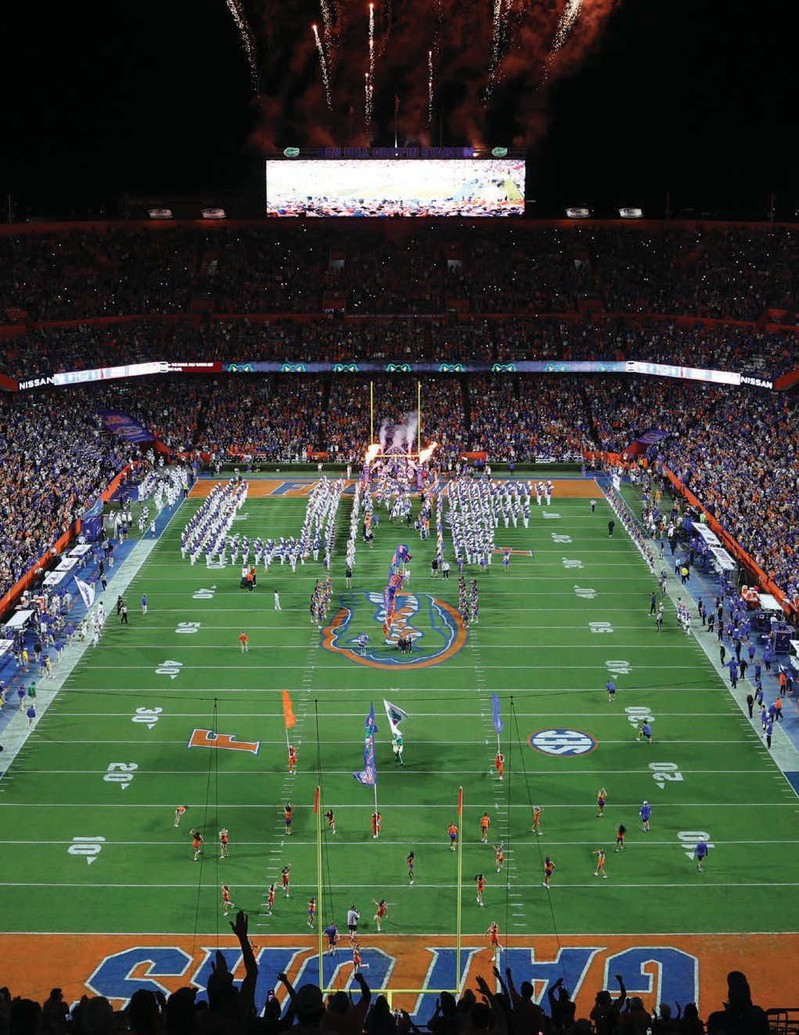
NOTES

2024-2025 | FINANCIAL STATEMENTS | 49

G AT ORS

Integrity



50 | UNIVERSITY ATHLETIC ASSOCIATION, INC.

ENGAGEMENT

The mission of the University Athletic Association’s Goodwill Gators Community Outreach Program is

to foster citizenship between staff, coaches, student-athletes and the greater Gainesville community. Through volunteerism, Goodwill Gators will:
enhance the personal development of student-athletes.
strengthen our commitment to the greater Gainesville and surrounding communities.
encourage citizenship, civic virtues and how one should behave as part of a community.



2024-2025 | FINANCIAL STATEMENTS | 51



INDEPENDENT AUDITORS’ REPORT ON INTERNAL CONTROL OVER FINANCIAL REPORTING AND ON COMPLIANCE AND OTHER MATTERS BASED ON AN AUDIT OF FINANCIAL STATEMENTS PERFORMED IN ACCORDANCE WITH
GOVERNMENT AUDITING STANDARDS

The Audit Committee,
The University Athletic Association, Inc.:

We have audited, in accordance with auditing standards generally accepted in the United States of America and the standards applicable to financial audits contained in Government Auditing Standards, issued by the Comptroller General of the United States (Government Auditing Standards), the financial statements of the business-type activities and the aggregate remaining fund information of The University Athletic Association, Inc. (the Association) as of and for the year ended June 30, 2025, and the related notes to the financial statements, which collectively comprise the Association’s basic financial statements, and have issued our report thereon dated September 9, 2025.
Report on Internal Control over Financial Reporting
In planning and performing our audit of the financial statements, we considered the Association’s internal control over financial reporting (internal control) as a basis for designing audit procedures that are appropriate in the circumstances for the purpose of expressing our opinions on the financial statements, but not for the purpose of expressing an opinion on the effectiveness of the Association’s internal control. Accordingly, we do not express an opinion on the effectiveness of the Association’s internal control.
A deficiency in internal control exists when the design or operation of a control does not allow management or employees, in the normal course of performing their assigned functions, to prevent, or detect and correct misstatements on a timely basis. A material weakness is a deficiency, or a combination of deficiencies, in internal control, such that there is a reasonable possibility that a material misstatement of the Association’s financial statements will not be prevented, or detected and corrected on a timely basis. A significant deficiency is a deficiency, or a combination of deficiencies, in internal control that is less severe than a material weakness, yet important enough to merit attention by those charged with governance.
Our consideration of internal control was for the limited purpose described in the first paragraph of this section and was not designed to identify all deficiencies in internal that might be material weaknesses or significant deficiencies. Given these limitations, during our audit we did not identify any deficiencies in internal control that we consider to be material weaknesses. However, material weaknesses or significant deficiencies may exist that have not been identified.

52 | UNIVERSITY ATHLETIC ASSOCIATION, INC.

Report on Compliance and Other Matters
As part of obtaining reasonable assurance about whether the Association’s financial statements are free from material misstatement, we performed tests of its compliance with certain provisions of laws, regulations, contracts, and grant agreements, noncompliance with which could have a direct and material effect on the financial statements. However, providing an opinion on compliance with those provisions was not an objective of our audit and, accordingly, we do not express such an opinion. The results of our tests disclosed no instances of noncompliance or other matters that are required to be reported under Government Auditing Standards.
Purpose of this Report
The purpose of this report is solely to describe the scope of our testing of internal control and compliance and the results of that testing, and not to provide an opinion on the effectiveness of the Association’s internal control or on compliance. This report is an integral part of an audit performed in accordance with Government Auditing Standards in considering the Association’s internal control and compliance. Accordingly, this communication is not suitable for any other purpose.

Gainesville, Florida September 9, 2025

2024-2025 | FINANCIAL STATEMENTS | 53

G AT ORS

Celebrate



54 | UNIVERSITY ATHLETIC ASSOCIATION, INC.



Only Florida has ranked among top 10 in national all-sports standings in each of the last 41 seasons.

2024-2025 | FINANCIAL STATEMENTS | 55

UNIVERSITY ATHLETIC A S SOCIATION, INC.
Fiscal Year 2024-2025 Board of Directors

Dr. W. Kent Fuchs
Interim University President and Chairman of the Board
Scott Stricklin Athletics Director and Chief Executive Officer
Chris Corr
Board President, Finance Committee Chair
Joelen K. Merkel
Audit Committee Chair
Amy Haas
Executive Associate Athletics Director
Bill Heavener
Board of Trustees Representative
Alvin Cowans
Gator Boosters President
Robert Buckner
Past Gator Boosters President
Dr. Chris Janelle
Faculty Athletic Representative
Curtis Taylor
Faculty Representative
John Brinkman
Student Body President
Jayden Emmanuel
Student-Athlete Representative
Kim Barton
Board Member
Ed Evans
Board Member
Preston Farrior
Board Member
Brian Levine
Board Member
Katrina Rolle
Board Member

Principal Accounting Officials
Melissa Stuckey
Senior Associate Athletics Director and Chief Financial Officer melissas@gators.ufl.edu
Raquhel Alexander
Senior Director, Athletics Business & Finance raquhela@gators.ufl.edu
Jasmine Wilkins
Director, Athletics Business & Finance jasminew@gators.ufl.edu





The University Athletic Association, Inc.
PO Box 14485, Gainesville, FL 32604-2485 • (352) 375-4683

PHOTOS BY UF PHOTOGRAPHY AND UNIVERSITY ATHLETIC ASSOCIATION, INC.

G AT ORS

Drive

Only Florida has ranked among top 10 in national all-sports standings in each of the last 41 seasons.

2024-2025 | FINANCIAL STATEMENTS | 59

