


Cost Analysis/Construction
Accounting

WELCOME!
POST IN THE CHAT:
- Your Name
- Where You Work
- How long you have been at UF

- Cost Analysis and Construction Accounting Overview.
- Key terms in Each Area
- Who to Contact for Assistance
- Learners post questions and responses in the chat.
Topic Overview


Who are we?
Cost Analysis assists UF departments
regarding compliance with Federal, State, and Sponsoring Agency rules and regulations.

- Part of Chief Financial Officer Division
- Located in Elmore Hall
- The main areas include:
  - Effort Reporting
  - MyUFL Commitment Entry
  - Space Reporting
  - Research Participant Payments
  - Construction Accounting

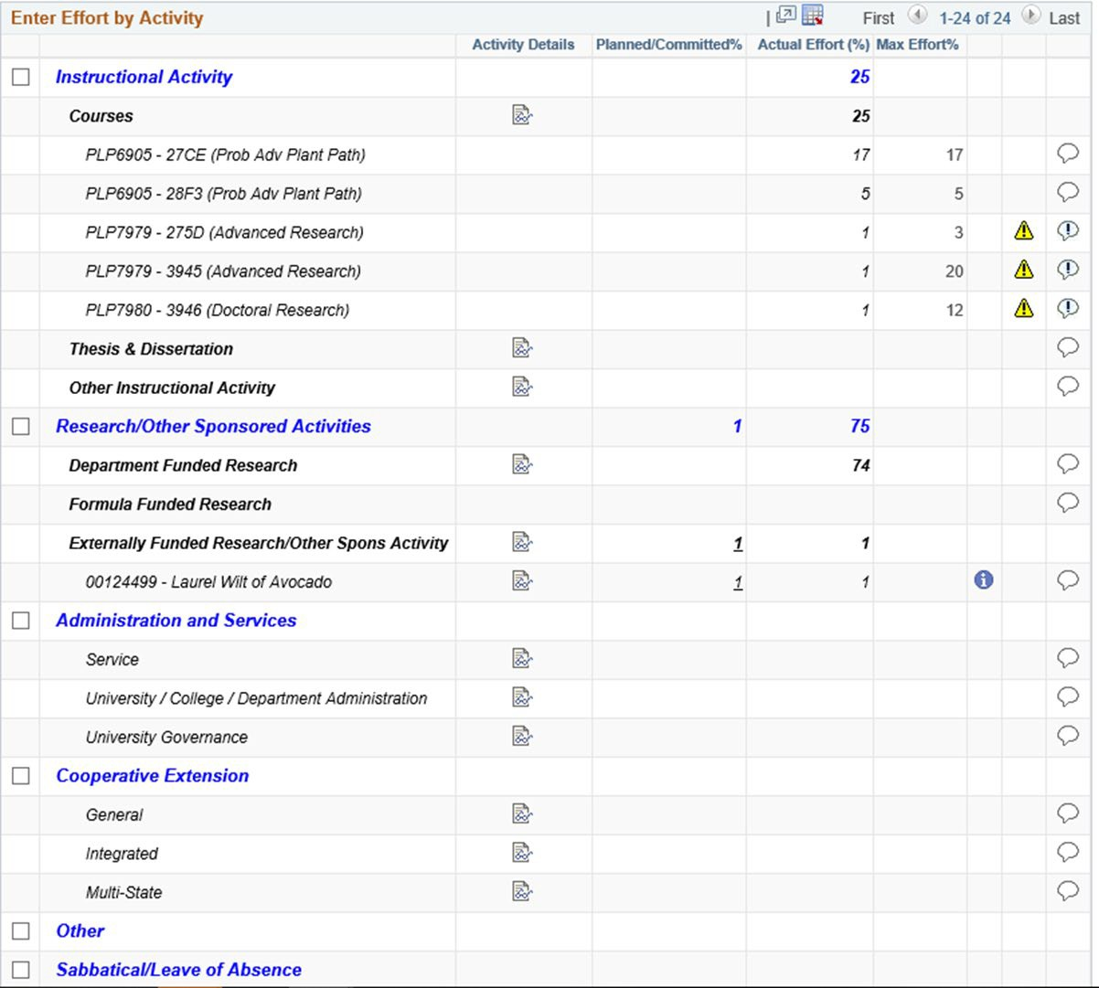
Effort Reporting



What part do you play in effort reporting?
    - To make connections:
    - There are many pieces to completing effort therefore many individuals are an integral part of the effort reporting process.
    - Know how your role contributes and interacts with effort reporting.
    - Feel confident in where to go to get your questions answered and who to contact for assistance.

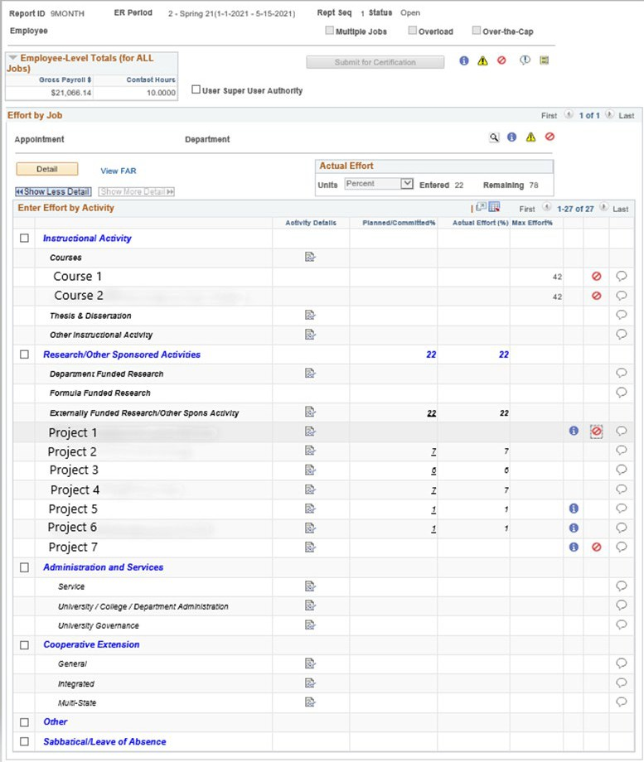
What is an
Effort Report?
A representation of an employee’s time spent each academic term for which they are compensated by the University.

Post in CHAT
- Is effort is based on a 40-hour work week? Why or why not?
- What must the effort total be equal to?
- Can effort be saved from one term to another? Why or why not?



Why Learn Effort ?
  - Payroll distributions, Academic Activity Reporting, Sponsored Research, and Human Resource functions all have an effect on creating an accurate effort report
  - Effort certification is typically a major focus of audits
    - Because University employees do not fill out time sheets, effort certification confirms payroll is charged to projects on sponsored grants
    - Accurate certification of effort minimizes risk and protects the University from fines and other adverse ramifications

Key Terms
Effort
  - The proportion of time spent on any activity and expressed as a percentage of the total professional activity for which an individual is compensated by Institutional Base Salary. Total effort for an employee must equal 100%.
Institutional Base Salary
  - The base annual compensation set by the University for an employee. It includes salary increments, augmentations and paid overtime. It does not include non-service payroll items such as awards, overload payments, bonuses or other incentive payments.
Effort Coordinator
  - The individual responsible for the allocation of the effort activities spent to 100%, working with others to fix any errors as a result of that, and submitting the record for certification to the certifier.

Who
Certifies Effort?
All faculty members

Anyone teaching a course

Anyone paid on or committed to a grant

Why Certify Effort?
  - Federal control requirements pertaining to payroll charged to sponsors
    - Payroll charges are the largest sponsored program costs and Effort confirms these charges
    - 2CFR200.430
  - Report the cost of teaching a course to the state
  - Tracking tenure

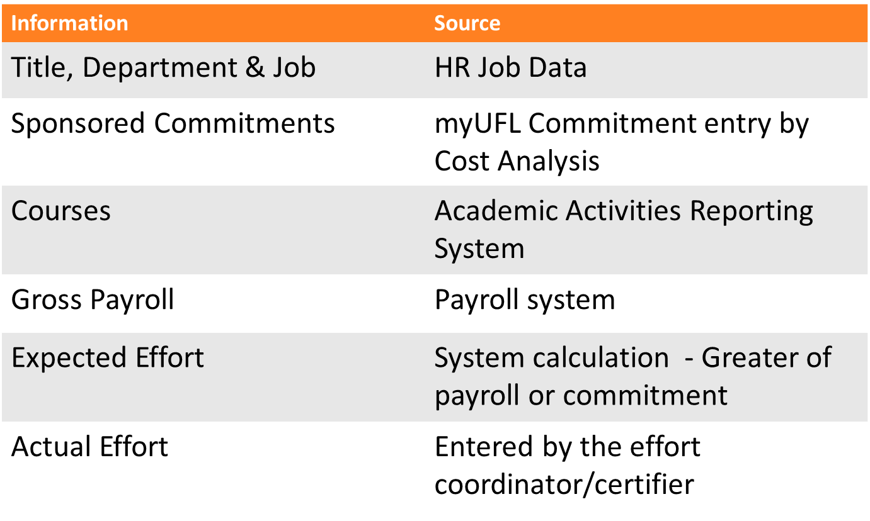

How Does Effort Receive Information?

Post in Chat – Do you Have a role in Effort Reporting?


AAR Courses –
- Office of Institutional Planning
- UF-AAR-Admin@aa.ufl.edu

UFIRST Commitments
- https://research.ufl.edu/about/contact.html

Who do you contact?
Effort Reporting
- Effort@admin.ufl.edu

MyUFL Commitments
- Commitments@admin.ufl.edu

Payroll Questions
- https://uf.tfaforms.net/315

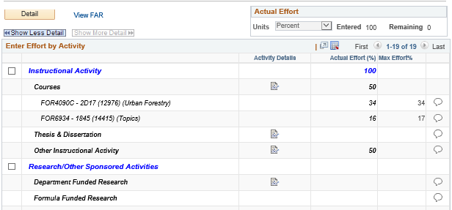
Post in CHAT
  - FOR4090C was not on the faculty member’s FAR. How do you determine if they taught the course?
  - What steps should be taken if they did not teach the course?

Effort Tips
- Actual effort cannot exceed 100%
- Effort is not based on a standard (e.g., 40-hour) work week
  - Based on percentage of total time worked in a given period (Regardless of the FTE)
- Effort should be a reasonable estimate of the time worked
- If an employee is paid 100% on a sponsored project, they must only work on that project and nothing else

Are You an Effort Coordinator? - Get to Know your Faculty!


- Review projects and courses one-by-one
- Verify employee distributions
- Review any pending actions with the PI
(follow up emails, waiting on PI, RA, central, agency, subs)
- Expiring projects, inquire if the PI plans to request NCE or move employees
- Inquire about upcoming proposals or awards

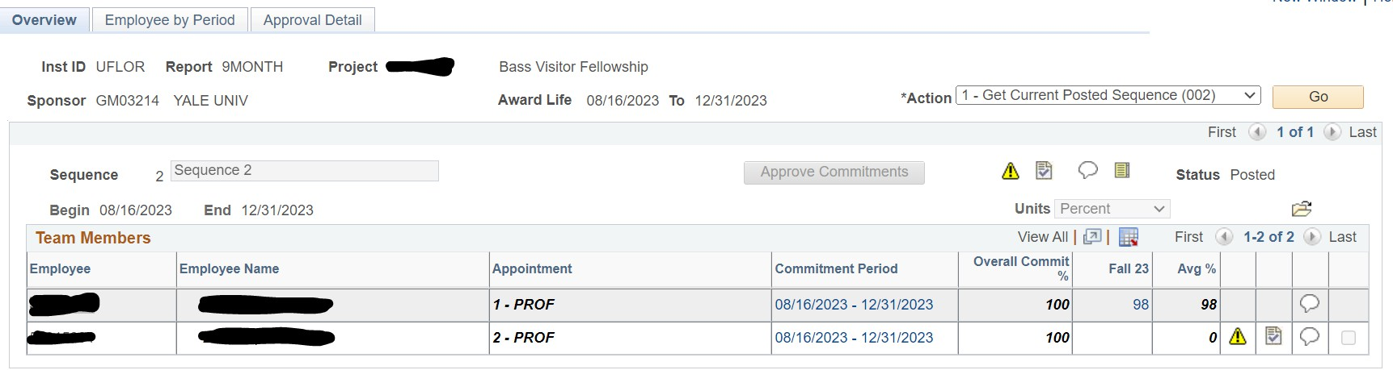
MyUFL Commitments

Key Terms
Committed Effort
  - The amount or percentage of time a university employee has agreed to work on a specific sponsored project.
UFIRST Commitment
  - The overarching guarantee to the sponsor of the commitment given to receive the sponsored agreement.
    - Only needs to be modified if: Overall commitment will need to be reduced (not a by term adjustment); the key personnel will take more than a 3 month leave of absence from the work; or the overall average of the commitment will not be met within sponsor terms conditions; any other awarding updates such as No Cost Extensions.
MyUFL Commitment
  - The system that is updated with by term ebb and flow commitment that feeds into the effort system.
    - This calculation is done based on the UFIRST data that is sent to Cost Analysis for the percentage expectations of the award. Can be updated each term and keeps track of the overall average of the commitment expectation.

DSP and C&G reviews the award and final submitted budget against UFIRST

Entering Effort Commitments
Cost Analysis does a Quality Assurance review of this documentation and enters the data into myUFL based on this confirmation

New commitment entries are reflected in the effort module after an overnight process runs

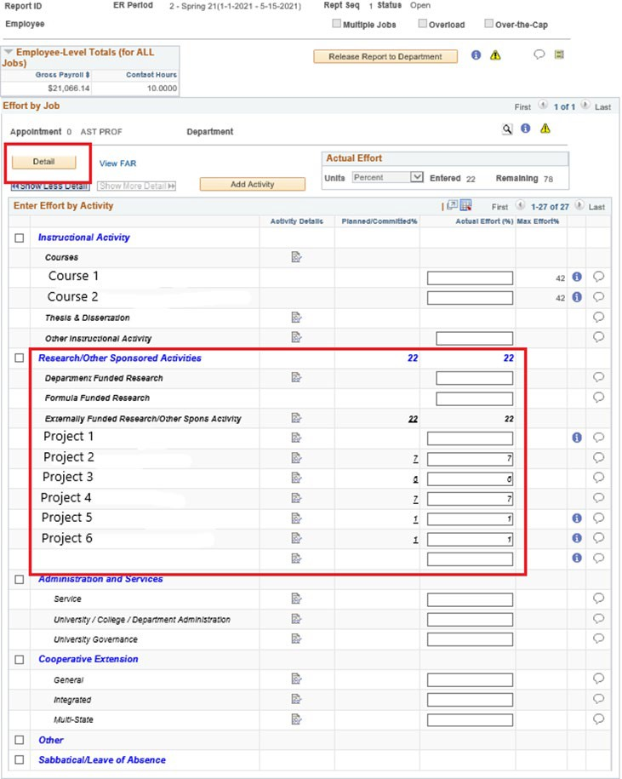

Committed Effort

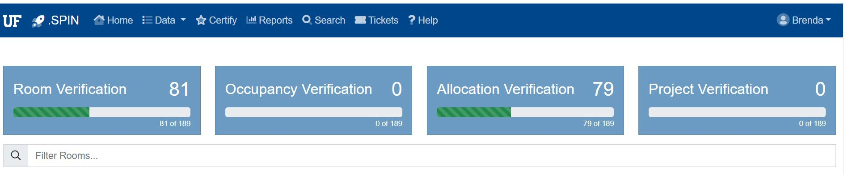
Space Allocation


What is Space
Allocation?
Space allocation is the process of allocation how a room is used during a fiscal year.

- Assist with the RCM Budget development of the colleges.
- The primary driver of the calculation of the Facilities & Administrative rate that shows how much it costs to do sponsored agreements at UF.
- Assist departments with tracking and managing the use of space so that better decisions can be made when hiring new faculty.

Key Terms
1
Certifier
2
Authorizer
•
Individual who often prepares and
inputs the space data.
•
•
Individual who “approves” the
Certified space information. Must be a DDD level individual.
3
Certification Period
4
Occupants
•
The complete fiscal year that the
space is being allocated for.
- Who is using the space.

What is Required?

Room Verification
Occupant Verification



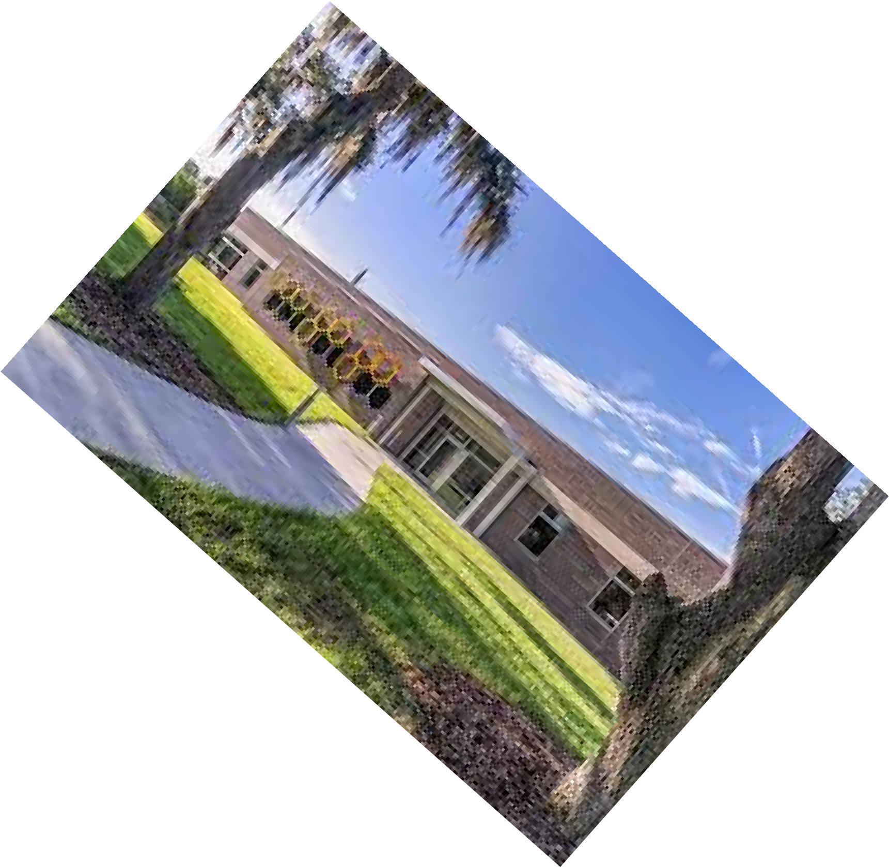


Allocation of How Space is Used
Adding Sponsored Projects when Needed


24

Allocation Categories
There are 5 Major Categories to allocate space usage
  - Administration

  - Instruction

  - Research

  - Vacant or Renovations

  - Other


Poll Time!

https://forms.office.com/r/ZQDnfNVnq6?ori gin=lprLink





Research Participant Payments (RPP)
It’s not just for research!

Why use RPP?
- To provide:
  - A central location for obtaining all payment types for participants
  - A secure database to house payment and participant information, reducing or eliminating data that departments must store
  - Quick turnaround on payment requests
  - Improved University compliance for required reporting including 1099’s
  - If gift cards are ordered, in most cases can be returned to our office for a refund of cards that are not used to the study chartfield.

What is the workflow of the system?

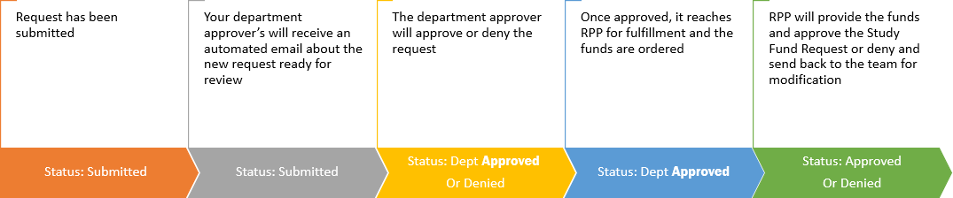

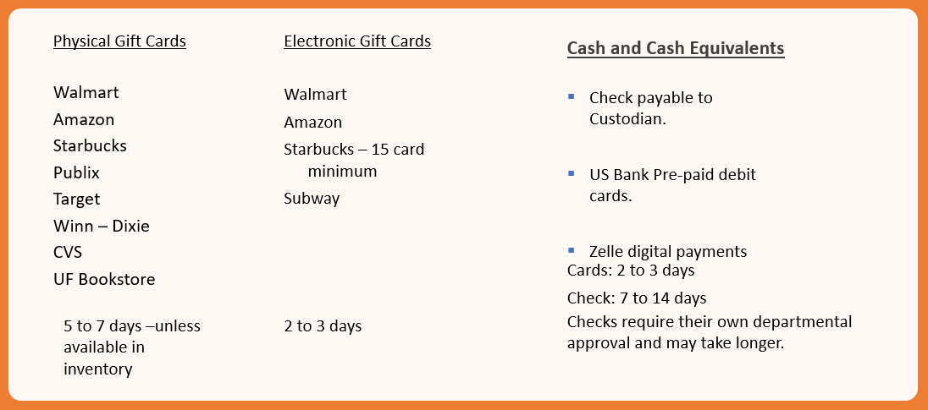
Gift card and Payment Options

Tips for RPP

If you are a Custodian of cards in a department, please do not leave the department until the cards have been verified to be returned to our office OR another individual takes possession in the system of those cards.

It is important to note that sponsored agreement expiration dates are reviewed to determine if the cards being requested make sense compared to those deadlines.

Make sure there is funding in the chartfield that is entered for payment types.

Research Participant Payments (RPP)
- Brenda Harrell, Associate Controller
  - Journal Entry Posting, Special Projects, Orders Gift Cards,
- Calais Johnson, Accounting Specialist
  - Cash Requests, Zelle Payment Transactions, Card Returns, Journal Processing, Banking Issues
- Carrie Thurman, Fiscal Assistant II
  - Processes all other payment type requests, customer service questions
- Shea Anderson, Financial Analyst II
- Assistance with all payment type processes, 1099 reporting, reconciliations and large RPP order review.
- Our Team Inbox, HSP@admin.ufl.edu



Construction Accounting

https://www.youtube.com/watch?v=IcdQ08isWt8


Construction Accounting
Construction Accounting Team
- Deborah Strickland, Assistant Controller
- Team Manager
- Angie Hyatt, Accountant II
  - PO change orders, journals & closeouts
- Sam Hinshaw, Accountant I
  - Journal entries & invoices
- Julie Stroud, Accounting Specialist
  - Invoices
- Arieol Williams, Accountant II
  - PO approvals & closeouts
Our Team Inbox, FACA@admin.ufl.edu


Constrution Project Financial
Administrators
- The team of financial administrator's primary focus is to assist Construction Project Managers with all financial data for a construction project including but not limited to:
- Purchase Order into the myUF Marketplace
- Review of Invoices for financial compliance
- Reconcilation of overall financial activity of a construction project
- Review of projects before close out procedures


Construction Project Creation

Planning, Design and Construction (ufl.edu)

Examples of the projects by Area

PDC
- Renovations
- Cabinetry modifications
- Painting or adding/removing walls
- Adding/moving doors
- Flooring replacement
- Installing lab hood or equipment
- Installing electrical outlet
Facilty Services
- Air Conditioning/Heating Repairs
- Plumbing Repairs
- Electrical/Lighting Repairs
- Exterior/Roof/Window Repairs
- Locks/Keys/Keycards
- Elevator Maintenance
- Landscaping

HOUSING service requests visit the i.ServiceDesk website.
For IFAS construction or building projects and maintenance requests, refer to the IFAS Facilities Planning & Operations website.

All Construction Projects must follow this procedure
Step 1: The project is requested by College/Department / Entity.
Step 2 (if applicable): The project is approved through the Construction Project Planning Executive Council (CPPEC).
Step 3: The project is then established , which is based on the “Facility Program that follows the Board of Trustee Internal Operating Memoranda 02-3 guidelines
Step 4: Upon receipt of funding commitment(s), the project is given formal notice to proceed with design
Step 5: The Project Manager and the Project Accountant are assigned
Step 6: Following CPPEC approval, the Project Manager creates a project in the Project Tracker system
Step 7: The College/Department/ Entity provides funding Source(s) that will be utilized
Step 8: Construction begins

When Additional Approvals are Needed for A
Construction Project

Projects that are $2,000,000 and over require:
- CPPEC Approval
- Board of Trustees Approval
- Board of Governors Approval

Projects that are between $1,000,000 - $2,000,000 requires BOT Approval.
- CPPEC Approval
- Board of Trustees Approval

Anything else that meets CPPEC Criteria

CONSTRUCTION PROJECT PLANNING AND APPROVAL EXECUTIVE COMMITTEE
- A Construction Project Planning and Approval Executive Committee (CPPEC) is established for the purpose of reviewing all projects that meet established criteria. University academic and operating units and their employees are encouraged to explore ways in which to advance the University’s mission by developing new uses of the University’s land and facilities. This might include, for example, (1) the development of land for future use, (2) the construction of new facilities, and/or (3) the renovation or
replacement of existing facilities. Before proceeding with plans to undertake a
project of this nature or magnitude, however, it is important that appropriate oversight, input, and approval be provided. This will better enable University leadership to determine that a proposed project meets university mission, goals, and procedures.

CPPEC-Policy-2021.pdf (ufl.edu)

CPPEC
Projects that require CCPEC Review are determined by the selection criteria. Projects typically do not go to all three levels of approval. Only one level is chosen based on the project type by PDC.

Level 1 – Full Committee Review
  - All projects >$2m total project cost and/or included in a UF unit’s Capital Budget
  - All projects utilizing state funds, debt financing or donor financing > $250,000
  - All projects that demolish an existing building with replacement cost >$1m
  - • All projects necessitating real estate transactions that require BOT approval
Level 2 – Sr. VP/COO, VPBA and area VP
  - All projects $1m -$2m total project cost
  - Demolish an existing building valued at ≤$1m
  - renovate or re-configure over 3,000 NSF
  - Campus Master Plan Compliance Criteria with total project cost ≤$2m
  - Reassign space from one UF budget entity to another (E&G, IFAS, etc.)
  - Include art, memorials, monuments, plaques or similar installations with total project cost ≤$2m
  - Necessitate other real estate transactions NOT requiring BOT approval
  - Include non-standard exterior signage/branding

Level 3 – AVP PDC and area VP
    - All projects that do not meet the criteria in Level 1 or Level 2
    - Generates new GSF including temporary space
    - Alters landscape and/or open space with a total project cost
≥$250,000
    - Includes demolition of existing building(s)
    - Alters circulation or parking




Construction Accounting’s Role

- Construction Accounting is responsible for the overall review of funding requests to support a construction project. This is guided by UF Policies, State Statutes, and Board of Governor’s regulations. It is the departments’ responsibilities to understand if their funding source meets the definition of the use of the funds for construction. For example, an auxiliary funding source overall may be ok as far as state statutes, but Construction Accounting would not be able to determine if the work being done is really for the auxiliary in the department’s space.

- In addition, Construction Accounting is the final review of an invoice, purchase order and journal entry that affects a construction project. This is to verify amount, project number, and vendor.



Wrap Up

  - Which section was the most informative to you?
  - What would you like to learn more about?

- https://forms.office.com/r/QaM W9cxf9t?origin=lprLink




Questions

