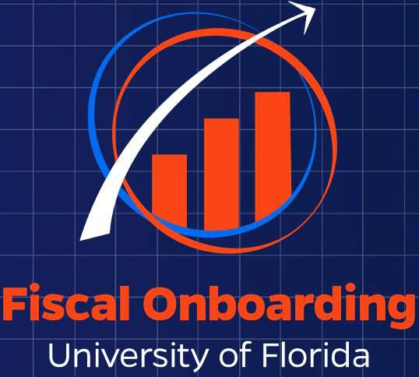
Data Literacy : It’s Not Just For Nerds
WELCOME!

POST IN THE CHAT:
- Your Name
- Where You Work
- How long you have been at UF

1



Who are we?

2

The CFO’s Finance Strategy & Analytics team is designed to achieve strategic goals through training, innovation, data, and implementation of efficient processes.

We coordinate Professional development opportunities for CFO staff and work with campus partners to better serve our customers (YOU).

Learning Objectives
- Define data curiosity
- Know how to find validated data
- Be empowered to be data curious

3


Topic Overview
Everything is data. Data is everything!
4

Data Literacy
The ability to read, understand, interpret, and effectively communicate with data
Validated Data
Reports or website that have been reviewed and vetted by the core offices
Data Curiosity
Data curiosity is a mindset and approach to working with data that encourages individuals to explore, question, and seek deeper understanding from the information they encounter.
Data Preparation
The process of collecting, cleaning, and organizing data in order to make it suitable for analysis.
Key Terms
5

Key Terms

Enterprise Analytics
University-wide reporting environment. Data shown here is as of the night before.

Monthly Financial Reports(MFR)
A set of 8 delivered reports that provide different information on a department’s financial activities. Normally used for reconciliation. Data is as of the end of the prior month.
Budgets Overview
Peoplesoft (MyUFL) screen that answers “what is my available spending authority?” Data here is real time.
myInvestigator
An online decision-support tool for sponsored projects. Data shown here is as of the night before.

Comprehensive Financial Reporting Suite
Reports within Enterprise Analytics similar to MFRs that can be run “on-demand” and using a variety of different prompts. Data here is as of the night before.

6

Big Idea!
Data Literacy + Critical Thinking
= Data Curiosity
7




Data Literacy Skills
The ability to read and comprehend data is like learning to read.

- Continuous growth, not a one-time thing
- Always improving, always learning new words and adding vocabulary
- Building skills to master language, just like building skills to analyze data
- Seeing patterns in reading helps comprehension, much like seeing patterns in reports leads to better decision-making
8


3 Pillars of Data Curiosity
Challenge Your Data And Observations
Ask Questions
Provide Actionable Insight
9



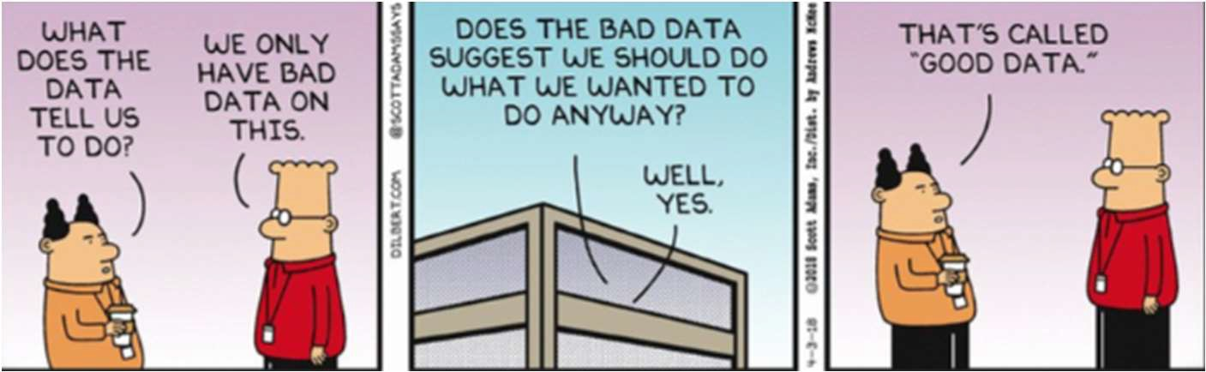
10

3 Pillars of Data Curiosity
Challenge Your Data And Observations
Ask Questions
Provide Actionable Insight
11

Data Tip! | A data curious professional knows where accurate data is found, thinks critically, and provides actionableinsight.
12



Importance of Data-Driven Decision Making
- Data provides clear answers that lead to actions
- Helps departments steward their finances to support the mission of the University
- Drives cutting-edge research for sponsored projects
- Upholds operational excellence by analyzing HR processes like payroll
13



Where can I find data?
Key Data Locations
- myUFL/Peoplesoft
- UFIRST
- myUF Marketplace
- myInvestigator
- Enterprise Analytics
- Delivered Monthly Financial Reports (MFR)
- Websites (in your handout)
*May need security role to access certain reports
14

myUFL (AKA  PeopleSoft) | UFIRST | myUFL Marketplace
myInvestigator | Enterprise Analytics | Delivered Monthly Financial Reports (MFR)
15

Timing of Data
Real Time | Prior Business Day | Prior Month

Data Tip! | Use validated data because it's efficient, reliable, and consistent. It allows employees to focus on analysis, ensures compliance with standards, and minimizes errors.
16



Validated Data Scavenger Hunt
17






Break Out Room #1
In your breakout group, find at least one of the items in each group found on the Scavenger Hunt Handout from the following websites:

- Financial Data Reports
- Enterprise Analytics Toolkits
- HR Data Services & People Analytics
- Sponsored Projects Reporting
18

Validated Data Scavenger Hunt – Activity #1

Find at least one from each group below:

- Visit the Financial Data Solution Center and find the following:
  - What is the email address for report suggestions/additional resources to be sent to?
  - How many payroll reports are currently listed in the Financial Data Reports?
  - What is the recommended output for the Comprehensive Open Encumbrance Report?
  - Where is the Enterprise Analytics-Basic-User-Guide_V2-1 found?

- Visit the Enterprise Analytics Toolkits website and find the following:
  - What is the number of “Comprehensive Report” specific guides?
  - The toolkit on the Comprehensive Available and Projected Balance Report. Does the MTD Expenditure include F&A?
  - The toolkit on the Comprehensive Transaction Detail Report. How many ChartField prompt values are there?
  - What is the name of one training course that is available?

- Visit the HR Data Services & People Analytics website and find the following:
  - What is the name of one training course linked on the website?
  - What is the name of one Data Report called out?

- Visit the Sponsored Projects Reporting website and find the following:
  - Where is the Sponsored Projects Report Guide found?

10

Validated Data Scavenger Hunt

Share Out

19



Comprehensive Reports
UF Offers a Suite of Comprehensive Reports as a Resource

- Comprehensive Transaction Detail
- Comprehensive Available and Projected Balance
- Comprehensive Open Encumbrance
- Comprehensive Payroll Reconciliation
- Comprehensive Projected Payroll

*More continue to be added to the suite
20

Remember
Data Literacy + Critical Thinking
= Data Curiosity
21


THE NUMBERS
THE STORY
For financial data, our ChartField values are the main data fields that start our story
Dr. Roe's lab (Dept ID) purchased lab supplies (Account Code) for research (Program Code) on his federal (Fund Code) R01NS110307 (Project) from HHS (Source of Funds)
Dept ID: 10045060
Fund: 201
Program Code: 2200
Account: 731100
Project: P0250287
Source of Funds: G000010
22

There is a saying…
GARBAGE GARBAGE


IN OUT
This Photo by Unknown Author is licensed under CC BY-NC
23




Where do I fit in?

Depending on where you are in your career, you might be the person entering the data, manipulating the data, or analyzing the data.

At any level, you can apply the pillars of data curiosity.
24

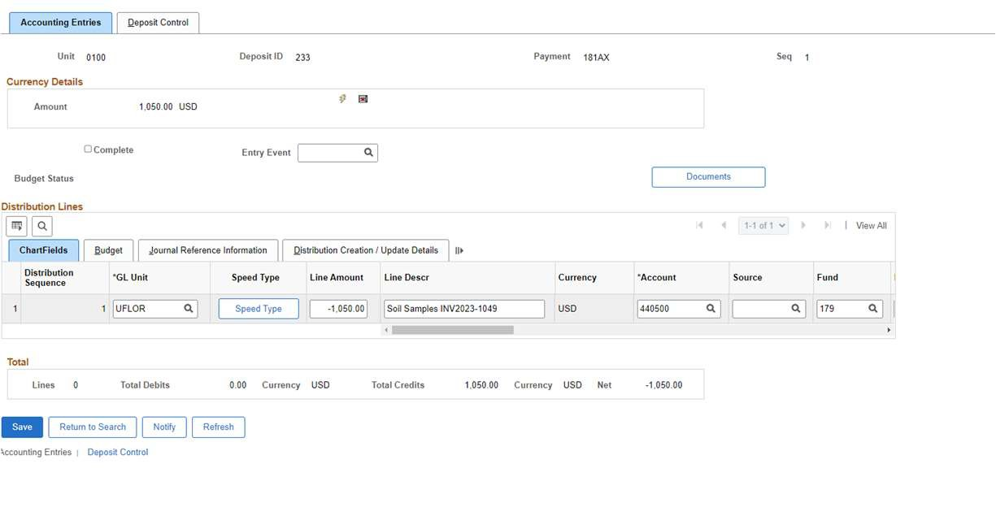
Source: Peoplesoft Deposits
25


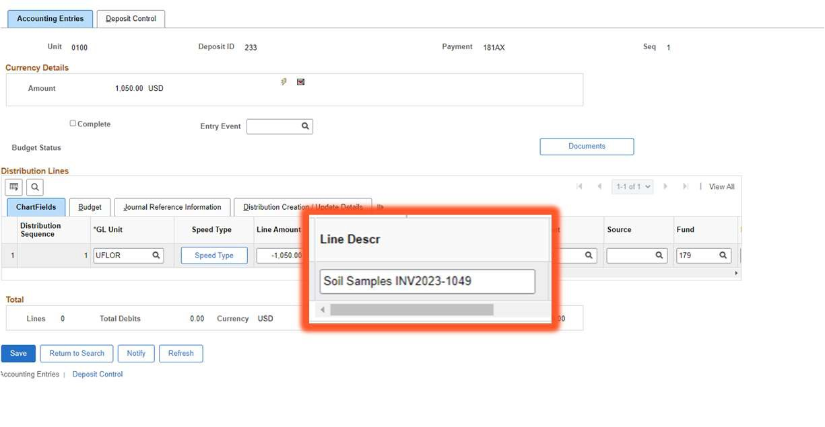
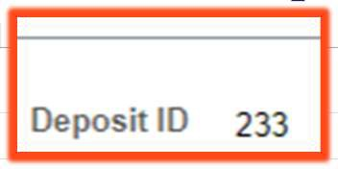
Source: Peoplesoft Deposits
26

 | 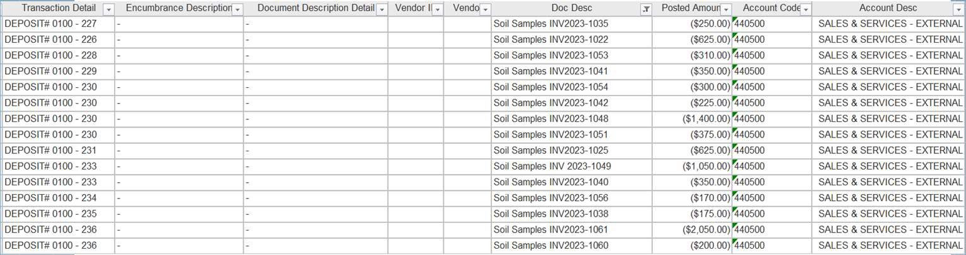  Comprehensive Transaction Detail
27

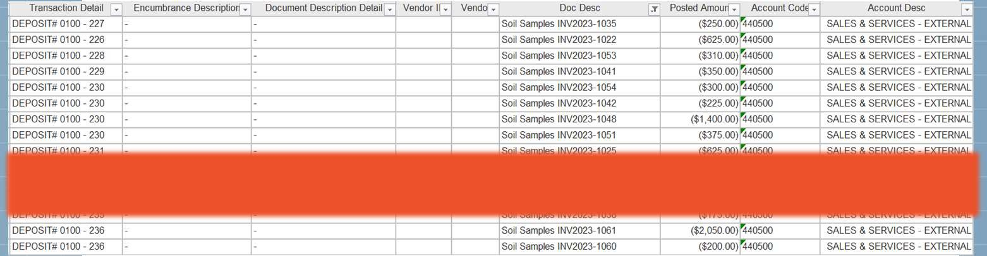
Comprehensive Transaction Detail
28

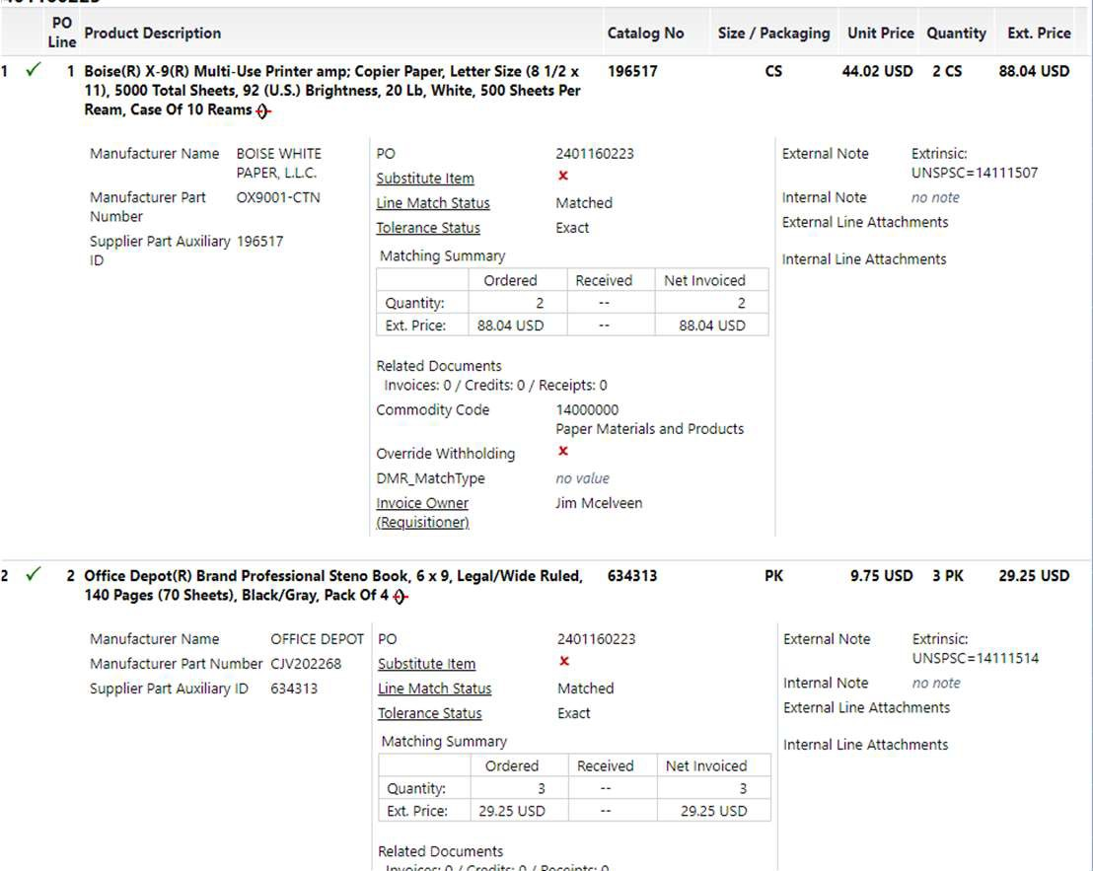
Source:
My UFMarketplace
29

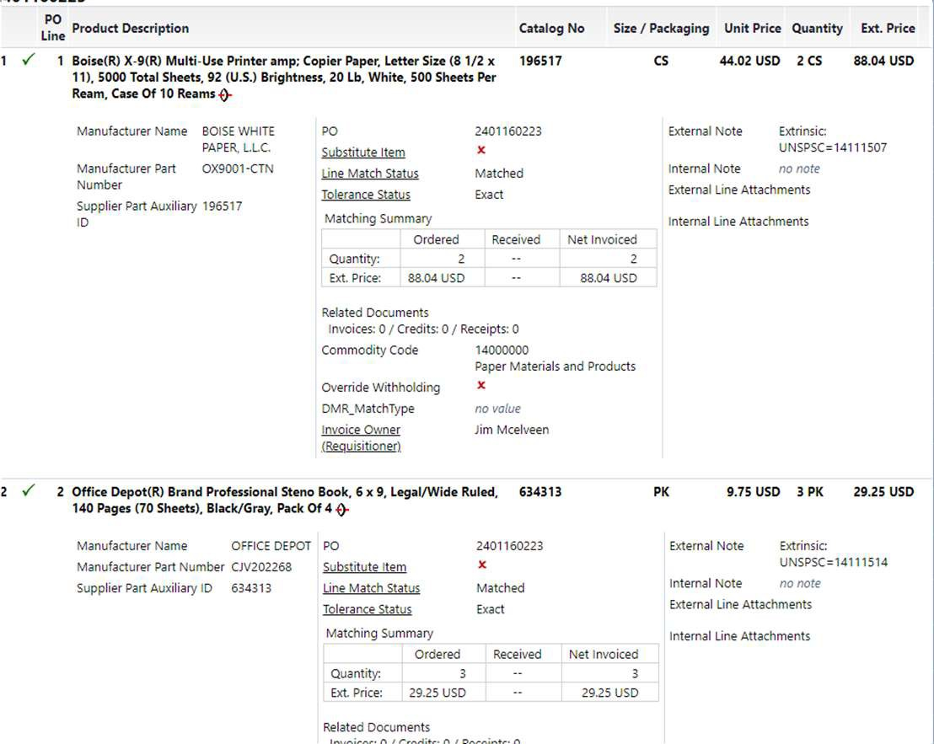
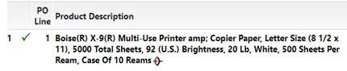

Source:

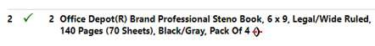
My UFMarketplace
30

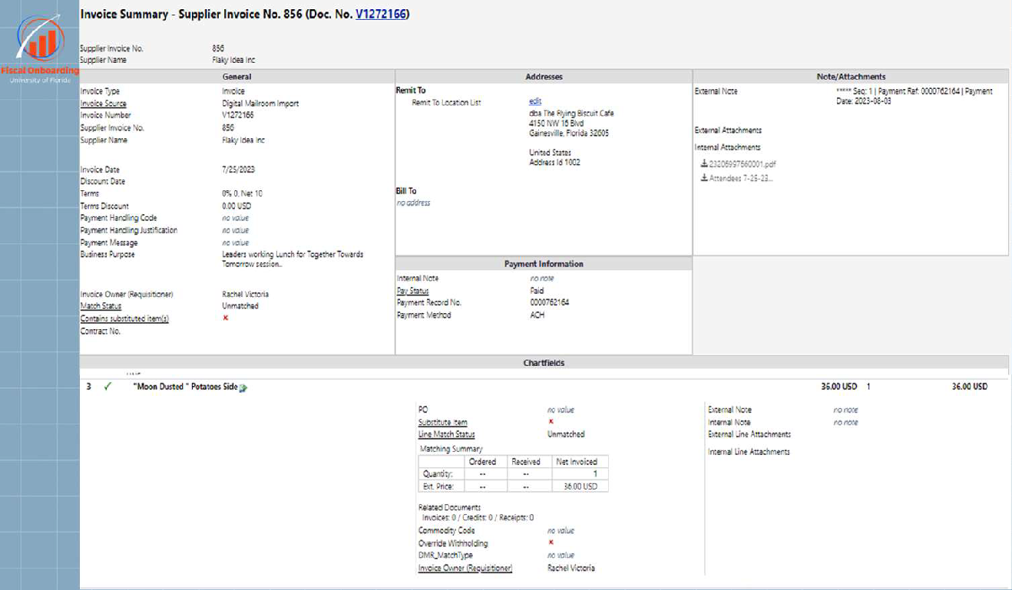

Source:
My UFMarketplace
31

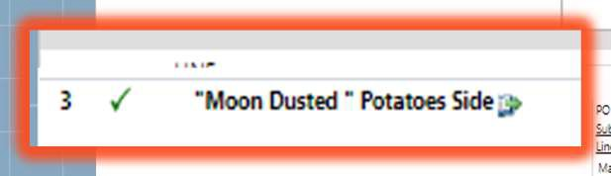

Source:
My UFMarketplace
32

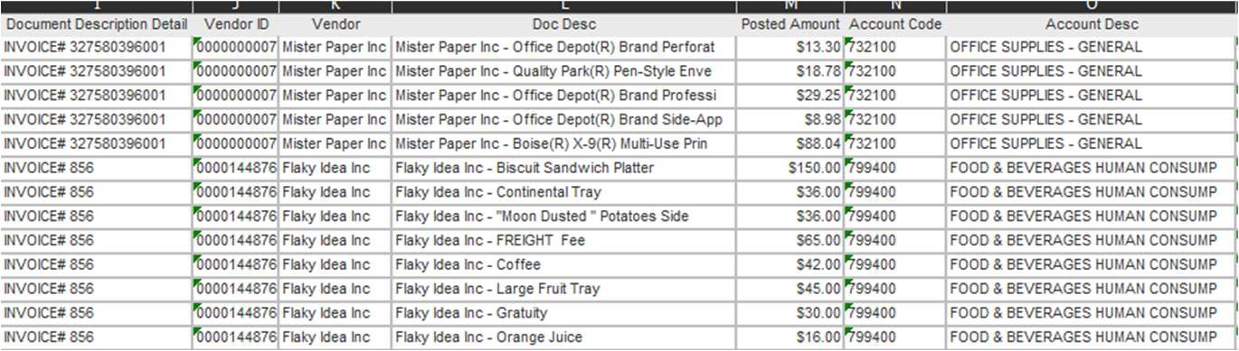
Comprehensive Transaction Detail
33

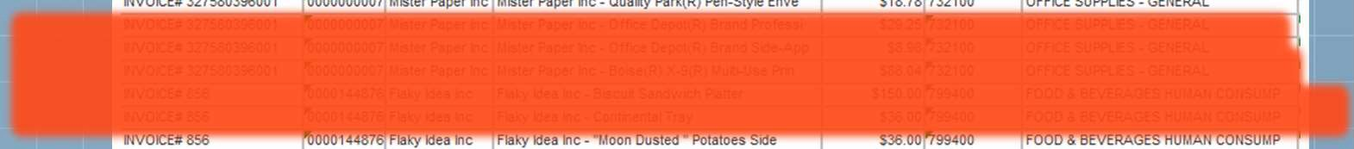
Comprehensive Transaction Detail
34

Work in silos, we do not. In silos, we do not work!
35

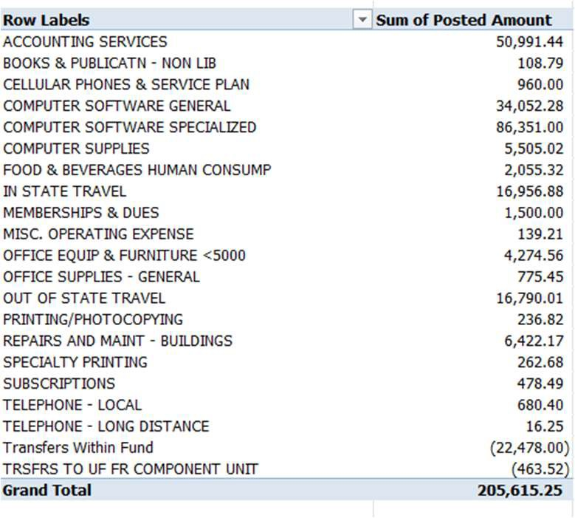
Comprehensive Transaction Detail
36

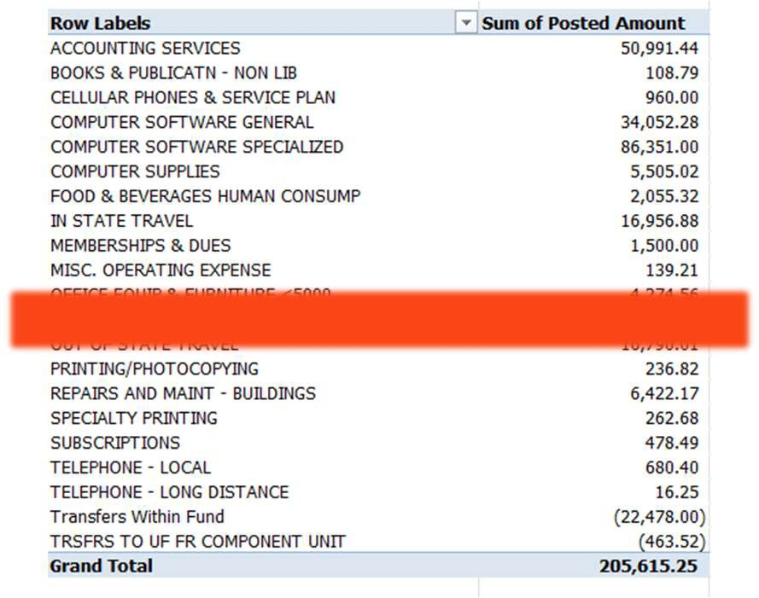
Comprehensive Transaction Detail
37

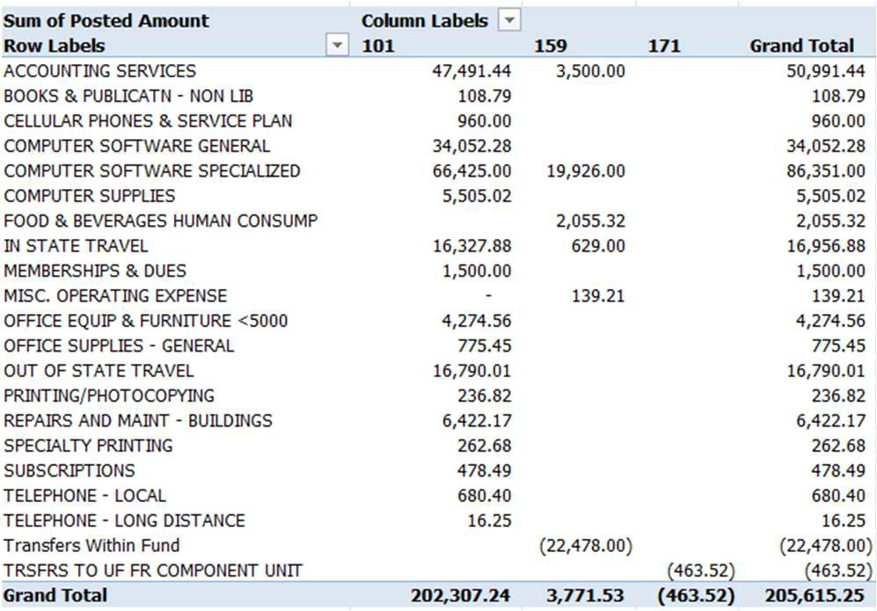
Comprehensive Transaction Detail
38

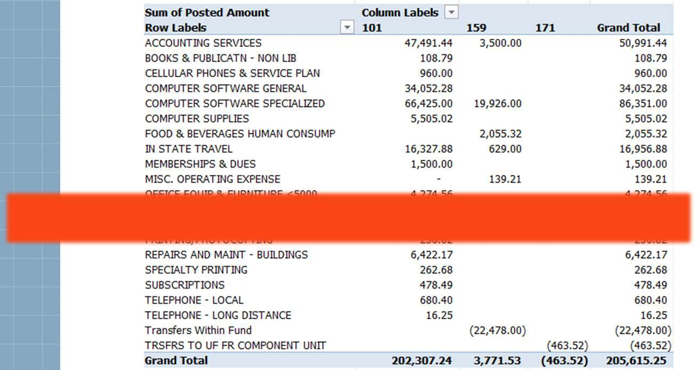
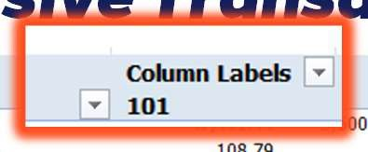
Comprehensive Transaction Detail
39

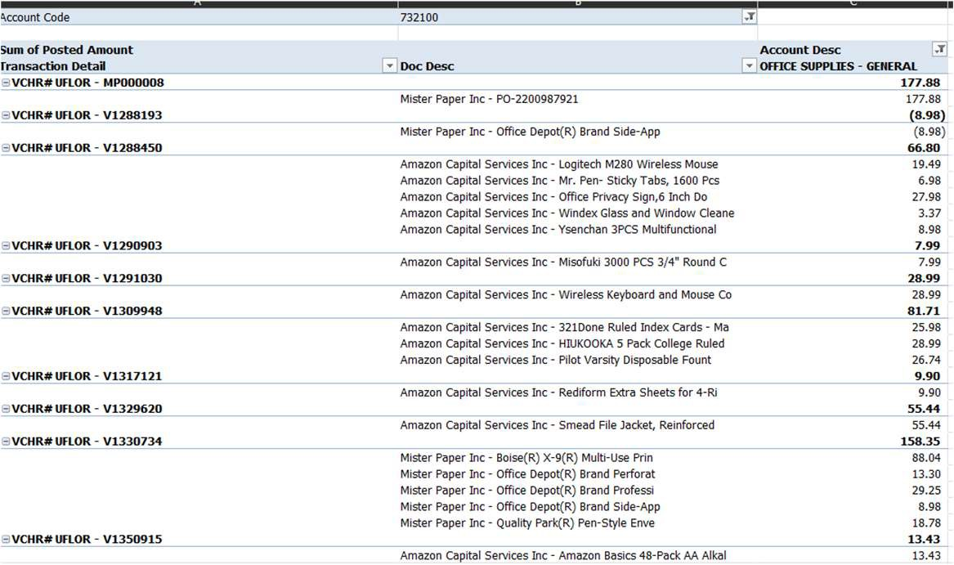
Comprehensive Transaction Detail
40

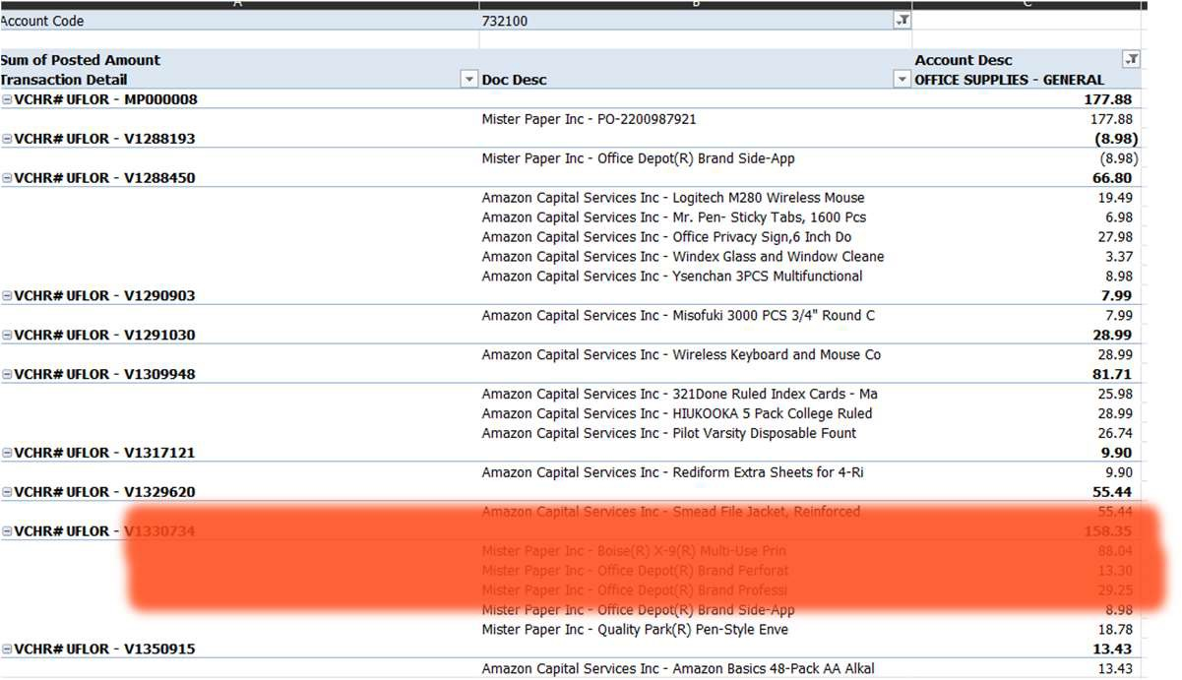
Comprehensive Transaction Detail
41



Comprehensive Activity
42

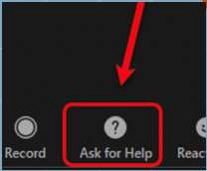
Break Out Room #2
In your breakout group review the handout for breakout room #2 activity.

There are three groups of questions:
- What’s the story?
- Dr. Luca’s receipt
- Get funky with it

* Please be sure to download the spreadsheet before manipulating it.
43



Activity # 2 Share Out
- What’s the story?

- Dr. Luca’s receipt

- Get funky with it
44

Virtual Fiscal Onboarding
Comprehensive Activity #2
The following handout will be used for your second breakout room activity.

What’s the story?
Remember when we talked about ChartField values being the main data fields that tell our story?

Using the transaction below, write up the story it is telling us. *Screenshot from the Comprehensive Transaction Detail*
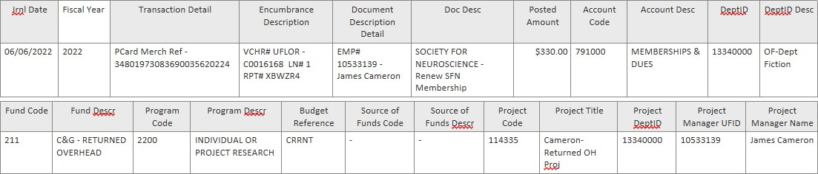

Spreadsheet Link
Download a copy of the spreadsheet below on your desktop before manipulating it. Comprehensive Transaction Detail Report

Dr. Luca’s Receipt
Use the receipt on page and your downloaded spreadsheet from above to answer the following questions:

Dr. Luca has just dropped off a receipt and said, “I’m not sure if this has been paid yet.” You check myUF Marketplace by the invoice number and that invoice isn’t there.
      - Which spreadsheet(s) would you use to find out if this invoice has been paid?

      - Are there any other questions you need to ask Dr. Luca?

      - Was the receipt paid?

    - Get Funky with It: Use downloaded spreadsheet to answer the following questions:
      - How much has been spent on out of state travel this past fiscal year?

      - Who are the top 3 travelers based on amount spent?

      - Was there anything else you learned from the data that you think your boss should know?


Big Idea!

As a data literate professional, you get an opportunity to craft your 'data story' to explain complex information clearly and effectively, ensuring that your data not only informs but also engages and inspires action in others.

45

Questions?
46


It only takes a few minutes to complete!
courses based on attendee responses.
We take your feedback seriously and make changes to our
Course evaluations are
distributed electronically
47

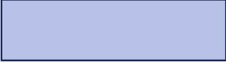
Upcoming Topic Sessions: Fall 2024

Registration details at Fiscal Onboarding | CFO CFO https://go.ufl.edu/2nmw0i9

UF Research Pre and Post Award 11/6

General Accounting and Financial Reporting 11/13

Financial Basics 11/20
November

Asset Management 10/2

Payroll Services 10/16
Procurement 10/23 Cost Analysis 10/30
October
September

Disbursements 9/18

Banking and Merchant Services 9/25
48

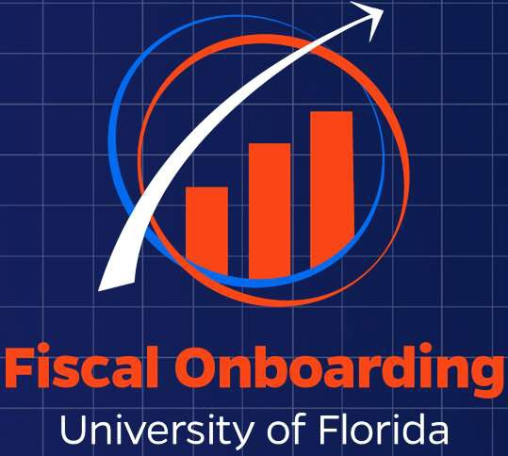
https://hr.ufl.edu/professional-development/training-programs/data-literacy/
Thank you!
Michelle Romero
controller-office@ad.ufl.edu
Additional Data Literacy Courses:

DLP103 – Finance Data Literacy: Analyzing Departmental Transactions
DLP001 – Data Governance and Data Management
49

