
Welcome to General Accounting

Networking
Post in the Chat Your Name Where you work
How long you have been at UF


Topic Overview
- General Accounting Overview
- Chart of Accounts at the University and Combination Codes
- Journal Entries, Month End, and General Ledger
- Scenarios




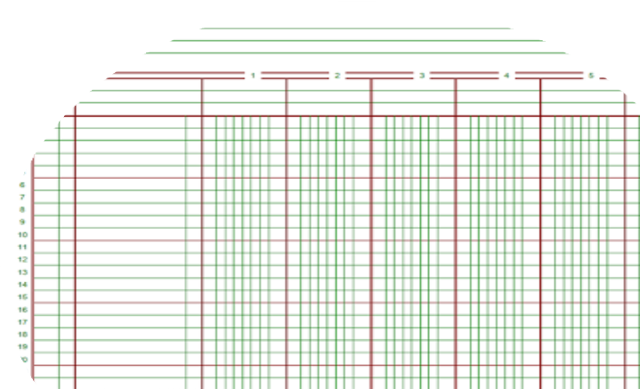
Who are we?
We are responsible for maintaining the University’s accounting records.
This means we:
  - Maintain ChartFields and Combination Codes
  - Review General Ledger (GL) activities
  - Perform month-end and year-end closings
  - Process GL journal entries such as cash transfers, inter-departmental transactions and expense corrections

Key Terms

ChartFields
A ChartField is a data field that stores accounting information, affects budget, and is used for reporting.

Combination Codes
Combination Codes are created by General Accounting and consist of unique chartfield values to be used for all payroll charges.



General Ledger (GL)
The myUFL General Ledger is the official
accounting record of the University of Florida.
Journal Entry (JE)
Journal entries are financial transactions that
are recorded to the general ledger.

ChartFields
- Identify transactions and track financial activity
- Required on all transactions (Basic Six Pack)
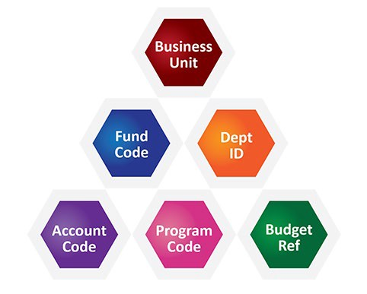
  - Business Unit
  - Fund
  - Department ID
  - Account
  - Program Code
  - Budget Reference
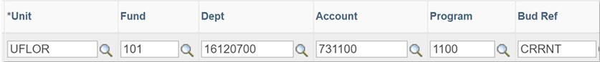

Why is the type of Fund used so important?
When monies are received by the university, they are “deposited” into a Fund depending on the funding source and how the resources may be used.
Fund accounting allows the university to track financial transactions that supports accountability per the University’s colors of money.

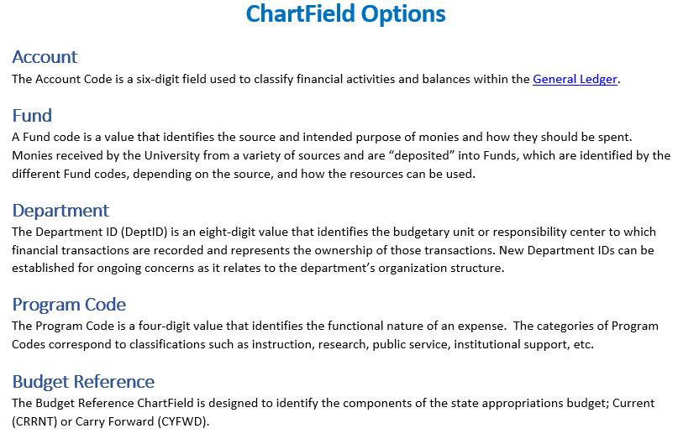
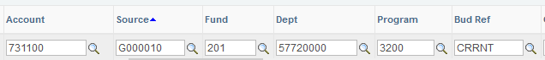

Chartfield Options (continued)
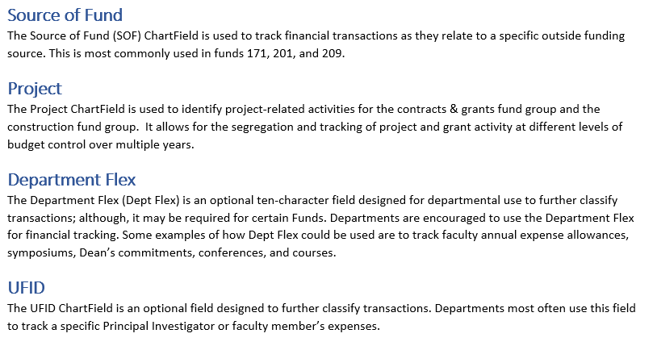
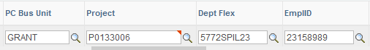

Combination Codes

A 7- or 9-digit number created by General Accounting that is used in the HR Commitment Accounting department budget table module of myUFL. It represents the unique collection of ChartField values (the cost center) in the General Ledger.

Combination Codes are used to distribute all payroll charges such as salary and additional pay. All Combination Codes must have at minimum the Department ID, Fund, Program Code, and Budget Reference.

Combination Codes


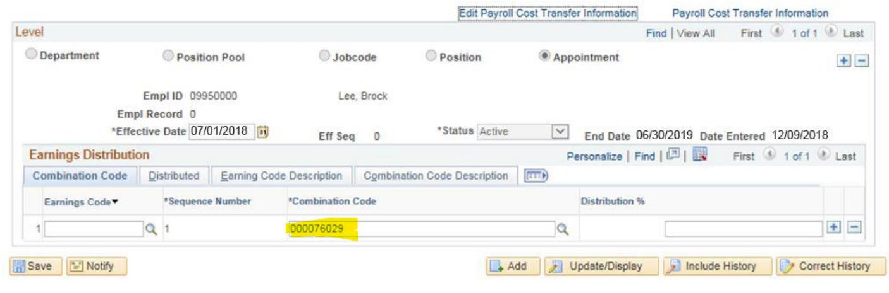
Human Resources (Department Budget Table)

Combination Codes

GL Combo  Code | Eff Date | Dept | Project | Fund | Program | Source | Bud Ref
000076029 | 9/1/2012 | 60150000 | 00104078 | 209 | 2200 | G000930 | CRRNT
 |  | AG-FOOD SCIENCE / HUMAN NUTR | IFAS Service Program: Dr. Mit | C&G - OTHER RESTRICTED | INDIVIDUAL OR PROJECT RESEARCH | MISC SPONSORS | CURRENT BUDGET

Journal Entries


Expense to Expense (E2E): Used when an expense needs to be moved from one ChartField string to another.
Expense to Revenue (E2R): Used to record internal sales or services that a department has provided to another department within the University.
Deposit Corrections (DPC): Used when a department’s ChartField string needs to be corrected on a deposit; must reference the original deposit.
Cash Transfers (ONL): Move cash from one cost center to another while updating Commitment Control (KK) at the same time. https://www.fa.ufl.edu/directives/cash-transfers-onl/


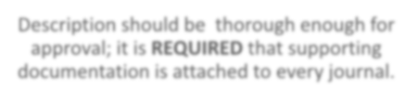


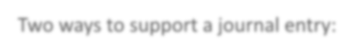

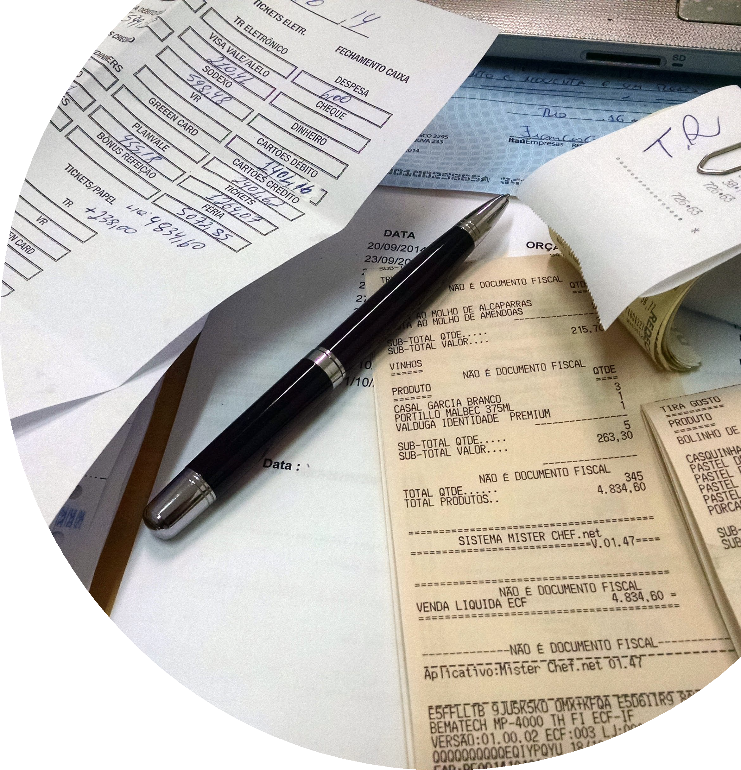
Supporting Documentation

Two ways to support a journal entry:
Attaching supporting documentation
Journal entry descriptions

Description should be thorough enough for approval; it is REQUIRED that supporting documentation is attached to every journal.

Journal Upload Process
It is possible to mass import journal entries for large journals. See the following for training material on how to complete this process:

PST957 – Spreadsheet Journal
- https://www.fa.ufl.edu/directive-categories/journal-entries/


Deadlines
The University is scheduled to close the General Ledger on the third business day of the following month.
However, the last day to submit journals is three full business days before the last business day of the closing month to allow time for review and processing before the General Ledger is closed.
https://www.fa.ufl.edu/directives/mont hly-closing-schedules/

General Ledger
myUFMarket

Vouchers
UF Go – Pcard Reconciliation
Vouchers
UF Go –
Expense Reports
Vouchers
myUFL–Journals
E2E, E2R, cash transfers
myUFL – Accounts Receivable
Deposits
General Ledger
The official accounting record of the University of Florida

Break Out Rooms
- We will now send you out into breakout rooms so you can go over the next four scenarios
- This is your chance to make connections and utilize the resources
- Open your chat within the video call and say Hello

SMEs will check into your rooms to see if you have questions.

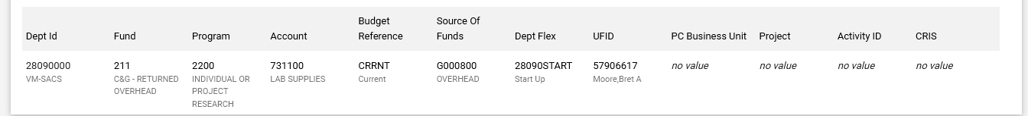
Scenario #1
You are given the ChartField string below to issue a requisition for some lab supplies. You receive an error based on the ChartField string. What corrections do you need to do to this Chartfield string to proceed?

Scenario #2
You are the office manager for the Mechanical Engineering department. For the first time, the Dean’s Office has provided annual expense allowances for the faculty and would like to track the spending of each faculty member.

What ChartFields can be used to track the spending of each faculty member?

Scenario #3
You are an office manager in the Chemistry Department. The Dean’s Office has decided to separate the Biochemistry program, which has grown significantly and will have (3) new full-time employees and its own budget allocation.

What ChartField should be used to track the spending of the new Biochemistry program?

Scenario #4
You are the payroll processor in the new Biochemistry department in scenario #2. There are (3) employees to be hired for the new department and you need to establish their payroll using the new ChartField values.

What will you need to enter the distributions?

Scenario #5
You need to transfer monies from your foundation funds into two Department IDs to distribute the cash.

How would handle this transfer? How would you handle a transfer if it involved an appropriation fund?

Scenario #6
You are a Fiscal Asst. II in the Chemistry Department. You have purchased a new $1,200 laptop for the department.
Fill in the ChartField descriptions below using the General Accounting website resources or MyUFL. Define the transaction using only the ChartFields and descriptions.
Website: https://www.fa.ufl.edu/departments/general-accounting-and-financial-reporting/
MyUFL: Main Menu > Financials > Set Up Financials/Supply Chain > Common Definitions > Design ChartFields > Define Values > ChartField Values

Account | Fund | Dept ID | Program | Budget Ref | Amount
734800 | 101 | 16120100 | 1100 | CRRNT | 1,200.00

Scenario #7
You are a Fiscal Assistant in the Chemistry Department. You have purchased a new laptop for the department but used the wrong Department ID.

How would you correct this transaction?

Reporting Fraud
If you are not sure if fraud is happening, talk to someone in Finance & Accounting, a trusted advisor, a supervisor, or someone you trust.
To report potential legal, policy, or ethical conduct violations or concerns.

Anonymous Compliance Hotline: 1-877-556-5356 https://app.mycompliancereport.com/report.aspx?cid=uofl
University of Florida Compliance Hotline:
https://compliance.ufl.edu/uf-compliance-hotline-2/ UF Controller’s Office: 352-392-1321

Thank you for attending!

Beth Groff Associate Controller
(352) 294-7237
Brandon Esposito Assistant Controller
(352) 294-7263



GAhelp@ad.ufl.edu

