

Welcome to Disbursements
PLEASE POST IN THE CHAT
- YOUR NAME
- WHERE YOU WO RK
- HO W LO NG YOU HAVE B EEN AT UF
1




Who we are?
We are Accounts Payable for UF. This means we manage:
- Suppliers
- Invoices
- Payments
2


Key Terms
Supplier
- An organization or individual who provides goods or services.
Supplier Portal
- Online portal for new suppliers to register or existing suppliers to request changes.
Supplier File
- Each supplier is identified by a unique Supplier ID number for the supplier file. Each Supplier ID has an exclusive Tax ID number relationship.
3

Key Terms
myUFMarketplace (Marketplace or myUFMP)
- The system used to create requisitions, purchase orders, and electronically receive and process invoices.

Digital Mail Room (DMR)
- The supplier emails the invoice to UFL.invoices@trustflowds.com. The Dept ID or PO number is required to be on the invoice labeled: “Dept ID #” and/or “PO #” EX: Dept ID 6440400
4


Key Terms
Purchase Order (PO)
- A contract for the purchase of a good or service, before the actual purchase, that ensures compliance with purchasing policies, budget checking for available funds and encumbering funds.
Unencumbered
- A transaction where funds are not committed in advance to pay for the purchase, such as freight.
Encumbrance
- An encumbrance represents a commitment to pay for goods or services being purchased that has not yet been received. The amounts of encumbered transactions are deducted from budget balances.
Cash-based funds do not deduct from the available balance. Departments must take care to not overspend.
Change Request
- You can process a change request directly in the Purchase Order in the Marketplace. You can increase/decrease either the quantity or amount. With a change request you can change the Chartfield string. Exceptions may apply.
5

Key Terms
Non-PO Invoice
- Utilized to process unencumbered invoices. This will also be used for instances such as refunds, honorariums and receipts, (ex: Publix, Sam’s Club).
PO Invoice
- Invoices for encumbered transactions that need to apply to an open PO or PO line or lines.
Select Expedited Approval (SEA) Invoices
- Invoices that are $500 or less go straight to PeopleSoft. These invoices bypass the approval process.
SEA Suppliers:
① Fisher Scientific ② Office Depot/Mister Paper ③ Bio-Rad ④ Quiagen
⑤ Henry Schein ⑥ Sigma-EMD Millipore ⑦ Airgas ⑧ Amazon
6

Tax Exempt Status
The University of Florida is not subject to Florida sales tax. Sales tax is only allowed when reimbursing an employee for expenses purchased.
Certificate of Exemption can be found:
https://www.fa.ufl.edu/wp-content/uploads/2019/06/Consumers-Certificate-of-Exemption-Sales-Tax-Exemption-Certificate.pdf
7



General Expenditure Guidelines
Expenditures should only be made for reasonable and appropriate goods or services necessary to accomplish the mission of the University.
To be an allowable expenditure:
- A clear business purpose must exist
- Must use a relevant and appropriate operating fund
All disbursements and expenditures must have documentation suitable for auditing purposes. If you are not sure if documentation is sufficient – contact us.
Ticket System: https://uf.tfaforms.net/f/Finance-Hub
8



General Expenditure Guidelines
- Invoices should be approved in the Marketplace, which creates a voucher in PeopleSoft that schedules a payment to the supplier.
- When you pay a PO invoice, make sure the invoice is linked to the correct purchase order. This reduces the committed funds on the PO.
- PO line matching is processed on the Summary tab. Non-PO lines can be added for unencumbered items not on the PO, such as Freight.
9

General Expenditure Guidelines
- Some purchase orders will have multiple invoices applied against them. When manually entering an invoice, the whole PO line(s) will populate. The quantity and/or amounts may need to be edited to match the invoice.
- Make sure that any sensitive information (SSN, credit card number, driver’s license number, etc.) is redacted before e-mailing or uploading.
10

Paying a Paper Invoice
If a department receives a paper invoice instead of Electronic or by DMR, it can be manually created in the Marketplace with the invoice uploaded.
All invoices sent to the DMR (UFL.invoices@trustflowds.com) should have either a 10-digit PO number or an 8-digit department ID number to ensure proper routing.
EXAMPLE
DEPT ID 6031 ####
AND/ O R
PO# 2501 ######
11




Supplier Maintenance
Natalia Saavedr a
12

Types of Suppliers and Requirements
Domestic Suppliers:
Documents required
- Companies (using EIN)
- Individuals (using SSN)
- W9 (for companies)
- Supplier Tax Information Form (individuals)
- Anti-Human Trafficking form
- Voided check or bank statement
Foreign Suppliers

- W-8BEN (individual) or W-8BEN-E (business)
- Bank wire form
- Anti-Human Trafficking form
- Foreign supplier requests are sent to payroll-services@ufl.edu
13

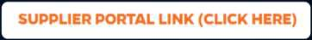
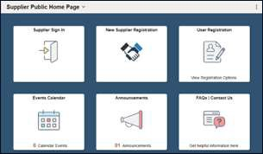

Supplier Portal
- New Supplier Registration
- Existing Suppliers
  - User Registration
  - Supplier Sign In for review of supplier information and submission of change requests

www.fa.ufl.edu/directives/supplier-portal/
14

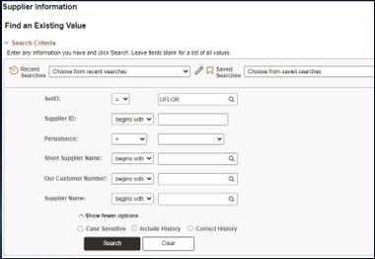

Looking for a Supplier

Using “Supplier Name”
- Search for supplier’s name
15

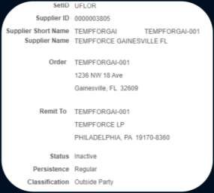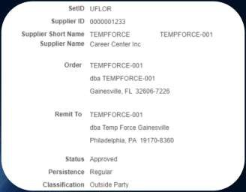

Supplier Status
16

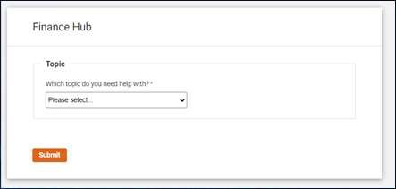
Wireless Device Allowance (WDA)
- Submit a ticket on the Finance Hub website https://uf.tfaforms.net/f/Finance-Hub

- Provide the name of the employee and the UFID that needs to be added for WDA.
17

Invoice Processing
Alisha Har go n
18

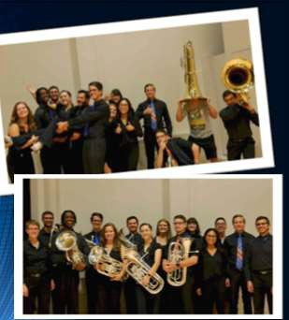

Scenario #1
- You work in the College of the Arts School of Music (Dept ID 13030100) and you purchased (3) new tubas for the Tuba/Euphonium Studio. The tubas (model King 2341) cost
$5,434.92 each and were ordered through Hoggtowne Music Inc. from myUFMarketplace.
- The invoice is in your folder on the Accounts Payable home page in the Marketplace. Since the asset has been received, you are ready to approve the invoice. The tubas, along with the packing slip, were received on 9/26/2023.
- Assistant Professor Dr. VanTuinen will be responsible for the tubas located at the College of the Arts Music Building Room 101. The serial number is 1122334455.
19

Scenario #1
KEY POINTS: Capital asset vs Capital tangible property?
- Long-term property that UF owns/uses in fulfilling its mission that is not expected to be “consumed” within (1) year of acquisition. This means it is not expected to be used-up within one year.
- Capital tangible property (like the tubas) is property that:
  - Can be physically relocated
  - Costs a minimum of $5,000
  - Has a useful life longer than 1 year
20

Scenario #1
KEY POINT: Why are Purchase Orders required for capital assets?
- Encumber funds before the purchase
- Ensure the purchase is approved prior to being completed

KEY POINT: Why is it important to link to the PO?
- Matches the payment with the encumbrance
- Releases the amount of the encumbrance upon Budget Checking
21

Scenario #1
Click the Voucher number to open the invoice

Click the Assign button to work the invoice
22

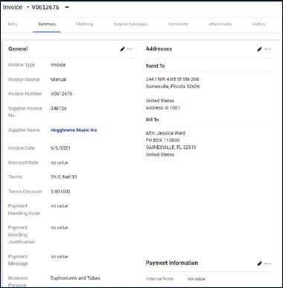
Scenario #1

You can work on the
ENTRY tab or the
SUMMARY tab
23

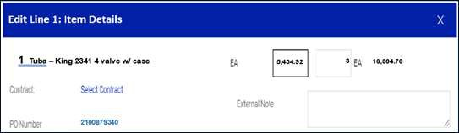
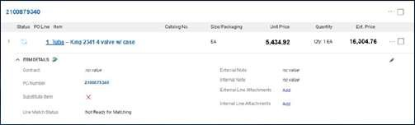
Scenario #1
ENTRY
SUMMARY
24

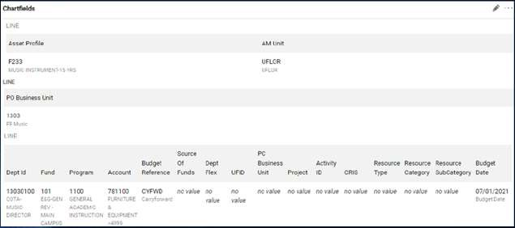
Scenario #1
Capital asset is identified under Asset Profile
25

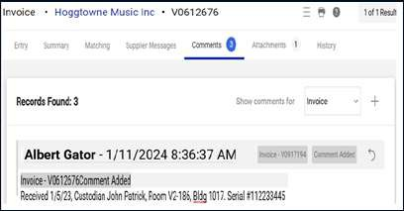
Scenario #1
Attach either a signed packing slip or signed delivery document along with entering the following information into the comment section.
Information needed:
- Received date
- Location
- Manufacturer & model
- Serial number
- Individual responsible for the Asset (Custodian)
26

Scenario #1

Click Finalize Step to approve the invoice. It will flow to the Secondary Approver in Asset Management.
27



Scenario #2
You are the office manager for the Chemistry Department. The professors in your
department have requested additional materials (lab coats, beakers, etc.).
You contact a new local laboratory supply company in Gainesville to purchase these requested items. The total cost is $523.
Using this scenario, answer the following questions.
28



Scenario #2
- What is the first thing you need to check?
- How will your department pay for the goods or service?
29

Payments
Gab riella Cromwell
30

Basic Payment Information
- Payments are processed on Tuesdays and Thursdays for both suppliers and Travel and Expense reimbursements.
- Scheduled pay dates are based on the invoice date and the payment terms for each supplier. If the invoice is past due, it will automatically get picked up in the next pay cycle.
- UF is committed to reducing paper checks and to pay all invoices electronically. There are very few reasons to pay by check. An example is Homeland Security.
31
nly.

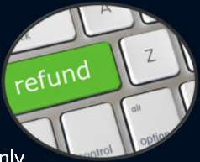

Refunds
- Create a Non-PO invoice using Supplier ID number 0000184773.
- This Supplier ID is used for refunds o
- Add a brief description of what is being refunded in the Business Purpose field.
- Add back up documentation as an attachment.
32

Alternate Delivery or Special Payment of Checks
- For alternate check handling choose the appropriate “Payment Handling Code” in the dropdown on the General tile of the Buyer invoice tab.
- Payment Handling Justification is required for any of the special payment selections above.
- If a check needs to be picked up, enter the name and phone number of the person picking up the check in this field.
**Example next slide.
33

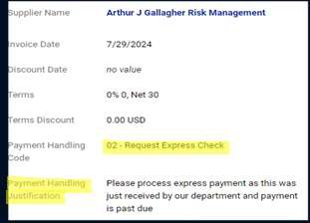
Alternate Delivery or Special Payment of Checks
34
en

USD and Foreign bank wires

- Foreign Bank wires and 3rd party banks require a filled bank wire form for every invoice. The bank wire form should be attached to the invoice and special paym t handling code -06 should be selected.
- From here the invoice will be routed to a special handling que and placed on hold so the department can email BMS directly. The hold is to prevent the payment from paying on pay cycle.
- For USD wires, the only time a bank wire form is required is if the supplier is new and being set up, or there is a change in account information.
35

View Payment Status
- Payments to a supplier can be viewed in Peoplesoft by navigating to:
Main Menu > Financials > Accounts Payable > Review Accounts Payable Info > Payments > Payment
  - You can search for a specific payment by payment number, supplier or amount.
36

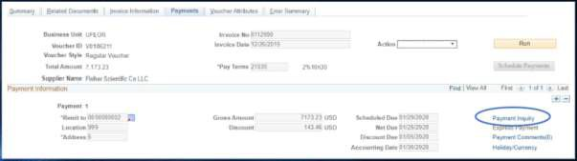

View Payment Status
Main Menu > Financials > Accounts Payable > Vouchers > Add/Update > Regular Entry
- You can search by the voucher number. Go to the Payments tab. By the Scheduled due date there is a link to the Payment info:
37

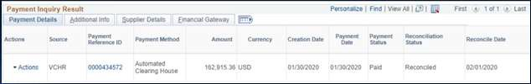

View Payment Status

You will then click the payment reference ID link
38

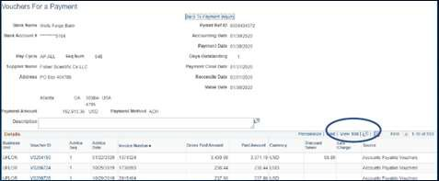

View Payment Status
This will list all vouchers paid on the payment reference. Be sure to click “view 100” to see more vouchers if there are more than 10vouchers on the payment.
39

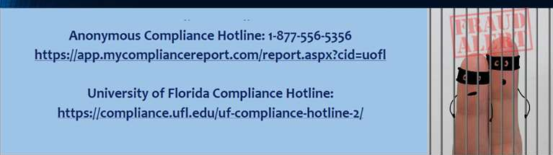
Reporting Fraud
- If you are not sure if fraud is happening, talk to someone in Finance & Accounting, a trusted advisor, a supervisor, or someone you trust.
- To report fraud, abuse, or actions of concern:
40





Questions?
41


Contact Us
Website https://www.fa.ufl.edu/departments/disbursements/ Ticket System https://uf.tfaforms.net/f/Finance-Hub
MyUFMP Helpdesk (352) 392-1335
Supplier (352) 294-1125
Invoice (352) 294-1119
Payments (352) 294-1116

For more resources, tips and instructions you can go to:
https://learn-and-grow.hr.ufl.edu/toolkits-resource-center/financial-toolkits/myuf-marketplace
42

