2022

University of Florida Space Inventory and Allocation System
(SPIN) User Manual

Department of Cost Analysis Po Box 115350
114 Elmore Hall, Radio Road 352-392-5778

Table of Contents

Introduction 4
Purpose 4
Meeting Established Deadlines 5
Gathering and Preparing Space Information 5
Step One 5
Step Two 5
Examples 5
If a Room Has no Occupants 6
If a Room is Used for Only One Purpose 6
If a Room is used from More Than One Purpose (Joint Use) 6
If a Room Has Been Vacant or Under Renovation 7
Accessing the Space Inventory & Allocation System 7
Online Security Request 7
Required Authority Area 7
The Main Menu of the SPIN System 8
View Selections 8
Data 8
Data Employees 9
Data Projects 11
Data Departments 12
Data Assets 12
Data Rooms 13
Search 14
Reports 15
System Status 15
Help 15
The Room List 16
Room Documentation 18
Room Information 18
Update Room Info 19
Occupancy Verification 21
Adding Occupants 21
Moving Occupants 24
Copying Occupants 25
Removing Occupants 26
Deleting Occupants 27
Editing Occupants 28
Verifying Occupants 28
Removing All Terminated Employees 29
Project Verification 30
Adding Projects 31
Moving Projects 32
Copying Projects 33
Removing Projects 34
Deleting Projects 35
Editing Projects 35
Verifying Projects 36
Rooms Designated as 1-99% Organized Research Usage 36
Space Allocation 38
Entering/Submitting Space Information 38
Space Allocation Category Definitions 39
Administration Categories 39
Department Administration (DA) 39
General Administration (GA) 40
Practice Plan Administration (PPA) 41
Sponsored Project Administration (SPA) 41
Student Administration (STU) 41
Instruction 41
Research/Other Sponsored Activities Categories 42
Departmental Research (DR) 42
Organized Research (OR) 42
Other Sponsored Activities (OSA) 43
Vacant Categories 43
Vacant 43
Under Renovation 44
Other Categories 44
Agriculture Extension (Ag Ext) 44
Auxiliary (AUX) 44
Recharge Centers (RC) 44
Other Institutional Activities (OIA) 45
Governance (GOV) 45
Library (Lib) 45
Operations and Maintenance (O&M) 46
Patient Care 46
Public Service (Pub Svc) 47
Union Activities (and APA) 47
Status of the SPIN System 47
Certification and Authorization 48
Where to Get Help 49

Introduction

University of Florida (UF) uses a web-based computer application called Space Inventory and Allocation System (SPIN) to annually collect information on how university buildings and rooms are being utilized. The system has been developed as a joint effort between the Division of Finance and Accounting / Department of Cost Analysis and Business and Technical Affairs (BATS).
There are two processes to reporting space: certifying and authorizing. Different individuals within the department must complete each of these processes. The Department of Cost Analysis requires that authorizers be at the Director, Department Chair, or Dean level.
The results obtained through use of the space survey can translate into millions of dollars in funding for the University of Florida. Whether you certify or authorize space for your department, you play a critical role in the University of Florida’s compliance with Federal and State guidelines, and its quest to remain competitive with other educational institutions.

Purpose

The information gathered as a result of this survey is used for many purposes.
- One objective is to assist with development of the Facilities & Administrative (FnA) Rate Proposal to the Federal government.
- Another purpose is to inventory UF space and internally track and monitor how well the University’s space is being used.
- Finally, data gathered as part of this allocation is also used as a part of the development of the UF budgeting model. Facility overhead will only be allocated to academic units.

Meeting Established Deadlines

The University of Florida is committed to completing its space allocation survey every fiscal year to obtain information necessary for required reporting to the State and for use by the Office of the Chief Financial Officer for the RCM budget process. In addition, completing the space survey every year assists in maintaining the knowledge of staff completing this task.

Deadlines are established and communicated for the completion of the space survey which are important for meeting these objectives. Therefore, if a department is noncompliant in meeting these deadlines, all their space will be reported with a use code of “Research Lab” to the Office of the CFO for RCM budgeting purposes, thus resulting in the highest RCM assessment available.

Gathering and Preparing Space Information

Step One
Before information is entered into the web-based system, it is necessary to become familiar with the space allocation categories. See Space Allocation Survey Category Descriptions for a complete description of each category. Please remember that allocation collection should be well-documented, include methodology used to determine room allocations.

Step Two
Interview the room occupants. A feature of the Space Inventory and Allocation Survey is the ability for each department to export to Excel or PDF Room Worksheets of all the buildings and rooms for which they are responsible. This data can be used as a tool to interview the occupants and to determine how the space has been utilized. All documented information should be maintained in the department to describe how space was collected by the department in case the department is selected for audit.

Examples
When preparing to allocate (spread) the use of space the question is, “Over the entire fiscal year (July 1st to June 30th), how was this space used?” The person responsible for reporting should interview the occupant(s) of a room or a responsible individual (Principle Investigator, Lab Manager, etc.) to determine all uses of the room during the fiscal year.

It is important to understand the differences and relationships between effort reporting and space allocation reporting. Effort reporting measures how an individual’s time was used during a specific period. However, when a space administrator interviews occupants of a room, he or she is asking what activities were performed in that space. There is usually a correlation between effort and space reporting, but not necessarily a one-to-one relationship. For example:
A professor reported his/her effort for all three semesters of a year as 60% Organized Research, 30% Instruction (including advisement), and 10% Department Administration. This represents the time spent on these activities by the professor. Two rooms are assigned to this professor: an office and a laboratory. After the space administrator interviews the professor, the following is clear:
Teaching is performed in classrooms that are allocated in a separate department as instruction. The professor’s lab is used 20 hours a week, entirely for organized research. It is therefore allocated as 100% Organized Research in the Space Inventory and Allocation system. The professor’s office is used approximately 15 hours a week and is estimated by the professor to be used 70% for Instruction, 10% for Organized Research, and 20% for Department Administration. The office is allocated similarly in the Space Inventory and Allocation System.

If a Room Has no Occupants
Identify the use of the room by talking with the chairperson and/or the individuals who utilize the room and allocate it accordingly.
Example: A departmental mailroom, conference room, and shared equipment room are examples of rooms that may not have assigned occupants.

If a Room is Used for Only One Purpose
Identify the room use and allocate it accordingly as 100%.
Example: A classroom lab used only for instruction that is funded by appropriations will be allocated as 100% Instruction.

If a Room is used from More Than One Purpose (Joint Use)
Estimate the percentage of time the room is used for each purpose. This should be based on interviews or other documentation. Avoid simply splitting the room 50%-50% or 33%-33%-34%, unless this is an accurate representation of how the room was used.
Example: If a lab is used for departmental research and organized research, it would be a joint-use room. A faculty member might use his or her office for work related to instruction, departmental administration, and clinical practice. These are examples of a joint use room, and the room should be allocated according to the percentage of each activity performed in the room during the entire fiscal year.

If a Room Has Been Vacant or Under Renovation
Determine the appropriate percentage of the year that the space was vacant. Normal absences for short work breaks (summer) and vacations do not mean a room is vacant. Also, if the classroom or lab is only used once a week the room is still not listed as vacant, and the use of the room would remain 100% Instruction or other correct allocation category.
Example: A room that was vacant (empty and unused) for 3 months of the year would be allocated as 25% vacant /renovated and the remaining 75% would be spread under the appropriate categories reflecting how the room was used during the rest of that fiscal year.
As a reminder, the question that must be answered for each space in your survey is, “Over the entire fiscal year, how was this space used?”

Accessing the Space Inventory & Allocation System

Online Security Request
To access the Space Inventory and Allocation System (SPIN), you will need to have your Department’s Security Administrator (DSA) create a security request through myUFL. The DSA will need to enter your UFID, your eight-digit Department ID in the Authority Area, and only one of the following roles:
UF_N_IND_COST_SP_ALLOC_BROWSE (a “view only” role) UF_N_IND_COST_SP_ALLOC_CERTIFY UF_N_IND_COST_SP_ALLOC_AUTH. (DDD’s Only)

Required Authority Area
When requesting any space allocation role, please remind your DSA to include the eight-digit DeptID(s) you will be reporting in the Authority Area of the request. If the field is not initially updatable, the DSA must select the Save button to activate the field for input.
Examples:
Þ 29000000 = provides access to all DeptIDs beginning with “29”
Þ 29010000 = provides access to all DeptIDs with “2901”
Þ 29010000,29020000,29030000 = access to all DeptIDs beginning with 2901, 2902, 2903 (Note the required comma between each department ID and at the end, with no spaces in between.)

The Main Menu of the SPIN System
Once you have obtained the security role to access the Space Inventory & Allocation System, you will log in using your Gatorlink ID and password. The first screen to appear is the Main Menu.

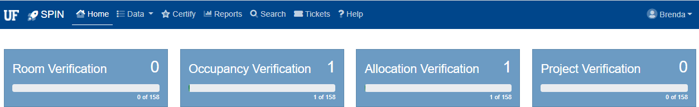

View Selections
Users can view the space by the room list from the main screen the room they would like to edit
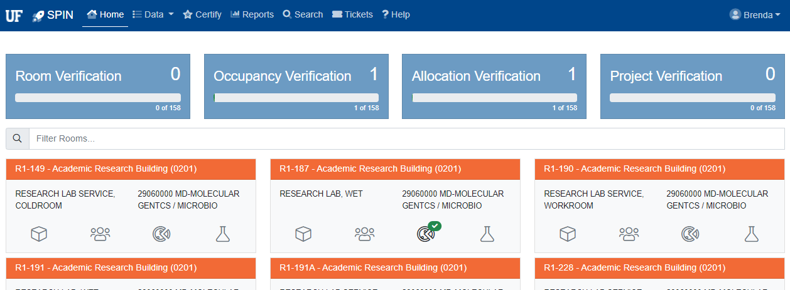

Displays all buildings and rooms within that department ID for the user to review and enter

Data
The Data selection of the main menu gives the user access to
- My Employees: This is a list of all employees within the specific department that the user has access to.
- My Projects: This is a list of all sponsored projects within the specific department that the department is responsible for assigning to a specific room in the space system.
- My Departments: This is a list of all departments a space certifier or authorizer has access to.

- My Rooms: This is a full list of rooms that a user has access to and responsible for allocating and updating.

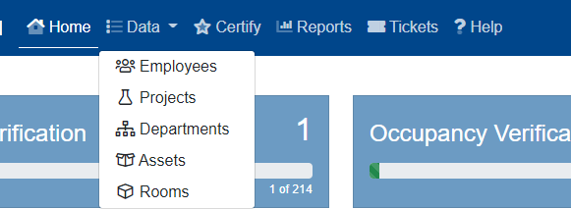

Data Employees
The data employees section of SPIN lists all staff associated with the department the user has security to.
From this screen employees can be added and removed.
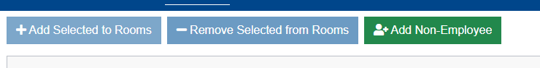

To add or remove from selected rooms, click on the checkbox by the employee’s Name and then click “Add or Remove Selected to or from Rooms”. Then fill out the required information that is requested.
In addition, the department can add a Non-Employee

Adding Non-UF Users/Occupants
The purpose of adding non UF individuals as users or occupants of space is that everyone must be accounted for in the SPIN system.
For example, if there is a visiting researcher that is in the department that is using the research lab space, that individual must be accounted for.
- To add a non UF Employee, select Add Non-UF Employee

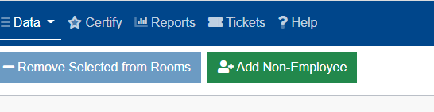
- Then a pop-up window will appear. Type in the Name and any other information that is helpful to the department for that individual:
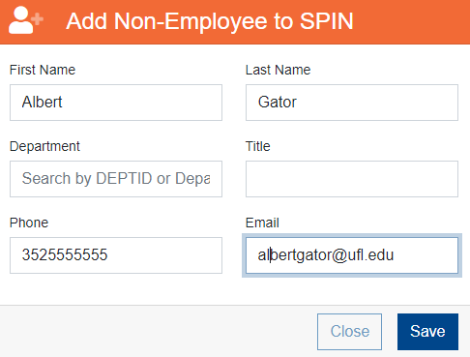
- This will add the individual in the employee’s list so that they may be added as an occupant or user of the space.

Filtering for Terminated Employees
The SPIN System allows the user to be able to filter to see terminated staff that are in rooms. From this screen these individuals can be removed without having to go into the space.

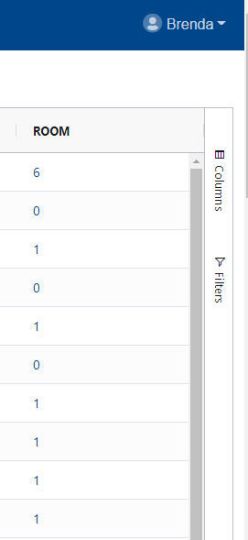

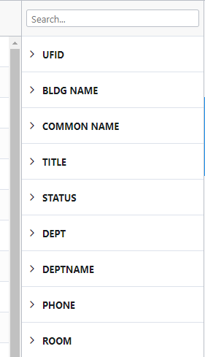

Data Projects
The projects list will display every project that the user is responsible for assigning to space. In addition, it will list the start/end date of the project and whether or not it is assigned to a room.

From this screen projects can be added and removed.
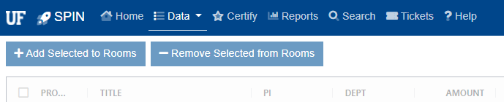

To add or remove from selected rooms, click on the checkbox by the Project Number and then click “Add or Remove Selected to or from Rooms”. Then fill out the required information that is requested.
NOTE – All projects that were active during the fiscal year must be accounted for in space. If the project was not worked on during the fiscal year, you must contact Cost Analysis to request an exemption from space at spacealloc@admin.ufl.edu

Data Departments
The data departments area lists all the departments that the user has access to, their status, how many rooms they are responsible for and what percent of completion they currently are:
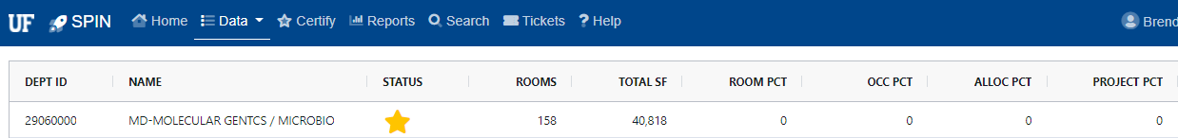

Data Assets
The area of this screen lists all the assets the department is responsible for.
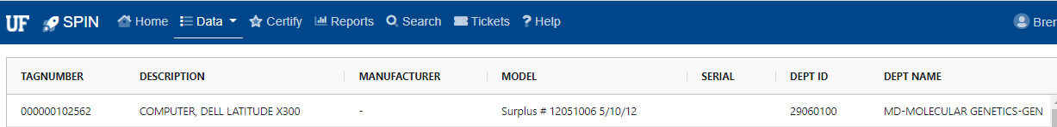

Data Rooms
The area of the data menu that allows the user to see all rooms that they have access to in one scrolling fashion instead of selecting one at a time.
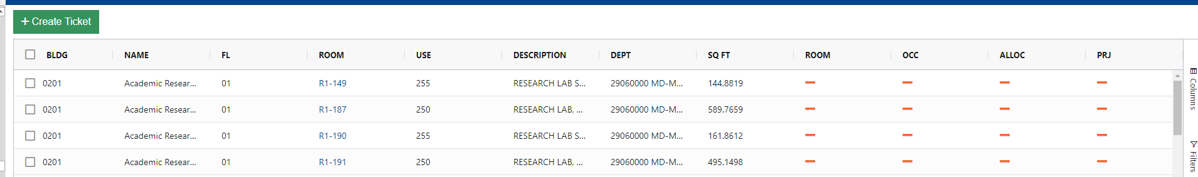

In addition, any room updates can be completed from this screen:
- Room Verification
- Occupants
- Projects
- Allocations
By clicking on the orange bars that is listed in the room.
Creating a Ticket for Multiple Rooms At Once
In addition, a ticket can be created for more than one room instead of created a ticket for each individual room.
This can be accomplished by checking the box next to the rooms that the request for update needs to be completed for and then selecting the “Create Ticket” option:
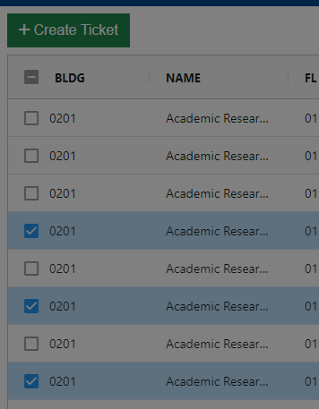

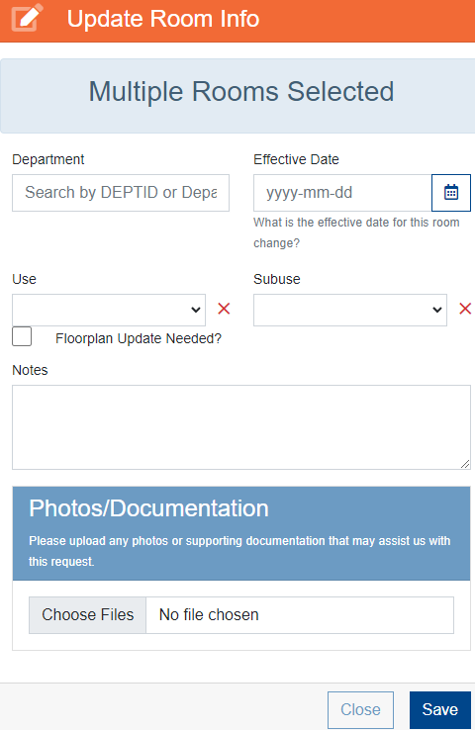

Search
This menu option gives the user the ability to search space for specific criteria. A user can select to search “My Space” or the Entire University by selecting “Search All Space”.

Can search for a specific location, occupant or project to determine who may own specific space, where an occupant may be identified or a project ID.
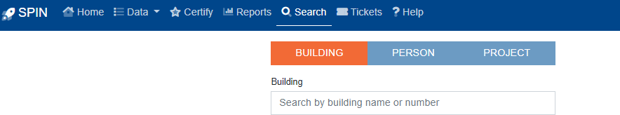

Reports
The reports area allows the user to have access to many reporting needs of the space system for their respective areas. There are status and historic reports for space reporting and supporting documentation including lists that can assist with the space allocation process.
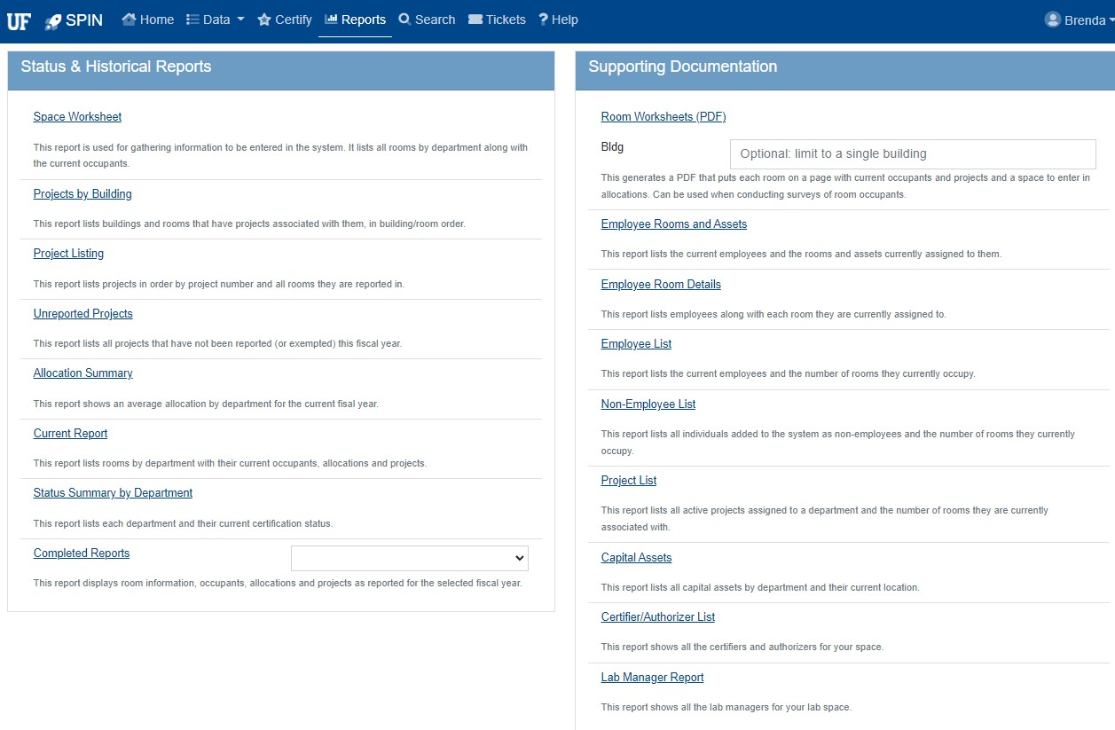

System Status
The status of the system will display on the main menu. When a survey is not in process, the system will be open only for occupancy edits and space change requests.

Help
The help menu selections gives the user the ability to be able to receive assistance related to questions of the space system. There is also the User Manual along with a list of Room Use Codes Definitions, a link to the floor plans in UF STARS, updated presentations for the space system and Allocation Definitions for your convenience.

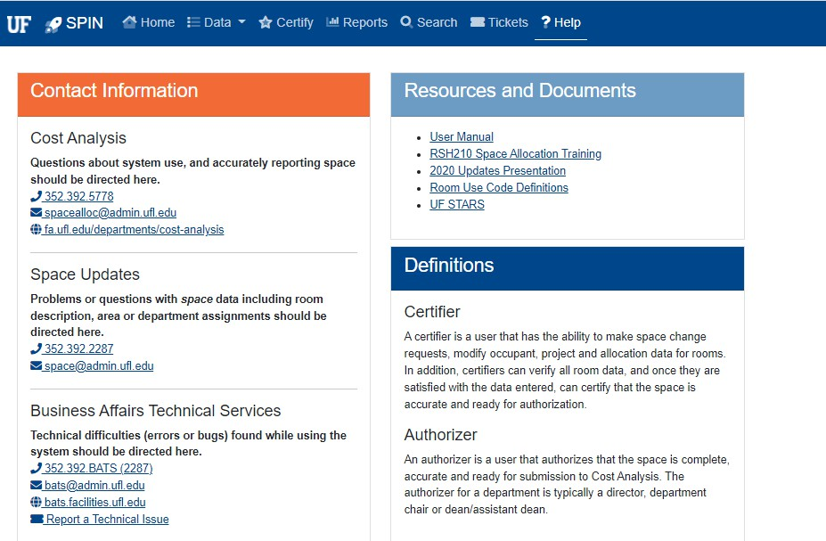

The Room List
On the Home Screen the following information will display your list of rooms:
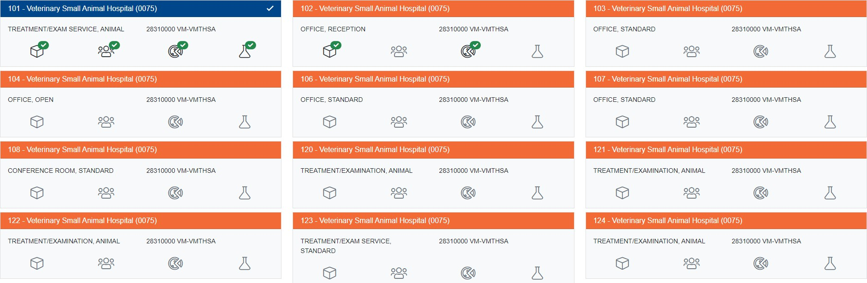

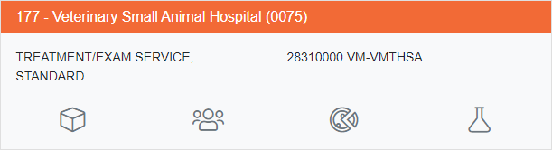
The room list will display all rooms and all buildings that you are responsible for. The list contains building, room and status of each allocation category.
Room
Verification
Occupants
Verification
Allocation
Projects

For each section of the room, it will place a checkmark by the areas that have been completed.
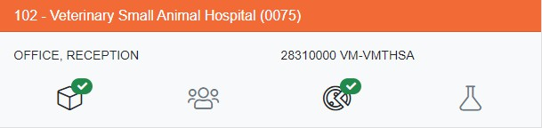

When the entire room is completed, the entire box for that room will change from orange to blue:

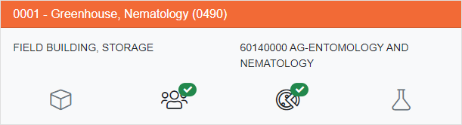

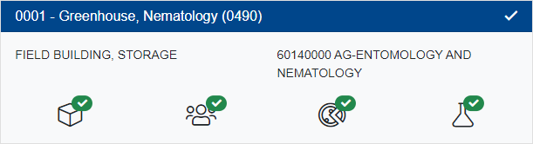

Room Documentation
From the Room List, select a row to view the detail screen for the room. This will include the occupants, projects, and allocation percentages of the room. Review the information on this screen for accuracy.
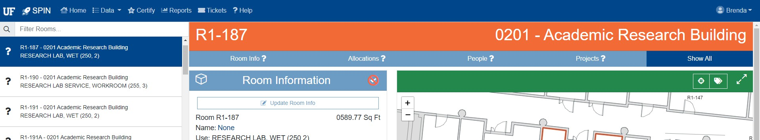

Room Information
The user will need to review the room information to verify:
- Is this still a room that was utilized for the fiscal year in the correct department ID?
- Has the room number changed due to renovations?
- Has the use of the room changed?

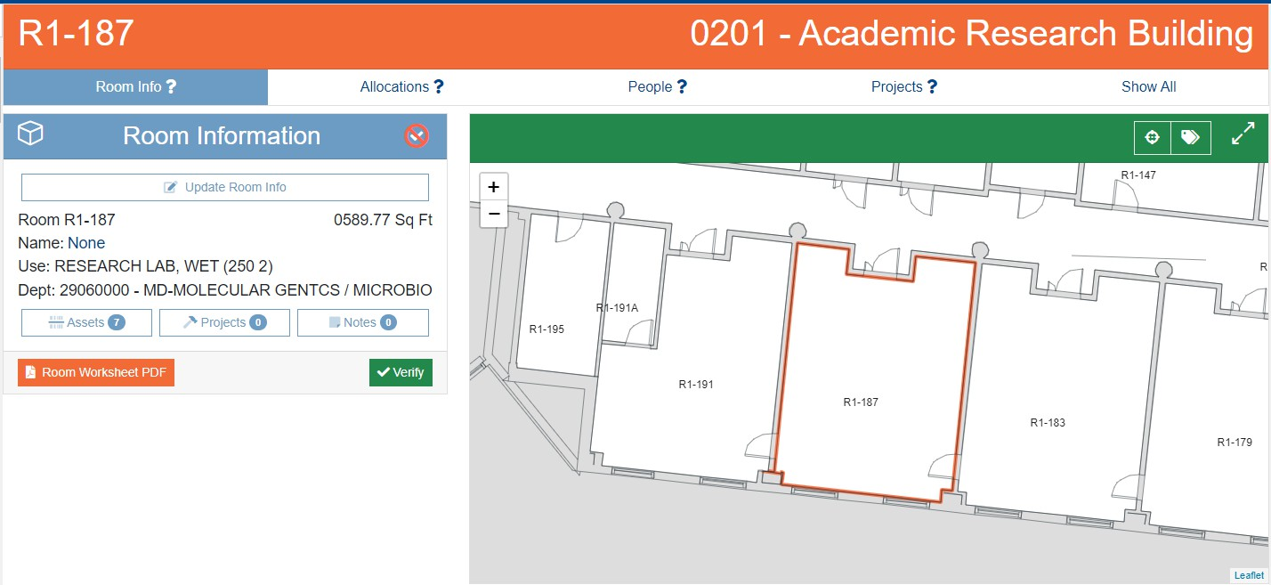

If there are no errors, simply click on the Verify button to show that the room has been verified for accuracy.
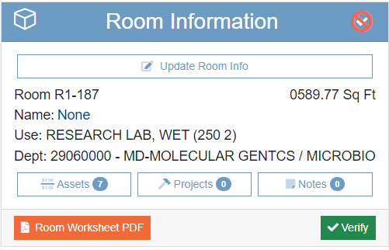

Update Room Info

If any errors based on these questions in the room utilization are present, click the update room Info to correct the information.

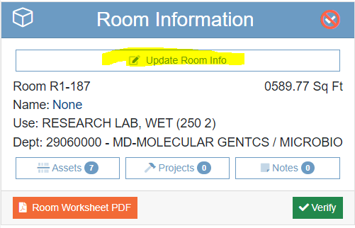

Here you can:
  - Change the department ID
    - Dept: If the room was given to another area within the fiscal year that is being reported, delete the department ID and if you know the other department that is receiving the data, type it in the comments area of the update room request. In addition, you must allocate the portion of the space that your area used before transferring ownership.
  - Change the Use and/or subuse of the room
    - Use: If the use is what is being updated, you will need to select the drop-down arrows for the primary use AND the sub use of the space.
  - Indicate that a floorplan update is needed
    - If this is the case notes are expected to comment on the change
    - Include as detailed a description as possible, what changed and how, any relevant room numbers, PDC project numbers and Project Manager, dates renovation occurred
      - E.G. Room 0360 was renovated in November. It was converted from a conference room into 2 offices (0360 and 0361). Albert Gator was the PM, project # MP02345.
    - Include any attachments to indicate what changed. Update floorplans, photos, handwritten markups on existing STARS plans can all be helpful.
  - You must indicate the Effective Date (MM-DD-YYYY) of the change, or the system will not allow you to save any updates.
  - Notes - this is very important to provide any information related to the change; why the use changed, or what new department may be.
  - Once done, click save and the system will automatically send a ticket to the space change system for you.

Occupancy Verification
At the start of each survey period, all rooms in the Room List screen will be marked as needing occupancy verification. During non-survey periods, occupant changes will still be permitted, however, you can not verify the occupants since the actual survey is not officially open.
The Occupants screen will show all occupants that were reported in the prior year’s Space Inventory and Allocation Survey.
Occupant information including title come from HR Job Data. If any of this information is incorrect, contact your department’s HR Coordinator to ask about a correction.
Note - if you see an occupant whose name in in red, it means that the occupant no longer has an active job appointment with the University.
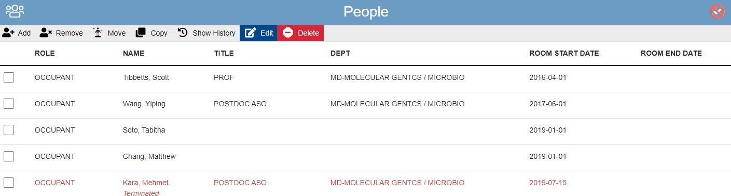
Review the occupants who are reported in the room to make changes for the fiscal year of the reporting period.

Adding Occupants
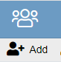
- To add a new occupant, select ADD.

- This will pop up a new window of informaiton required.

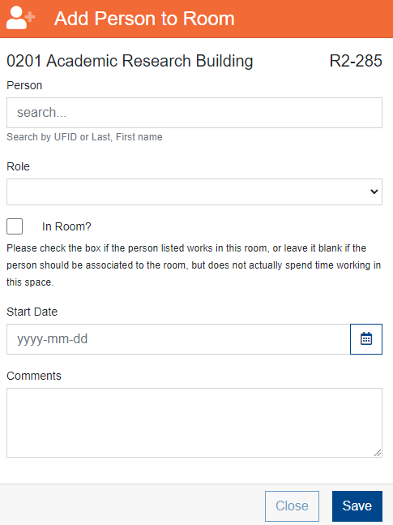
- Enter the Person by searching for the name or UFID. You can search for an occupant using their UF ID, Gatorlink or Last Name. The results are displayed. Use the navigation tools to scroll through the search results until you find the name you are looking for. You will have to add the start date as to the date the individual began occupying the space.
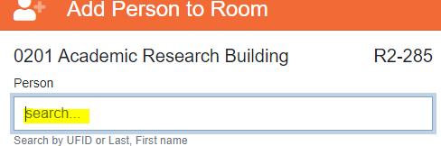

- Then select what role the person is in for the space:

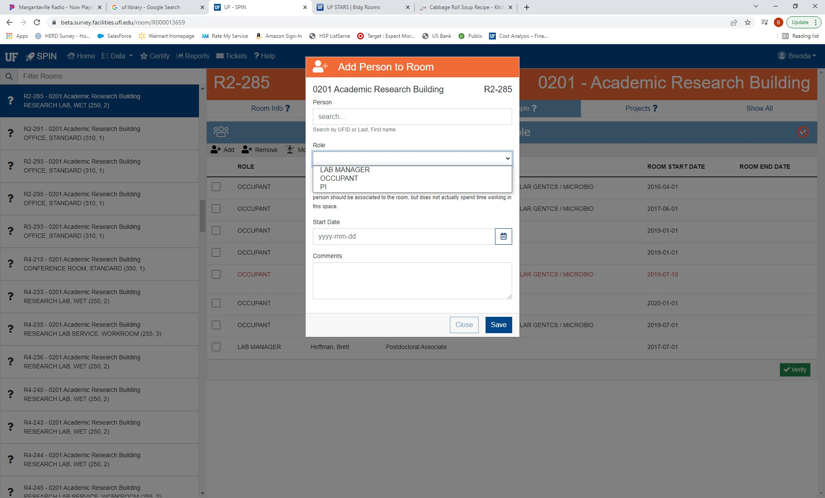

  - Occupant = a direct user of the space
  - PI = PI responsible for the space even though they may not be sitting in the space
    - Review the check box for “In Room?” that means they are responsible but does not actually spend time in the space.
  - Lab Manager = not in the space but responsible for the maintenance of it
    - Review the check box for “In Room?” that means they are responsible but does not actually spend time in the space.
  - Enter Start date that the person began using the space.

- Make sure to enter the date that the occupant started residing in the space .
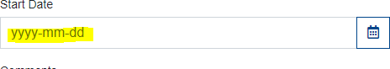
- Then click save.

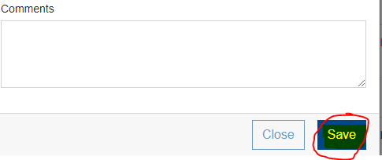
- This will add the user to your occupant list.

Moving Occupants
Occupants can be moved from one room to another - without being removed and added again - by using the “MOVE” function. This will remove the occupant from the current room and move them to a new room.

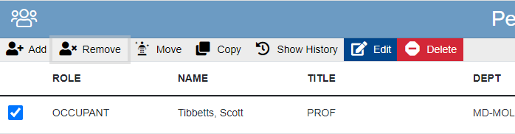
1. Select Occupants
2. Click on the “Move”
Button

A Pop Up Screen will give you the options of where to move the person to. You must type the building name or number, then select all the rooms to move the person to. You must enter the start date that the person started using the space before the system will allow you to select move the occupant.

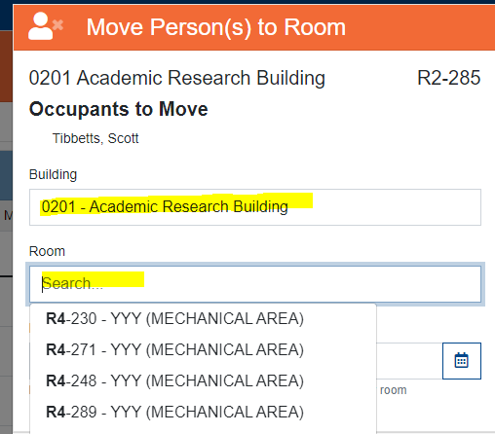

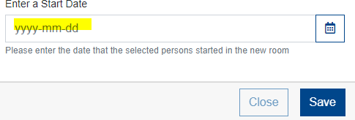

Copying Occupants
Occupants can be copied from one room to another by using the “COPY” function. This is especially useful in instances where a professor and research assistants occupy both an office and one or more laboratories. This function will copy selected occupants of the room to other rooms. In the copy function, you can select more than one room by holding the Shift OR control key down if not in a series.

In addition, you must enter the start date that the person started using the space before the system will allow you to select move the occupant. However, you also have the option

to copy the start date from the room you are working on to the new areas you are copying the user to by selecting the “OR…” checkbox.

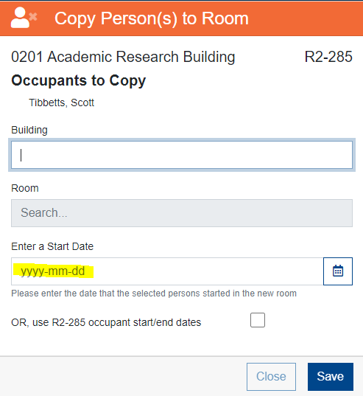

Removing Occupants
An occupant should be removed, if no longer using the space within the fiscal year of allocations.
To remove an occupant, select the occupants you wish to remove and click on the Remove button.
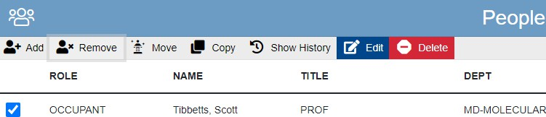
2. Click on the
“Remove” Button
1. Select Occupants

A Pop-Up window will appear to enter the date the user no longer used the space. You will also have the ability to remove the occupant from all your space at once if selected:
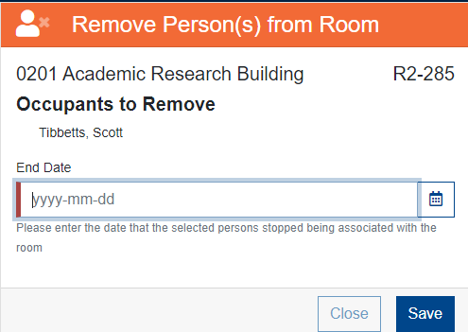
If the occupant moved out during the Fiscal Year that you are reporting, the individual will still be displayed on the screen because they worked in the room during the fiscal year.

Deleting Occupants
If the occupant shown never occupied the space and needs to be completely removed from this room, click on the “Delete”
DO NOT USE THIS BUTTON if the user did work on the space at anytime during the fiscal year. Use the remove selection if they started and then left.
In addition, you will not be able to “Delete” if the user has any history in the space. You must use the remove function.
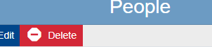

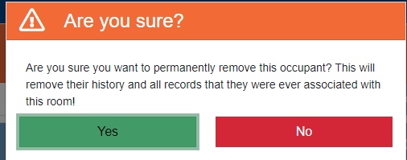

Editing Occupants
The edit occupants function allows the user to correct mistakes with room start date or room end date of the space when originally entered.
Click on the check box by the person then select edit:
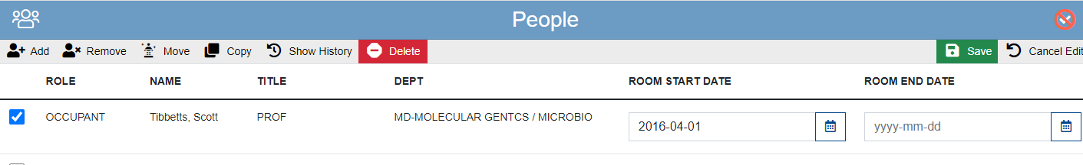
Opens up the boxes for editing purposes.

Verifying Occupants
The final step to Occupancy Verification is to click on the “VERIFY” button. Once you have verified occupants, the title will change from light blue to dark blue and the symbol will change to a white check mark.
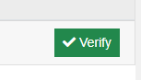

Removing All Terminated Employees
Users also have the option to have the system input the termination date in all rooms that the occupants selected are located in. This is done in the Data selection of the SPIN System.
Data > Employees
Filter for All Teminated Employees
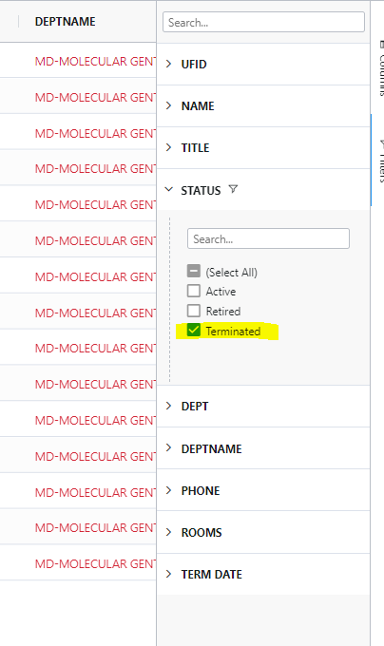
Click on the “Select All” Check Box. This will select all occupants with the “T” status. To exclude anyone from the list, simply uncheck the box.
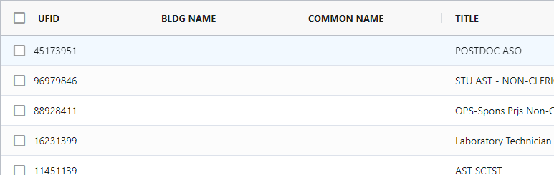

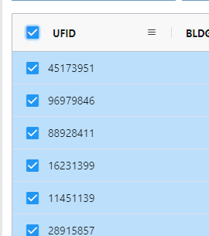

Project Verification
If the room was allocated to Organized Research (OR) or Other Sponsored Activities (OSA), the associated project numbers must be added to the room. In addition, if a room is allocated between 1-99% OR or OSA Federal requirements dictate that you not only designate the sponsored research projects that are occurring within the room, but that you also provide the funding sources (chartfield string) supporting the non-sponsored activities occurring in the room.
Both projects and chartfields entered in the previous fiscal year will be shown in the Room Information screen. If a project was not worked on in this space for any part of the current fiscal year, the project should be removed with an end date of June 30, 2021 or earlier.
Projects that ended within the fiscal year of the survey must still be accounted for.

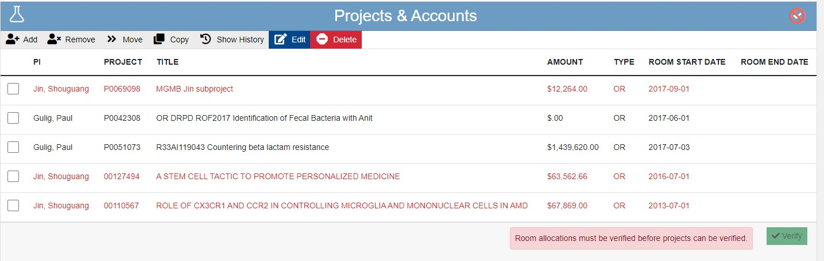
Projects that have expired will show in red to make you aware that they may need to be removed from the room.
Indicates the date that activity on
the project was stopped in this space. Does not necessarily indicate the project’s end date.
The box will not allow you to verify if there are
errors that need to be resolved. For example, if you did not allocate Organized Research to the room in the allocation, the system will tell you that in order to have a OR project in the room, you must have an allocation to OR.
In addition, projects that the purpose is for instruction are not required to be entered into the project space. Any activity related to these projects should be allocated to the instruction category.

Adding Projects
To add a project, select the “ADD” button. The user can search for a project using the project number, PI UF ID, or a title keyword. Active projects within the past two fiscal years will display.
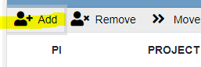

Search for the Project by entering the numbers or name and click on the “Search” icon:

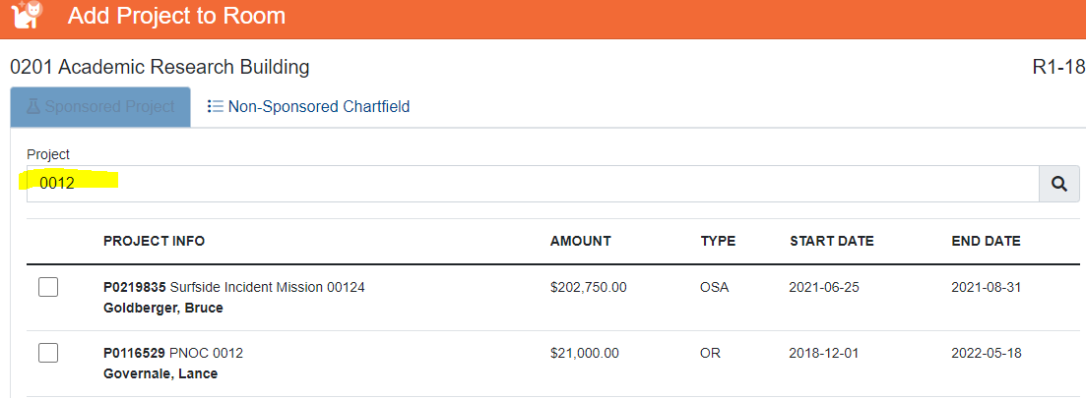

Check the box next to the project you wish to add and make sure to enter a start date the work began in the space (not necessarily the project begin date). The click Save button:
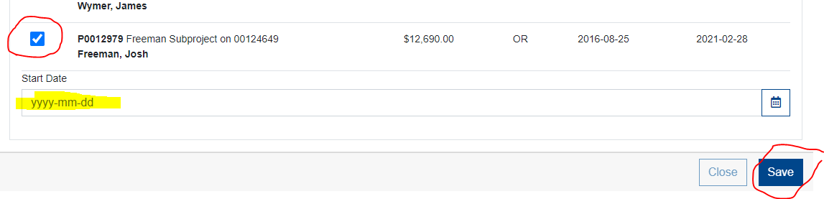

Moving Projects
Projects, just like occupants, can be moved from one room to another - without being removed and added again - by using the “MOVE” function. This will remove the project from the current room and move it to a new room.
Select the project number that you wish to move to a different room by checking the box by the project number. Then select the three dashes to see the “move” function.

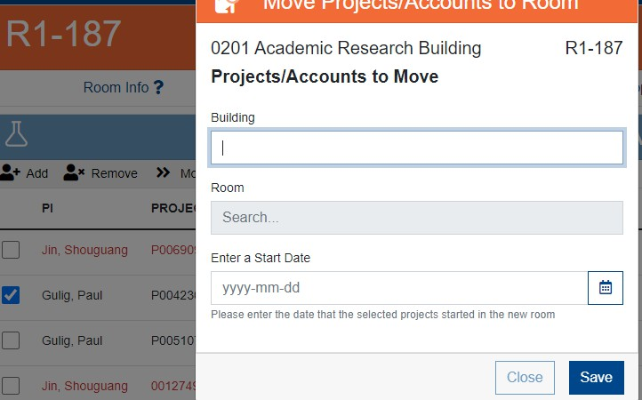

Copying Projects
Projects can be copied from one room to another by using the “COPY” function. This is especially useful in instances where work is being done on a project in more than one location. This function will copy selected projects in the room to a new room.
Select the project number that you wish to move to a different room by checking the box by the project number. Then select the copy button:
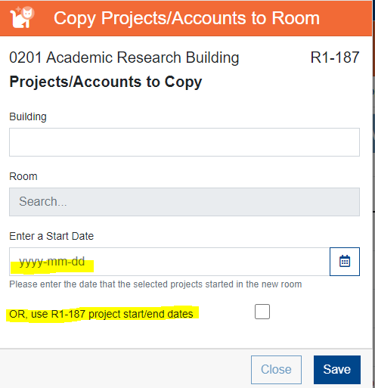

In addition, you must enter the start date that the project started in the space before the system will allow you to select copy the occupant. However, you also have the option to copy the start date from the room you are working on to the new areas you are copying the user to by selecting the “OR…” checkbox.

Removing Projects
To remove a project, select the project that needs to be removed and click on the “REMOVE” button. If the project listed was never worked on in the space and needs to be removed from the system entirely, enter the same end date as the beginning date.

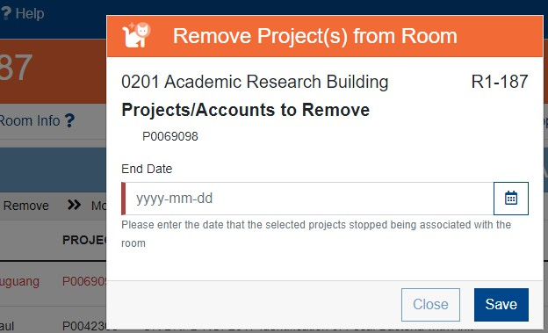

If the project completed work during the Fiscal Year that you are reporting, the project number will still be displayed on the screen because it was conducted in the room during the fiscal year. If the project was not worked on during the FY that you are reporting, the user can change the end date to the end of the previous fiscal year.

Deleting Projects
If the project shown work was never done in the room and needs to be completely removed from this room, click on the “Delete” button.
DO NOT USE THIS BUTTON if the project did have some type of activity on the space at any time during the fiscal year. Use the remove selection if it started and then expired.
In addition, you will not be able to “Delete” if the project has any history in the space. You must use the remove function.
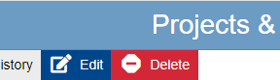

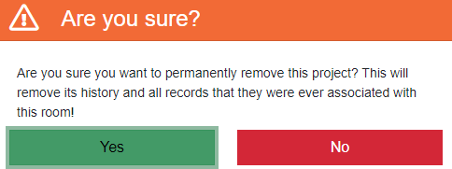

Editing Projects
The edit projects function allows the user to correct mistakes with project room start date or room end date of the space when originally entered.
Click on the check box by the person then select edit:
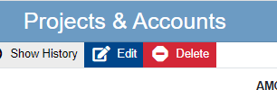

Opens the boxes for editing purposes.

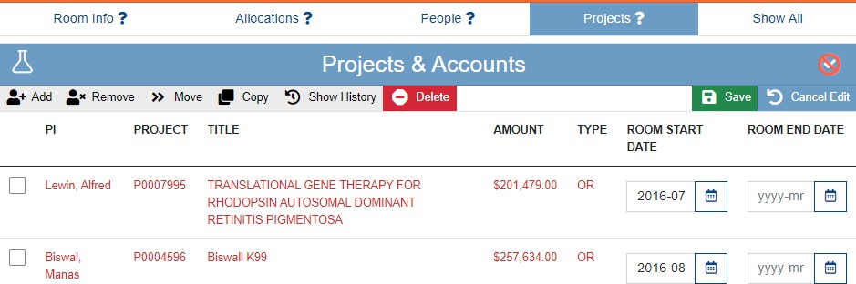

Verifying Projects
The final step to Project Verification is to click on the “VERIFY” button. Once you have verified occupants, the title will change from light blue to dark blue and the symbol will change to a white check mark.

Rooms Designated as 1-99% Organized Research Usage
If the room is partially allocated to Organized Research, Federal requirements dictate that you not only designate the sponsored research projects that are occurring within the room, but that you also provide the funding sources (chartfield string) supporting the non-sponsored activities occurring in the room.

Adding Non-Sponsored Sources
Once the sponsored projects have been added to a room that is allocated to Organized Research, you must select the non-sponsored funding sources supporting the other allocations in that room. To do this, from the Sponsored Projects & Non-Sponsored Chartfields Section click ADD and select “Non-Sponsored Chartfield”.
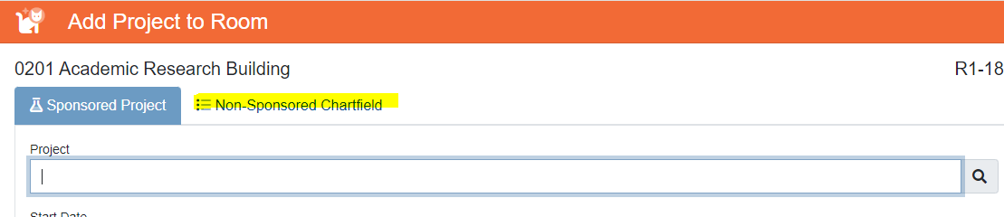
You can search by:
- Department ID
- Fund Number
- Program Code
- Source of Funds
- Project ID
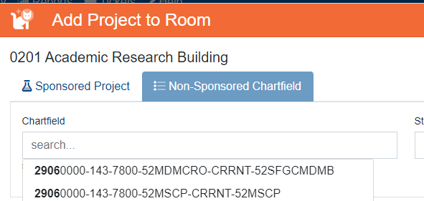
Once you are able to locate the right chartfield select it and click Add.

Note: The Non-Sponsored Chartfield string is NOT required if there is no organized research or other sponsored activities in the space. The system will not allow verification if this is listed and there are not allocations to these space allocation categories.

Adding Non-Sponsored Sources when no MyUFL Chartfield Exists to Support the Space
In the drop-down box, there are special selections that can be made to document the non-sponsored allocation(s) when MyUFL ChartFields are not applicable.

Use these selections to report the non-sponsored portion of a room that has been partially allocated to Organized Research:
Not UF: This can include laboratories and other research space used by students, visiting researchers, Emeritus faculty, and volunteers who are not paid by UF.
GA Grant: Students who are paid by the grant being conducted in the room AND have a desk in the room at which they can work on their own dissertation or other course work.
Vacant: This can be used if the room has some portion allocated to Organized Research and Vacant/Under Renovation for the fiscal year.

Space Allocation
Space Allocation is the development of how the space was used during an entire fiscal year of data. Using 100% to total for the usage of the entire year.

Entering/Submitting Space Information
Each room you are required to enter will be listed. During non-survey periods the Space Allocation will not be available for input. Click on room that you are ready to allocate the space.
The certifier must allocate the room to one or more of the subsequent categories for a total of 100%. If the total does not equal 100%, an error message will be displayed.

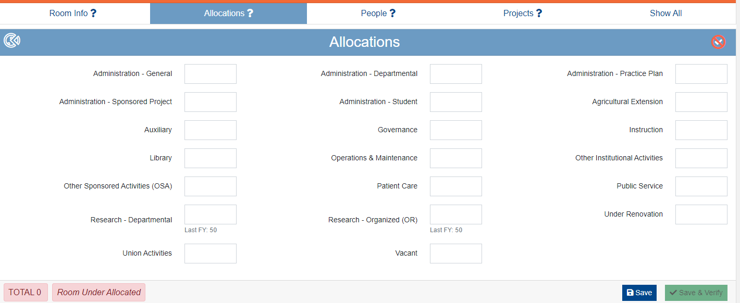

Space Allocation Category Definitions
During the space survey it is important that the right allocation of category of the space usage is chosen.

Administration Categories
These categories are for the administration areas of the university.

Department Administration (DA)
Use this category to report space used for administrative and supporting services that benefit common or joint departmental activities or objectives in academic deans’ offices, academic departments and divisions, organized research institutes, study centers, and research centers.
Examples:

Academic deans’ offices: Space attributable to administrative functions.

Academic departments: Space attributable to the administrative work (including bid and proposal preparation for new awards by departmental staff only) or faculty (including department heads) who have administrative functions of the department or college.

Includes Space Used For:
  - General departmental office functions, including that of a chair and departmental staff, secretarial, clerical, assistants, and administrative officers.
  - Administrative functions in deans’ offices.
  - General departmental services, including mail distribution, copy rooms, and telephone service.
  - Departmental staff participation in the development of a bid and proposal for new research activities.
    - Faculty Development of a bid and proposal is considered “Departmental

Research”
  - Departmental conference room.

Does Not Include Space Used For:
  - Direct administrative effort related to a specific course. That is considered Instruction.
  - Direct administrative effort related to a specific sponsored project and funded by the sponsored project. That is considered Organized Research.
  - Space used for undergraduate or graduate coordination. That space is considered Instruction.

General Administration (GA)
Use this category to report space used for activities of the general executive and administrative offices of the University and other activities of a general character that do not relate solely to any major function of the institution: i.e., solely to Instruction, Organized Research, Other Sponsored Activities, or Auxiliary/Other Institutional Activities. This category is only for areas that benefit the entire university. CORE OFFICES ONLY

Includes Space Used For:
  - President’s and vice-presidents’ offices
  - Institution-wide financial management, business services, budget and planning, personnel management, and risk management
  - Office of the General Counsel
  - UF Enterprise Systems
  - Finance and Administration
  - Chief Financial Officer
  - Central administration of health affairs.
  - Payroll
  - Human Resources

Does Not Include Space Used For:
  - Activities within non-university-wide dean’s offices, academic departments, organized research units, or similar organizational units. That space is considered Departmental Administration.

Practice Plan Administration (PPA)
Use this category to report all space used in support of clinical practice activity, including administrative activities related to the Faculty Practice Plans.
Includes Space Used For:
  - Administrative and support services for the billing, collection, and distribution of professional fees.
  - Faculty effort related to scheduling, reviewing patient charts, or other administrative activities related to clinical practice.
  - Administrative support to faculty for any activity related to clinical practice.

Does Not Include Space Used For:
  - Actual health care delivery and/or treatment. This is considered Patient Care.

Sponsored Project Administration (SPA)
Sponsored Project Administration includes space used for all activities performed by Cost Analysis, Contracts and Grants, Division of Sponsored Programs, and Office of Clinical Research. These organizations are designated primarily to administer sponsored projects. This category is only for areas that are fully supported to administer sponsored program activities.

Student Administration (STU)
Space used for activities for the administration of student affairs and for services to students. Includes: Offices of Deans of Students, Admissions, Registrar, counselors, as well as student health and the infirmary. This category is only for areas that benefit the entire university. CORE OFFICES ONLY

Instruction
Use this category to report space used for all teaching, training, and instructional activities, whether offered for credit toward a degree, certificate, or on a noncredit basis. Includes all activities related to teaching, such as preparation, grading, labs, and assistance to students registered in class.
Examples:

  - Syllabus production, exam preparation, textbook orders, and roster preparation.
  - Formal classroom teaching.
  - Academic counseling and advising students.
  - Course preparation.

  - Departmental libraries that are not part of the library system.
  - Sponsored Instruction Grants.

Research/Other Sponsored Activities Categories
These categories are directly related to research uses in the room.

Departmental Research (DR)
Use this category to report space used for research development and scholarly activities that are not Organized Research and, consequently, are NOT separately budgeted and accounted for.

Examples:

  - Research-related activities that are funded with unrestricted funds, such as miscellaneous donors, combined grants or allocation of overhead funds.
  - Research-related activities that fund Gap or Start-Up for faculty.
  - Development of bid and proposals for new research activities by the faculty.

Organized Research (OR)
Use this category to report space used for research and development activities of an institution that ARE separately budgeted and accounted for.
Sponsored Research. This includes all research and development space used for activities that are sponsored by federal and nonfederal agencies and external organizations. This category includes space used in the training of individuals in research techniques (commonly called "research training") where such activities utilized the same facilities as other research and development activities and where such activities are not included in the instruction function.
Examples: Outside Sponsored Research, such as federal, state, or local government; Industry; and Foundations.
Payroll and expenditures must be utilizing one of the below Funding Sources:
- 201, 209, 214
- 103 or 223 Where Program Code is for Research, Example: 2200

Cost Sharing. Even if the funding for the space is not one of the listed fund numbers, but it is being used to meet a mandatory or voluntary mandatory cost share requirement for a sponsored research award, then the space should be coded as Organized Research.

University Research. This includes all research and development space that is sponsored by institutional funds and is separately budgeted and accounted for. This type of organized research is awarded after review of an internal application for support of a specific
project. Examples: Division of Sponsored Programs (DSP) grants

Other Sponsored Activities (OSA)
Use this category to report space used for sponsored projects that are not Organized Research or Sponsored Instruction. These projects are designated by the agency as “Other Than Research.”
Payroll and expenditures must be utilizing one of the below Funding Sources:
- 201, 209, 214 - with a program code in the chart field string that does not begins with a “1” or a “2:. Example: 3200

Examples:

  - Agricultural Extension related projects
  - Sponsored Museum Exhibits
  - Sponsored Conferences
  - Sponsored Journal Editorships
  - Children’s Medical Services
  - Fund 223 with a program code of 3XXX.

Vacant Categories
The use of these categories is designating that the space was not used during specific periods. Normal absences or not using the space for a few days a week, does not mean the space was vacant in any category.

Vacant
Use this category to report space that is closed, entirely unused, or empty. Space that has been unused during part of the year should be shown at the corresponding percentage that it was vacant.
Example:
A room that was empty, due to staff leaving a position not being filled for three months would be shown as 25% Vacant on the fiscal year’s Space Allocation Survey.

NOTE: Normal absences for breaks and vacations do not mean a room is vacant. Also, a room does not have to be used a specified number of hours a week. A class lab for instruction of students that is used three days per week and unused the other two business days would still be allocated as 100% Instruction.

Under Renovation
Space that is undergoing renovations or new construction.
Space that has been vacant due to new construction or renovation during part of the year should be shown at the corresponding percentage that was under renovations.
Example:
A Room that was empty, due to renovations, for three months would be shown as 25% Under Renovation on that fiscal year’s Space Allocation Survey.

Other Categories
List of all other categories related to space reporting

Agriculture Extension (Ag Ext)
Use this category to report activities involving the Institute of Food and Agricultural Sciences’ (IFAS) Cooperative Extension Service.

Auxiliary (AUX)
Use this space to report space used for revenue generating activities that serve students, faculty, staff and the general public or other University departments.
Includes space used by:
- Residence halls, dining halls, student unions, intercollegiate athletics, bookstores, faculty housing, chapels, theaters, public museums, and other similar auxiliary enterprises.
- Space used by true auxiliary functions that are self-supporting areas, meaning not having subsidies from other funding sources to cover the costs of operations.

Do Not Use this category for space used for:
- Educational Business Activities/Service Centers/Recharge Centers/Specialized Service Facilities.

Recharge Centers (RC)
Use this space to report space used for revenue generating activities that serve students, faculty, staff and the general public or other University departments.
Includes space used by:
- Service Centers
- Generally, any space area that charges others for a service. Those services that are calculated are subsidized by other department funding sources.
  - Examples Include: Animal Care Services, McKnight Brain, UFARM, CBMI, and

other recharge activities that not only charge for services, but do not charge fully burden costs.

Do Not Use this category for space used for:
- Auxiliary areas that are state statute defined for recharge purposes. Examples include, Residence halls, dining halls, student unions, intercollegiate athletics, bookstores, faculty housing, chapels, theaters, public museums, and other similar auxiliary enterprises.

Other Institutional Activities (OIA)
Use this category to report space used for all activities of an institution that are not specifically assigned to other categories.
Includes space used by:
- Department Break rooms, Department Kitchens, Emeritus Used Space (Non-UF Paid), Volunteer Used Space (Non-UF Paid), Rare book collections, Small Department Libraries, Intercollegiate Activities, Public Relations , Development and fund-raising, Intercollegiate activities

Also includes space used for any other function, the activities of which are unallowable per Uniform Guidance 2 CFR 200.

Governance (GOV)
Use this category to report space used for any significant effort devoted to college and university-wide committee assignments.
Does not include space used for:
- Undergraduate or graduate coordinating/advising, which is considered Instruction.

Library (Lib)
Use this category to report space used for the operation of the libraries in the official university library system. Library administration should also be reported to this category.
Includes space used for:
- Storage of books and purchased material of the library.
- Reading areas.
- Study rooms.
- Library administrative room areas.

Specifically includes:

Library West, Smathers Library, Marston Science Library, Education Library, Journalism Reading Room, Music Library, Architecture and Fine Arts Library, Health Science Center Library, Borland Library (Jacksonville), Map and Imagery Library, Mead Library (P.K. Yonge), Veterinary Medicine Reading Room, and Legal Information Center.

Does not include space used for:
- Small departmental libraries that are not a part of the official university library system, which are considered Instruction.
- Rare book collections, which are reported as Auxiliary/Other Institutional Activities.

Operations and Maintenance (O&M)
Use this category to report space used for the administration, supervision, operation, maintenance, preservation and protection of the institution’s physical facilities.
Includes space used by:
- Physical Plant Division (PPD).
- Facilities Planning & Construction offices.
- Environmental Health & Safety offices.
- University Police Department.
- Campus Mail.

Patient Care
Use this category to report any and all space used for clinical practice activity, including the treatment of patients related to the Faculty Practice Plans.

Patient Care includes space used for:
- Health care delivery and treatment rooms not related to research or instruction.
- Patient care rooms (if any that are assigned to your department).

Does not include space used for:
- Administrative and support services for the billing, collection, and distribution of professional fees.
- Faculty office space when used for scheduling, reviewing patient charts or other administrative activities related to clinical practice.
- Administrative support to faculty for any activity related to clinical practice.

These are all considered Practice Plan Administration.

Public Service (Pub Svc)
Use this category to report space used for assigned duties such as serving as a consultant to local, state or national agencies; serving as an officer in professional societies; acting as an editor for a professional journal.

Union Activities (and APA)
Use this category to report space used for effort expended on United Faculty of Florida (UFF) or Academic and Professional Assembly (APA) activities.

Status of the SPIN System
You can see that status of the space reporting from many different locations. The certifier’s goal is to have all rooms to be 100% verified for all areas.. The best place to see the status of each room is on the home page of the SPIN system.

Another way to review your status is from the “Certify” or “Authorize” menu. This lists each department ID that you are responsible for and its status.
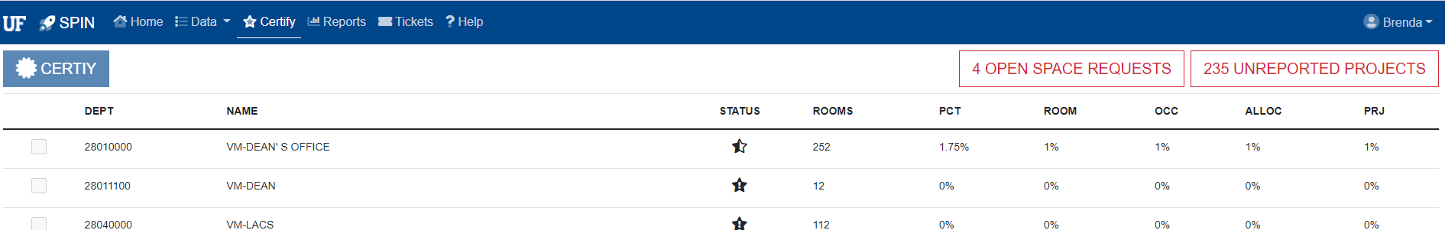

All Organized Research and Other Sponsored Activity projects must be accounted for in the Space Inventory & Allocation System before certification can occur. If there are any projects that have not been associated with space, a message will appear indicating how many

unreported projects remain. Clicking the “Unreported Projects” button will show all projects that still need to be associated with a room. If a project is included on this list in error, please contact the Office of Cost Analysis at spacealloc@admin.ufl.edu

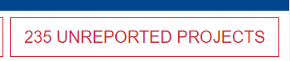

In addition, all space requests must be completed before certification can occur. If there are any pending space requests that have not been resolved, a message indicating how many pending requests exist will be displayed. Clicking the “Open Space Requests” will show the user all the pending space requests. If a request shows on this list in error, please contact the Space Management team at space@admin.ufl.edu

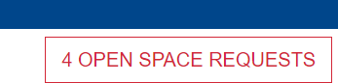

Certification and Authorization
The steps for certifying and authorizing your space are identical. Depending upon your security you will see either a “Certify Space” link or “Authorize Space” link on the status report. This link will only be activated once ALL projects and pending space requests have been cleared for the department that you are certifying for.

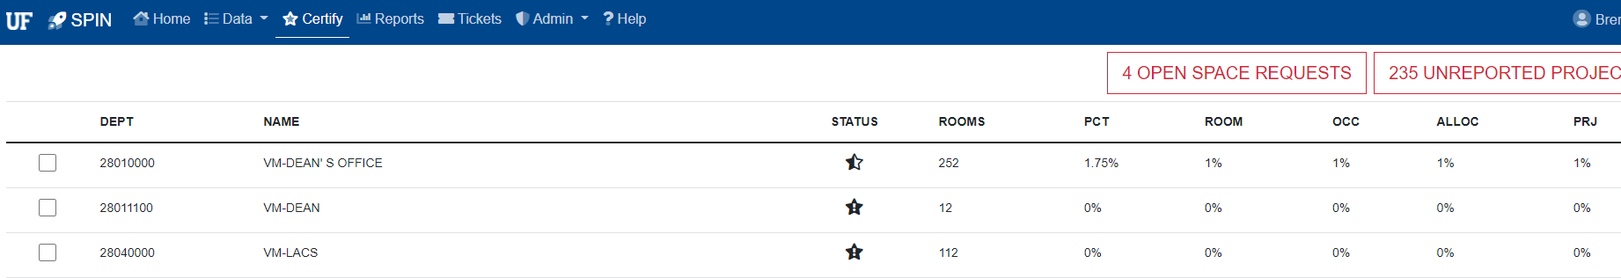

Select the Department ID you would like certified or authorized and select “Certify” or “Authorize”. Multiple Department IDs may be selected at once.

After certification, the status will change from “Complete” to “Certified”. Once the space is authorized the status will change to “Authorized” based on the key.

Where to Get Help
Cost Analysis
Questions about system use, and accurately reporting space should be directed here.
- Phone: 352-392-5778
- Email: spacealloc@admin.ufl.edu
- Website: https://www.fa.ufl.edu/directive-categories/space-allocation/
Space Change Requests
Problems or questions with space data including room description, area or department assignments should be directed here.
- Phone: 352-392-2287
- Email: space@admin.ufl.edu
Business Affairs Technical Services
Technical difficulties (errors or bugs) found while using the system should be directed here.
- Phone: 352-392-BATS (2287)
- Email: bats@admin.ufl.edu
- Website: https://bats.facilities.ufl.edu/

