Adding a Journal Entry Attachment
Depending upon the nature of a Journal Entry (JE), it may be required to attach needed documentation to it prior to submitting for posting to the General Ledger (GL). Follow the steps below to add an attachment to a journal.
Navigate to Main Menu > Financials > General Ledger > Journals > Journal Entry > Create/Update Journal Entries

Journal Entry Header Tab
- On the Header tab, click the Documents button. This will open a new tab in OnBase where you can attach supporting documentation for the journal. The number of attachments will be indicated in the Documents button in brackets once the document(s) is saved.
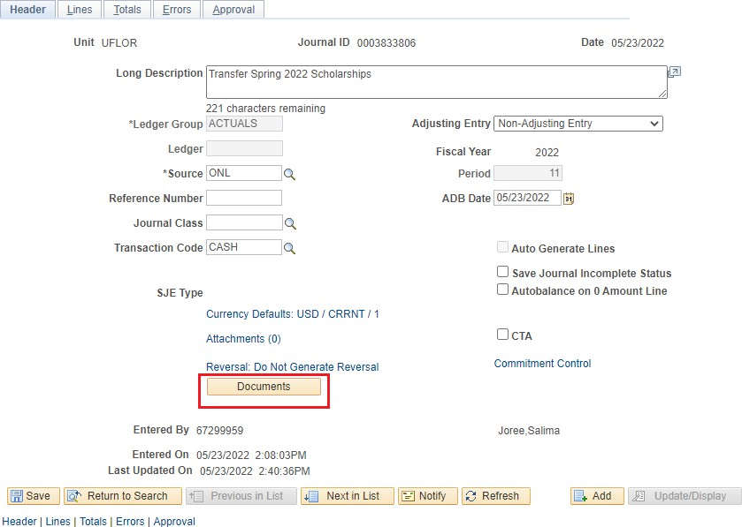

Attach File in OnBase
- Click the Upload File button (up arrow) in the top left corner of the OnBase screen.
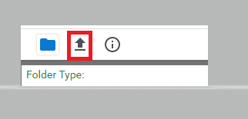
- Select a file to attach using the Choose File button in the top left corner of the screen.

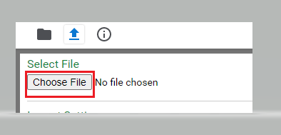
- Click the Import button at the bottom left of the screen.

- An Imported Successfully message will appear once document is uploaded
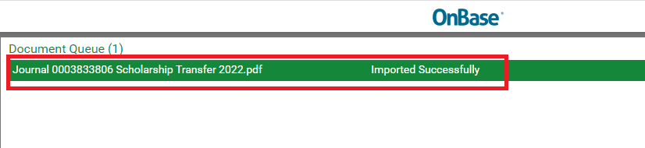
- Repeat steps 2-5 to upload additional documents

- Once done, return to the document folder to review or edit the attachment(s), if needed.

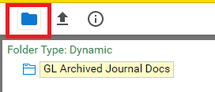
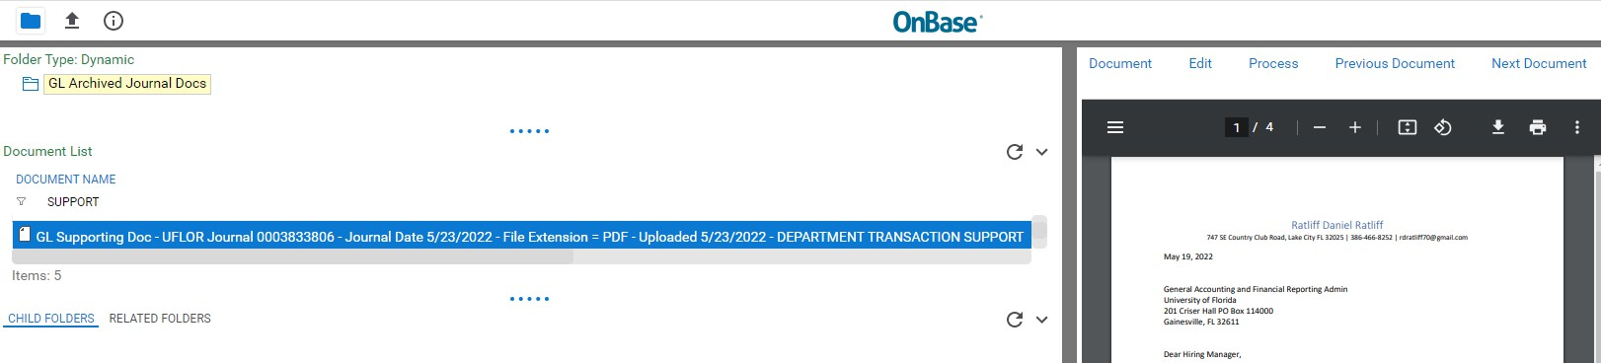

- To add to the description of a document, right click on the document and select Keywords. Fill in the File Name field and hit Save. This step is optional.
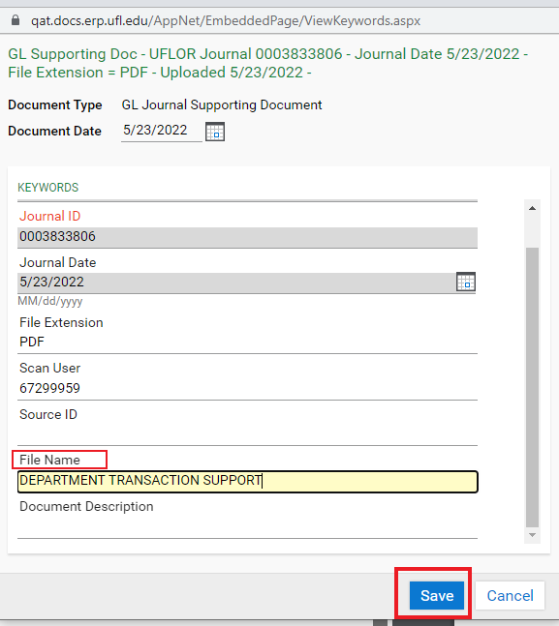

- Click Exit at the top right corner to return to Journal Entry in myUFL.

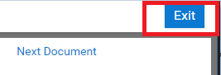

Important: Deleting a Journal Attachment
Sometimes an attachment needs to be deleted if it’s not necessary or is the wrong file. Deleting Journal Attachments is restricted to the core office. If there is a journal attachment you need removed from OnBase, email GL Journal (GLJournal@ad.ufl.edu), to have the attachment removed.

Other Notes
The PeopleSoft/MyUFL attachments method is no longer supported and all prior JE supporting documentation is now available in OnBase.
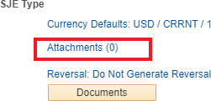

Your journal must have a saved status in myUFL before you can attach documents through OnBase.

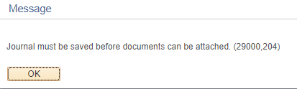

For Additional Assistance

Technical Help  UF Computing Help Desk 352-392-HELP  helpdesk@ufl.edu | Processes and Policies  General Accounting 352-392-1326  gahelp@ad.ufl.edu http://www.fa.ufl.edu/departments/general-accounting/

