How to Delete a Journal that is not Posted

- Search for the journal

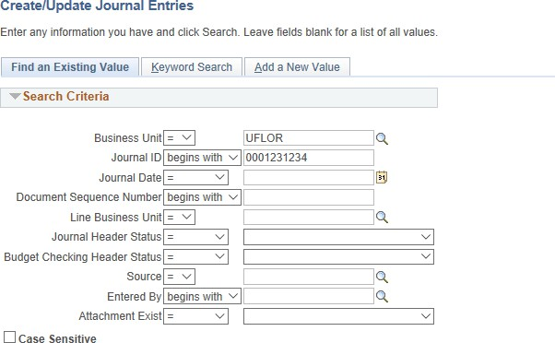
Navigation: Main Menu → Financials → General Ledger → Journals → Create/Update Journal Entries

- Click on the Lines tab
- Click ‘Delete Journal’ in the Process drop down menu
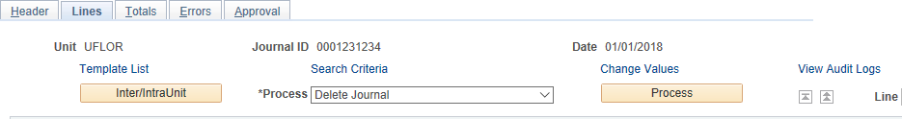
- Click ‘Process’

- Click ‘Yes’ to confirm you want the journal deleted
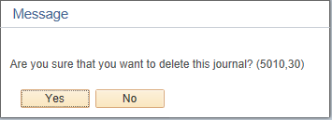

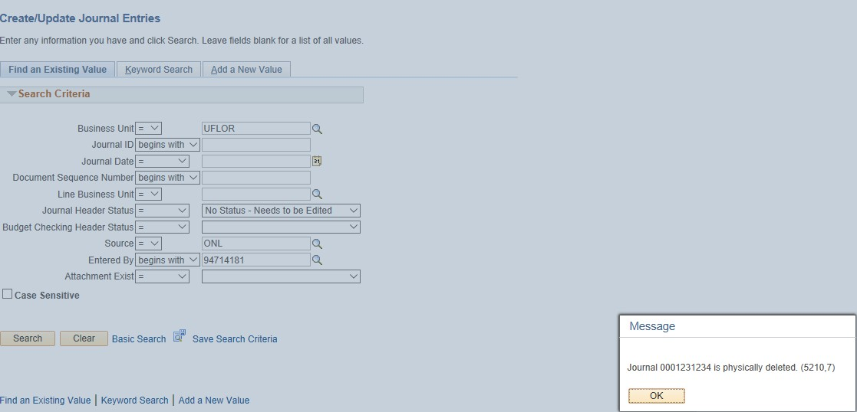
- Message box will pop up when journal has been deleted

