
Florida Prepaid: Tuition & Fees
University Bursar Office
S-113 Criser Hall Ph: 352.392.9545


Account Information
- University Bursar bills Florida Prepaid for tuition and applicable fees

- No Florida Prepaid card is needed

- Account information is linked by the enrolled student’s SSN

- View tuition statement on one.uf.edu for amount billed to Florida Prepaid

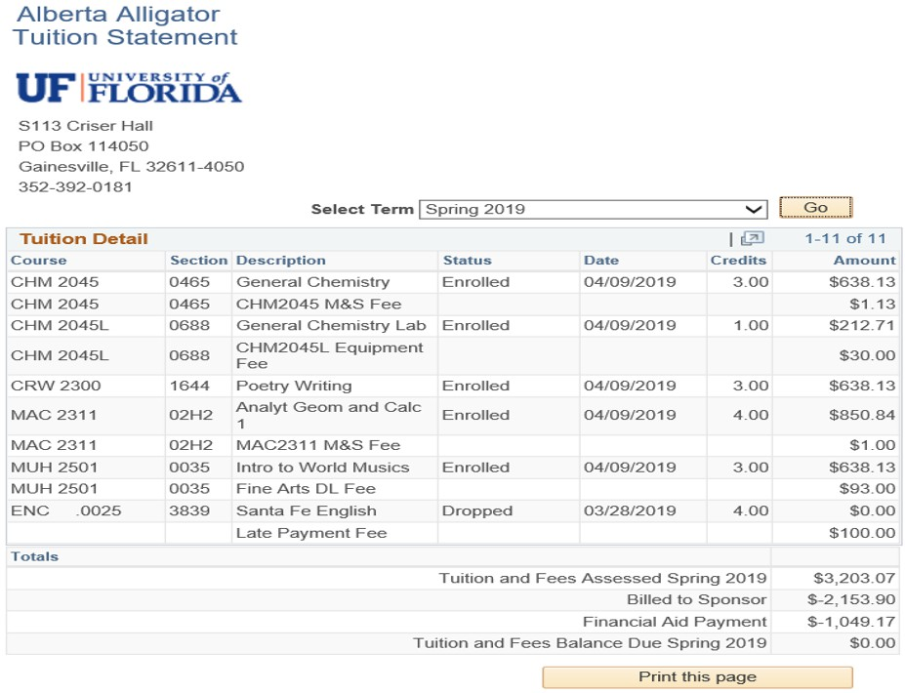


Reasons why prepaid is not applied:
- The SSN on file at UF or FL Prepaid may not match

- The FL Prepaid account could be delinquent

- You may have placed a hold on your FL Prepaid account

- The enrollment (or matriculation) year may be incorrect

- The student chose to opt out
*Matriculation year is the year of enrollment in college


True of False
Does Florida prepaid cover 100% of tuition & Fees?


Fees not covered by any Florida Prepaid Plan:
Local Fees: $14.69/credit hour Transportation Access Fee Technology Fee

Other Possible Fees:
Test Fees
Material & Supply Fees Equipment Use Fees Distance Learning Fees
Repeat Surcharge {same course taken 3+ times}
Excess Hours Surcharge {student exceeds maximum hours to graduate}


Undergraduate Tuition & Fee Rates:
- Prepaid Plans with a 2007 contract date or prior:
  - Students are exempt from the Tuition Differential Fee of $44.17/credit hour
    - $168.54/credit hour

- Prepaid Plans with a 2008 contract date or after:
  - Students are charged the Tuition Differential Fee
    - $212.71/credit hour

*These rates are for traditional, on campus students only

To view the Tuition & Fee breakdown, please visit the University Bursar website

Prepaid Plan Types

Plan Type: Amount FL Prepaid Covers:
Tuition Only $117.08

Tuition & Local Fees | $153.85
Tuition & Differential | $161.25
Tuition, Differential & Local Fees | $198.02

*The amount billed to FL Prepaid ranges from $117.08 to $198.02 per credit hour and depends on what type of
plan you have as well as when it was purchased.


Opting Out of Florida Prepaid
- Students have the option to “opt-out” of using FL Prepaid for any semester. This must be done prior to Fee Payment Deadline!

Fall & Spring semesters:
The “opt out” option is available online at one.uf.edu

Summer semester:
Student must come by our office or send an email by visiting one.uf.edu and click “Ask Bursar Help”

Remaining Florida Prepaid Hours

- Graduate School: Prepaid pays at undergraduate rate

- Transfer to an eligible family member*

- CA$H OUT: Receive a refund of what was paid in*

*Handled through Florida Prepaid



Florida Prepaid and Other Aid
  - Florida Prepaid is applied to the tuition first

  - Other scholarships/aid will begin disbursing after Drop/Add

  - For information regarding Bright Futures or other aid, contact Student Financial Aid and Scholarships


Dormitory plans are not processed in the Bursar’s Office. Please contact Housing & Residence Education for information regarding dormitory plans.

Housing & Residence Education Contact Information:
352.392.2171
www.housing.ufl.edu/

Contact Information Located on Your Handout
    - University Bursar: Third Party Contracts
Phone: (352)-392-9545 Website: www.fa.ufl.edu/bursar/ Lobby Hours: 8:30am-4:00pm Office: 8:00am-5:00pm

      - FL Prepaid
Phone: 800-552-GRAD (4723) Monday-Friday, 8am-6pm EST
http://www.myfloridaprepaid.com/using-your-plan/all-about-fees/

- Housing & Residence (handles all FL Prepaid for housing plans)
Phone: 352-392-2171

  - Student Financial Aid and Scholarships
Phone: 352-392-1275
















UNIVERSITY BURSAR

Third party contracts

Questions?

S-113 CRISER HALL

352.392.9545

