Appendix 1

Asset Management’s Transaction Detail by Account Code Report
A report is available in Enterprise Reporting that will provide departmental expenditures, including pcard charges, for the account codes used for purchasing attractive and sensitive property. These account codes are listed below.

Account | Description

729900 | FAX/PHONE EQUIPMENT <5000
731700 | MEDICAL EQUIPMENT <5000
731800 | AUDIO/VISUAL EQUIPMENT <5000
731900 | LAB EQUIPMENT <5000
732900 | OFFICE EQUIP & FURNITURE <5000
734800 | COMPUTER EQUIPMENT <5000
734900 | COMPUTER PERIPHERALS <5000
739400 | OTHER EQUIPMENT < 5000
739700 | SMALL HANDTOOLS <5000
739800 | MUSICAL EQUIPMENT <5000
739900 | FIREARMS <5000

The role needed to access the Transaction Detail by Account Code Report is UF_ER_USER.

Navigation to the report in myUFL is: Enterprise Reporting/Access Reporting/Shared Folders/64405000 – Asset Management/Transaction Detail By Account Code 73XXXX. This will take you to the report prompt page. At the prompt page enter four digit department ID(s), a date range and select “ok”

Department ID – Enter the four digit department ID in the box labeled “Provide a Value” and select Insert to move the department ID to the “Choices” box. More than one four digit department ID can be selected but you will need to click “Select all”.

Date Range - Select a “from” date and a “to” date on the calendar, or scroll down and select one or multiple fiscal years. When using the fiscal year option, be sure to click the insert button to move the fiscal year to the “Choices” box. More than one fiscal year can be selected but you will need to click “select all”.
The next page displays what would be entered to select department 6440 for fiscal year 2015.

� v� for the� you�,-e �?::a.t to n.n.
- �e �� rie'l!I.
+ ?birbto mc:singintortr�.

Insert♦
644-0
  - Remove

Pn)v-ide:e deteertdtime:
°"'°'..
''°Fm"-,�=======��
◄�
h:i f$ M:ir !z � J,.r,
!!!!
"""
Seo
""
!!a,
Sun Mon Tt.re Wed Thu Fri Sat
°"'
2
§
il l:Q ll
z
� li
l§
!
§
12
22
�
l
�
!§
ll
1 �
!Q
ll
g
�
�
!Z !§
� �
12 ll

�

ff
·�<b!e
·��
,,,
!!!!
""
"" !!a,
Sun Mon Tt.re Wed Thu Fri Sat
"""
Seo
""
!:!,,: ·,,,,
°"'
g
2
�
�
! l 1 �
§ z § � !Q ll
il � 12 !§ !Z !§
l:Q li 22 ll � �
ll l§ � 12 ll

T():

�

FrtcelYee.r
Pn)v-ide:e r,,um.ber:

Insert♦
2015
  - Remove

OK 11 Cancel I

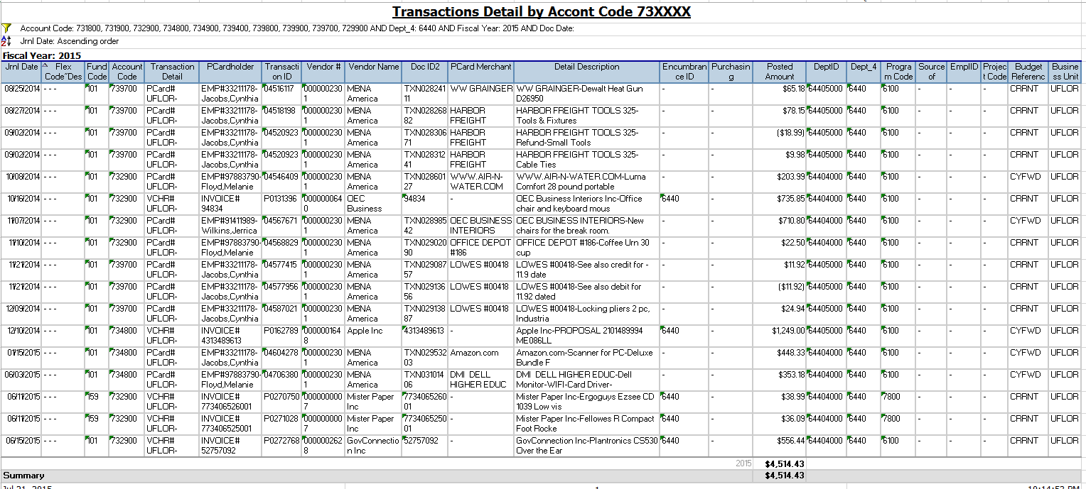
Using the prompts provided above will produce this report

