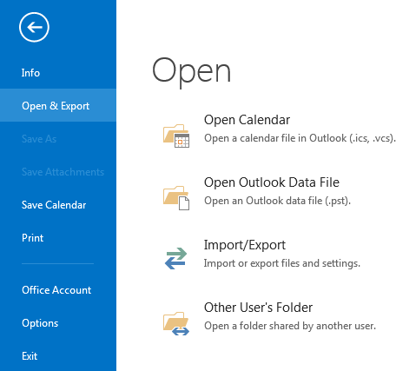
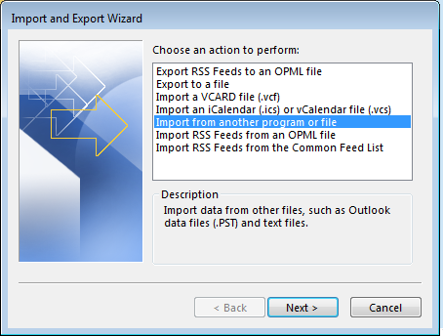
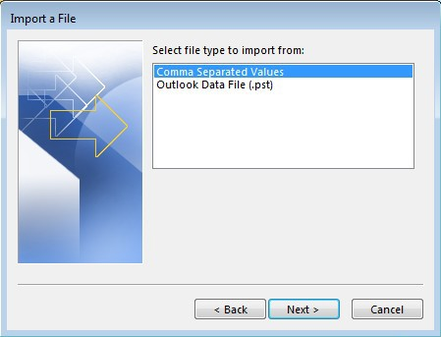
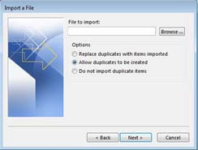
Import Payroll Calendar 2019

Save the .csv file to your Desktop.
Launch Outlook and click "File." Then select "Open."
Click "Import."

Select "Import from Another Program or File" and click "Next" to continue.

Select “Comma Separated Values” and click the “Next” button to continue.

Browse to locate the file you just saved to your desktop. Click the “Next” button to continue.

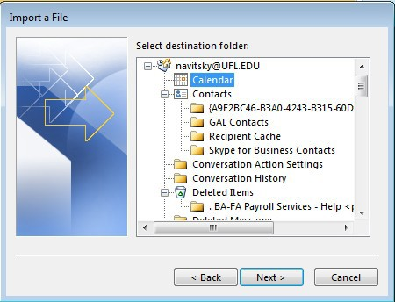
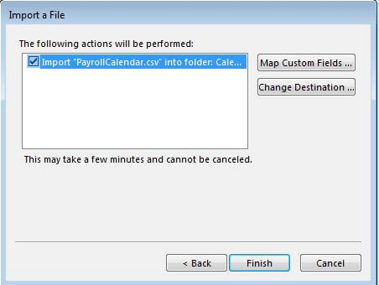
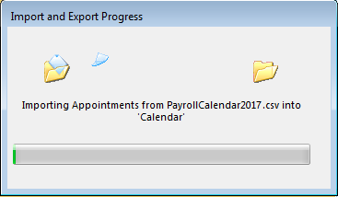
Select your “Calendar,” then click the “Next” button to continue.

Click the “Finish” button.

You’ll see the file being imported. Once this disappears, you can review your calendar to make sure the file was imported.

For example, check July 26th, 2018; you should see two entries:
- B072618 Pay Period Ends
- B072618 Time & Labor Closes

Once this process is complete, I’d recommend deleting the file you saved on your desktop.

