Quick Guide: Spot-Checking the Transaction Detail Report
This guide provides details on formatting the Transaction Detail in Excel to allow for easy spot checking and provides suggestions for transactions to look for during your checks. Even if your Tier 2 person gives you the Monthly Financial Reports in another format, such as a PDF, you can skip to Page 2 of this guide (“Spot Check”) to get tips on what to look for during your review.

Format the Transaction Detail Report
- Download the Transaction Detail Report. myUFL Navigation: Main Menu → Enterprise Reporting →
Department Reports (see Quick Guide: Obtaining Monthly Financial Reports)
- Delete all columns “A” through “P”.
  - Click on column “A” at the very top (where the “A” is) and hold down the mouse through “P”
  - Right-click and select “Delete”
- Delete columns “C” and “D”.
  - Click on column “C” at the very top (where the “C” is) and hold down the mouse through “D”
  - Right-click and select “Delete”
- Add a filter to the report.
  - Go to the “Data” tab at the top and click on “Filter”
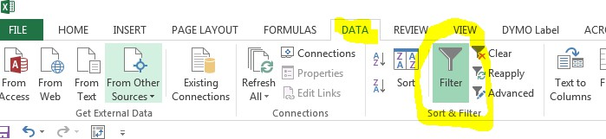
- Go to the “Data” tab at the top and click on “Sort”
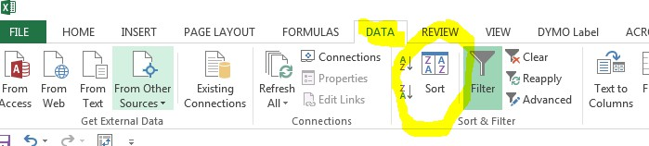
- If the Payroll Reconciliation Report is separately reconciled and reviewed, the payroll amounts can be excluded from this review.
  - Click on the drop-down arrow next to “Account Code” (Column J) and uncheck all accounts starting in 6XXXXXX (these are the payroll account codes).
  - All accounts remaining are for operating expenses.

Spot-Check the transaction detail report
SORT AND SPOT-CHECK BY AMOUNT
- Go to the “Data” tab at the top and click on “Sort”
  - Complete the pop-up box to match the following, then click “OK”:
**Please note – “Sort On” could say “Values” or “Cell Values” – both are okay
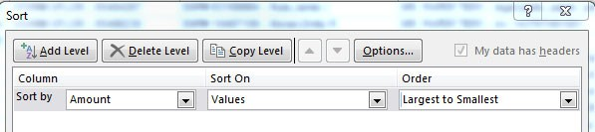
- This will allow you to quickly spot check transactions by amount for some or all of the following:
  - Round numbers or recurring numbers
  - Unfamiliar employee names associated with transactions
  - Appropriateness of the transaction
- For any inconsistencies or questions arising from the spot check, request or review supporting documentation.

Sort and Spot-Check by Highest Dollar Only
For a very high level review of a few large-dollar transactions throughout the month:
- Click on the drop-down arrow next to “Amount” (Column H) and
  - Select “Number Filters”
  - Select “Top 10”
- This will allow you to review the largest dollar expenditures quickly for some or all of the following:
  - Correct Account Code description
  - Existence and accuracy of source documents
  - Appropriateness of transaction

Sort and Spot-Check by Vendor
- Go to the “Data” tab at the top and click on “Sort”
  - Complete the pop-up box to match the following, then click “OK”:
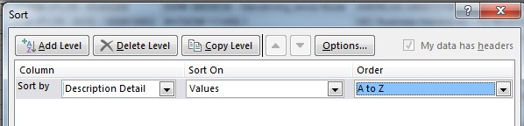

- This will allow you to quickly spot check transactions by vendor for some or all of the following:
  - Recurring payments to the same vendor throughout the month
  - Unfamiliar vendors
  - Non-UF Market vendors such as Publix, Amazon, Lowe’s, Walmart etc.
  - Appropriateness of the transaction
- For any inconsistencies or questions arising from the spot check, request or review supporting documentation.

Sort and Spot-Check PCard Transactions
- Click on the drop-down arrow next to “Transaction Detail” (Column D) and
  - Type “PCard” in the search bar that comes up and click “OK”
- Go to the “Data” tab at the top and click on “Sort”
  - Complete the pop-up box to match the following, then click “OK”:

- This sorts the PCard transaction by vendor. If preferred, you can also sort by “ID Detail” to sort by cardholder.
- This will allow you to see all PCard transactions during the month and quickly spot check for some or all of the following:
  - Unfamiliar PCard holder names (found in “ID Detail” – Column F)
  - Split amounts (two transactions to the same vendor by the same employee on the same day)
  - Unusual PCard activity
  - Appropriateness of transaction
- For any inconsistencies or questions arising from the spot check, request or review supporting documentation.

Sort and Spot-Check – Entertainment/Miscellaneous Account Codes
For a very high level review of a few account codes:
- Click on the drop-down arrow next to “Account Code” (Column J) and
  - Select “Text Filters”
  - Select “Contains” and type “799” and select “OK”
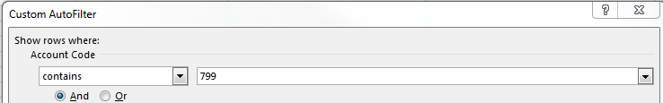
- This will allow you to review the account codes for Entertainment Expense, Food & Beverages Human Consumption and Miscellaneous Operating Expense quickly for some or all of the following:
  - Existence and accuracy of source documents – it is more important for these unrestricted accounts to check all itemized receipts for a clear business purpose. We want to ensure these funds are being used in an appropriate manner.
    - List of attendees
    - Business purpose of event
    - Appropriate approval
    - If alcohol was purchased, is it allowed in that fund?
    - Extravagant/lavish expenses (limo, etc.)

Sort and Spot-Check – Fund
For a very high level review of a specific funds, such as Foundation or other accounts.
- Click on the drop-down arrow next to “Cost Center” (Column K) and
  - Type “17” to pull up all 171 (Foundation) and 179 (Miscellaneous) funds
    - Type 15, 14, etc. to pull up other funds that might warrant extra review
- This will allow you to review the expenditures on these funds quickly for some or all of the following:
  - Correct Account Code description
  - Appropriateness of transaction for any fund restrictions
  - Existence and accuracy of source documents

For additional Assistance

Technical Issues
The UF Computing Help Desk 352-392-HELP
helpdesk.ufl.edu

Policies and Directives
Office of the Controller
(352) 392-1321
http://www.fa.ufl.edu/controller/

