•I UNIVERSIT pf
Ul

I !FLORIDA
Business Affairs
Finance and Accolirtting DiVisibn
Asset A1anagement Services
hllp:/ /fa.ufl.edu/a:m/

July 13, 2007

To Whom It May Concern:

ll6 Flmore Ha.JI
PO Box 115300
Gainesville, FL 32611-5300
352-392-2556

352-392-4687 f-ax
'

.�

Please Accept this letter ofauthorization for · • follo�q,ge�ployees of our organization to sign and p'ck up us - -operty or

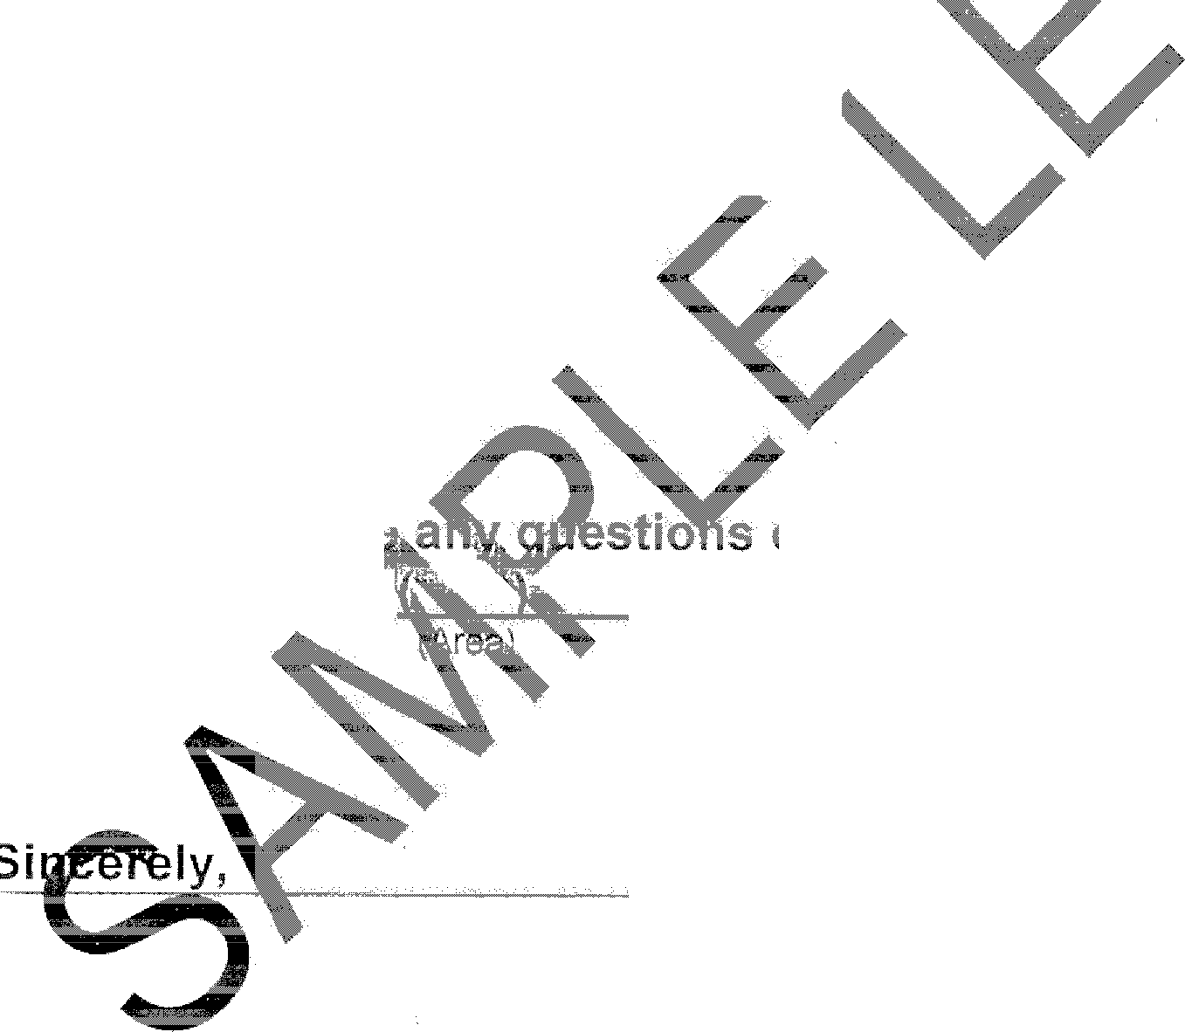
(Name of Organization)

John Doe Jane Doe Doe Deere John Deere

Should you hav concerning this matter p ease eel free
to contact me at
(Phone.Number)

