

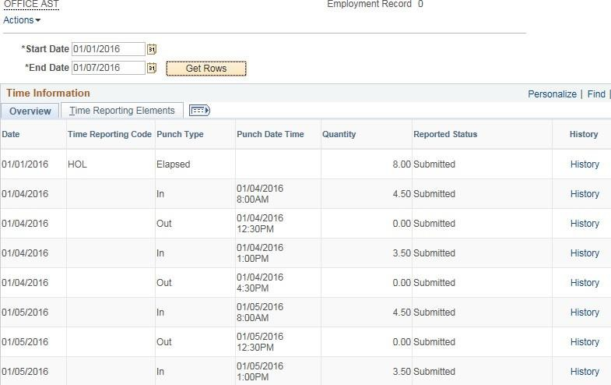
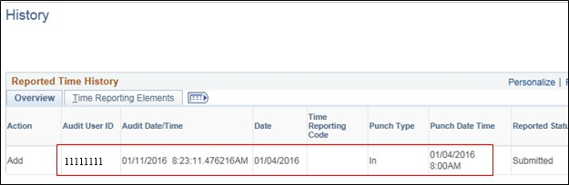
Who Entered Time and When???

Who Approved Time and When???

Main Menu • > Manager Sell Service • > Time Management • > View Time • > Payable Time Detail

OFFICE AST Employment Record 0  AebOnS•  Start Date[01/13/2016 ]l!il  End Date [0111912016 ]l!il ,.,.. Previous Employee  Payable Status Filter | Next Employee
Payable Time ?
Qvervlew l[ limeReporting Elements 11 Task f!eporling Elements lflCost and ApprovalIi-=IJ!'!!="�►l �
Date Status ReasonCode TimeRepo,ting Q<Janlity Approved at Use1'10
Code

1/13/2016 Distnbuted USH 8.0 01/14/2016 22222222
1:Z-40:ltPM
D1/14/2016 DIStributed USH 8.0 01/14/2016 22222222
D 12:40:11PM

Return toSelect Total Quantity 16.000000
Employee

Updated 7-18-17

