Adding Images to PCard Transactions
PCard supporting documentation is electronically “attached” to PCard transactions at the time they are verified or approved in myUFL.

Navigation
Use the following navigation to get to the Reconcile Statements page in myUFL
- Click Main Menu
- Click Financials
- Click Purchasing
- Click Procurement Cards
- Click Reconcile
- Click Reconcile Statement

Process
- Save the image of the documentation to be attached to the transaction.
  - The saved documentation can be things such as a scanned receipt, an email, a web page, or an electronic invoice.
  - More than one document can be attached to a transaction.
- Identify the transaction to be verified or approved.
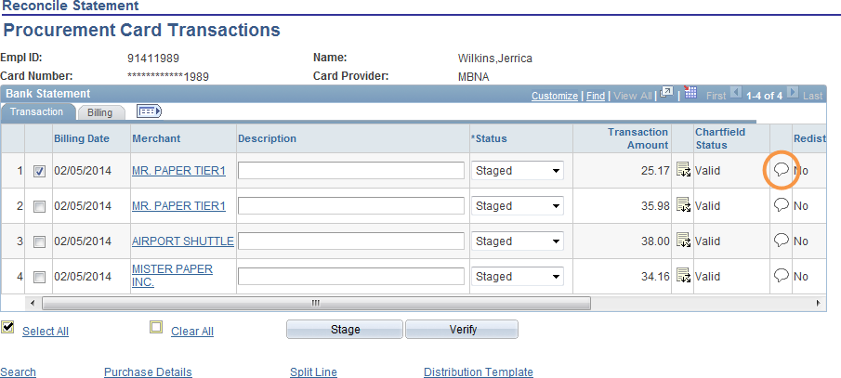
- Click on the Comments icon

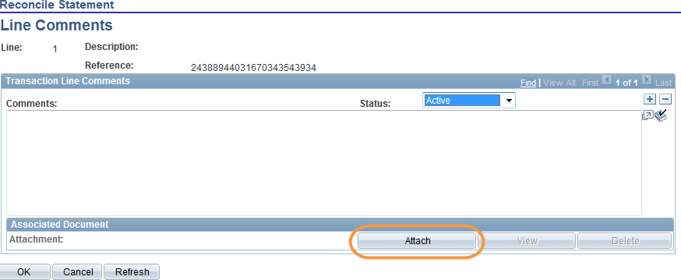
- Click the Attach button
- Click the Browse button
- Select the document to be attached
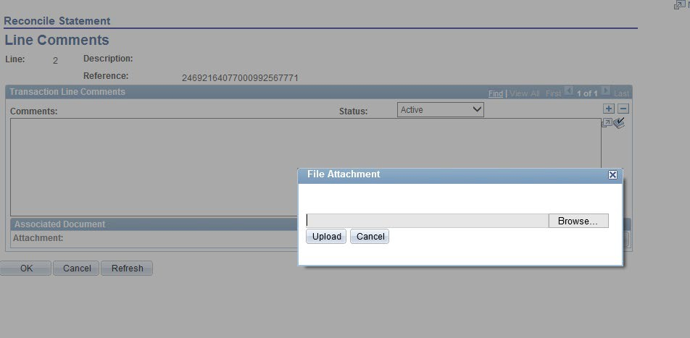
- Click the Upload button
- Click the OK button
  - Under the Associated Document section, you can see the document that is being attached
  - To add additional documents click the plus sign located in the upper right corner.

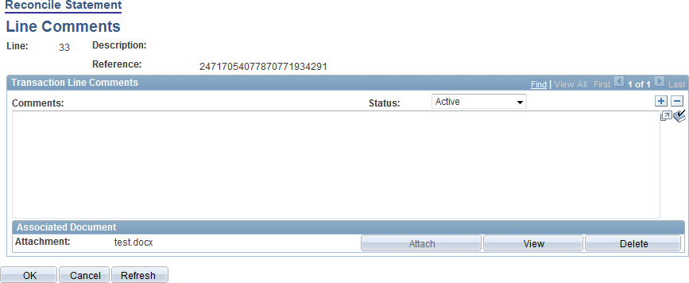

- To confirm the document was attached, click on the Comments icon When there is an attachment, the
Comments icon changes appearance

- Proceed to verifying and/or approving the charge by adding a description and changing the chartfield as necessary
- Save the transaction
- Enter CRRNT into the Bud Ref field
- Click the OK button
  - The ChartField strings in the Distribution Template are applied to all of the transactions that you have checked
- Click the Save button

For additional Assistance

Technical Issues  The UF Computing Help Desk 352-392-HELP  helpdesk.ufl.edu | Policies and Directives  Procurement Services: Pcard Services 352-392-1331  pcard@ufl.edu  procurement.ufl.edu/uf-departments/procurement-cards-pcard

