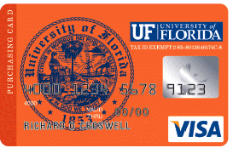
PCard Replacement Receipt Form

This form is to be used only if the actual receipt, invoice, packing list or internet order form is not available. It will be allowed only as a rare circumstance.
It must be filled out COMPLETELY and signed by the cardholder’s Supervisor.

Cardholder Name: UFID: Department: DeptID: Explain why the receipt is not available:

Project/Grant to Charge
Vendor Name: Purchase Date: Vendor Phone Number: Contact:
Description of Purchase (list items and quantities)
Description | Purpose |  | Cost
(Use additional pages if needed) Total Purchase Amount $ |  | 0.00

CARDHOLDER: By signing below I certify that the above purchase was made for official university business only.
Signature: Date:

SUPERVISOR: By Signing this form I agree that the above purchase was for business purposes. The cardholder was reminded that vendor receipts are required for all PCard Purchases.
Signature: Date:

