Prior Employees in Commitment Accounting
When attempting to create a distribution in the Department Budget Tables USA, you may see a message like the following:
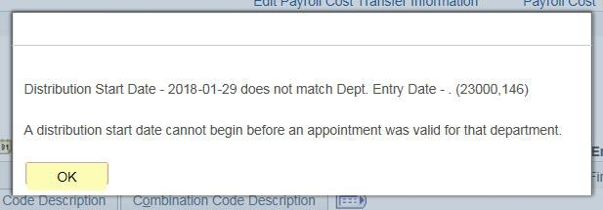
You must use a start date of the beginning of the Fiscal Year. In the case of the example above, you would need to use a Start Date of 07/01/2018.
You’ve entered an effective date that appears to be correct. However, because this employee was employed at UF and because there was prior year history on this employee available in myUFL, you will get this message.
- Also note that you will get a “retro is happening” message come up just because of using the 7/1/18 start date --- but, no retro will actually happen since no pay was actually paid from your dept id/record # in the past.
- Also, should you be using a combination code that is a fund 201/209 then you will also get the Payroll Cost Transfer Information Form pop up to fill out.
- Just fill it out using N/A – No Retro in #1 and “see above” in #2 and then YES, NO and OTHER in the other required fields and then OK.

Prior Employees in Commitment Accounting – Project Related
If the project doesn’t begin until after the start of the Fiscal Year, you must distribute the individual to a substitute account from 07/01 to the beginning date of the project. Keep in mind; nothing pays until the actual rehire date.

