Banking and Merchant Services Resources for Fiscal Onboarding

Key Terms:
Accounting Date
The date the deposit is processedby the bank for cash/checks, the date of the settlement for credit card transactions, or the date on the advice for EFT/ACH or wires.
Expense Refund
Refunds, reimbursements, rebates, or other returned funds from a vendor. They ALWAYS relate to an expense paid for by the University and must be returned to the same ChartField string the expense was paid from. An Expense Refund form is required for all expense refunds.

EFT Advice Report
Also known as "Advice" or "Addendum," this is a deposit statementextracted from the UF bank account that provides information about an EFT/ACH or wire payment.
Restrictively Endorsed
A control technique that restricts further action regarding a financial instrument (normally a che ck). The result of a restrictive endorsement limits the use of the check, such as "for deposit only." Note: Endorsement stamps can be purchased through an office supply store such as Mister Paper/Office Depot Refer to F&A website for proper wording to be used on the endorsement stamp.

1

Scenario 1
Activity 1

- For these exercises, feel free to use this handout while referencing the PowerPoint PDF.
- Remember to choose a Scribe to write notes and choose a Spokesperson when it is time to share out.
- Turn your cameras and mies on to meet your colleagues and for a better interactive experience if you can.

- Once ou com lete these, move on to Scenario 2.
Al Swamp Cityville, ZA 00000
98765
�a;,"'.i'"Dr Smith JJF Department ofBiotes:booJogy SI 2 000 00I
.._.T,,..,._'O....,tho.,..ua.sp.d..._,do.,..J.l.a.;:sL.aan..,.d""OOJ....,IOQ..,.s Dollars
Memo Conference
A.lSwamo

 Process Deposits Breakout Activity Scenariol
Activityl

The morning of 9/l6/20XX, you receive a check in the mail made out to "Dr. Smith, UF Department of Biotechnology'' in the amount of $2,000 (Check#1). Your Deposit Unit is 1000.

Even though the memo line on the check says "Conference", the letter included with the check says $1,500 is a registration fee for a conference your department is hosting through Teaching & Technology and $500 is for lab services sold by the department.
Checkl

.

- Explain what you think needs to happen.
- How many different accounting lines will be needed to distribute this money correctly? Why?
- Before you go into myUFL, what needs to be done to the check? Why does this need to be done?
- When does the deposit need to be made by?
- Using the screenshots on the following pages, prepare the deposit in myUFL for Check #1.

What is your Deposit Unit?

Where would you click to go to the next screen?
Deposit Screenshots Navigation
Nov Bar Main Menu Financials Accounts Receivable Payments Online Payments Regular Deposit

Screen 1: Add a New Deposit
Regular Deposit

Eind an Existing var�I Add a New Value

Deposit Unit: Q.
Deposit ID: NEXT

Add

Find an Existing Value I Add a New Value

2

Scenario 1
Activity 2
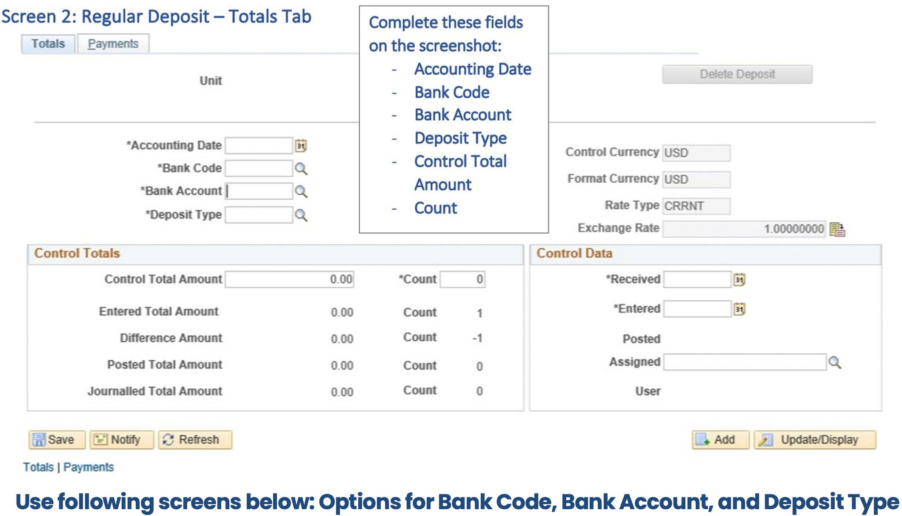

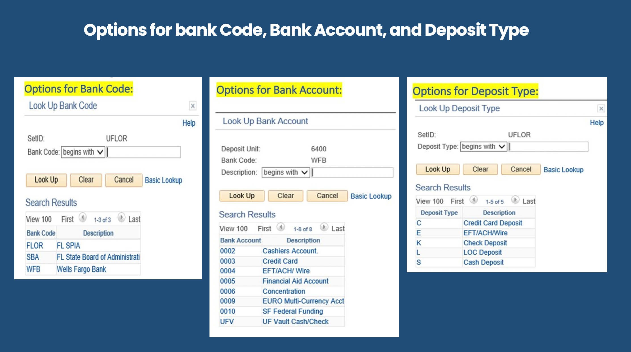

Scenario 1
Activity 3
Screen 3: Regular Deposit - Payments Tab
Iotals Payments

Unit

Payment Information
Payment Seq

Deposit ID NEXT Date Balance Nol Balanced

Find I View All FIISt < 1 of 1 ► Last
'Payment ID I .±.Id
PymtRef

Amount 000
Complete these fields on the screenshot:
Amount
Payment ID is either deposit ticket number or your department's location ID. ex 640001 Payment Reference

Customer Information
Customer ID

Remn From
Name Corpo<ate SUbCust1
Currency USO

OJoumat Direcdy Attachmenls (0)

Business Un11 Q.
Remit SeU0

Corpo<ate SeU0
SubCusl2

•Accounting Date

Tips:

Once you select Journal Directly, everything in "Customer Information" becomes inactive.
After the deposit is balanced and you click "Journal Directly'' and "Save", the Apply Payment button appears. You click this button to navigate directly to "Create Accounting Entries."
After selecting save, a Deposit ID is assigned to the deposit. This ID will be used in the next step to create an accounting entry.

Screen 4: Create Accounting Entries
Assume you olreody scrolled oil the way ta the right an the accounting line and selected the "+" to add the second line. Rememberfrom the discussion, the entire
lab service fee was to revenue, and there were no taxes. If there were taxes, you would add a third line to enter that distribu�ti_ o_n· �

Accounting Entries .Qepostt control

Unit Currency Details
Amount

□complete
Budget Status Distribution Lines

OeposltlO

USO

Entry Event Q.

, l!I

Payment

Documents

Seq t
Complete these fields on the screenshot for both Lines 1 and 2:
- Account Code
- Fund Code
- Department ID (Dept)
- Program
- Budget Reference

OittribuUon Sequence -GL UM
Speed Typo UneAmount

Currency •Account Source Fund

Dept

Program
Bud Ref

 | - UFL0R  - UFL0R | Q.  Q. | Speed Type  Speed Type |  | USO  USO |  | Q.  Q. | Q.  Q. | Q.  Q. | Q.  Q. | Q.  Q. | Q.  Q.
Total  Lines 2 | Total Debtts |  | 0 000 | Currency |  | Total Credits | 0000 | Currency | Nol | 0 000

n Save Return to Search Accounllng Entries I 0ePoslt Control
' Nexlln Ust
:.::)NoOly Re�esh

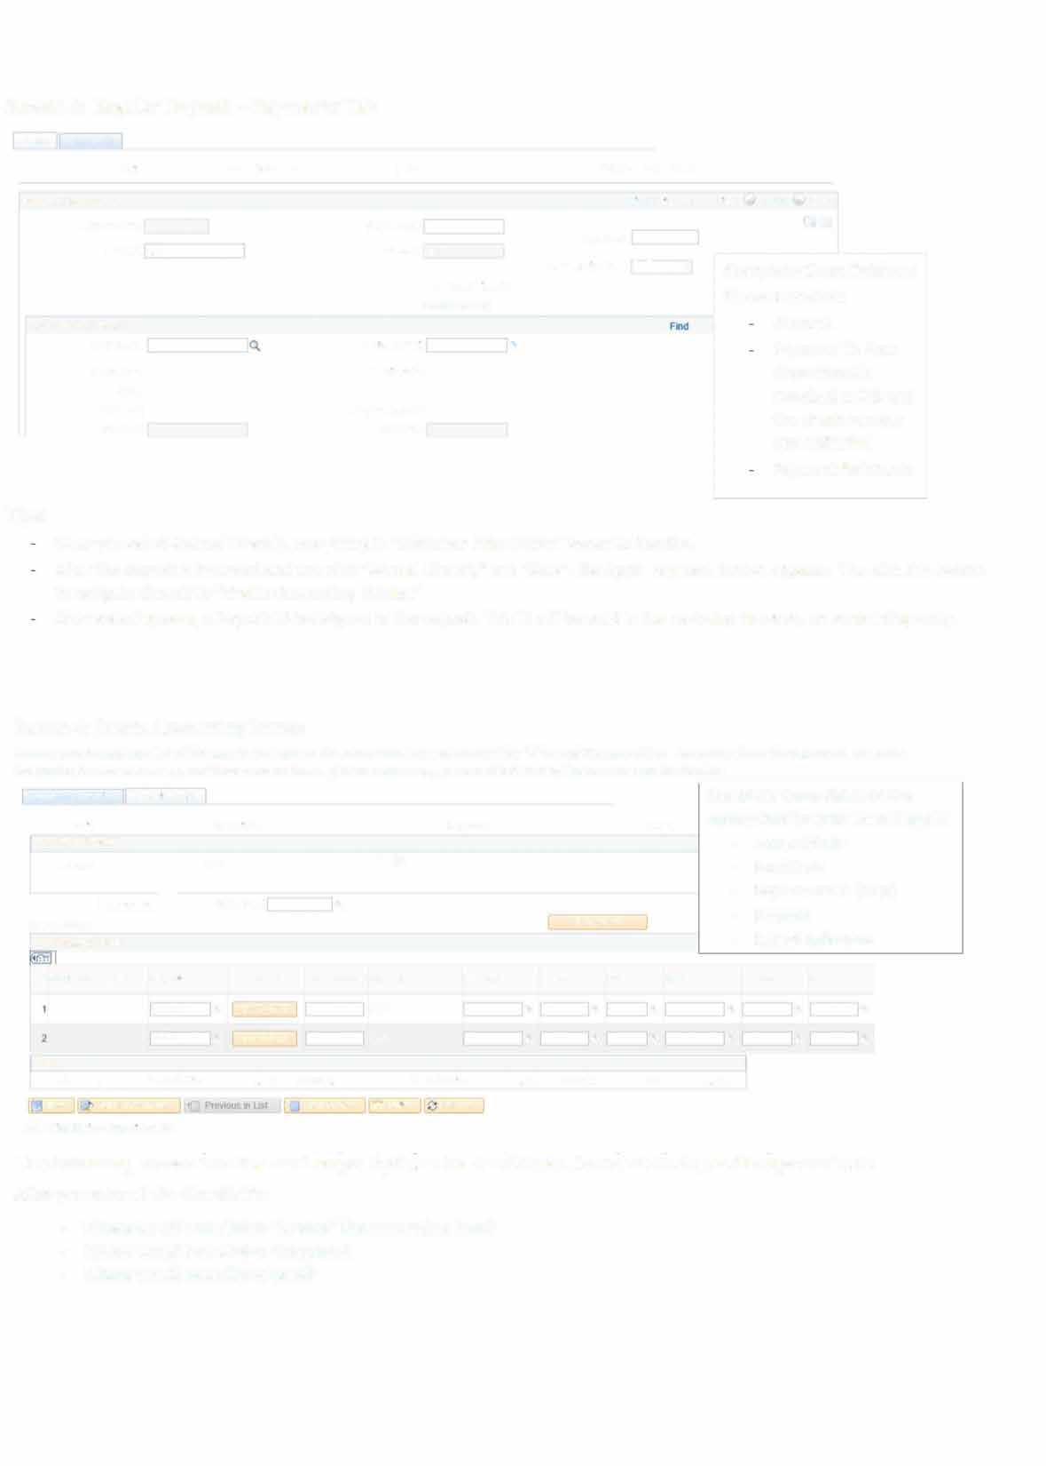
Use following screens on the next page: Options for Fund Code, Account Code, and Program Code After you enter all the Chartfields:
- Where would you click to "Create" the accounting lines?
- Where would you click to Complete?
- Where would you click to Save?

4

Fund Options:
- Auxiliarv Enterpri e-Di tanre and ontinuing Education Fund

ty p g

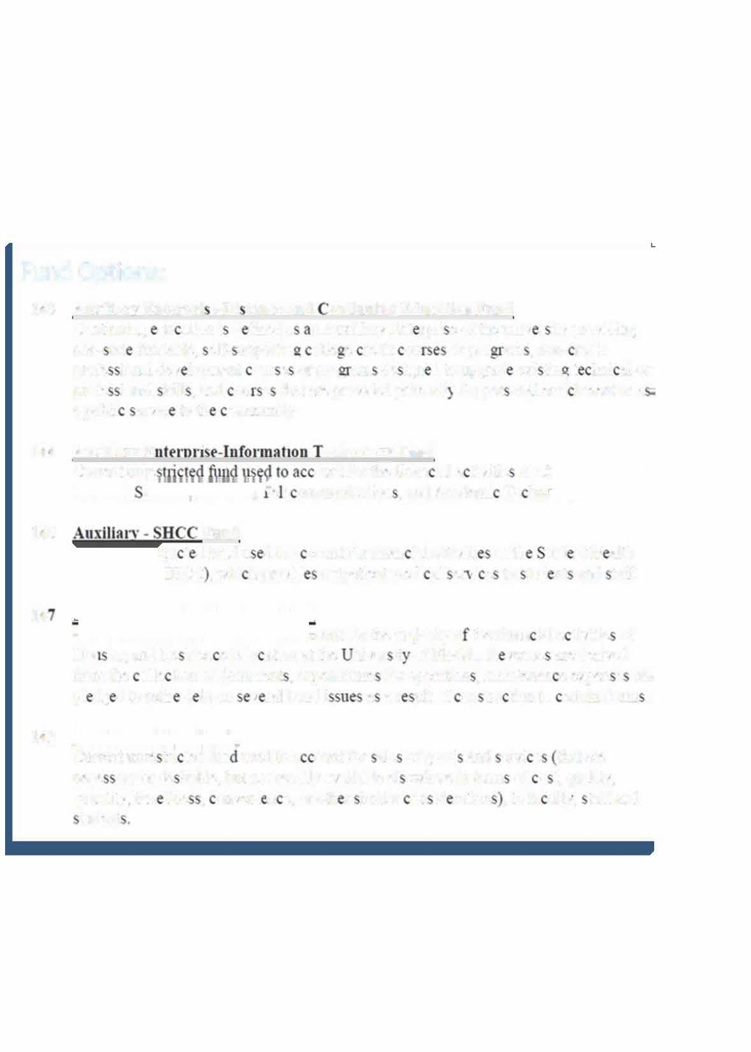
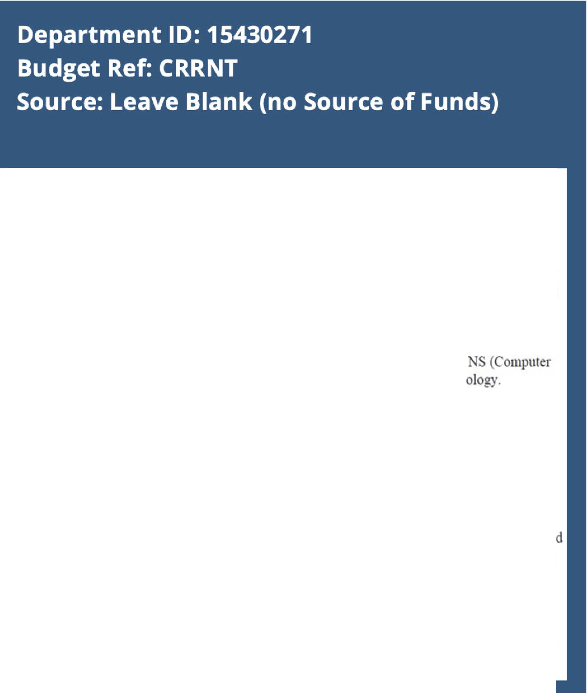


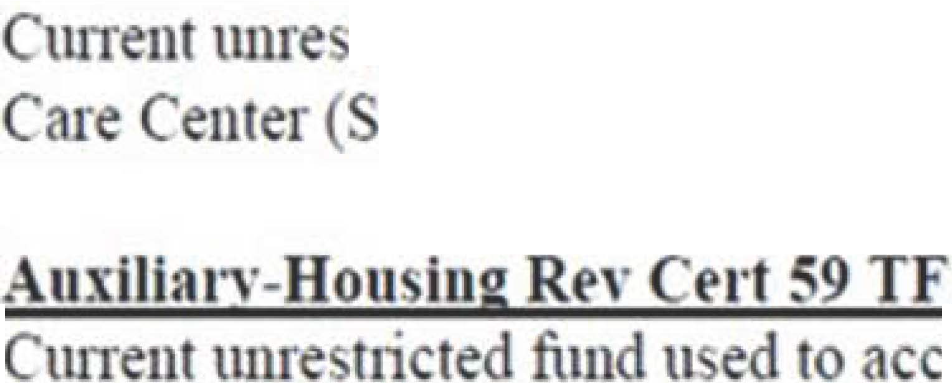

Continuing du ation i d fined a n Auxiliary Ent rpri e of the mti,· r i ro,·idin
non• tat fundable. pelf• npportin� olle e redit ou or pro am . non- redit
profe ional de,· lo ment our e or pro� am de ig:u d to upgrad exi tin.. t lmi al or
profe ional kill . and ou e that are proYided primaril ' for per onal enri hmeut or a a publi enic to th ommunity
- Auxiliary E · · erboology Fund
CtuTent mne Olllll for the fl.nan ial a th·itie of C
. e e Ollllnunication . and Academi Te hn
1�5 Fund
tri t d fund u d to a count for finan ial acti,·iti of th tud nt H alth HCC . whi h pro,·id outpatient medi aJ e1 ·i e to md nt and tatT.
u
ount for the majority o the finau ial a ti,·itie of
Hot iog and Re iden e Edu atiou at the ui,·er ir of Florida. R ,·enue are deri,·ed from the olle tion of dom1 rent . expenditure for operation . maintenan e expen e an pl dg d to retir d bt on ,. ral bond i a a r ult of on trn tion to ertain dom1 .
U9
CuITent unre Hi ted fun used to a Olml for ale of good and erYi e that are nece ary or de irable. but not readily a,·ailable el ewhere in te1111 of o t. quality. quantiry. tim line . onYeuj n e. or oth r imilar on id ration . to fa nit). raff and n1dent

5

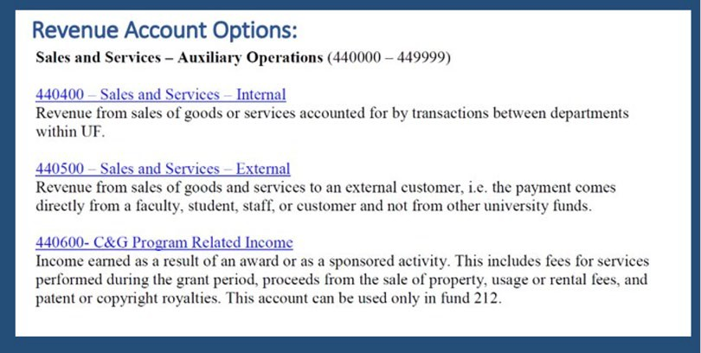

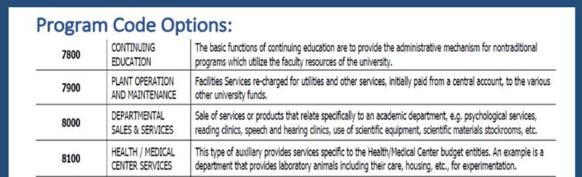

6

Scenario 2
Activity 1

- For these exercises, feel free to use this handout while referencing the PowerPoint PDF.
- Remember to choose a Scribe to write notes and choose a Spokesperson when it is time to share out.

- Turn your cameras and mies on to meet your colleagues and for a better interactive experience if you can.
Ima Gator Town, AZ 11111
1001
�• 9-l3"20XX
�root'JJnivcrsicynfflnrida sl 600001
,.Sjx.._..bu.p.d.[.fS.!...,.d..q.Jl.w.....o.n...l.y Dollars
M""°------
lmaGJtM
Process Deposits Breakout Activity Scenario2
You are the Fiscal Assistant in the Department of
Biotechnology.
Check2
Late one afternoon, 9/l6/20XX, you received a check made out to "University of Florida" for $600 (Check#2).

It is a refund for part of a $975 registration fee that one of your travelers, Dr. Jeske paid to attend a conference in Kalamazoo, Michigan on 8/l/20XX. The conference host is refunding part of the registration fee since the traveler was also a
speaker at the conference.
Department ID: 15430271
Deposit Unit: 1000
UFID: 98765432
Expense Report: 000Olllll
ER ChartField string: 10000000-101-6100- 771200
The original registration fee was paid by your
department.
- Explain what you think needs to happen.
- What do you need to complete this transaction? (Think: Is there a form? Transaction in myUFL?)
- Complete the necessary task.
GENERAL INSTRUCTIONS- SELECT ONE OF THE OPTIONS BELOW
OPTION 1:  Original expense Is related to a GRANT FUND: 201,209,211,  212, 213, or 214 | - Contract< & Grant< will enter the deposit In myUFL Forward the endorsed check and the completed f•pense Refund form to PO Bo• 113001, Room 033 Tlgert Hall.  - Fund 214 -The Office of Clinical Research will enter the deposit In myUFL Forward the endorsed check and Expense Refund form to PO Box 100158.  - Upload support documentation to the original e•11ense transaction In myUFL
OPTION2:  Orlglnal expense Is related to TRAVEL (non-grant fund) | - Travel Office will enter the deposit In myUFL  - Forward the endorsed check and completed Expense Refund form to PO Bo• 115350, 116 Elmore Hall.  Use the form Travel Advance Refund when returning advanced funds and send all to the Travel Office address above.
�  AU OTHER Expense  Refunds | - Enter a deposit In myUFL. Upload the Expense Refund fonm to the deposit In myUFL  - Endorse the check and remit to the bank for deposit.  - Upload support documentation to the original ex(!!lnse transattlon In myUFL.

EXPENSE REFUND
V R !TY FFLORJDA

1

2

3
Circle the number of the orocess above that is aoorooriate for this check.
 | ORIGINAL EXPENSE INFORMATION
 | Original ExpenseDate
 | Traveler'sName and UFID (if applicable)
 | Original Voucher, Expense Report No., or Journal ID (including line number)
 | ALL EXPENSE REFUNDS |  | - If reimbursing a PCard, you must lndude original voucher number.  - If reimbursing multiple vouchers, expense reports, or Journal IDs please break down the amount being refunded to each.

7

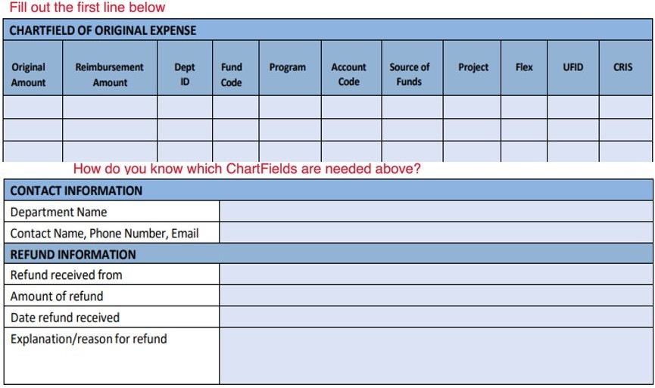

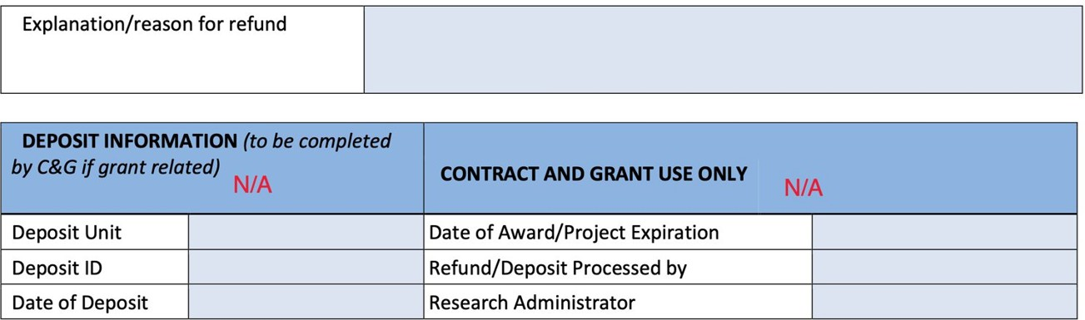

BE READY TO SHARE OUT!

8

Banking and Merchant Services Forms & Resources

Master List of all Forms:
https://www.fa.ufl.edu/departments/banking-merchant-services/forms-resources/

Request for Incoming Bank ACH/WIRE/EFT:
https://www.fa.ufl.edu/wp-content/uploads/2019/04/ACH-Wire-Request-Form.pdf

List of EFT/ACH and Wires for the Current Fiscal Year:
https://www.fa.ufl.edu/wp-content/uploads/treasury/eft-cashier-log.xlsx

Expense Refund Form:
https://www.fa.ufl.edu/wp-content/uploads/2022/02/Expense-Refund-Form.pdf

Check Log to Record Checks Received in Mail:
https://www.fa.ufl.edu/wp-content/uploads/2021/12/Check_Mail_Log.pdf

Mobile and Desktop Scanning Deposit Check Retention Log:
https://www.fa.ufl.edu/wp-
content/uploads/2022/10/Mobile_and_Desktop_Scanning_Deposit_Check_Retention_Log.pdf

Glossary of Banking Wire Terms:
https://www.fa.ufl.edu/wp-content/uploads/2022/02/Glossary-Banking-Wire-Terms.docx

