
Welcome to Procurement Networking
Post in the Chat Your Name Where you work

How long you have been at UF

Topic Overview
- Brief high level overview of Procurement (purchasing)
- Small Group Work
Learners post questions and responses in the chat. Practice searching resources (website, toolkits) Learn where to find some of the answers
Learners will figure out the activity answers in a small group.

Use the chat or unmute to ask questions.
Be sure to take your own notes.



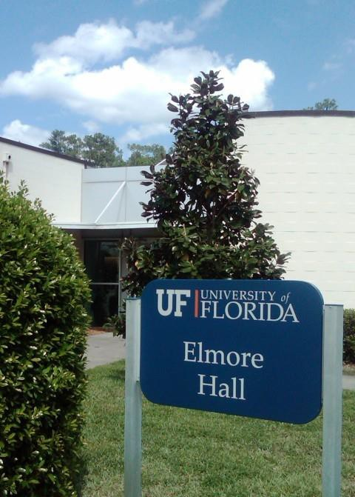
Who/what is Procurement?

Procurement Services – purchase of goods and services
UF Procurement’s vision is to set a standard of excellence by creating partnerships with customers and leading innovatively in strategic sourcing, contract
management and efficient procurement processes to facilitate the UF mission and create outstanding value for the University
Our role: to provide: Service, ensure UF receives best value and to mitigate risk

- Primary contracting authority for the University
- Sole department with signature authority for purchases
- Handles public solicitations which result in contracts used by UF
- ~ 100,00 PO’s/year = ~ $600 million + PCard
- Reports directly to the CFO
- UF and BOG Regulations govern
- Florida Statute and Federal Uniform Guidance also govern
Staff listing on Procurement.ufl.edu/about-us




Office team
How do you know what we do?
Office supplies Hardware Software
Research & Scientific
Fisher Scientific Airgas
MRO/Minor Construction
Electric charging stations Lightbulbs & tissue
Services/Events
Dining Services Printing/Copying

Why learn about purchasing ?
How to get what your unit needs

Best value Business process

Good stewards of public funds by knowing the rules

Getting what you want within the rules –
so it will be faster


Starting a purchase
What do you need? Has it been purchased before? How?
PCard // Unencumbered // Requisition-PO
- PCard – for low dollar purchases or travel – fiscal on-boarding class
(List of allowable PCard purchases on PCard webpage under Procedures)
- Unencumbered – short list of things paid without a PO
(List available on Disbursements website under "Allowable Unencumbered Expenditures")
- Purchase orders are required at $5,000 and up
  - Does UF have an existing contract supplier?
  - Check myUF Marketplace, Procurement website
  - Contact Procurement Agents – Procurement@ufl.edu

Quote Thresholds
- Up to $10,000 – No additional quotes required
  - PO required & Asset threshold: $5,000
  - Best business practice: always get quotes
- $10,000 - $149,999 – Three competitive quotes
- $150,000 and above – Required*: Public Competitive Solicitation

*Board of Governors(BOG) & UF Regulation require public solicitation at $150,000 and up


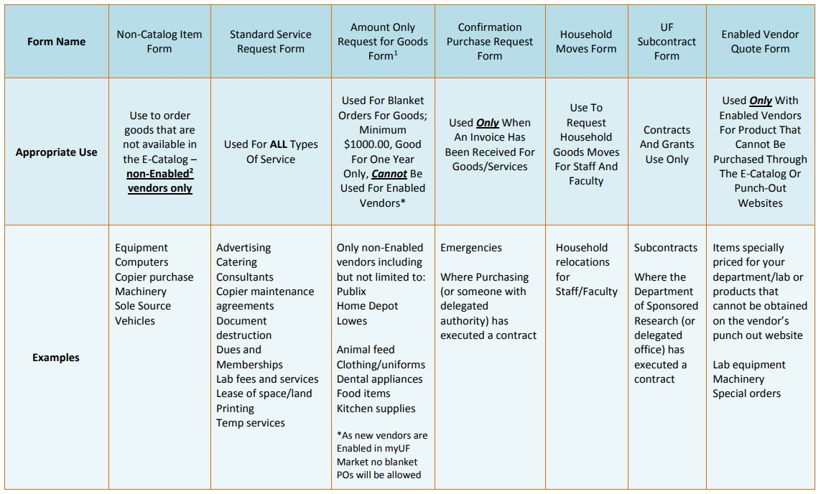
myUF Marketplace Forms

Key Terms

myUF Marketplace: shopping; request PO & pay bills

Requisition request for PO
Purchase Order “PO”–legally binding contract between UF & supplier

Encumbrance – sets aside funds to be used specifically

Regulations – UF BOT and BOG
Public Solicitation - formal process for getting quotes/proposal from suppliers
Quote or Proposal: Supplier response to a request
for pricing

Working with Procurement

Classes to take:
Color of Money – Pro302 Procurement 101 – Pro305
Intro to Purchasing in myUF Marketplace – PST073 PCard (see fiscal onboard class or PCard website) Procurement 102 – Service Contracts – Pro352

Information to know: Chartfields and Budgets
General Accounting website – Chartfield Overview & instruction guide
Budget & Commitment Control – instruction guides


Security Roles – myUF
Marketplace

UF_N_MKT_REQUESTOR UF_N_MKT_APPROVER

We are all financial stewards
Transaction Processors
- Know the rules
- Create requisitions
- Pay invoices
- Process PCards

Decision makers
- May know the rules

Reporting Fraud
If you are not sure if fraud is happening, talk to someone in Finance & Accounting, a trusted advisor, a supervisor, or someone you trust.
To report potential legal, policy, or ethical conduct violations or concerns.

Anonymous Compliance Hotline: 1-877-556-5356
https://app.mycompliancereport.com/report.aspx?cid=uofl

University of Florida Compliance Hotline: https://compliance.ufl.edu/uf-compliance-hotline-2/

UF Controller’s Office: 352-392-1321

Group Exercise
https://procurement.ufl.edu/
- Where can I find a list of suppliers who can print documents for UF?
- What is a Commodity Code?



Practice Time
This exercise is designed to help you learn how to search our website to find answers to some common questions.

Search for answers to at least one questions. Post answer in the shared Word Document.

Exercises
Post your answers to the document.
- Where can I find a list of suppliers who can print documents for UF?
- What is a Commodity Code?
- Where do I find “How to fix a Rejected Requisition” information?
- What is needed when buying software?
- How do I buy a car/vehicle?
- How do I know what kind of Form to use in myUF Marketplace
(when not using an e-catalog)?
- What are the quote / bid thresholds?
- How do I buy office furniture?
- How do I make a change to a purchase order?

Zoom Breakout Room
  - Self-select your “room”
    - Last names A-H in Group 1
    - Last name J-W in Group 2
  - Open your chat within the video call and say Hello
  - Solve Scenarios together in Breakout Room

SMEs will check into your rooms to see if you have questions.

Exercise Instructions
- Read each scenario
- Answer the discussion questions for each part
- Be ready to share out

Scenario #1
Your building’s Facilities Manager has given you a quote from Cummins Power
Generation for a 50kW Natural Gas and Propane Liquid Cooled Generator.
The total amount of
the quote is
$16,688.00.

1 Are additional quotes required?

What forms should be used in myUFL Marketplace?
2

3 What is the commodity code?

Scenario #2
You are given three quotes from a Principal Investigator (PI) for a fancy new microscope. The quotes received are from Leica, Nikon, and Micro Optics of Florida. Your PI wants to purchase the new scope from Leica. The total amount of the quote is $160,000.00
Hint: read the Procurement website (search Microscope)

Q1. What is needed for purchases over $150,000?

Q2. What form should be used in myUF Marketplace? (what account code?)

Scenario #3
One of your labs was awarded a grant on
Federal Funds, Fund 1
201. In the grant
budget proposal, there is a line for Consulting Services. The PI wants to use University of
Virginia for the 2
services. The quote is
for $25,000.00.

Are additional quotes required?

What forms should be used in myUFL Marketplace?

Whole Group
Return to the main Zoom Room.
Use the chat or unmute to share your answers to the scenarios.

Wrap Up
- What was your biggest takeaway from today’s session?
- What information from today’s session do you think you might use in your job? What would you like to learn more about?
  - Use the chat or unmute to share your answers.

Questions


Thank you for attending!
  - Jennifer Leckerling, Assistant Director, Procurement Operations 352-294-1159
Jenniferkerns@ufl.edu

  - Karen Olitsky, Procurement Manager 352-294-1163
kolitsk@ufl.edu

