ERA 300 ENTERPRISE ANALYTICS - ANALYSIS STUDIO
ENTERPRISE ANALYTICS - ANALYSIS STUDIO
QUICK START WORKSHOP



Analysis Studio Quick Start Guide
This guide is intended for customers that are familiar with and use the PowerPlay cubes in Enterprise Reporting. Analysis Studio replaces PowerPlay and provides the same functionality in Enterprise Analytics with a very similar interface. Users can use Analysis Studio to: Explore data from different angles and gain new insights; find fast answers to organizational questions and make informed decisions by analyzing your data.

Objectives
- Overview of Analysis Studio Basics
  - Navigation
  - Analysis Studio Interface
  - Menu Option
  - Gathering Data
  - Organizing your Canvas
  - Drill Through Reports
  - Custom Subsets
  - Additional Reference Material

myUFL Toolkits - hr.ufl.edu/training/myUFL/Toolkits/
- Web Simulations
- Instruction Guides
- Security Roles
- Training
- Contact Information
- Other Helpful Information

Access & Security
- ER is available to all faculty and staff
- Request Roles via myUFL with your Departmental Security Administrator o FI access is granted with the UF_FI_UNIVERSAL_INQUIRY o HR access is tied to your HR PeopleSoft Roles

Benefits of Enterprise Reporting
- Self-service/On-demand Web Access
- Get what you need FASTER
- Reduce need for shadow databases
- Reduce reliance on IT staff
- Meet reporting needs for all departments
- New and historic data

The Best Experience
- Internet Explorer with Compatibility Mode enabled for ufl.edu
- Save time by turning data off while creating your view and filtering - Get Data Later –
Settings > Get Data Later
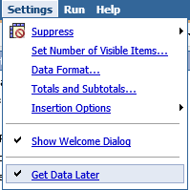

Navigation
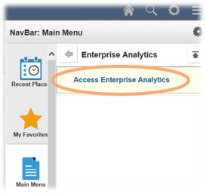
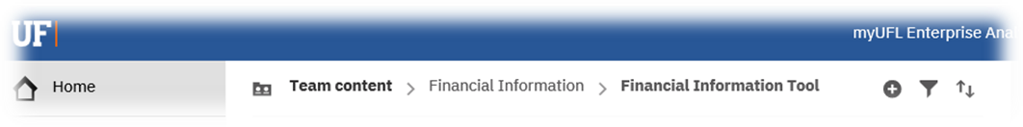

Analysis Studio Interface – Similar to PowerPlay!

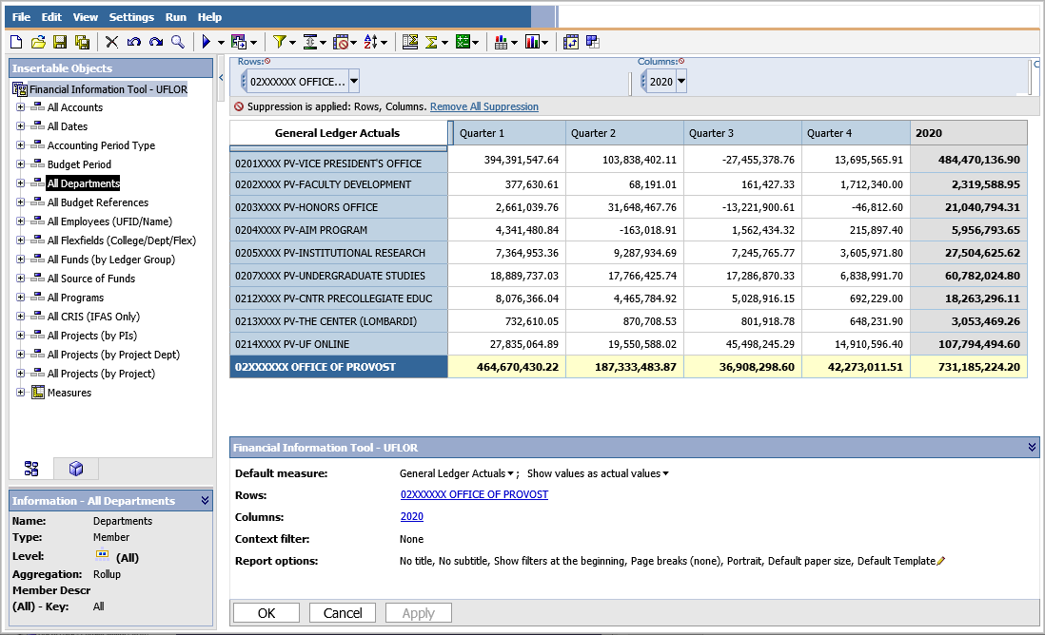
- The Work Area - The work area contains the crosstabs and charts that you use to explore and analyze data. You can view your analysis as a crosstab, a chart, or a crosstab and a chart.
Information Pane
Properties Pane
Analysis Tab
Work Area
Source Tree
Overview Area

- The Source Tree - The Source tab of the Insertable Objects pane contains the source tree for the package selected for the analysis.

- The Analysis Items Tab - The Analysis Items tab contains items created in the analysis, such as custom sets and named sets.

- The Information Pane - The Information pane shows the name, level, attributes (if any), and aggregation associated with the selected item in the source tree, as well as any additional information provided by the data modeler.

- The Properties Pane - The properties pane provides a comprehensive view of the crosstab or selected set in the work area.

- The Overview Area - You can use the overview area as a convenient place to quickly explore and change the contents of the work area.

The Menu Bar – Now at the Top!
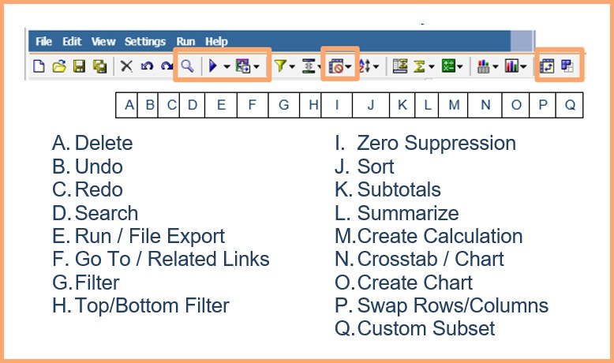

Gathering Data

Search for specific values or descriptions
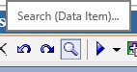
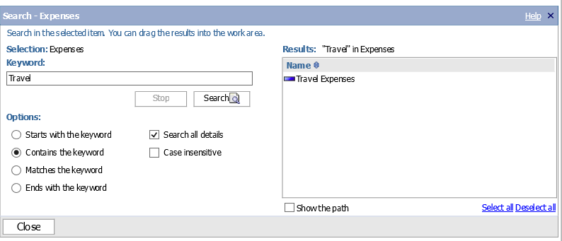

Using Source Tree or Overview Area

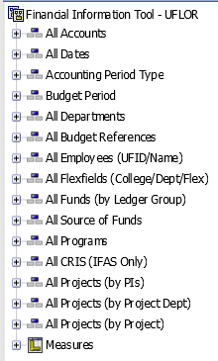
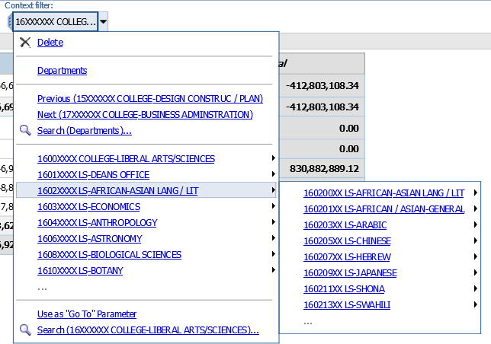

Organizing Your Canvas

‘Drag-n-Drop’ onto the “Hot Spots” just like PowerPlay!
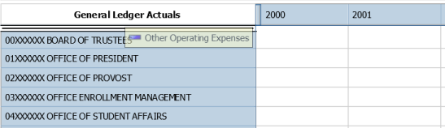

Insert, Replace or Nest Rows and Columns just like PowerPlay!
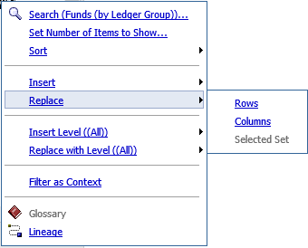
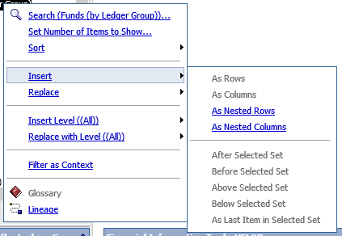

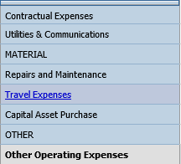

Expanding and Drilling Up or Down a Level
Down a
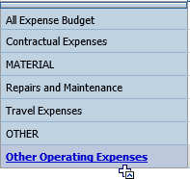

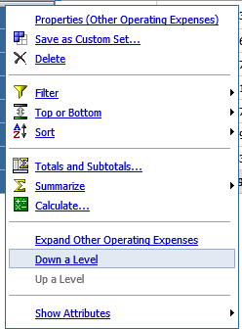

Up a Level
Expand or Down a Level

Reorder Columns or Swap Rows and Columns
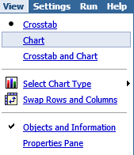
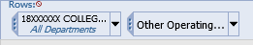

Delete Data from Your Work Area
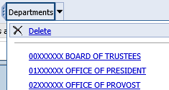

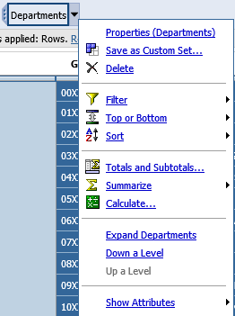

Drill Through Reports – Get the Details!
Access any Related Reports (Drill Through Reports) from within the Cross Tab body by highlighting a cell and using the right click on the mouse to access the drill menu. Navigate to the option Go To and click on Related Links.
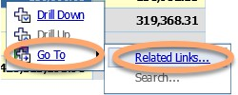
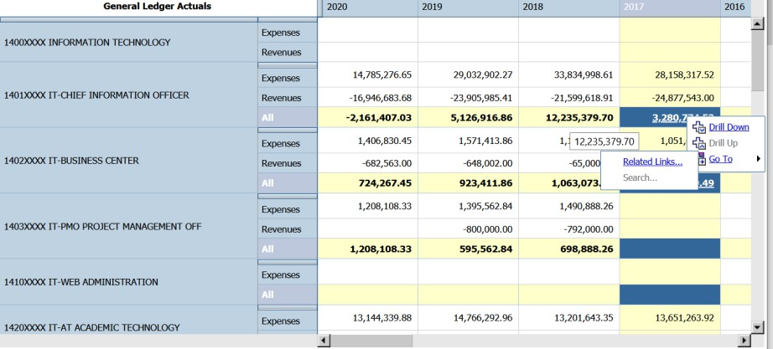
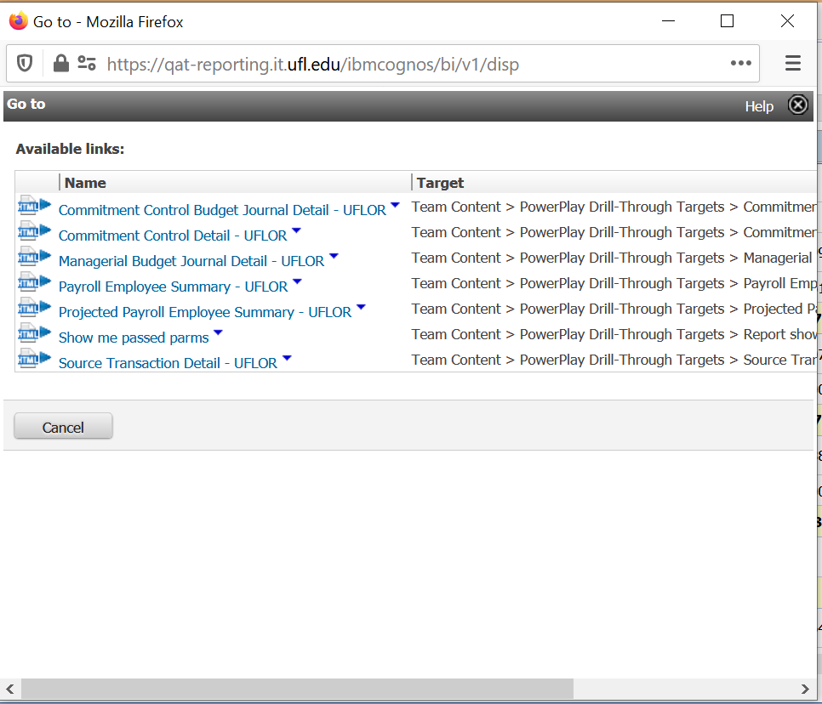


Custom Subsets – 2 Options

Insert, Replace or Nest Rows and Columns just like PowerPlay!
Select multiple items directly from the tree using the Ctrl key and your mouse.
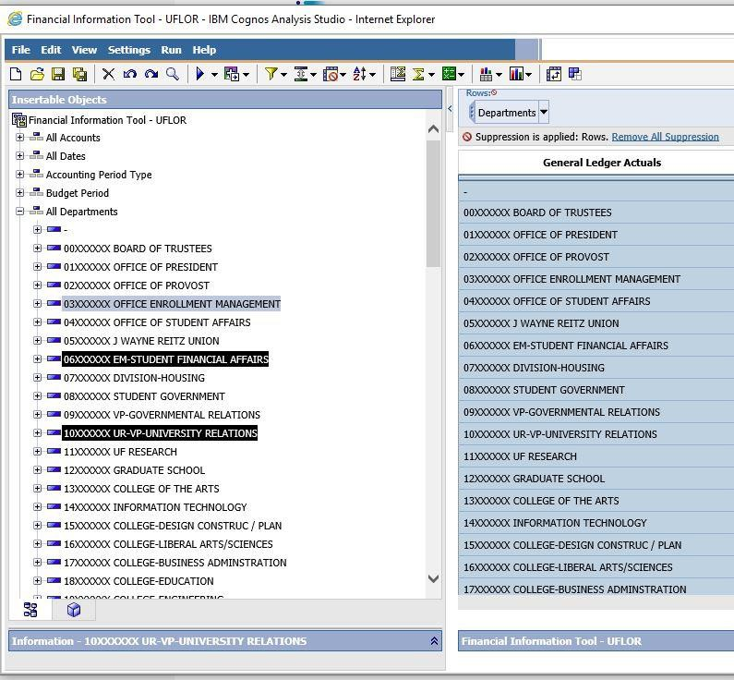
Drag the selected items over to the crosstab and drop.
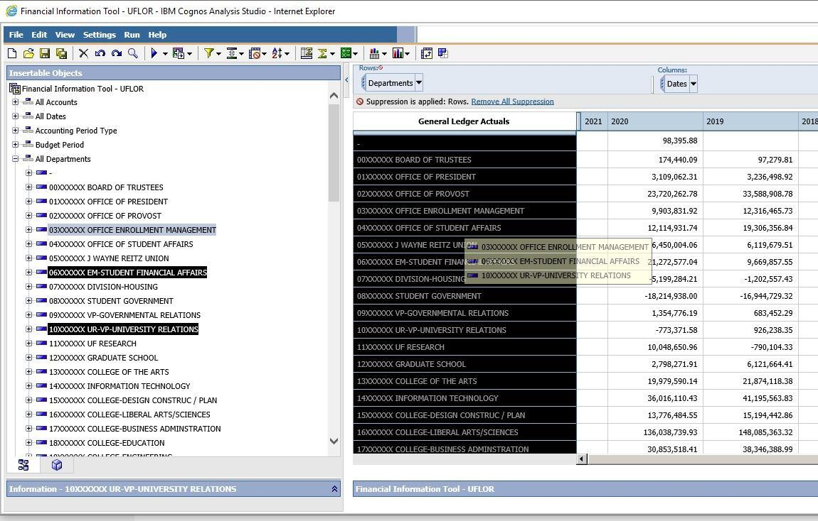

Once you drop the selected items, the crosstab will reflect your selection as seen below.
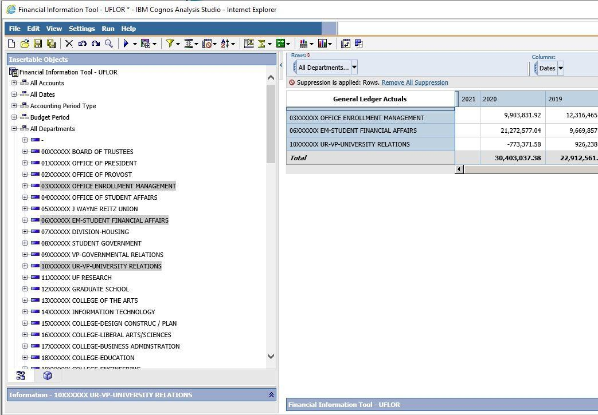

Finally, from here if you right click on the selected items in the crosstab, you can see a drop down menu where you can save your items as a custom set.
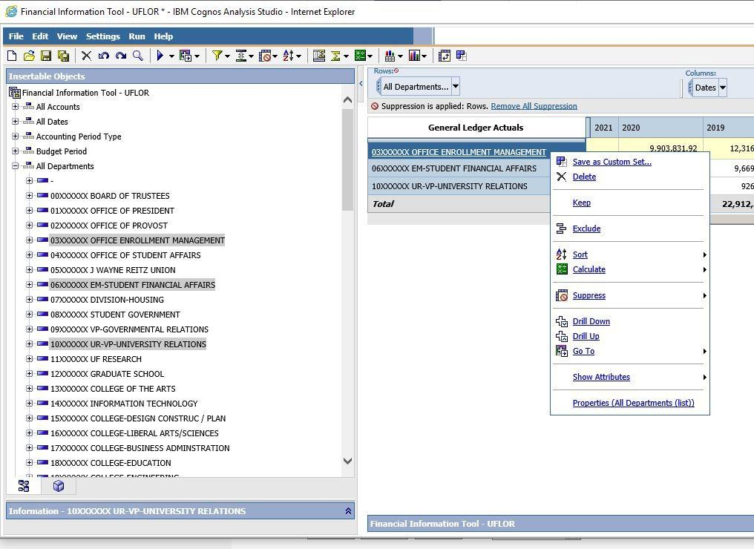

Create a subset without using the drag and drop method.
To create a subset of items, you can select the items holding the CTRL key and using the mouse to Left Click on each item you wish to group. Right click on the item(s) selected and you will be presented with a drop down menu shown below.
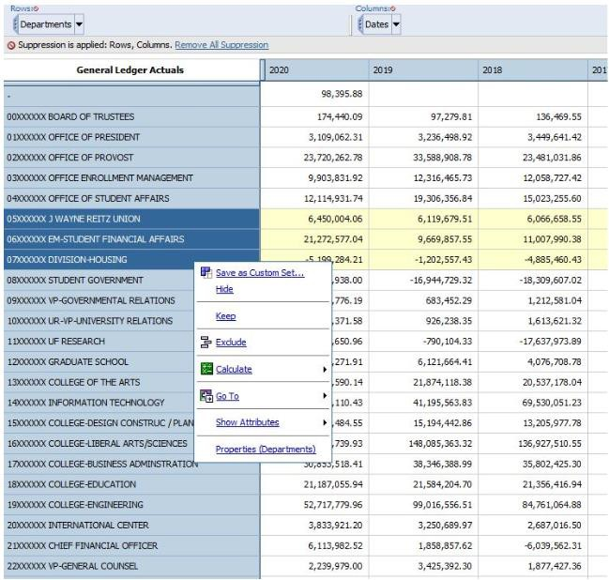

From this drop down menu, select the Save as Custom Set… option. This will open the Save as custom set dialog window shown below. Here you will give your Set a name and optionally provide a Description for your set. You can save over an existing Custom Set or save a newly created subset.
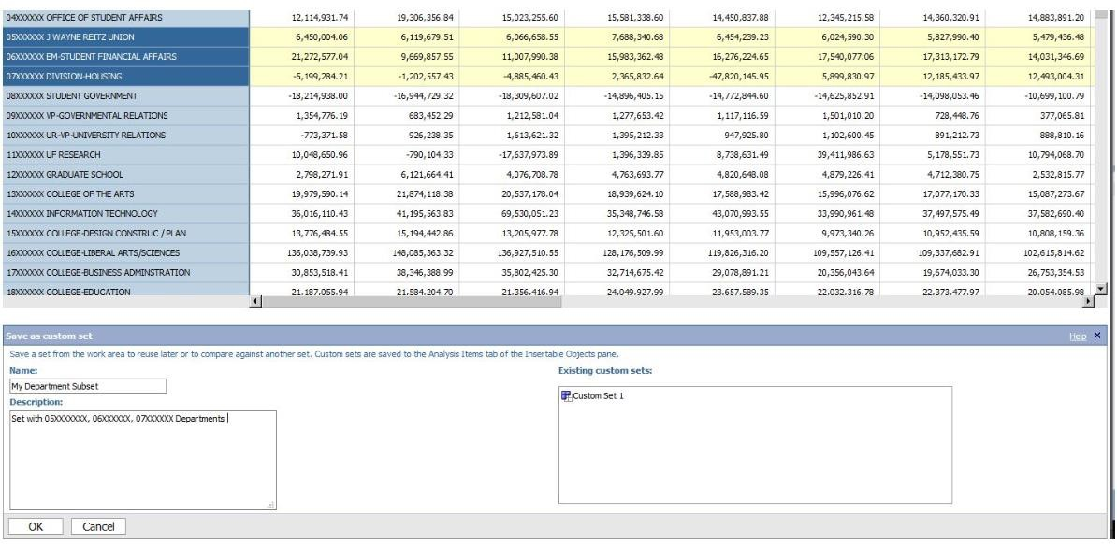

Your custom Sets are saved to the Analysis Items tab of the Insertable Objects pane.
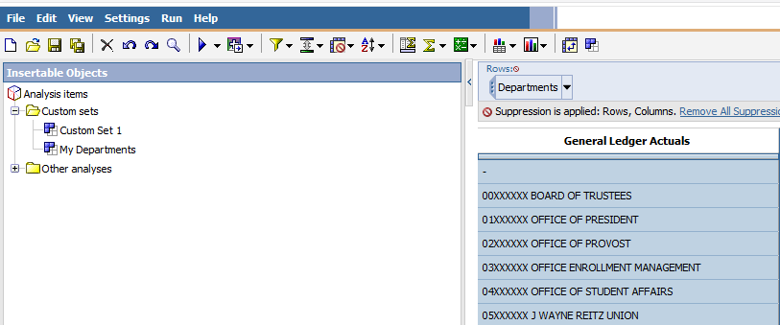

Where they can easily be dragged onto the worksheet to replace rows, columns, or used as a Context filter. The Custom Set’s use menu can be accessed by right clicking on the Custom Set. See below.
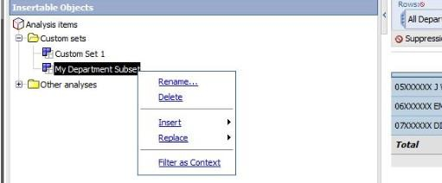

A Few Reminders
- Drag-n-drop—it’s that easy!
- Use Internet Explorer browser

Help
- 392-HELP – UF Help Desk
- Include details:
  - Browser Information
  - Navigation
  - Error Messages
  - Expected Results
- Include your UFID and/or GatorLink username

Additional Reference Material
IBM® COGNOS® ANALYSIS STUDIO OVERVIEW -
https://www.ibm.com/support/knowledgecenter/en/SSEP7J_11.0.0/com.ibm.swg.ba.cognos.ug_cr_pp s.doc/c_id_ans_overview.html#id_ans_overview
IBM® COGNOS® ANALYSIS STUDIO CANVAS/INTERFACE
https://www.ibm.com/support/knowledgecenter/en/SSEP7J_11.0.0/com.ibm.swg.ba.cognos.ug_cr_pp s.doc/c_id_pps_ui_window.html#id_pps_ui_window

