
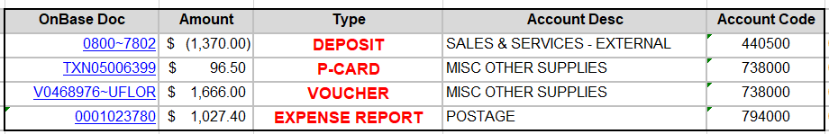
New Option – Source Document Hyperlinks
Transaction Detail Report will provide the hyperlinks to supporting documentation in OnBase (all supporting documentation except for journal entries).

New Navigation to Access Monthly Reports
- Starting May 3rd to access Enterprise Analytics via myUFL: Main Menu > Enterprise Analytics > Department Reports
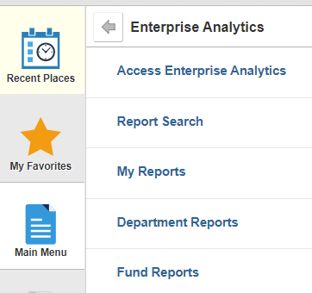
- Department or Funds Reports: Select Department Reports or Fund Reports
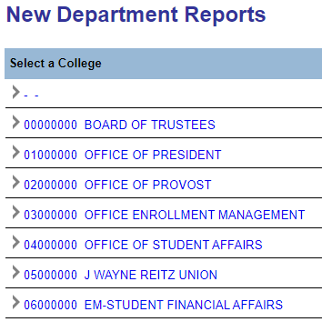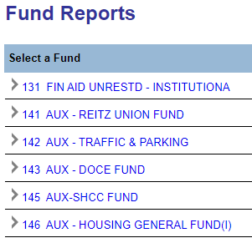

- Available monthly Delivered reports are available, same format as previously
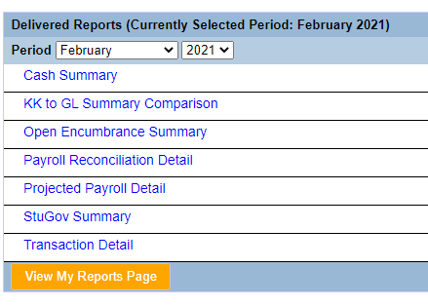
- Other Reports: All other reports (Sponsored Program Reports, Residual/Overhead Reports, Construction Project reports) can be also accessed through Enterprise Analytics:
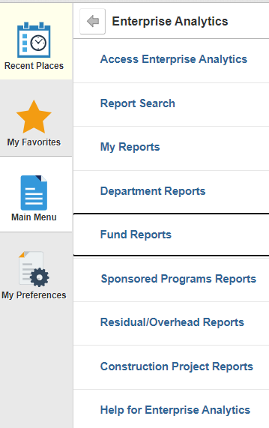

Helpful Tips

  - All transaction details, except for journal entries, will have hyperlinks to corresponding supporting documentation in OnBase.

  - When using the report, either download the report to your desktop or right-click on the hyperlink to open the supporting documentation in a new tab.
    - If you simply click on the hyperlink, you will be redirected towards OnBase and will be required to reopen Enterprise Analytics.

  - If the hyperlinks do not work properly in the Excel version of the report, you may need an update on your computer.
    - If you are using a UF-owned computer, contact your department’s IT support.
    - If you are using a personal computer or are unsure of who to contact, please contact the UF Computing Help Desk at 392-4257 or email helpdesk@ufl.edu.
  - To access OnBase source documents, please verify that you have myUFL Security Role: UF_FI_UNIVERSAL_INQUIRY.

  - If you have questions regarding financial data or appropriate use of Enterprise Analytics financial reporting, please contact General Accounting
at gahelp@ad.ufl.edu.

