How to Create a Pivot Table
The following instructions will walk you through how to create a Pivot Table in Microsoft Excel.

Navigation
Login into myUFL and navigate to:
Main Menu > Enterprise Reporting > Department Reports > Select a College

Instructions
- To download the Transaction Detail, Select a Department > Open Transaction Detail as Excel Report by selecting the Excel icon .
- In Excel, on the Insert tab, of the Pivot Tables group, select PivotTable.
- The Transaction Detail data should automatically be selected in the table range. If it is not selected, then do this:
  - Under Choose the data that you want to analyze, click on the radio button for Select a table or range.
  - Verify the cell range in the Table/Range field by selecting the data from the Excel worksheet.
- Under Choose where you want the PivotTable report to be placed, click on the radio button for

New worksheet.
- Click OK.

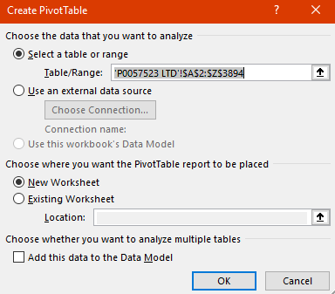

- From the Pivot Table fields, drag Posted Amount into the Sum Values area.
Note: Consider formatting this number into an Accounting format to help compare numbers.
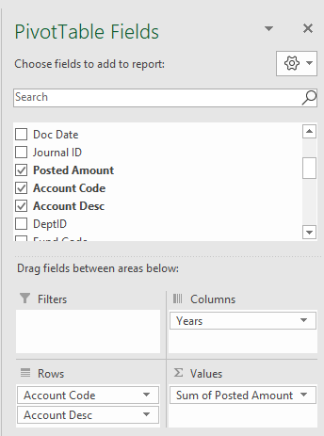
- Drag Fiscal Year from Pivot table fields to the Columns area.
- Drag Account Code and Account Desc to the Rows area.
- Compare amounts or create variance columns.
- Double click on any cell with an amount to review the data behind the number.
