Index Match Formula Instruction Guide
A helpful tool to identify possible risky transactions is to use the INDEX MATCH formula in Excel. This formula combines two functions, INDEX and MATCH, to look up and return the value of a cell in a table based on vertical and horizontal criteria. The advantages of using an INDEX MATCH formula, instead of the VLOOKUP function, include having the ability to:
- return values in columns to the left
- specifically focus on searching a single column to look up and return values.

Navigation
Login into myUFL and navigate to:
Main Menu > Enterprise Analytics > Team Content > Monthly Financial Reports

Instructions
- Login into myUFL and navigate to: Main Menu > Enterprise Reporting > Department Reports > Select a College.
- To download the Transaction Detail, Select a Department > Open Transaction Detail as Excel Report by selecting the Excel icon .
- Start a new Excel file and label Sheet 1 tab as Data.
- Copy and paste information from the Transaction Detail into the Data worksheet.
- Add another worksheet (a new tab in the same workbook) and label it Risk Term.
- Open the sample Risk Term Table Excel file located on the Financial Data Solution Center Website and copy and paste it to the Risk Term worksheet you created.

Note: The sample Risk Term table includes keywords that potentially indicate risky transactions, and should be adjusted based on the Fund, specific terms applicable for your department, or based on specific focus areas. These keywords will be used by the INDEX MATCH formula to search your data for possibly risky transactions.

- On the Risk Term worksheet, click on cell 1 row A, and click on the Table Design tab from Table Style Options Group.
- Review the Table Name in the Properties Group as you will need this information for your INDEX MATCH formula. In this example, our Table Name is Table1. The table name can be changed to your preference.
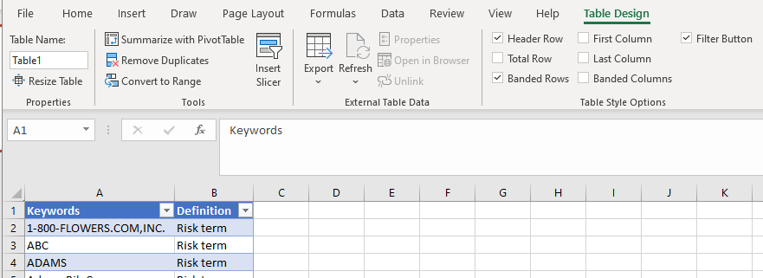

- Return to your Data worksheet. Insert and label a new column to the right of Doc Detail called Risky Term?.
- After adding your Risky Term? column, change the format of the column from Text to General on the Home tab.
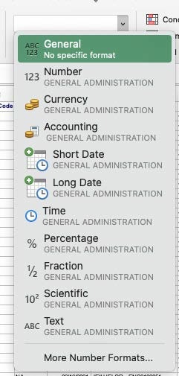

- In this new column, enter our INDEX MATCH formula into row 2:
=IFERROR(INDEX(Table Name[[Definition]], MATCH(TRUE,ISNUMBER(SEARCH(Table
Name[Keywords],Column#)),0)), “not”)
Note: Items in boldface should be changed according to your data/naming conventions explained below.
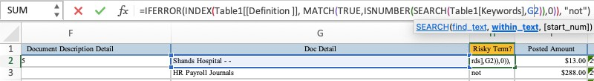

a. =IFERROR is an Excel function that returns a custom result even when a formula generates an error & returns standard results when no error is detected. INFERROR is used instead of complicated IF statements.
  - INDEX is the Excel INDEX function being applied to our Risk Term Table, aka Table Name (in this example, Table1). Furthermore, [[Definition]] is the specific column our INDEX formula is pulling from the Risk Term Table to filter our data.
  - MATCH is the Excel MATCH function being applied to our Risk Term Table, Keywords column.
  - TRUE is an Excel function that will return results that match any of the Keywords from the Risk Term table
  - ISNUMBER and SEARCH are Excel functions working together to search a string of texts to return a match to the Keywords from the Risk Term table
  - Column# requires you to enter the corresponding column that contains the details of the transaction. In our example, our column would be G2 since we are analyzing the second row for the Doc Details located in column G. If the Doc Detail column is different in your data, you would use that column.
  - 0 is used in MATCH functions to look for an exact match
  - “not” is used in conjunction with IFERROR. If the transaction description does not contain any keywords in the data, the results will indicate no keywords found with “not” as the placeholder in the field

- After the INDEX MATCH formula has been applied to one row, double-click on the bottom-right corner to apply the formula to the rest of the data set.
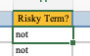

- To further filter the Data worksheet by risky keywords, refer to the How to Create a Pivot Table instruction guide.

