


Introductory Enterprise Analytics
User Guide

Last Updated: December 2021
0 | P a g e

Contents

Introduction 3
Basic Information 3
New Features of Enterprise Analytics 3
About the Data Warehouse 3
Accessing Enterprise Analytics 5
Welcome Page 5
Navigation 8
Top Navigation 9
Left Side Navigation Panel 9
Home 11
More/Set as Home 11
Page Switcher 12
Personal Menu 13
Notifications 13
Exploring Content and Menus 14
My Content, Team Content and Recent 15
Search and Find Content 17
Narrow Search with Filters 18
Viewing and Interacting with Content 19
The Action Menu 19
Running Reports 20
Changing Report Format 23
Properties of a Report 25
Prompts 26
Changing Report Prompts 27
Report Options 28
Subscriptions 28
Report Views 29
Schedules 30
Managing Your Schedules and Subscriptions 33
Password Protecting PDF Documents 33
Editing Reports 34
Report Versions 35
Thank You and Additional Assistance 37
For Additional Assistance 37

Introduction
Welcome to Enterprise Analytics! The University of Florida utilizes Enterprise Analytics, powered by Cognos 11, a web-based reporting solution for creating and running reports that includes financials, human resources, sponsored projects and student information data. The data in Enterprise Analytics is comprised of daily financial transactions and employee and student information data processed in myUFL.
Specific departments within the University of Florida take ownership and govern the data in the data warehouse. The main three security roles needed to access packages are UF_FI_UNIVERSAL_INQUIRY (financial data) , UF_HR View/Inquiry (HR data), UF_ER_SA_Student_Financials (student data) To acquire access to a specific package, work with your supervisor and Department Security Administrator (DSA).

Basic Information
- Information in Enterprise Analytics is current as of the close of the prior business day.
- Enterprise Analytics works with any of the following browsers – more information can be found on the IBM website:
  - Firefox *
  - Chrome
  - Internet Explorer*
  - Safari

 Analysis Studio(Cubes) is only compatible in Internet Explorer or Firefox.

New Features of Enterprise Analytics
The first thing you will notice when you login to Enterprise Analytics is the modern interface, which has more emphasis on self-service and the user experience. Here are some of the features to look forward to (depending on your security roles):
- Completely redesigned interface – prior users of Enterprise Reporting should know that “Report Author” replaces Query Studio and “Analysis Studio” replaces the FIT Cubes
- Prior users of Enterprise Reporting will note My Folders and Public Folders have been renamed
- New and improved search functionality
- Fly-out menus(a horizontal version of a dropdown menu) to see folder content
- Ability for users to upload data
- Dashboard and storyboarding functionality
- Subscriptions for end users instead of (and/or in addition to) schedules

About the Data Warehouse
The University of Florida data warehouse is a database that is optimized for rapid data retrieval. Within the data warehouse are data warehouse tables, which can be thought of as individual spreadsheets within an Excel document. The data model is built on top of data warehouse tables and allows end users to build reports or dashboards visually instead of using code (i.e., SQL, HTML) to pull data.

On a nightly basis, via the Extract, Transform, and Load (ETL) process, the data is moved from the source systems (like myUFL) into the warehouse (and Enterprise Analytics). Therefore, information in the data warehouse is as-of the close of the prior business day. Remember, data in Enterprise Analytics is only as accurate as the data entered into source systems like myUFL. If you see data that doesn’t seem correct in Enterprise Analytics, the first step is to check the source system.
This diagram shows how data flows from source applications into the reporting
application. Understanding this process at a high level will help end users think critically about the data.

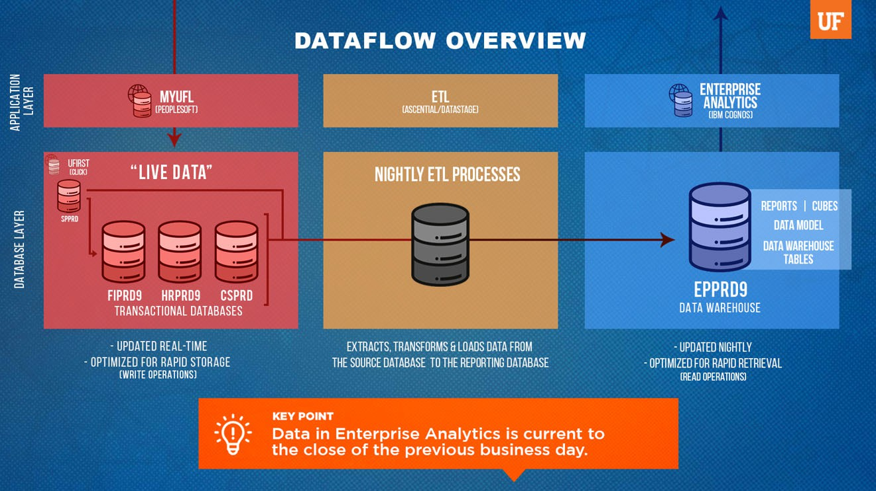
Here are some key parts of this diagram:
- On the top left is the application layer where end users access the myUFL application (aka PeopleSoft). Data entered into myUFL is stored real time into the PeopleSoft Databases.
  - There are multiple databases "underneath" or behind myUFL and each one is represented by a stack of three cylinders.
    - FIPRD9: FI stands for Financial: This database stores financial transaction data like vouchers and journal entries
    - HRPRD9: HR stands for Human Resources: This database stores hiring, job changes, leave and more
    - CSPRD: CS stands for Campus Solutions: This database stores student data like scheduling and course loads
  - To the upper left of the myUFL databases is the UFIRST application. End users enter grant proposals into this system and it is stored real time in the UFIRST database. The UFIRST database is named SPPRD (SP stands for Sponsored Programs).
- In the middle is the nightly ETL process. The ETL is the bridge between where end users enter data into myUFL and where end users report on data in Enterprise Analytics. These processes

retrieves data entered into myUFL, organize it to make it easier for end users to pull reports, and load it into Enterprise Analytics every night.
- On the right is the database layer, where data is stored in the Data Warehouse.
- The last step is Enterprise Analytics on the top right. This is in the application layer where end users access Enterprise Analytics and where data flows back out to end users.

Accessing Enterprise Analytics
- Login to myUFL with your Gatorlink username/password.

Navigate to: Main Menu >> Enterprise Analytics >> Access Enterprise Analytics.

Welcome Page
The first screen you may see is the Welcome Page – this is where everything happens. Your opening screen might look different depending on your “view” of Enterprise Analytics or whether you have accessed the system before. From the Welcome Page (depending on your security roles) you can run reports, search for content, view content, open dashboards, upload files, check your notifications, set your preferences, review your subscriptions, watch “how-to” videos in ‘Getting Started’ and view samples developed by UFIT.

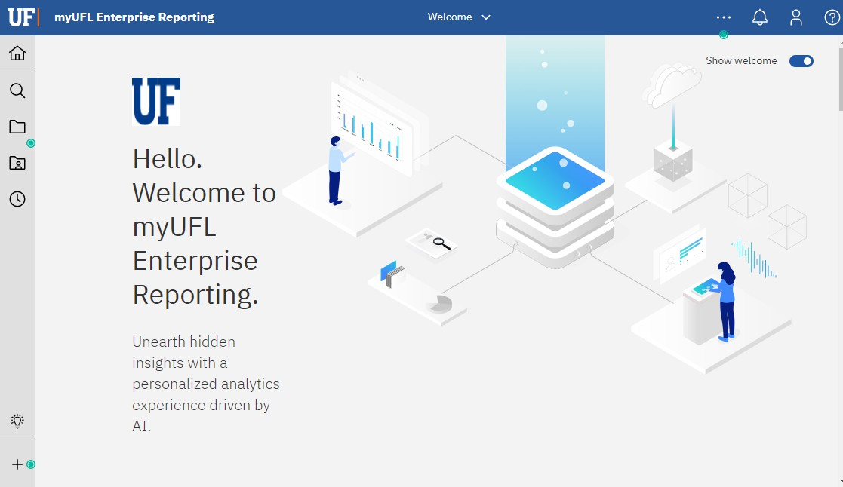
Depending on your magnification and/or browser, you may or may not see text next to the icons on the left navigation pane. Increasing or decreasing your zoom level will determine whether the left navigation pane includes only icons (as seen above) or text next to

the icons.

If you see the glowing green dots, these are “Hints” to help you navigate Enterprise Analytics.
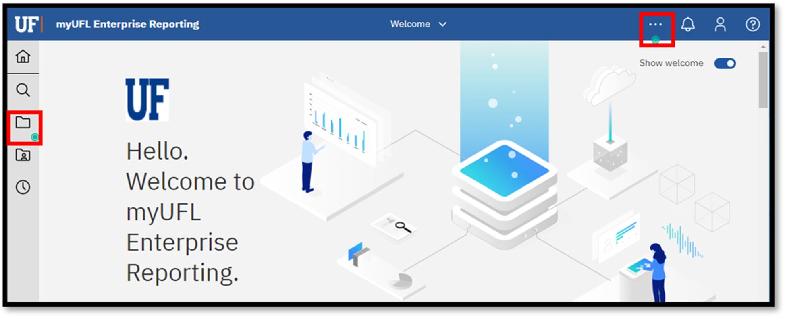

As you get more comfortable with the tool, you can select one of the hints and click Turn off hints to turn off that particular hint.

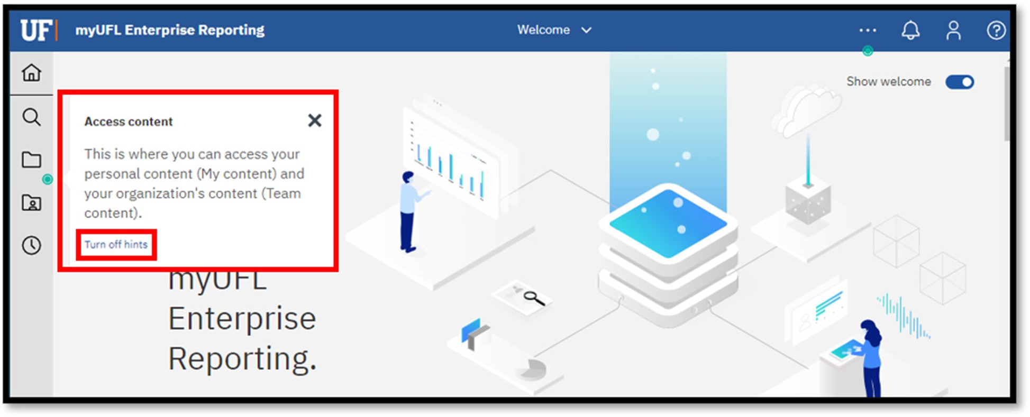

You can also turn all hints on or off from My preferences under the Personal menu by unchecking Show hints.
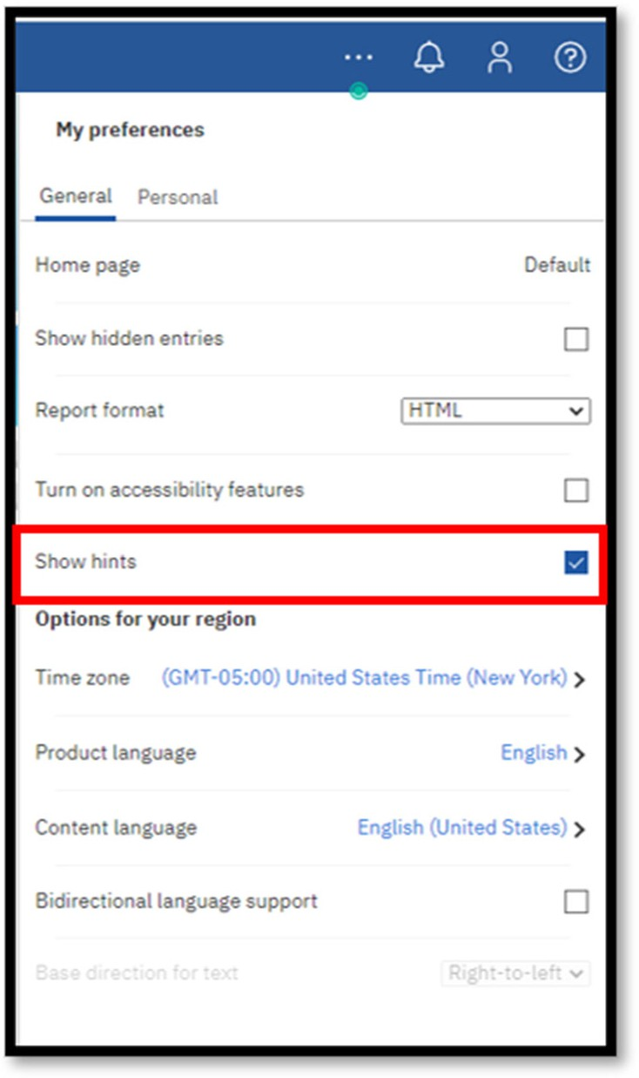
Finally, the bottom of the Welcome Page has tiles to quickly access items you have recently used. By default, you will see up to 20 tiles. You can change the view from tiles to a list by selecting the “List” image.
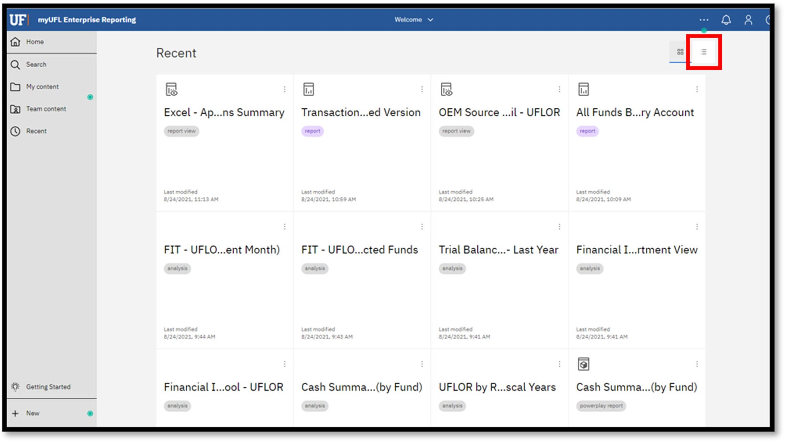

Clicking the (Action Menu) for a tile will reveal an action menu to allow you to interact with the item. This is a quick way to return to items you have recently used, and helpful for fiscal users that often access the same items.
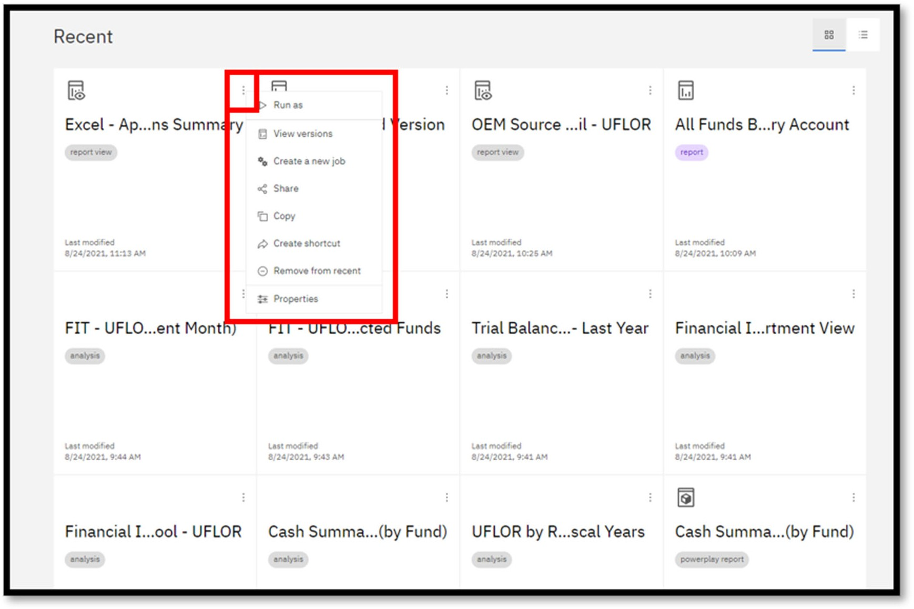

Navigation
The new user interface means that you will have new ways to move around in Enterprise Analytics. Here are some navigation tips!

Top Navigation
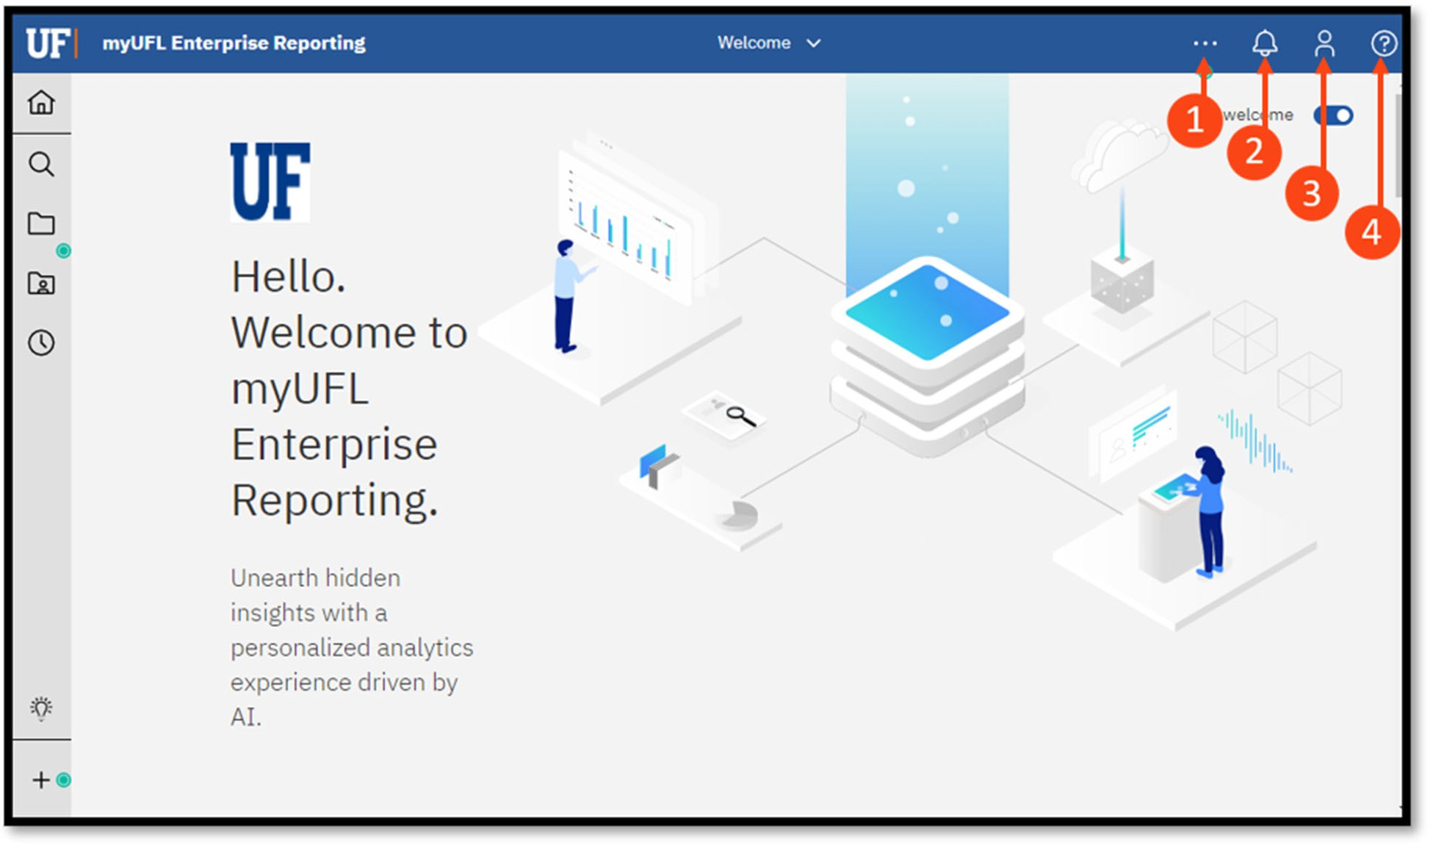
The icons at the top right corner of the Enterprise Analytics home screen include:



More icon: context sensitive content depending on where you are in the system


Bell icon: provides alerts for notifications (such as when a scheduled report has been run or sent)


Person icon: set personal preferences (such as default report format)

Question icon: access to the help, tool specific

Left Side Navigation Panel
On the left side of the screen are new icons that represent features from the prior tool used by the University, Enterprise Reporting.

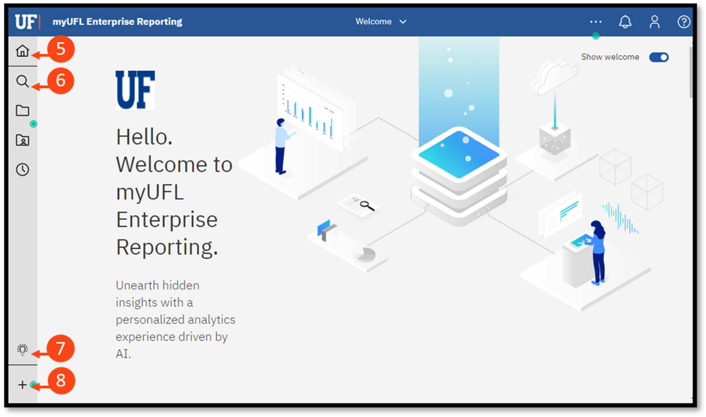



Home: returns you to the home screen


Search: search functionality for finding reports


Getting Started: contains help videos

New: click to create a new report, dashboard or upload your own CSV or Excel file (These options are used by Advance Users and are covered in the Advance Guide)

Home
The Home button will return you to your home screen in a single click.
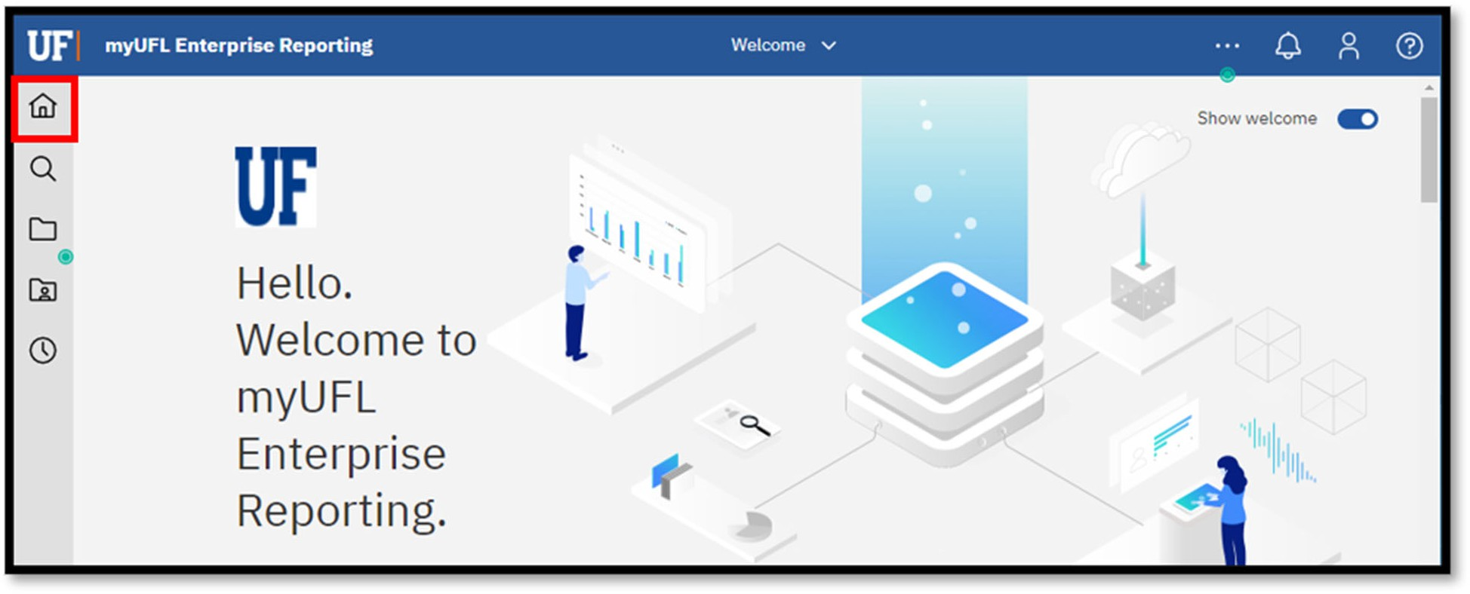

More/Set as Home
You are encouraged to click the More (…) button anytime you see it, especially as you explore and learn the new user interface. The options behind the More button could change as it contains context sensitive content depending on where you are in the system.
If you prefer, it is possible to make other content (like reports or dashboards) your Home Page. Click the More button on the application toolbar and select Set as home when your current view is the one you would like as your home page.
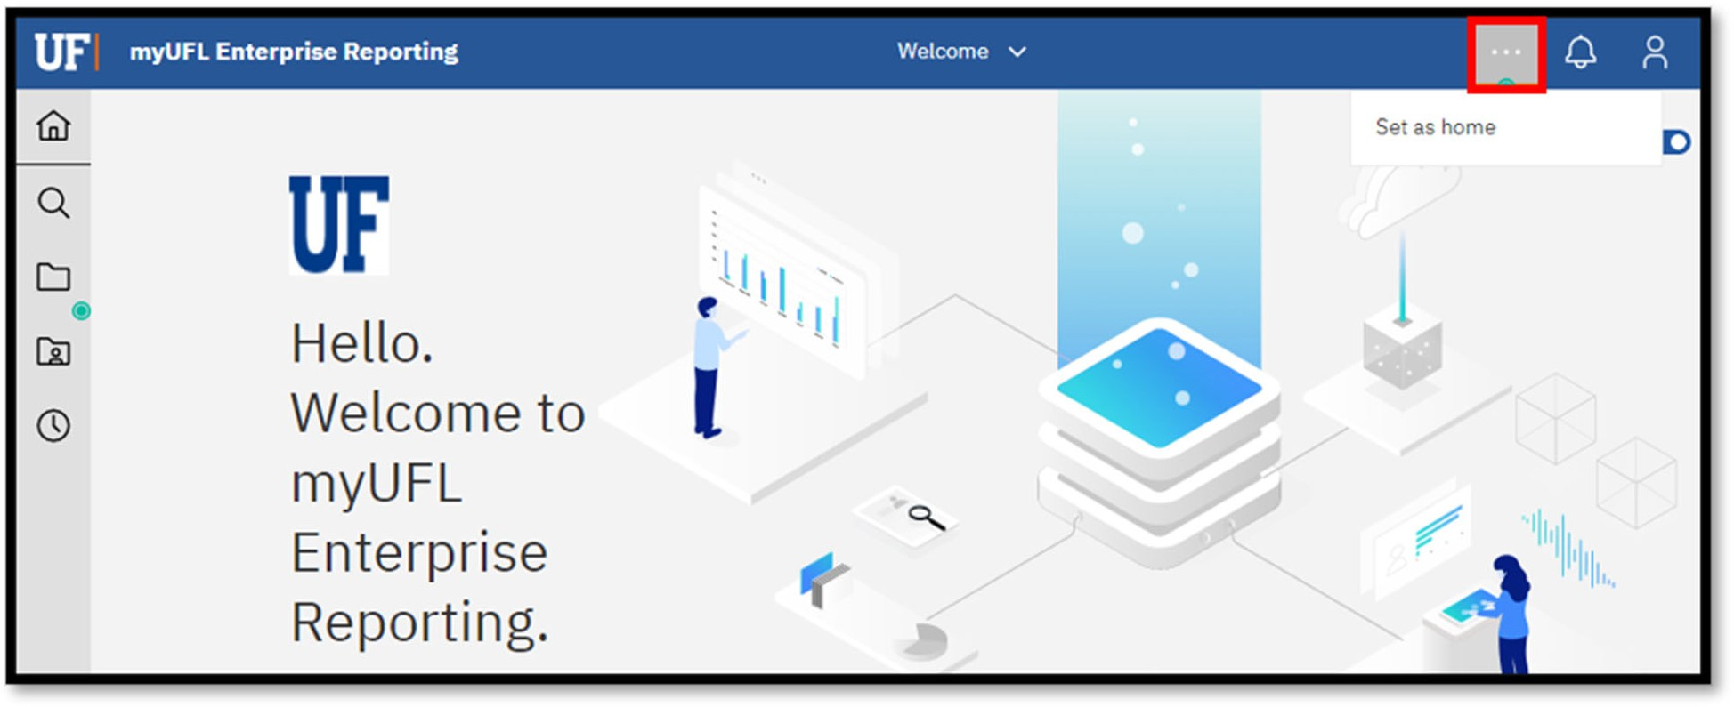

Page Switcher

At the top of the page is the Welcome/Page Switcher drop-down icon. If you click the drop-down on the Welcome/Page Switcher drop-down, you can select a different page. If you select Welcome, you will return to the Welcome Page.
This is useful if you set a different page as your Home page but would like to get to the Welcome Page quickly.
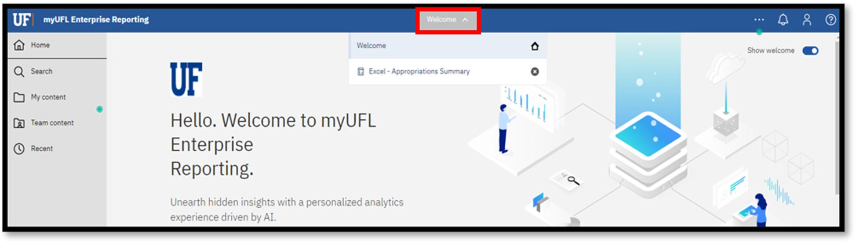
The Page Switcher in Enterprise Analytics offers the ability to have multiple reports, dashboards, etc. open at the same time (in the current session) making it easy to quickly switch between them. Once a report has been run, it will remain open in the Page Switcher tray until you close it (or end the session).
You can close objects that are open in the tray by clicking the X to the right of the name.

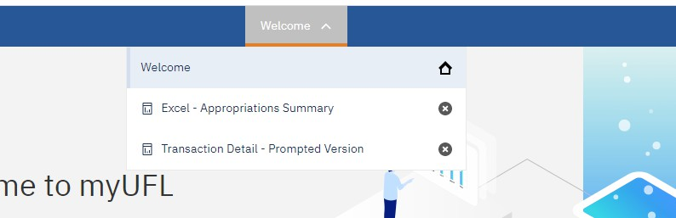
Clicking back to an open report from the Page Switcher will not “re-run” the report or allow you to choose new prompts. It will only return you to the report’s last output based on your prior selections.

If you need to re-run your report, you will first need to close the active report from the Page Switcher tray as shown above or use the steps in the Prompts section later in this guide to reset your prompts.

Personal Menu

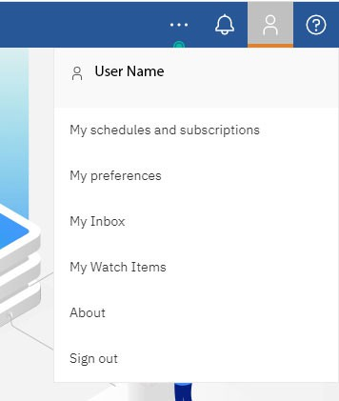
This menu allows you to adjust your personal settings, change your preferences, easily make modifications to your schedule and subscriptions, and logout of Enterprise Analytics.

 You can turn on accessibility features in My preferences under your personal menu.

Notifications
Alerts are shown as numbers next to the Notification (bell) icon. If you Subscribe to reports, once they finish running the numbers of alerts will increase next to the icon and a direct link to the report will show in the Notification pane.

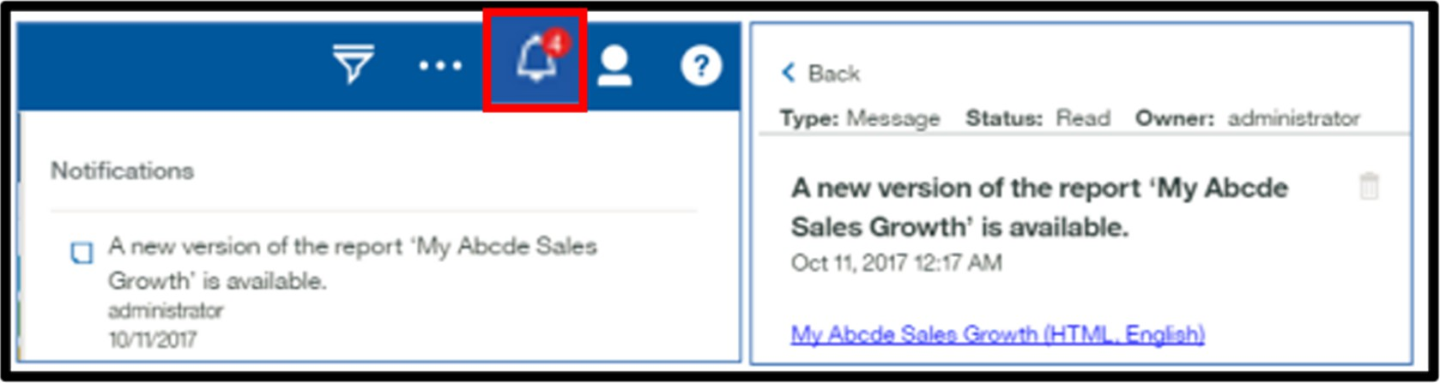

Exploring Content and Menus
The fly-out menus easily let users explore content within their folder(s) and perform other tasks depending on their security roles.
Hovering over a report (or other object in the content pane) will reveal the More (…) button. The More

button provides an Action menu, which shows the tasks you can perform for that particular item. Below are some key parts of the menu:


Use the breadcrumbs to navigate within the content and get back from a destination within your folder(s)


Use the Filter button to narrow the contents being viewed in the pane


Click the Sort button to sort content in ascending or descending order by name or last modified date

Resize the content pane by clicking and dragging the two small lines on the border of the pane to the desired location
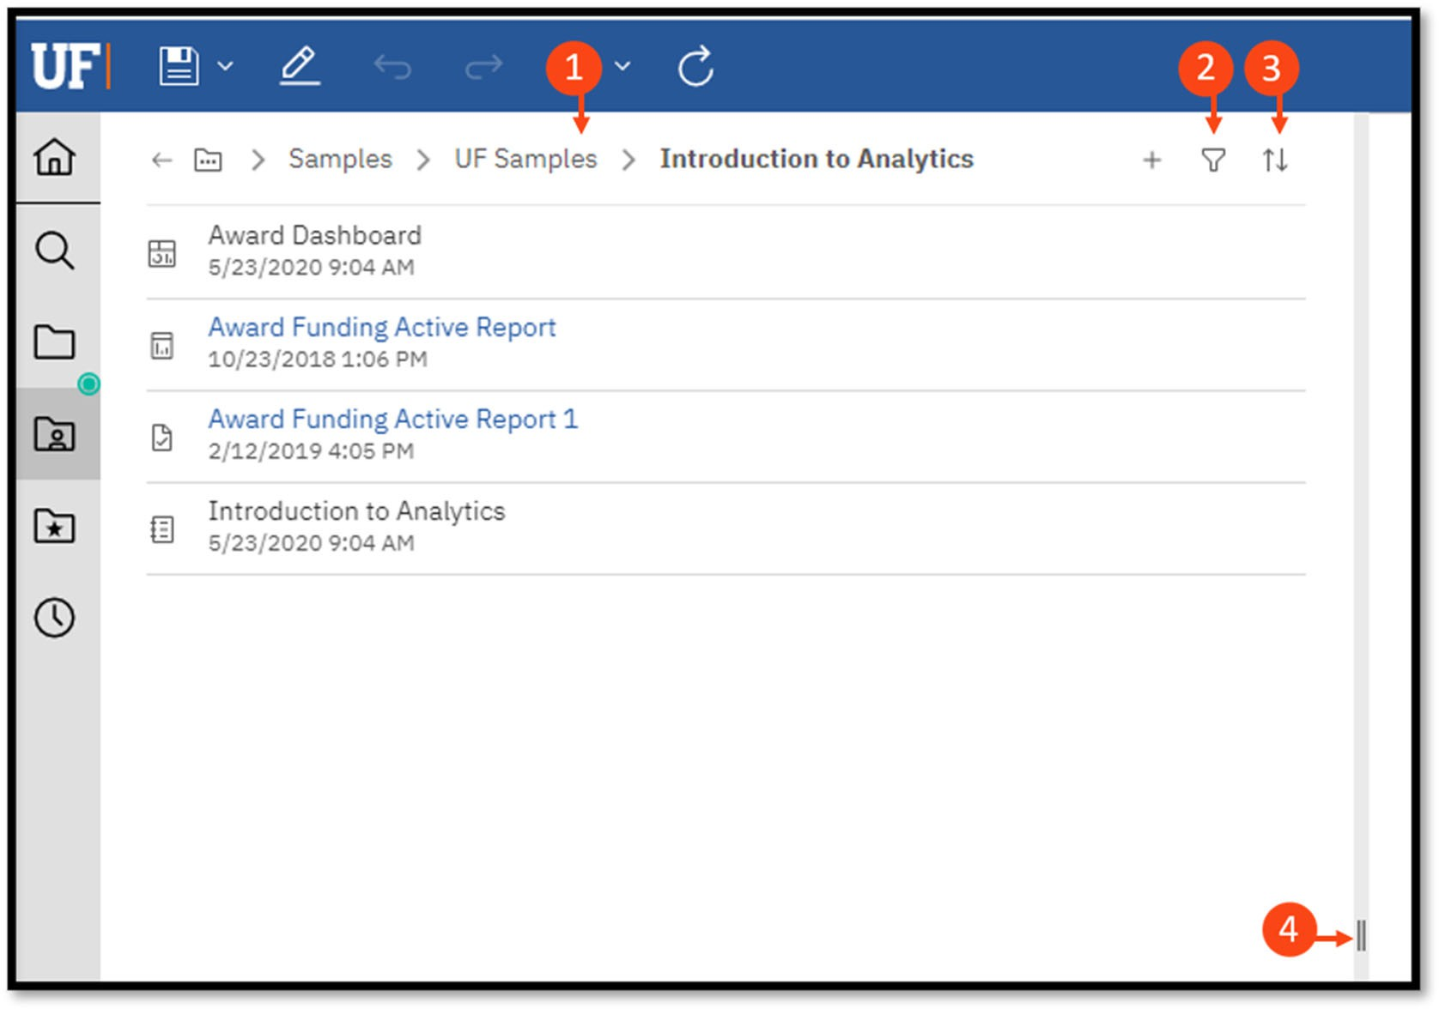

My Content, Team Content and Recent
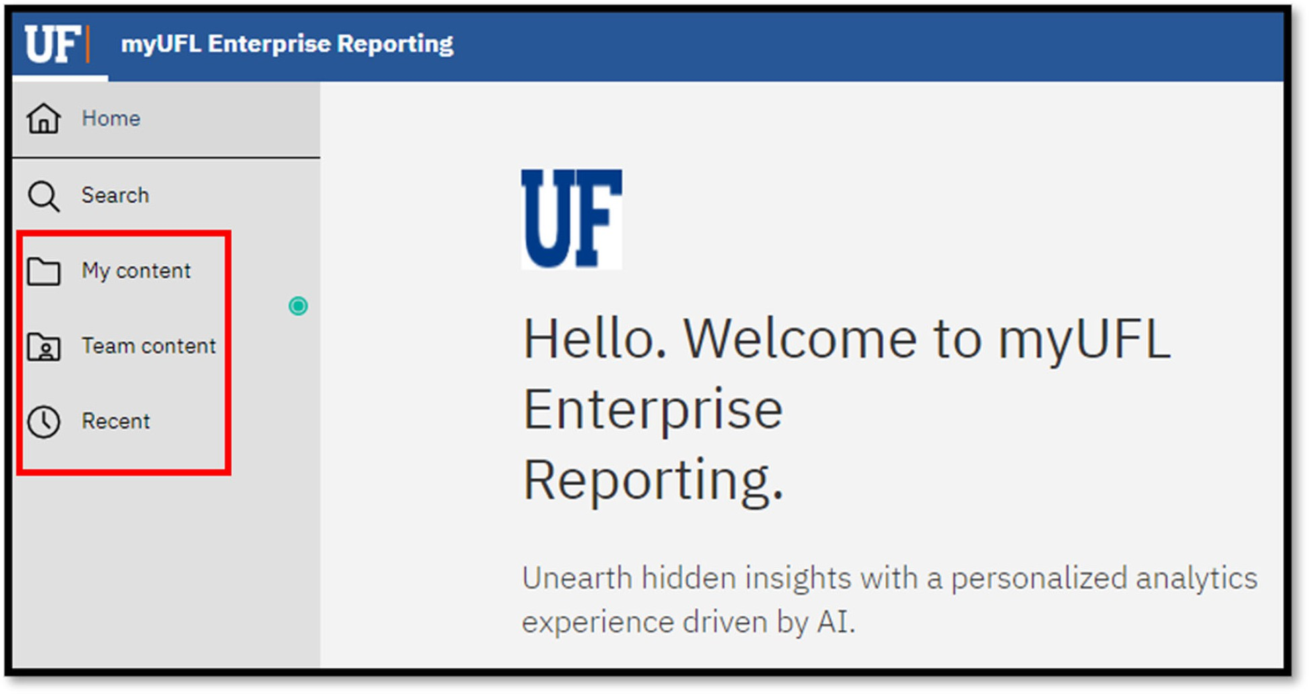
My Content (formerly known as My Folders) is a user’s secured area within Enterprise Analytics that provides direct access to any content you have saved there. It cannot be accessed by other users.
A key feature is that once reports have been saved to My Content, you can modify and personalize them. My Content gives you the ability to copy reports from Team Content folders and save them to your My Content folders (how to do this will be covered later!).

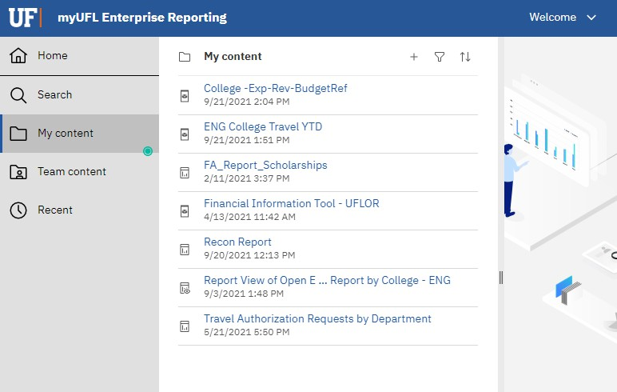

Team Content (formerly known as Public Folders) is the area within Enterprise Analytics that reveals any folder containing reports (or other objects) that you have access to based on your security roles. You cannot modify or personalize reports in these folders. Many of the reports developed by the core offices that can be helpful for users are found here, such as:
- Financial Information
- Human Resources Information
- Monthly Departmental Reports
- Sponsored Projects Information
And more! Continuing to scroll down Team Content will bring you to the Shared Folders that are department specific.


Check with your team to find out the useful items that are found in this folder.

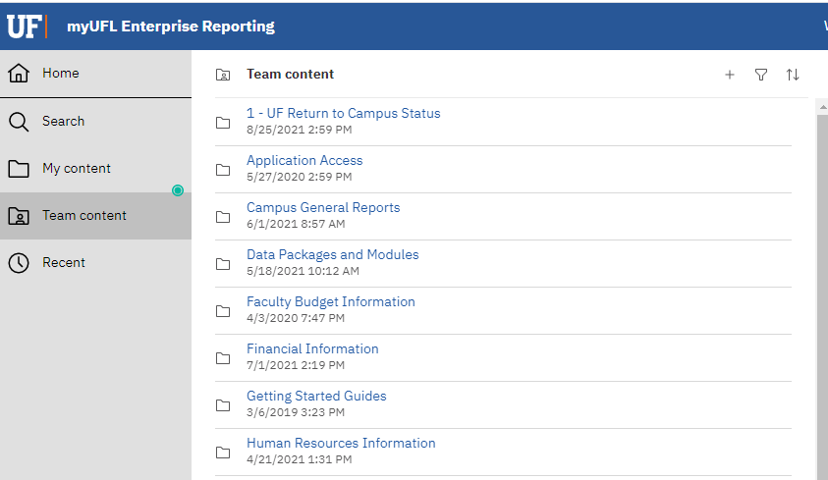

Recent shows recently used content, up to the last 20 items. Click directly on a report name to run it, or hover over a report/object name to reveal the More button for a list of new actions.

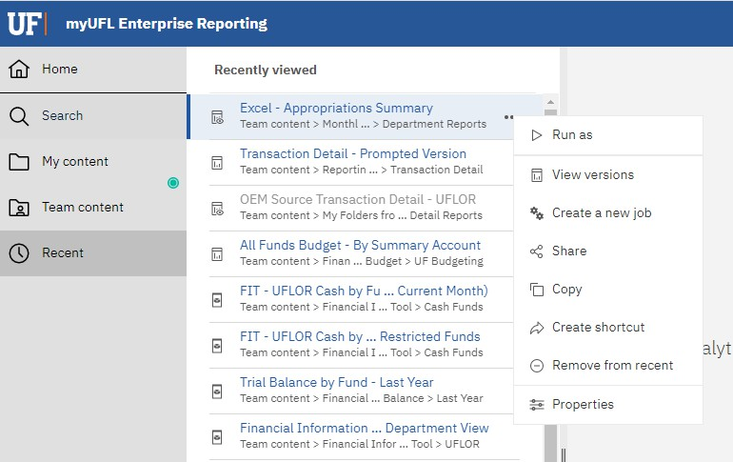

Search and Find Content
Whether you are looking for reports, dashboards, data, files, folders, or other items, you can find any object by opening your My Content or Team Content folders, or by checking your Recent list if you have used it in the past. However, the Search is a quick, easy way to find exactly what you are looking for!
To find items, type keywords into the Search field and click Enter. You can also search for text, including table or column labels, shortcuts, templates, and more.

You might see many files show up when you search. However, if the breadcrumbs start with Shared Folders that is someone’s personal version of the report that cannot be accessed. You will want to use content found in Team Content.

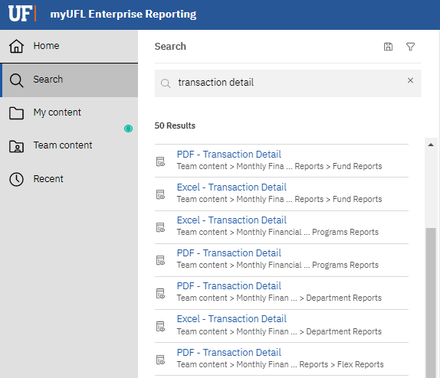

Narrow Search with Filters
If your search returns too many results, you can click the Filter icon to narrow your criteria.


The option to filter is only available after you perform your initial search.

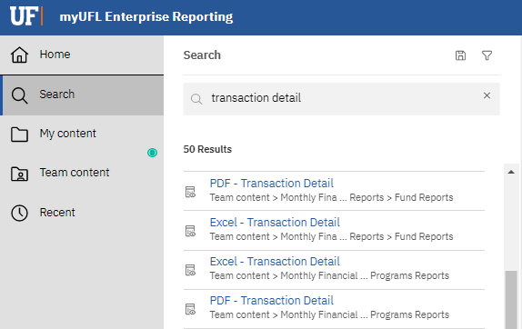

Viewing and Interacting with Content

The Action Menu
By right-clicking on a report or by clicking the “…” (More) button to the right of the report name, an
Action Menu will appear.

Depending on your security access, you might not see everything on this list. Work with your supervisor and DSA if you have questions about your security roles.

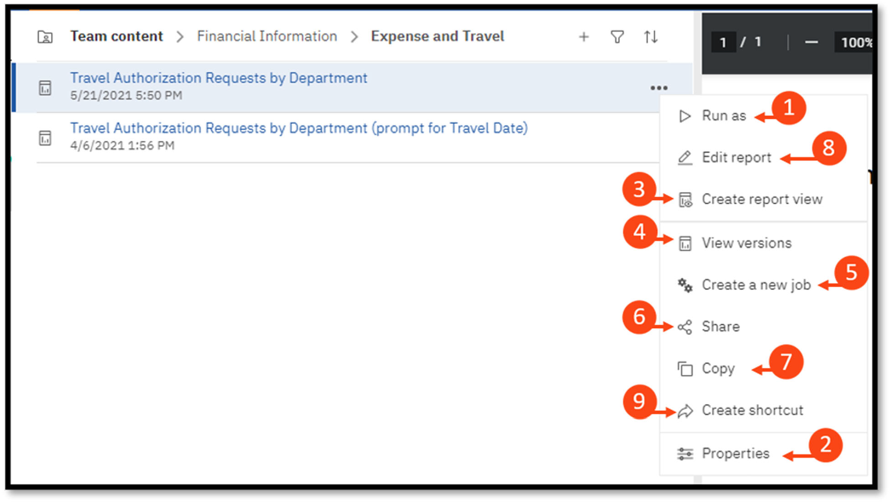



Run as: Allows you to choose from a list of desired output formats and to run directly to that format. Also allows for the option to Run in background while you do other tasks in Enterprise Analytics.


Properties: Displays the report owner, shows when the report was created and last modified, and reveals the report description, if applicable.

Create report view: Creates a report view of the report in your My Content folder. Usually used to create a dynamic copy of the report that you can Schedule (covered later in this guide) and set/save your prompts. This is our recommended practice and is best used for creating a ‘favorites’ listing in a specific folder instead of creating new copies/versions of a report.



View versions: Displays any previously saved report outputs.


Create a new job: A job identifies a collection of reports and/or report views that are scheduled together and share the same schedule settings.


Share: Copy link to share content with other users.


Copy or move: Copy or move a report to another destination within Enterprise Analytics. The user must have the security access to write a report to the new destination (for example, you could not copy a report to someone else’s My Content or a different department’s folder). A user can copy anything to their My Content area.

Edit report: (Report Authors only) Allows you to make changes/edits to the original report (Will be covered in the Advanced User Guide- coming soon).


When you Edit a report, it is editing your copy of the report from Team Content if you saved it to My Folders.


Create shortcut: Used to create a shortcut of the report in My Content.

Running Reports
When you find a report, you would like to run, you have several options.


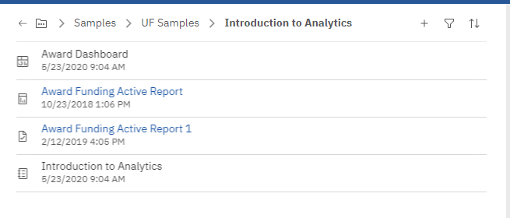

- Navigate to the desired report from My Content or Team Content on the Left Navigation menu and click directly on the report name.
- From the same navigation, hover over the desired report and click the More (…) button to the right of the report. Choose Run as, which will open up a new menu where you can select a method to run the report to a specific output type. This is especially helpful if you encounter a report with a default format.
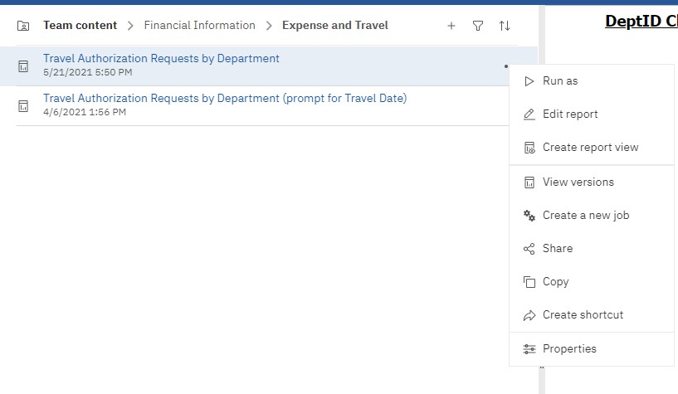

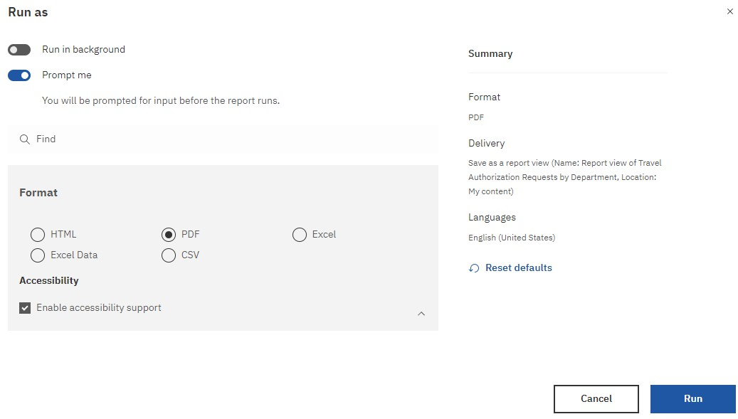


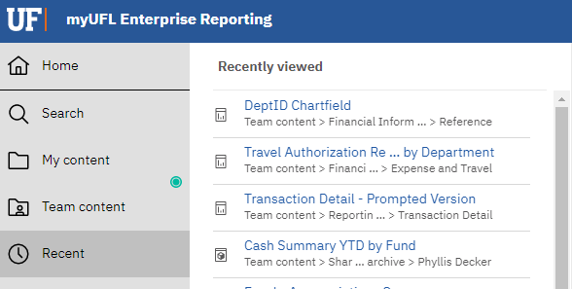

- Navigate to the report from the Recent icon on the Left Navigation menu.


Once a report has been opened in a current session, it will remain open in the Page Switcher tray until you close it (or end your session). Clicking on an already-opened report from the tiles or Page Switcher will launch the report with its last generated output.

Changing Report Format
If you run a report to one format, you can change the format of the output by selecting the Run (play) button on the application toolbar and choosing a new output from the list that appears on the menu. This will re-run the report with the prompts you have already selected.
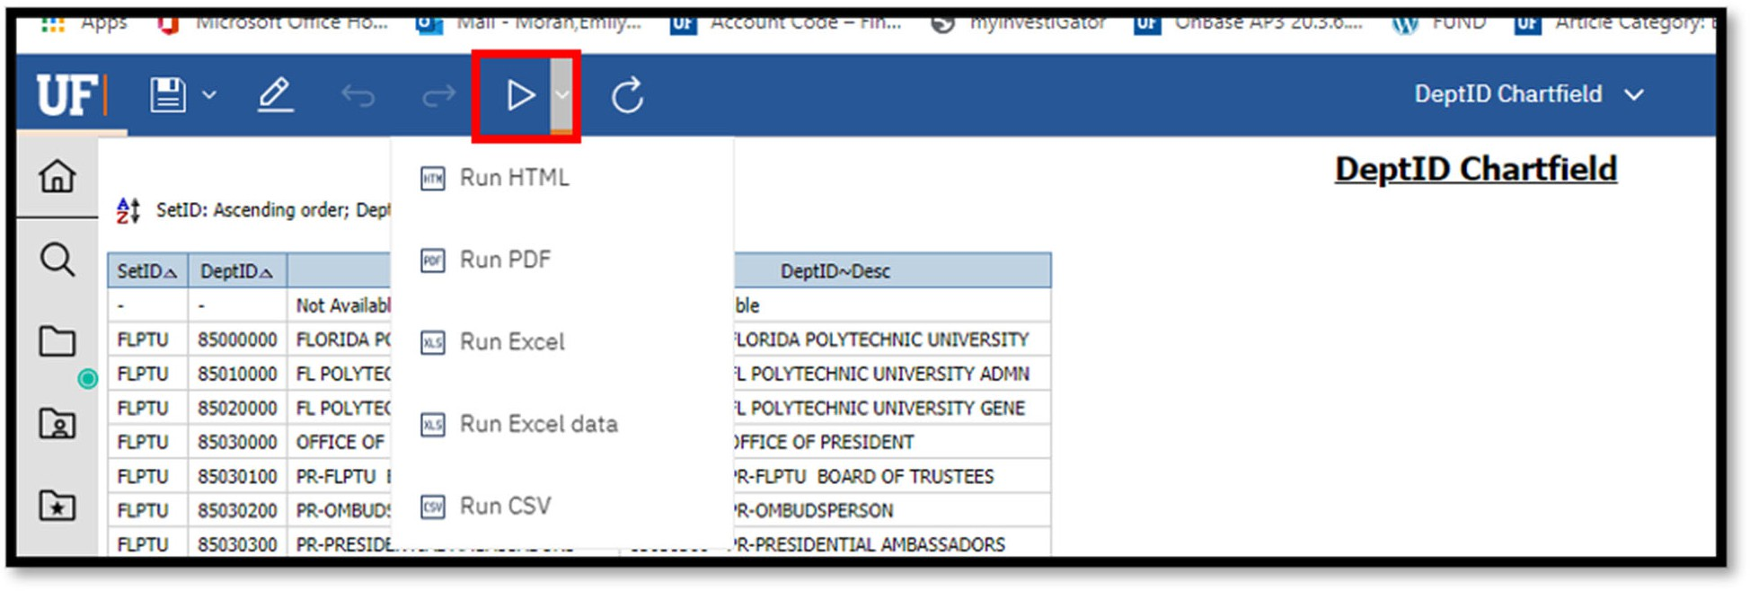
As we mentioned above, you may also encounter reports with default run views. Instead of clicking on the report name, hover over the desired report and click the More (…) button to the right of the report. Choose Run as, which will open a new menu where you can select a method to run the report to a specific output type (see table below for a breakdown of options).
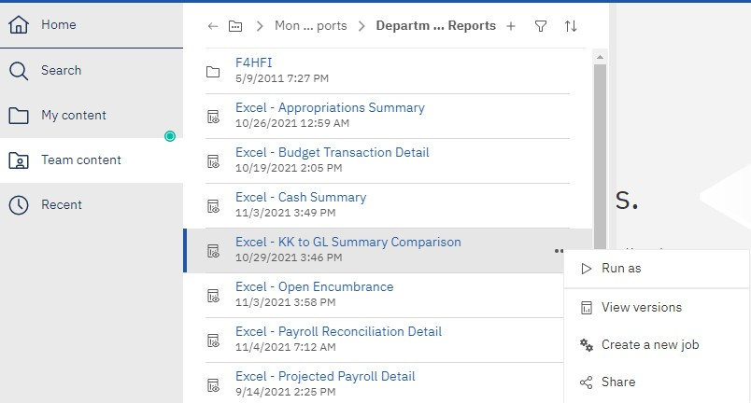
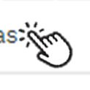

 | HTML | - Default output  - Web based and designed for viewing report output on-screen  - All pages are displayed and accessible for any report containingtabbed layouts

 | PDF | - Used for printing and distributing in Adobe AcrobatReader  - Each page in a tabbed layout report will render its own page
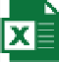 | Excel | - Supports lists, crosstabs, icons, titles, subtotals, totals and charts  - Each page of a tabbed layout will render as its own worksheet
 | Excel data | - Contains raw data of report  - Report formatting (e.g., titles, charts, icons) are dropped and data is returned in spreadsheet format  - Only the first page of tabbed layouts will appear
 | CSV | - Exported data which is tab-delimited and can be imported to (or read by) other software  - Strings are not enclosed in quotation marks  - Show only the results of the report query  - Page layout items, such as titles, images, totals and subtotals do not appear

Properties of a Report
To get to the Properties of a report, navigate to the report and click the More (…) button to reveal the
Action Menu and select Properties.

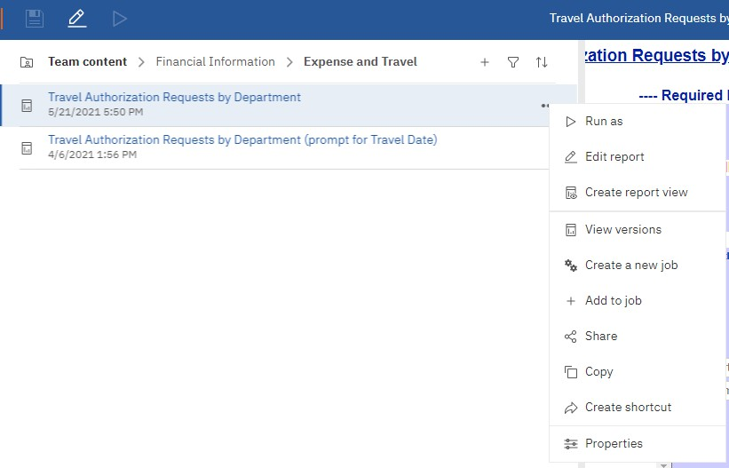


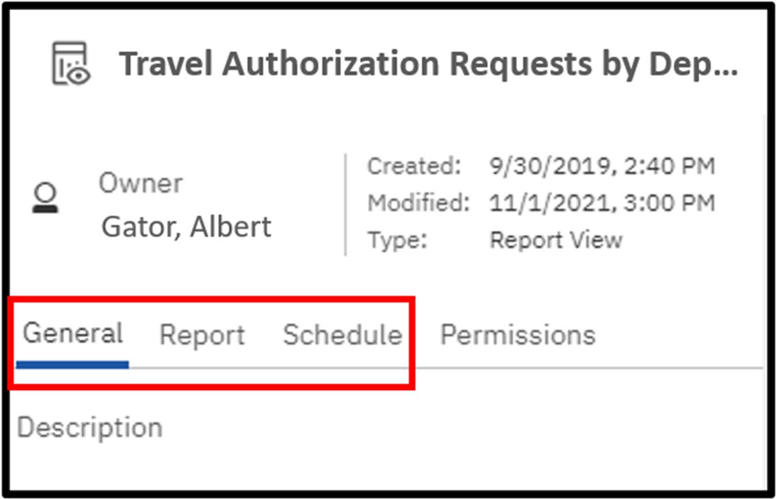

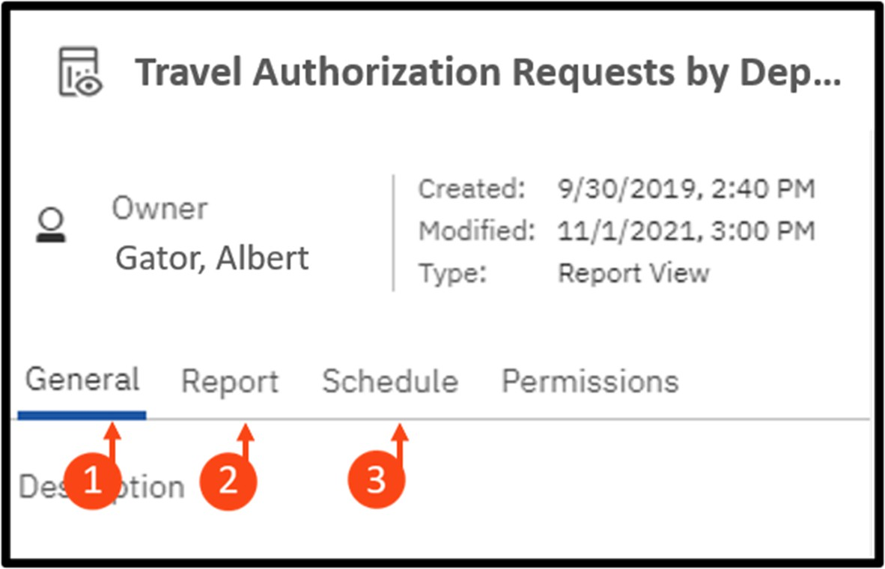

The Properties pane will open. Depending on the report and your security access, the available options will be different.


General Tab: Includes the report description. The Core Offices and the Reporting Services team is working to ensure most (if not all) reports have detailed descriptions in them.


Schedule Tab: Before you create a schedule, create your own report view (See Schedules section below for more information)

Report Tab: shows you the default run formats and how many prompts for the report

Prompts
Many of our reports have a prompt page that we see prior to the report’s execution. This helps make reports more versatile by allowing users to select targeted data for the report. It also helps the report process faster by limiting the amount of data coming back from the database.
- Prompts can be on one or more pages
- Prompts can be required or optional – an asterisk* indicates the prompt is required
- Finish/Submit/Run buttons are grayed out until a mandatory prompt is selected
- Some prompts only allow you to choose one option, while others let you multi-select
- CTRL+click to select multiple values within the prompt box
- For convenience, some prompts have Select All and De-Select All links below the prompt
- All prompt pages contain a Cancel, Submit, Finish, Run or OK button to either cancel or execute the report
- If prompts are optional and none are selected, the report will probably take longer to complete


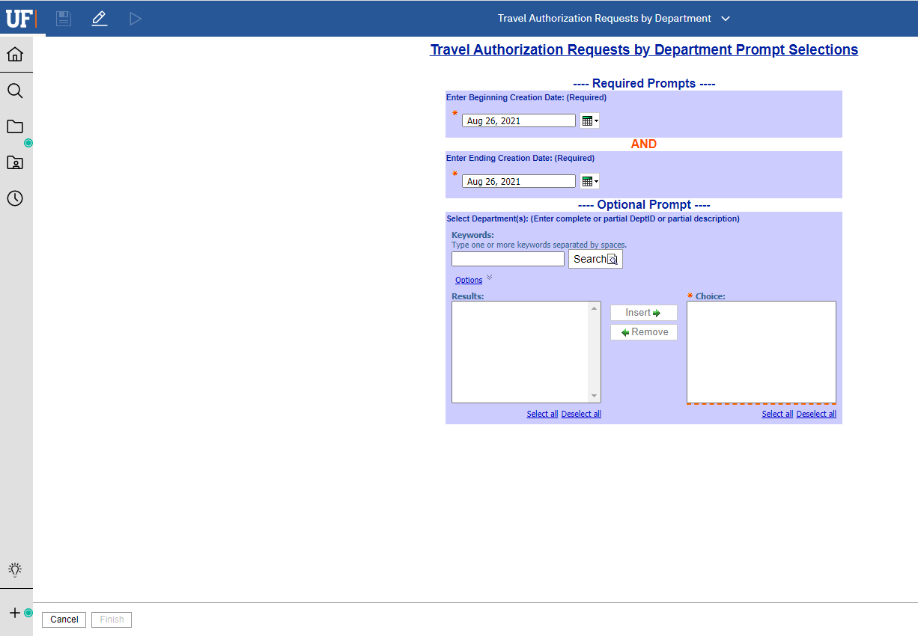
- Not all prompt pages look the same!

Changing Report Prompts

Sometimes you need to change the prompts for a report that you already ran. In order to run the report with different prompts, select the Run button and select Reset prompts and run.
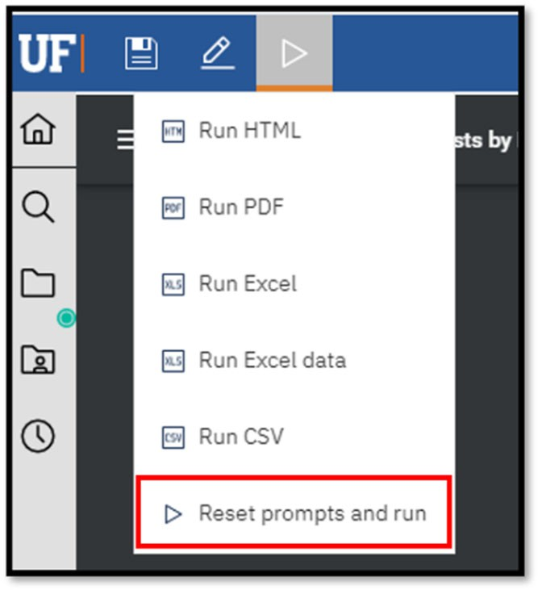
If you do not see the Reset prompts and run option, simply rerunning the report will refresh the prompt page.

Report Options
The options available to you depend on the type of report you’re viewing as well as your security access in Enterprise Analytics.


Here are some tips to get started with the options we will cover in the next few sections:
- If it is an important report or somewhere you’ll visit or start from each day, you can set it as your Home Page
- If you want to see and typically run a report on a regular basis, Subscribe to it
- If you entered prompt and parameter values that you want to save (so you don’t have to enter them each time you go to run the report), save the report as

a Report View
- If you want to have it sent to you and others, create a Report View and Schedule it

Subscriptions
Enterprise Analytics has a new feature called Subscriptions, which is available when viewing a report.
Subscribe allows the user to schedule a personal copy (or report view) of the report more quickly.

See section on Report Views below for more information.

If you use a report regularly, you might want to Subscribe to it. The Subscribe feature can only be used once the report has been run and is then found under the More (…) button.
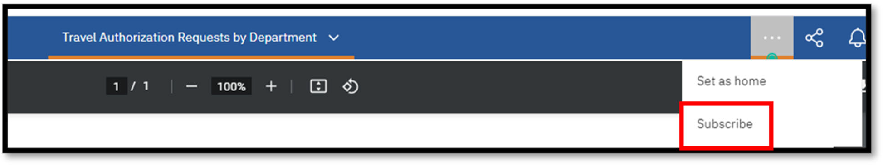
When you Subscribe, you pick the time, date, format, and where you want it to be delivered. The subscription includes all your prompt and parameter values.

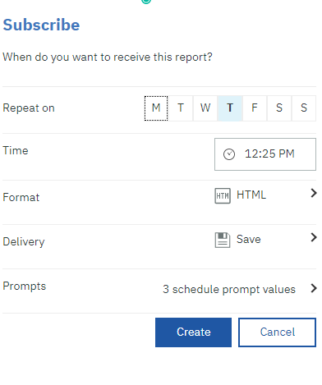
Creating subscriptions automatically creates a Report View in your My Content. The reports you subscribe to will be delivered (to you only) with your custom prompt values and options.
After you have subscribed to a report, you are notified each time it is delivered. Click the Notifications
(bell) icon to view any messages, which will contain a link to view the report output.


See section on Notifications for more information.

 The ability to schedule reports for broader distribution still exists and is covered below.

Report Views
While your report is still open, you have the option to Save report as report view.

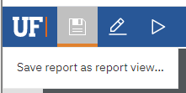

Creating a Report View is simply storing the output of the report in a specified format (e.g., HTML, PDF) for specified prompt conditions. Report Views are a combination of a shortcut and a dynamic copy of the original report. So, if you have a report that you want to run with different prompt values, schedules, delivery methods, run options, or output formats, you can create one (or more!) Report View(s).
The Report View will always refer to the report from which it was created. Any changes or modifications that are made to the original report, after creating the Report View, will not be captured in the Report View until you re-run it.

Creating a report view does not change the original report. In the Properties panel for the Report View, you will see a link to the source report.

If you would like to edit the prompt values for the Report View, open the Properties panel.

If the source report is moved to another location, the Report View link is maintained. However, if the source report is deleted, the Report View link will break.

Schedules
Whether you need to run your report on a daily basis or only every so often, the Scheduling Tool in Enterprise Analytics makes it possible to schedule your reports to run automatically, as frequently as you need.
Your original report can only have one schedule associated with it, so you will need to create a Report View (or multiple report views, as needed) unless the report is in your My Content folder. This keeps the original report intact and allows you to create as many unique schedules for each report view as necessary.
Each schedule can have a different frequency, distribution, and delivery option attached to it. *See section above on Report Views.

To create a new schedule on a report or report view:
- Navigate to the Properties of the report

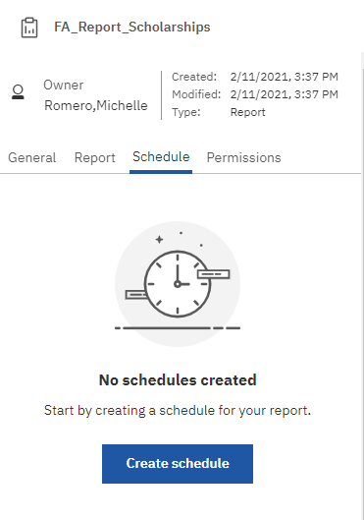
- Click the Schedule tab and click Create schedule

- Enter appropriate criteria on Schedule tab
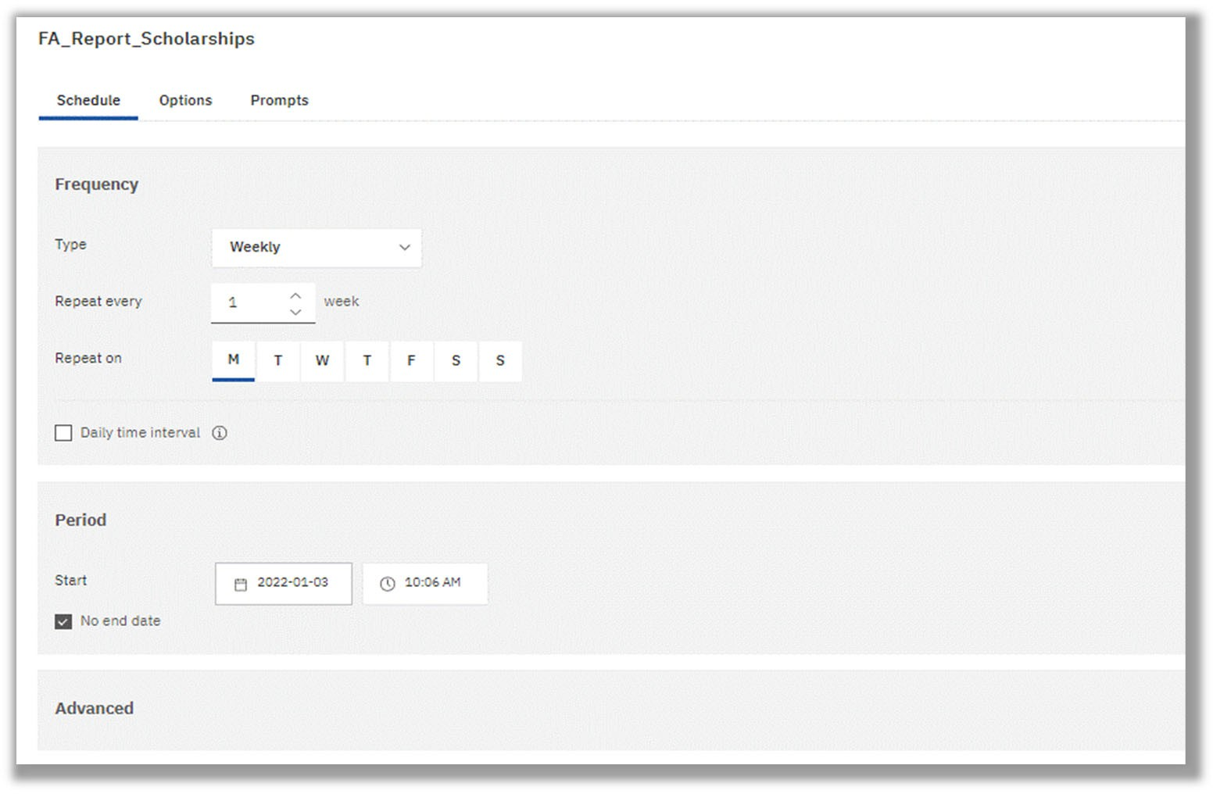


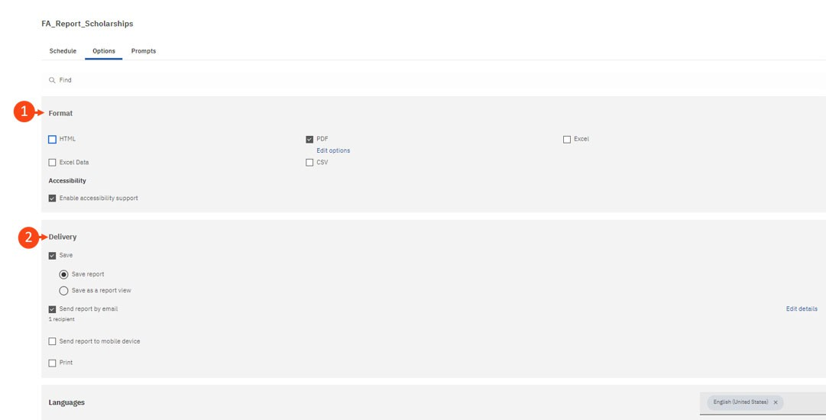
- Review and customize report format and delivery on the Options Tab



Format: Choose from listed output types. You will notice that the PDF format shows an “edit options” button, here you can set up the orientation/paper size of the report, and/or password protect the report.

Delivery: Choose your report delivery method. If you are trying to send the report via email to multiple people or create a custom subject and message, select the “edit details” button to the left of that delivery method.

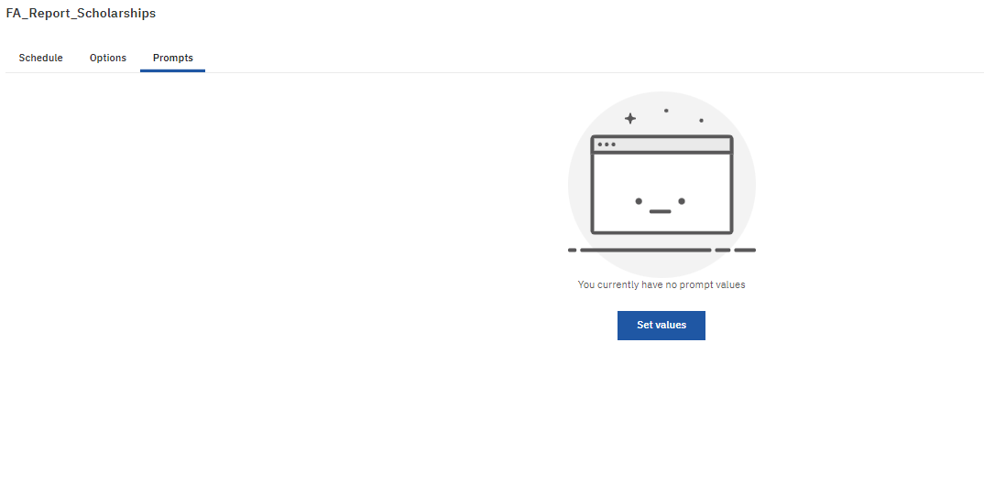
- Set or clear prompt values in the Prompts Tab

Managing Your Schedules and Subscriptions
You can view and manage all of your schedules and subscriptions by selecting My Schedules and Subscriptions from the Personal Menu.


You can enable, disable, modify, or delete Schedules or Subscriptions and view their saved outputs or archived versions. If you view the versions, you can also open the version details panel for information such as the run status, error messages, and run time.

Password Protecting PDF Documents
If you choose to password protect a PDF copy of a report, this can be done from the Properties menu within a report view.

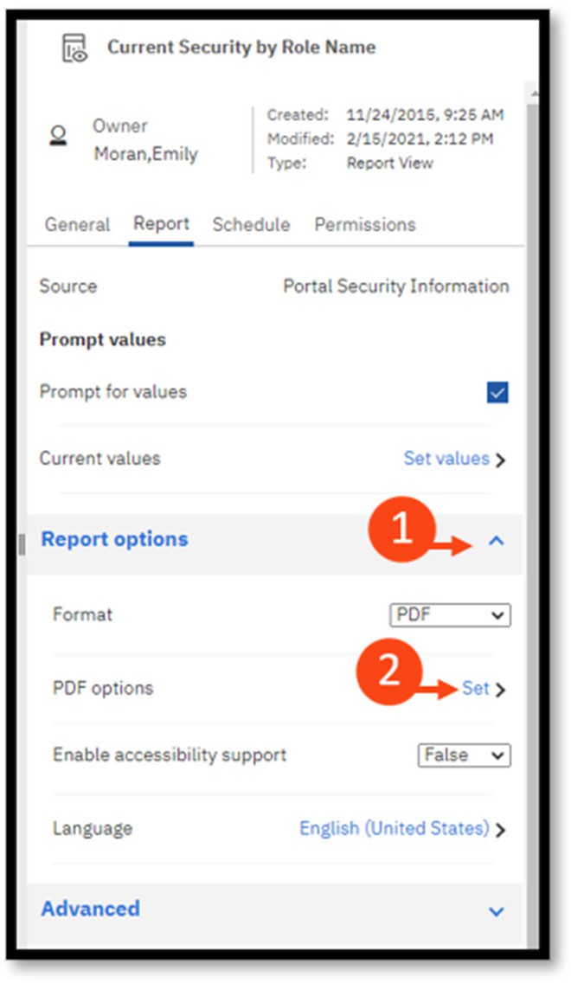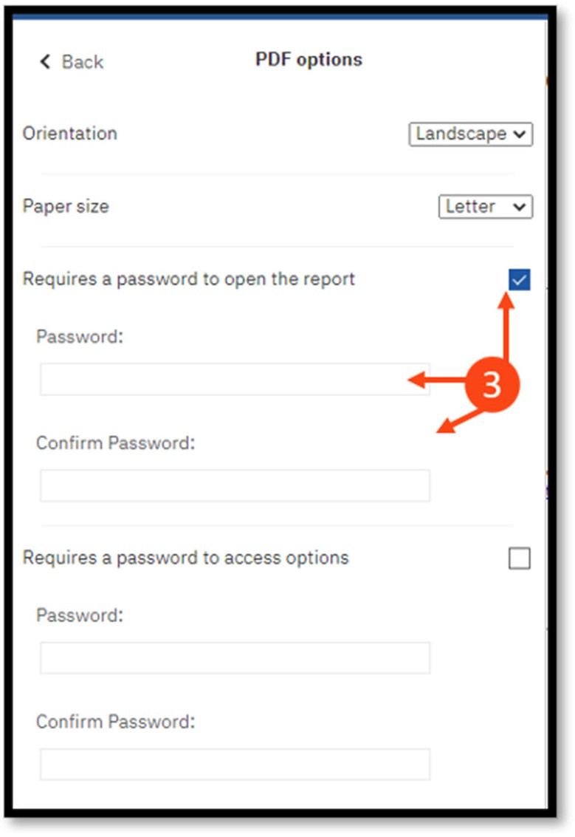


From the Report tab, click the ^ next to Report Options to open the menu, and select PDF

for the format


Next to PDF options, select Set

Check the box next to Requires a password to open the report, then set and confirm the password

Editing Reports
After you run your report, Report Authors will see an Edit (pencil) icon. Clicking this icon opens Reporting and, depending on your security permission, allows you to make changes to your report in authoring mode. The Report Author role is only given to select users at the discretion of the core offices. See the Enterprise Analytics Advanced Fiscal User Guide more information.


Contact the core office associated with your data if you are unsure whether the Report Author role is appropriate for your use.


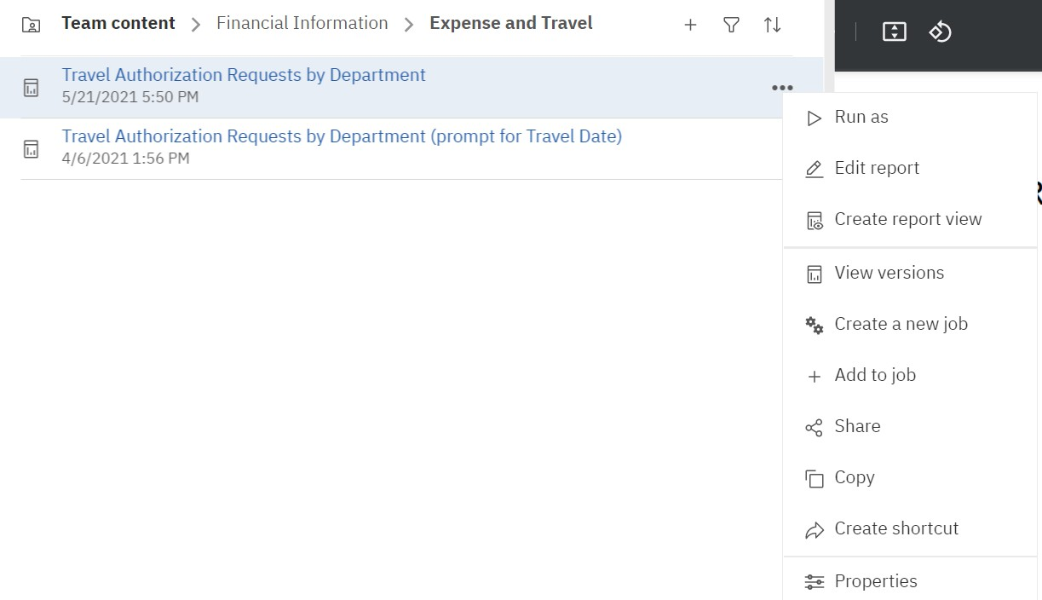

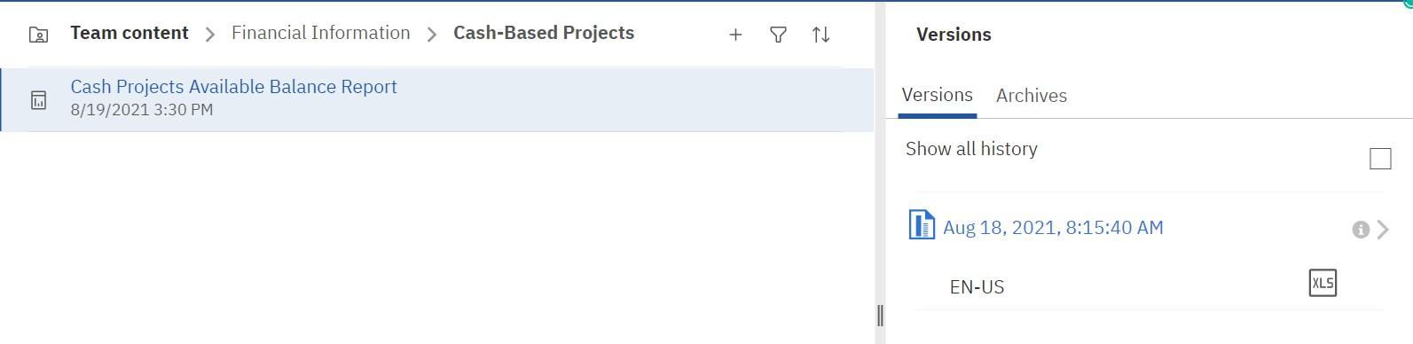
Report Versions
If you run reports, you will see the latest data from the data source at the time you run the report. However, when you view report versions and outputs, such as when a report you Subscribe to is delivered, you are viewing the data that was captured when you saved the version or view of the report.
To view report versions and archived versions:
- For a report in a content list, click the More (…) button and then select View Versions

- This will open up the list of available versions

- Click on the date to show the output format of that version and click on the format to run the report with the prompts and parameters from that version
To delete saved report versions:
- Click the More (…) button
- Select View versions and click on an entry in the list
- Select Delete report version

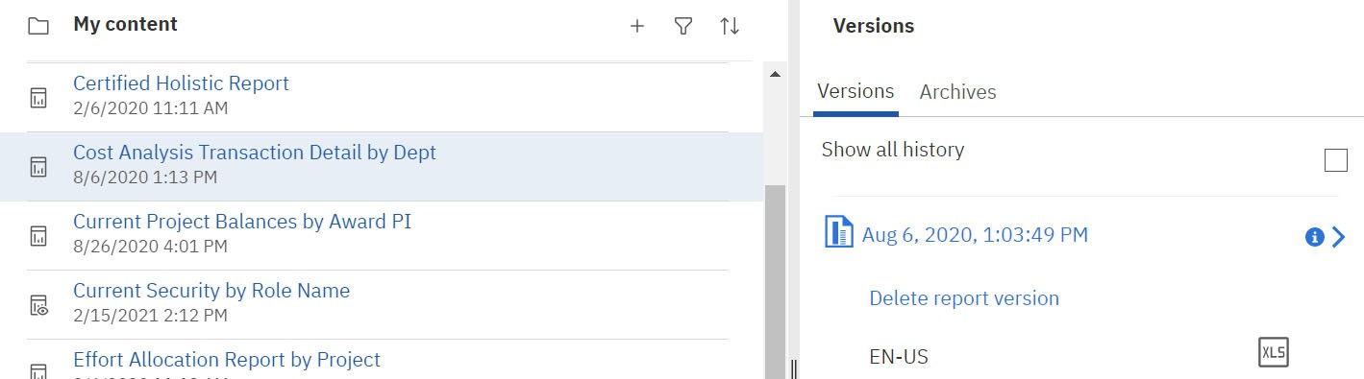

Deleting removes all saved output formats of the version.

Thank You and Additional Assistance
Thank you for taking the time to review our Introductory Enterprise Analytics Fiscal User Guide. We hope you found it useful in understanding the navigation and reporting capabilities of Enterprise Analytics.
We are currently working on more resources and trainings to better support our community in Enterprise Analytics. For news, resources and trainings please visit our new Enterprise Analytics Team within Microsoft Teams.

For Additional Assistance

Enterprise Analytics and Reporting UF Reporting Services Reporting-Services@ufl.edu

User Guide Enhancements
UF Controller’s Center for Excellence controller-office@ad.ufl.edu

