Prepaid Debit Card Activation Steps and Tips

1 Receive Card
2 WAIT 2-3 Business Days
5-Steps to Activate Your Card

Thank you for joining our study! Bank loads funds to your card.
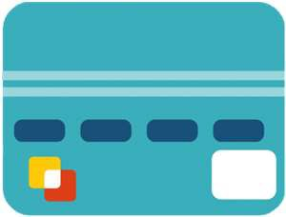


- Create an account online at usbankfocus.com, call 888-863-0681, or download the U.S. Bank Mobile App (search for U.S. Bank from your iPhone® or AndroidTM phone).
- Enter 16-digit card number.

3 Activate Card
4 Use Card
- Enter 3-digit CV2 code found on

Follow steps to the right. Make purchases or obtain cash.
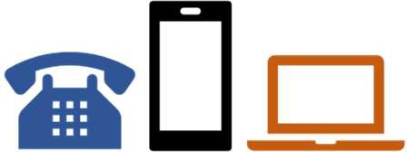

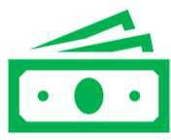
back of card.
- Enter your zip code.
- Create a 4-digit PIN number to use for cash withdrawals at ATM or PIN-based purchases.
Note: If asked to enter a phone number, skip this step.
- Sign your name on back of card with ink.


For additional assistance contact Cost Analysis at 352-392-5778 or hsp@admin.ufl.edu.



Did You Know?

  - Use your card to make purchases everywhere Visa® debit cards are accepted.
  - Get cash at any ATM, bank, or credit union or get cash back with purchases at participating merchants such as grocery or convenience stores.
  - Earn rewards by using your card at certain stores and restaurants, after activating the offers that you want – no promotion codes or coupons needed.
  - If you’re receiving additional funds as a research participant, your prepaid debit card is reloadable. Retain for additional payments to be issued.

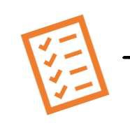
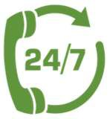
Track Your Spending

Lost or Stolen Card
Call Cardholder Services at
888-863-0681 to report your card lost or stolen. A replacement card will be sent to your home address within
7-10 business days.
    - Check balance, view recent transactions, and sign up for alerts when money is added, a purchase is made, or when your card balance gets low at usbankfocus.com.
    - Quickly see your account balance and transaction history from your smartphone. To download the mobile app, search for U.S. Bank from your iPhone® or AndroidTM phone.

