
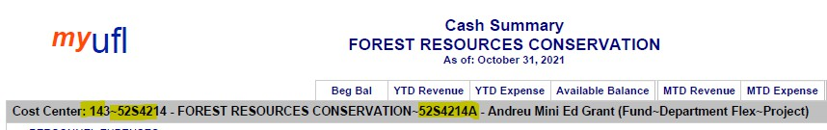
Monthly Financial Reports (MFR) for Fund 143
The monthly financial reports for fund 143 have changed effective October 2021. This new format will support reporting using projects numbers to allocate and identify resources used from continuing education courses or programs. Transitioning is still underway and the MFR reports will have a mix of reporting with and without the project number.

Notes:
- Fund 143 will require project numbers as an additional field within the ChartField string to track revenues and expenses within the 143 FLEX account but the Commitment Control (KK) configuration remains the same at the Flex level; budgetary controls are still aggregated at the Fund, Flex, Dept.
- Available balance will not be controlled by the project, so you may see several projects running negative balances. The 143 MFR reports will show you the available balance for each Project number but the available balance in myUFL will be the cumulative of projects of each flex.

Changes to the MFR Fund Reports
Flexes can be shared by multiple departments, so the 143 Fund Reports excludes the Department ID so you can look at a dept flex in totality across department IDs.
The Fund Reports can be accessed through: Enterprise Analytics > Fund Reports > 143 AUX – DOCE FUND > FLEX.

Cash Summary
The Cash Summary report now includes Project number as part of the Cost Center. This report will give you the running balance of transactions posted to the fund-dept flex-project. The beginning balance for the available balance is life to date for the project. This is a cumulative report that can help you budget and plan out the project’s expenses.
Example shown below: 143 (Fund) ~ 52S4214 (Department Flex) ~ 52S4214A (Project).


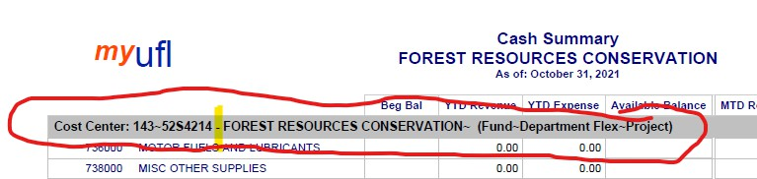

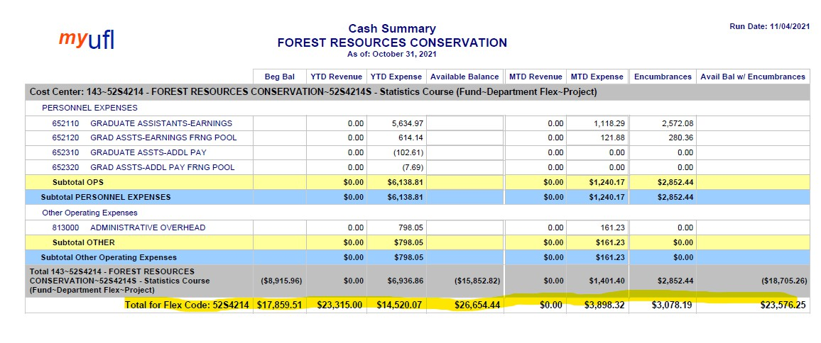
The first page may show a blank Project number (see screen shot below). This will be your cash summary for the Fund-Flex without project numbers assigned. You will see a balance with no Project number until your flex has fully transitioned to the required project field. The goal is to have all flexes using a project number by the end of the fiscal year 2022.

You may note many of these projects have a negative balance. Since the project is not a KK ChartField for this fund, the system will not keep you from running the project negative. As long as the flex overall is positive you will pass budget checking. The new MFR reports now include a Total at the end of the Cash Summary report for each Flex Code so you can still review the entire flex balance. This is the available balance that should match the myUFL KK balance for the Flex’s total.


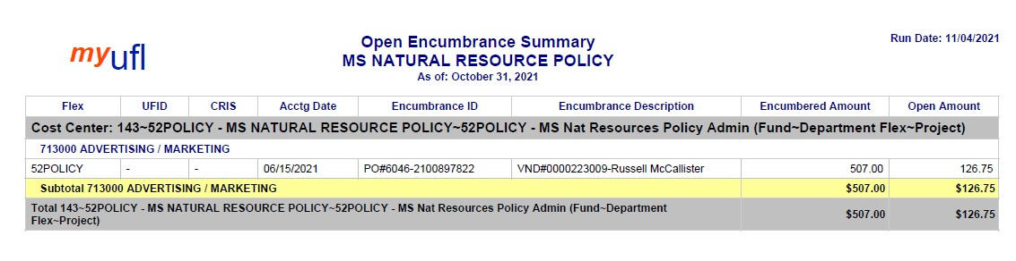
GL/KK Summary Comparison
The GL to KK Summary Comparison has not changed from the prior configuration. Project is not a controlling ChartField for this fund, so it will not be a factor when considering GL to KK variances.

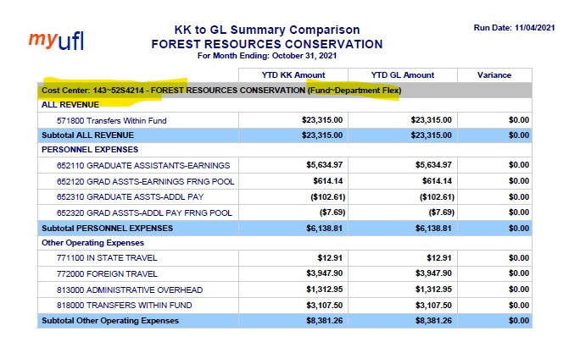

Open Encumbrance/Payroll Reconciliation Detail/Projected Payroll Detail/Transaction Detail
All these reports are similar to the previous format but are now distinguishing transactions by Project number. This will help you review, report, and plan out the project’s expenses.


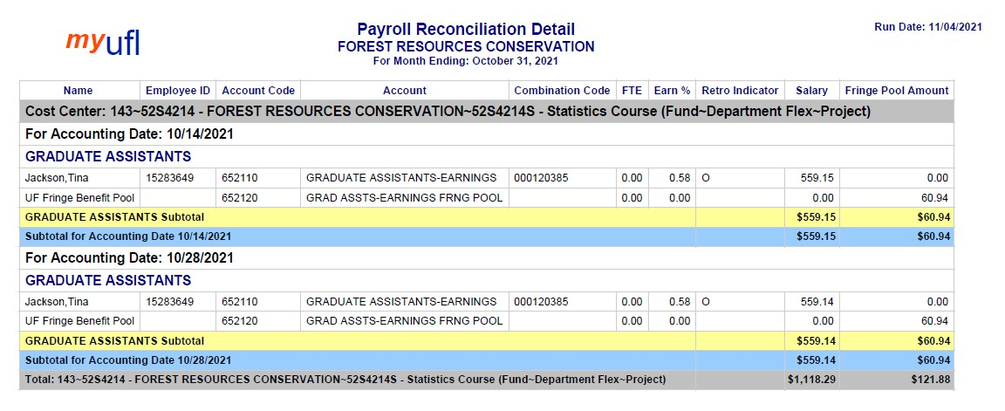

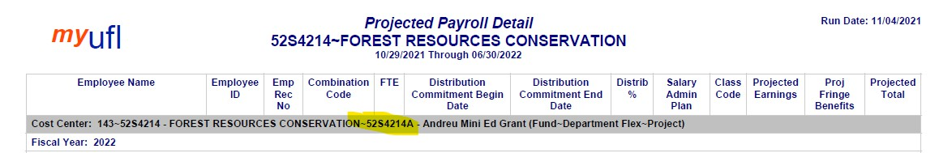

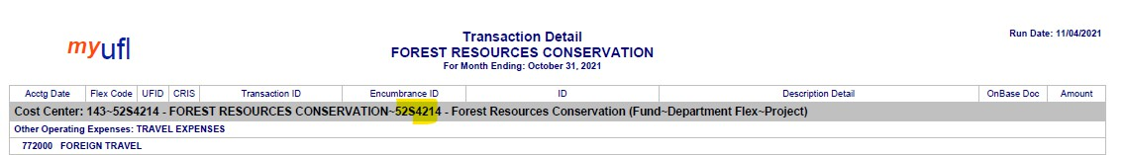

Changes to the MFR Department Reports
The changes are similar to the fund reports above except there is no total for the Flex. To review the total for a flex, you must use the fund report.

