UFIFLORIDA
University Bursar
Finance and Accounting Division http://www.fa.ufl.edu/bursar/

S113 Criser Hall PO Box 114050
Gainesville, FL 32611-4050
352-392-9545 Phone
352-392-3448 Fax

Florida Prepaid: Q&A Session
How does FL Prepaid work at the University of FloridaP
- UF downloads a file from FL Prepaid & the information is linked through the student's Social Security Number. Therefore, the University Bursar does NOT need your FL Prepaid card.
- Once the student is registered for classes, FL Prepaid will automatically be applied towards the tuition amount If changes are made to the course schedule by the end of the drop/add period, FL Prepaid will automatically recalculate.
- Students can view the amount billed to FL Prepaid by looking at their "Tuition Statement" at one.uf.edu >Student Self Service>University Bursar>Tuition Statement There will be a "Billed to Sponsor" towards the bottom of the statement, which is the amount being billed to FL Prepaid.
ff'hyis FL Prepaid not app6edP
- There are a few reasons that FL Prepaid may not be applied:
  - A hold could be placed on your account with FL Prepaid
  - The FL Prepaid account could be delinquent
  - The SSN on file at UF or at FL Prepaid may not match
  - The enrollment (matriculation) year could be incorrect
  - The student chose to opt out

Does FL Prepaid cover 10096 ofThitionP
- There is no Florida Prepaid Plan that covers 10096 tuition and fees.
- Below is a list off ees that are not covered by any of the FL Prepaid plans:
- Transportation Access Fee (Campus Fee) {built into the tuition rate}
- Technology Fee {built into the tuition rate}
- Test Fees
- Material & Supply Fees
- Distance Learning Fees for online classes
- Equipment Use Fees
- Repeat Surcharge {same course taken 3+ times}
- Excess Hour Surcharge {student exceeds maximum hours to graduate}

llPage


lVhatare the differenttypes ofFL PrepaidPlans & what does itcoverP
- Tuition Only: This plan covers the tuition component ONLY; the student is responsible for paying the local fees& any other fees assessed by certain classes.
$117.08 per credit hour will be paid by FL Prepaid
- Tuition& Local Fees: This plan covers the tuition component, as well as local fees except thetechnology fee and transportation fee
$153.85 per credit hour will be paid by FL Prepaid
- Tuition& Differential: This plan was only available after 2007. This plan covers the tuition component and the tuition differential component. The tuition differential was implemented after 2007 by the State Legislature
$161.25 per credit hourwill be paid by FL Prepaid
- Tuition, Differential& Local Fees ("Bundle"): This plan covers the tuition component, the differential component and the local fees except the technology fee and transportation fee
$198.02 per credit hour will be paid by FL Prepaid
Note: The amount billed to FL Prepaid ranges from $117.08 to $198.02 per credit hour and depends on the type of plan you purchased as well as the year it was purchased. You may call FL Prepaid or our office to determine your plan.
lVhatifIdo not wantFL Prepaid billedP
- Students can choose to decline the use of their FL Prepaid plan for any given semester. For Fall&. Spring semesters, the "opt out" option must be completed prior to fee payment deadline. The online opt out option is not available on fee payment deadline day; therefore, students choosing to opt out on the deadline day or those who need to cancel an online selection must contact the University Bursar. To opt out online, the student will log in to
their one.uf.edu account and select the following:
Student Self Service>University Bursar>Opt out of FL Prepaid
- To opt out of the Summer semester, the student will need to come in person or email us by visiting www.fa.ufl.edu/bursar/& click on "Ask Bursar Help" prior to Tuition& Fee Payment Deadline.
Howdoes FLPrepaid work with other ScholarsbipsP
- FL Prepaid will be applied first, then the other scholarships will be disbursed after the established Drop/Add date. For questions regarding Bright Futures or any other scholarships, please contact Financial Affairs & Scholarships at the number below.
Is there any otherhelpfulinformationP
- We realize this is an exciting, but oveiwhelming time for you and your student. Here are some tips to help ease your mind:
  - Encourage your student to enroll in Direct Deposit to receive refunds faster
  - Encourage your student to fill out a Financial Information Release on their one.uf.edu The individuals listed on this form will be able to inquire about the student's financial account details.
Contact Information:
  - Housing& Residence 352-392-2171
  - Student Financial Aid & Scholarships 352-392-2244
  - Florida Prepaid 800-552-4723
http://www.myiloridaprepaid.com/using'-your-plan/all-ahout-fces/

21Page

FLORIDA PREPAID TUITION PLAN INFORMATION
At the University of Florida, the Third Party Contracts Department in the University Bursar's Office administers Florida Prepaid. The University Bursar's Office is open from 9:00am-4:30pm, Monday through Friday. Below are the procedures for processing Florida Prepaid:

- We will automatically defer the maximum amount that can be invoiced. Participants must be in good standing with Florida Prepaid. Please note: You are not required to notifi; the University Bursar's Office that you want to use your plan.

- All remaining fees not covered by your FL Prepaid Plan will be due by your payment deadline. Students can check their charges due on one.uf.edu and selecting Student Self Service>University Bursar>Charges Due
Please be aware of payment deadlines. Failure to pay your remaining balance by the time specified will result in a $100.00 late fee, a financial hold and/or may result in cancellation of your courses.

FLORIDA PREPAID COVERAGE CHART:

Tuition & Fee Components:

Tuition
Capital Improvement Fee Financial Aid Fee
FL Prepaid Tuition Only Plan: Covered Covered
Covered
FL Prepaid Tuition & Local Fee Plan: Covered
Covered Covered
' ,, h •,' •fj, j
Undergraduate Per Credit Hour Rate:
$105.07
$6.76
$5.25

Local Fees:
11, '···'�·- ·�,_:,,, ,. ,,,:1�,�: ,,
It·, .;,j 1.::�-1�
,t' '"!',,.,; '.,!
�"'' •· t•.
;J :�- ;�
iJ'.: ill; / 'tl

ActivitlJ & Service Fee
·•,;, l: .' •;;"
,,Ii�;, �
Athletic Fee Health Fee
Tuition Differential
*Exempt if plan was purchased prior to 2007 Transportation Fee (Campus Fee)
TechnologtJ Fee
t··'.�:i"';
Not Covered
Not Covered Not Covered

Not Covered Not Covered
No�t Covered
Covered
Covered Covered

Not Covered Not Covered
Not Covered
'+
$19.06
$1.90
$15.81

$44.17

$9.44

$5.25

Other Fees:
·.i:1:"'0,1�: .�-: .
,cs-. ·.; A?t >• , _,,. --�rv::·•••t�U>I"
· ·b.<';,2ii.:::(�,!\_;;1,·1>'ih"'i ,1 ),� :(:�, ' 'J';'.V' :t'.iJ:t>c�'1f-�..,,):Ji i, .;�J,:c;,;;,it.i-,�:

Distance Learning Fee
Repeat Surcharge
Not Covered
Not Covered
Not Covered
Not Covered
Varies
$192.47

Material & Supply Fee
Not Covered Not Covered
Varies

Equipment Fee
Excess Hour Surcharge
Not Covered Not Covered
Not Covered Not Covered
Varies
$105.07

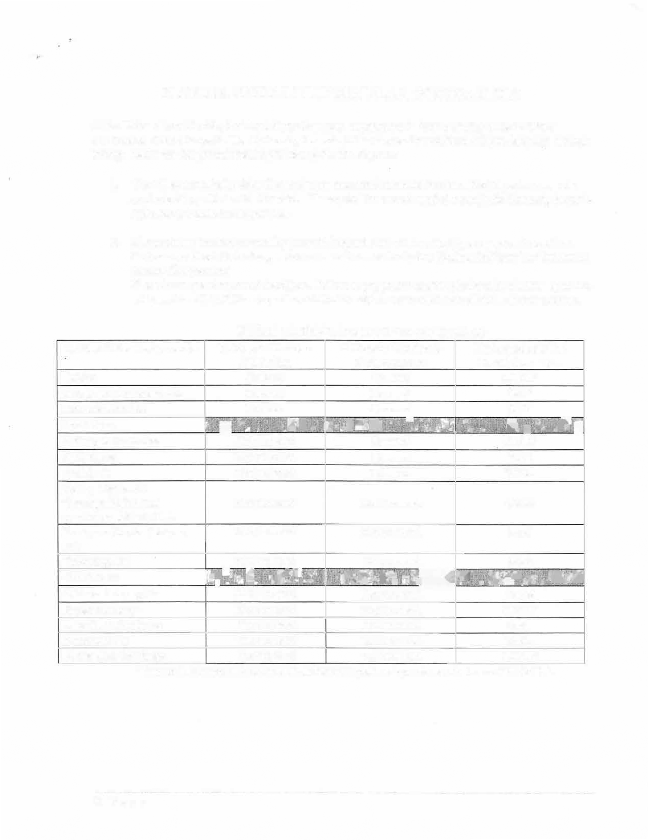
*Tuition Differential is covered if differential plan was purchased between 2008 &2010.

3jPage

CURRENT TUITION & FEE RATES:

Traditional On-Campus Students with a Tuition & Fee Rate of $168.54*

*Students will receive the Tuition & Fee Rate of $168.54 IF the FL Prepaid Plan has a contract date of 2007 or prior

Contract Date 2007 & Prior: | Tuition Only Plan: | Tuition & Local Fees Plan:
Prepaid Pays: | $117.08 | $153.85
Student Pays: | $51.46 | $14.69

Traditional On-Campus Students with a Tuition & Fee Rate of $212.71

Contract Date 2008 & After: | Tuition Only Plan: | Tuition &  Local Fees: | Tuition &  Differential: | Tuition, Differential &  Local Fees:
Prepaid Pays: | $117.08 | $153.85 | $161.25 | $198.02
Student Pays: | $95.63 | $58.86 | $51.46 | $14.69

UF Online Students: Contract Date Prior to 2007

 | Tuition Rate: | Tuition Only Plan: | Tuition &  Local Fees: | Tuition &  Differential: | Tuition, Differential &  Local Fees:
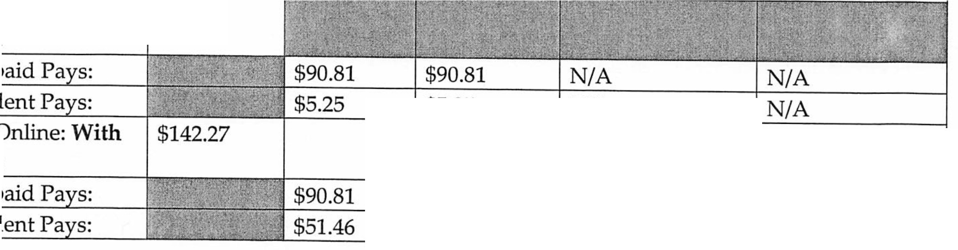  UF Online: No | $96.06
Fee |  |  |  |  | NIA NIA
Pre |  |  |  |  | NIA NIA
Stu | $5.25 |  |  | NIA | NIA NIA
UF |  |  |  |  | NIA NIA
Fee |  |  |  |  | NIA NIA
Pre  Stu | $127.58  $14.69 |  |  | NIA  NIA | NIA NIA

41Page

,-

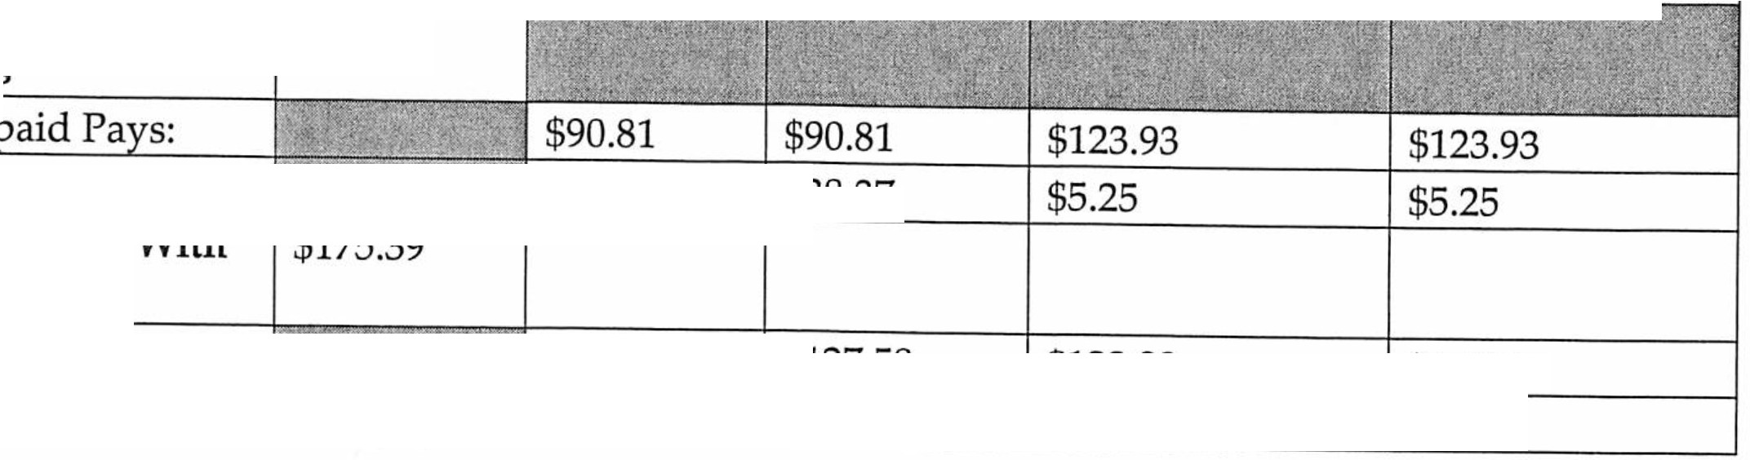
UF Online Students: Contract Date 2008 or After
Tuition Rate:
$129.18
Tuition Tuition &
Only Plan: Local Fees:
Tuition &
Differential:
Tuition,
Differential & Local Fees:
UF Online: No Fee
Pre Stu
UF On1in .
Fees
$38.37

Pre s: |  | $127.58 | $123.93 | $160.70
Stu s: |  | $47.81 | $51.46 | $14.69

Tuition & Fee Breakdown Link:

http://www.fa.ufl.edu/bursar/

Florida Prepaid Link: Explanation of Fees
http://www.myfloridaprepaid.com/using-your-plan/all-about-fees/

SI Page

