Locating SEA Invoices
SEA invoices are identified during a workflow step, so myUF Marketplace is not able to automatically notify department recipients. Therefore, a report has been written to enable departments to identify these SEA transactions.

Navigate to: User (silhouette profile icon) > Manage Searches > UF Searches. Click on Select Expedited Approval (SEA)
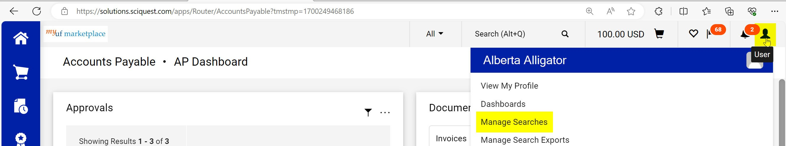

This will produce a listing of all SEA invoices processed.

Filters can then be added to narrow down by “Dept ID” or other criteria (see diagrams listed below).
