
Refresher Training
April 4, 2024
Space
Allocation
1



Agenda
- Purpose
- Space Definitions
- Allocation Categories
- Tips
- Deadlines
- Contact Information
- Resources
- Questions
2


Purpose
Required by the Federal
Office of Management & Budget per CFR-200 Circular
Reports are necessary to
develop the University of Florida’s Facilities & Administrative (FnA) Rate Proposal to the Federal Government.
Facility costs are a major
part of the FnA rate and Space is the main driver for allocation of these costs.
Therefore, the Federal
auditors pay close attention to the survey results.
3



Purpose

- Also assists departments to manage and track the use of their space.

- The university uses the space system to verify occupancy, usage, and development of the RCM Budget allocation.
4


Space Allocation Definitions
Certifier – Person who Authorizer – Person who Certification Period – often prepares and “approves” the Certified the complete fiscal year: inputs the data information July 1, 2023 – June 30,
2024
Allocation (Spread) –
Reporting the functional use of the space across categories; must equal 100%
Occupant – Person who
is an occupant or user of the space (More information to come)
Sponsored Project –
Contract, Grant or Cooperative Agreement
5


What is This Year’s Certification Period?
July 1, 2023 – June 30, 2024
6


Space Allocation Categories
- The primary question to ask is “How was the space actually used during the entire Fiscal Year?

- Some of the rooms, as a space certifier, you will know the answer to.
  - For example –a copy room, breakroom, or a normal administrative conference room – is typically department administration.
  - However, when talking about faculty lab space and offices it gets more complicated.
    - Who is the best person to know what is going on in that space?
7


Space Allocation Categories
- There are basically 4 main categories that departments use for Space Allocation:
  - Administration
  - Research
  - Instruction
  - Other
8


Space Allocation Categories - Administration
- Department Administration - If there is administration in space for a department
  - Examples of types of department administration – General Departmental office functions, department chair offices, fiscal support staff, mail rooms, copy rooms, departmental conference rooms.

- Practice Plan Administration - would be found in the Health Science Center or Vet Medicine areas.
9


Space Allocation
Category – Instruction
- Instruction space is space used for all teaching, training, and instructional activities.
  - Examples: Preparing a syllabus or grading papers
  - Classroom teaching or classroom labs
  - Departmental Libraries that are not a part of the Library system
*Note - If a student is UF paid salary, and is working
in a lab, then the student can be doing other functions than instruction.*
10



Space Allocation Categories - Research
- There are two different types of research:
  - Organized
  - Departmental
11

Space Allocation Categories – Organized
Research
- Organized Research is all space that is funded by a sponsored project including research training grants. This space is known at an institution as separately budgeted and accounted for or funded research.
  - Can be any type of space including offices, labs, lab services, closets, etc.
- Funds:
  - 201 (Federal)
  - 209 (Non-Federal)
  - 214 (Non-Federal Clinical Trials)
- Specific for College of AG (Some Vet Med Areas) Also includes:
  - 223 – Federal Capacity Funding
  - 103 – Where used to meet cost sharing for Capacity Funding
    - Department ID will End 60XXX088
    - Does not include REC’s – all 103, program code 2XXX is Organized Research
    - Can be seen using enterprise reporting information
12


Space Allocation Categories – College of Ag OR

There will be “fake” Project numbers in order to use the fund 103 and fund 223 sources
  - FUND103
  - FUND223R

It is important to note that not all activities that use this source is OR
  - Writing new proposals
  - Fiscal staff in department (DA)

If the salaries are supported by these sources with the research program it is VERY important that the space is coded as OR.

13


Space Allocation Categories - Research
- Departmental Research looks and acts just like Organized Research, but the salary and funding support is from a departmental source and is not separately budgeted and accounted for.
  - This includes GAP and Start-Up Funding
  - Other examples: Indirect Cost Funding, development of proposals for new research (not continuations).
  - NOT MANDATORY OR VOLUNTARY COMMITTED COST SHAREING – this
is Organized Research activities
14

Space Allocation Categories - Other

- Other Sponsored Activities (OSA) - comes in a variety of forms. It is funding from outside agencies that are not research or instruction (Ag Extension Grants as an example)
  - College of Ag - FUND223 – Program Code 3XXX should be allocated here if anyone is working in your space that is paid from this source – “Fake Project” FUND223E to add to the projects area
- Agriculture Extension - Space related to activities involving the Agricultural College and Vet Med – DO NOT USE THIS CATEGORY IF FUNDED BY A SPONSOR OR CAPACITY FUNDING.
- Governance – preparing for a faculty senate meeting or university-wide search committees. This is only a when a significant amount of work is devoted to these university wide committees.
- Patient Care – All space used for the clinical practice activity, including the treatment of patients related to the Faculty Practice Plans.
15

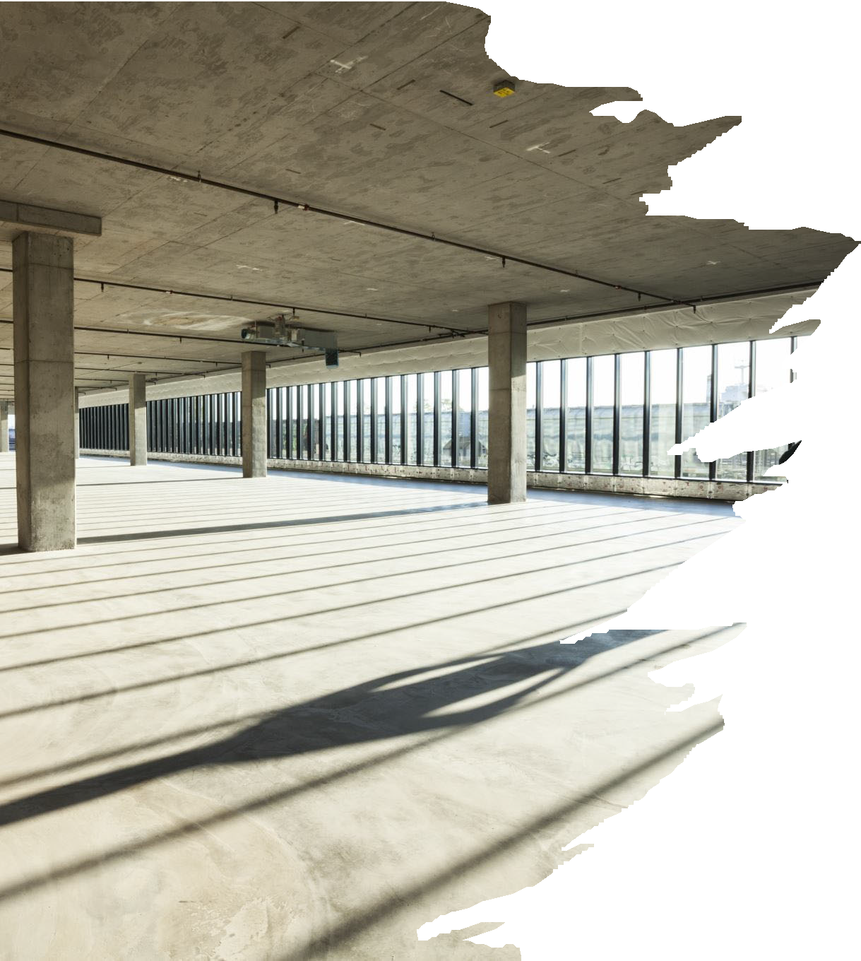
Space Allocation Categories - Other
- Vacant - Space that is closed, entirely unused, empty and not due to renovations.
  - Space that was used during part of the fiscal year should be shown at the corresponding percentage that it was vacant.
    - Example: If a room is vacant from May 2024 – June 2024 of the fiscal year of reporting that is 2 months. 2 months / 12 months = 17% vacant
  - Normal work breaks, vacations, and absences does not mean the room is vacant.
- Vacant/Renovated – Space that was vacant due to renovations during the fiscal year
  - You should have a construction project number if this is the case.
  - The project number will be listed in the room information section of the screen.
16




Space Allocation Categories - Other

Public Service – Example: Serving as a consultant to a local, state or national agency. This is a rare category to use.
Union Activities – Space used for the United Faculty of Florida (UFF) or Academic and Professional Assembly (APA) pretty much need to be an officer. This is a rare category to use.

17

Space Allocation Categories - Other
  - Other Institutional Activities (OIA) – Everything else that can not be reported in the other categories.
    - This is NOT the same as the effort reporting category OIA – Other Instructional Activities. This category is not to be used for instruction purposes.
      - Examples: Breakrooms, Non UF Paid: Volunteers, Visiting Researchers, or Emeritus Faculty, Etc.

18

Space Allocation Categories - Other
- Recharge Center - Use this category to report space used for revenue generating activities that serve students, faculty, staff and the general public or other University departments.
  - Includes space used by:
    - Service Centers
    - Generally, any space area that charges others for a service. Those services that are calculated are subsidized by other department funding sources.
      - Examples Include: Animal Care Services, McKnight Brain, UFARM, and other recharge activities that not only charge for services, but do not charge fully burden costs.
      - Do Not Use this category for space used for: Auxiliary areas that are state statute defined for recharge purposes. Examples include, Residence halls, dining halls, student unions, intercollegiate athletics, bookstores, faculty housing, chapels, theaters, public museums, and other similar auxiliary enterprises.
19

Space Allocation Categories - Other
- Auxiliary (AUX) - Use this space to report space used for revenue generating activities that serve students, faculty, staff and the general public or other University departments.
  - Includes space used by:
    - Residence halls, dining halls, student unions, intercollegiate athletics, bookstores, faculty housing, chapels, theaters, public museums, and other similar auxiliary enterprises.
    - Space used by true auxiliary functions that are self-supporting areas, meaning not having subsidies from other funding sources to cover the costs of operations.
    - Do Not Use this category for space used for:
      - Educational Business Activities/Service Centers/Recharge Centers/Specialized Service Facilities.
20


Space Allocation Core Office Categories
A core office is an area that supports the entire university, not a specific college, center, or department.
- General Administration – Includes IT, ES, F&A, HR
- Sponsored Project Admin – Includes Sponsored Programs, C&G, Cost Analysis
- Student Administration – Includes Criser Hall, Registrar’s Office
- O&M – Includes PPD, Facilities, Campus Mail, EH&S, UPD
- Library – Includes the operation of a library in the official library system, not small departmental libraries or rare book collections.
21


Tips for Allocating Space
- Interviewing the occupants of the space is the best way to get an idea of the activities that goes on in the space.
- Get out and tour your space! How do you know if a refrigerator or lounge sofa is in a research lab if you have never been?
- If someone says the space is research, verify how those occupants are being funded to determine what kind of research.
- Students in lab space with a desk must have proportion allocated to instruction regardless of how they are paid. UNLESS they have dedicated space to do their schoolwork in a different area.
22


Tips for Allocating Space
- Avoid Standard splits! If all the research space is coded 90% OR and 10% DR every space year, it will be viewed as if no review of the space has been done.
- It is also recommended that the space certifiers work in conjunction with your payroll processor, effort coordinator, and grants administrators in your department.
- Storage Rooms – What are you storing in them?
23


Tips for Allocating Space
- Payroll Matters! It is important to have a space to base match.
- Effort Matters! We expect that if a faculty member has multiple activities on their effort record, there would be multiple activities in their office space.
  - *Note – Effort to space is rarely a one-to-one match!* Example – a faculty member has administration on his effort record. We would not expect administration to be in the research lab.
24



Use Your Resources

- Enterprise Analytics
  - Reports for Staff Payroll
  - Reports for Effort Holistic
25

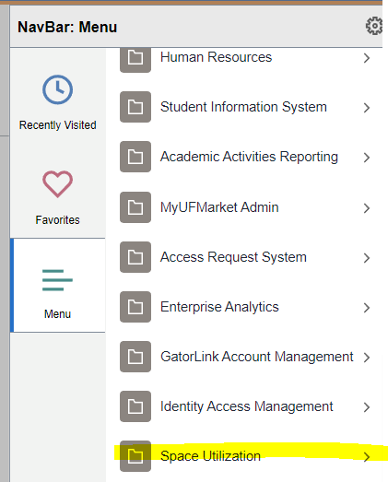
The Space System
From MyUFL
Direct Website Link
- https://survey.facilities.ufl.edu/
26


Tips of the Space System
- Don’t forget that the Data screen is very useful! You could input all of your information from this screen.

- There are also ways you can download your data into Excel from this screen to work with the information.
27

Tips of the Space System
- A Room allocated to Organized Research (OR) or Other Sponsored Activities (OSA), must have the associated project numbers must be added to the room.
  - In addition, if a room is allocated between 1-99% OR or OSA Federal requirements dictate that you not only designate the sponsored research projects that are occurring within the room, but that you also provide the funding sources (chartfield string) supporting the non-sponsored activities occurring in the room.

- Both projects and chartfields entered in the previous fiscal year will be shown in the Room Information screen. If a project was not worked on in this space for any part of the current fiscal year, the project should be removed with an end date of June 30, 2023 or earlier.

- Projects that ended in the fiscal year must still be accounted for.
28

Tips of the Space System
- In the system, there are special selections that can be made to document the non-sponsored allocation(s) when PeopleSoft ChartFields are not applicable.
- Use these selections to report the non-sponsored portion of a room that has been partially allocated to Organized Research:
  - Not UF-Paid: This can include laboratories and other research space used by students, visiting researchers, Emeritus faculty, and volunteers who are not paid by UF.
  - GA Grant-Funded: Students who are paid by the grant being conducted in the room AND have a desk in the room at which they can work on their own dissertation or other course work.
  - Vacant/Renovated: This can be used if the room has some portion allocated to Organized Research and Vacant/Under Renovation for the fiscal year.
29


Tips of the Space System
- You will be unable to certify space:
  - As long as there are unreported projects
  - If there are any space room update tickets not closed
  - Your space is not 100% complete
30



Tips of the Space System

- If you have a project that was not worked on in space, meaning not even in an office, OR, the project has yet to begin work this fiscal year 2024
  - Contact our office so that we can mark it as exempt to remove the requirement to have it reported.
    - spacealloc@admin.ufl.edu
31


For Room Type Updates
For Example – Changing a Research Lab to an Office
32

For Room Type Updates
- The University of Florida utilizes the nationwide standards to categorize and report space to the Board of Governors. In the case of an “office” versus a “lab”, equipment and FFE are not considerations in these space use types; rooms are coded as they are used.
- For example, a Psychology research lab looks much different than a Chemistry research lab. They are each coded as a research lab in our system. Simply put, if research activity is conducted in the room, it is coded as a research lab.
- Please, do not, under any circumstances, attempt to re-code your space solely to save on your facilities costs. Intentional inaccurate space reporting will get reported to the Provost’s Office.
  - If there is a suspicion that space is being recoded incorrectly it will have additional scrutiny (regardless of research specifically).
33


Other Space Training
- It is mandatory to take the space training to become a space certifier. To register you can navigate to myUFL > My Self Service > Training and Development > mytraining and type in RSH210 in the Activity.
- If you would like for us to walk the space with you if you have a questions, send us an email and we would be happy to assist:
  - spacealloc@admin.ufl.edu
34



Coming to SPIN

- Email notices of receiving and removing rooms
35



Keep Sending In Your Suggestions
- We are always happy to hear your suggestions and comment. Please keep sending them in!
36


Deadlines for Fiscal Year 2024 Space Allocation
15 May 2024
Suggested that Interviews should be completed before
- This is to avoid any faculty who may leave for the Summer if you are a 9month college
6 Sep. 2024
Input of all data in the Space System should be completed and Space Certification Completed by
30 Sep. 2024
Authorization of the Space Data Completed by
37



Need Assistance
Cost Analysis – For Space Allocation, Training,
or General Questions
Business Affairs Technical Services – To Add,
Remove, Update Space Room Information
Email: spacealloc@admin.ufl.edu Email: space@admin.ufl.edu
Phone: 352-392-5778
UF Space Reporting Team
38

Resources
- The Help Menu in the Space System
- Website: https://www.fa.ufl.edu/directive-categories/space-allocation/

39


Thank You
40

